Graph Search System using BFS and DFS
SLE-3: REPORT
Course | 02AML204 – Introduction to Artificial Intelligence | Name | Shreyash Potdar
Program / Semester | SY B.Tech. CSE (AI & ML) / SEM-VI | PRN | 26UAM305
Division | A | Date | 04 Oct 2026

System Title and Short Description:
This system searches a directed graph for a route from a given start node to a goal node. It provides Breadth-First Search (BFS), which explores with a queue, and Depth-First Search (DFS), which explores with a stack. The result includes the discovered path and a count of expanded nodes.

C4 Architecture

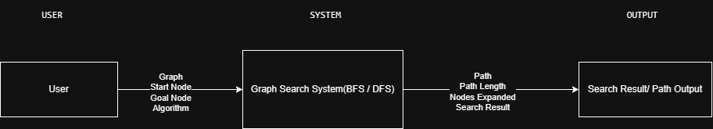
Level 1 Context Diagram:

Figure 1. User input and graph-search results at the system boundary.

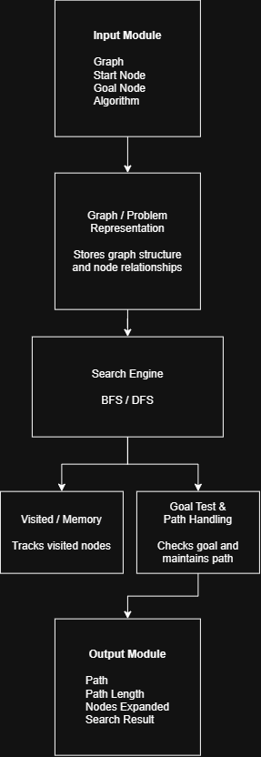
Level 2 Container Diagram:
Figure 2. Recorded functional containers for input, search, memory, path handling, and output.

C4 Architecture Continued

Level 3 Component Diagram:
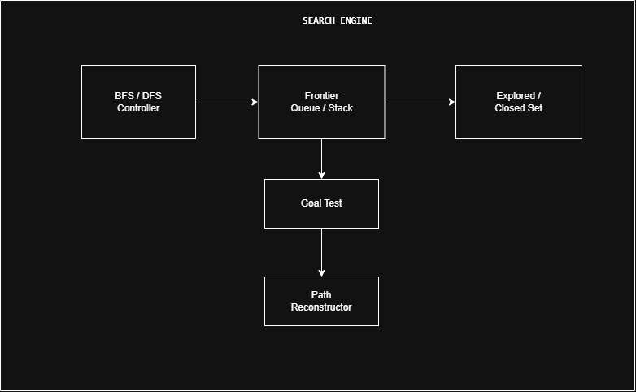

Figure 3. Search Engine components: controller, frontier, explored set, goal test, and path reconstructor.

Level 4 Code Level Overview:
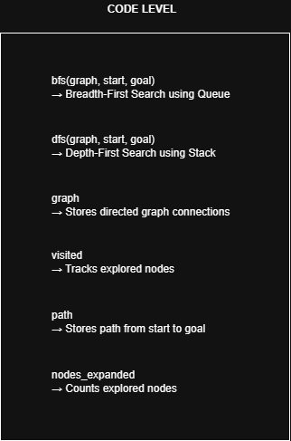
Figure 4. Main functions and data: bfs(), dfs(), graph, visited, path, and nodes_expanded.

Design Decisions:

The system is divided into separate modules for input, graph representation, search processing, memory management, path handling, and output to keep the architecture simple and modular. BFS uses a queue and DFS uses a stack so that both algorithms can solve the same graph-search problem. A visited set avoids repeated exploration, while separate goal testing and path handling make the search result easier to process and display.

AI Contribution Note:

AI assistance was used during the preparation of the SLE-3 architecture to understand the C4 model, organize the Context, Container, Component, and Code levels, and improve the clarity of the diagrams and documentation. The BFS and DFS system was continued from the student’s SLE-2 work, while the final architecture, diagrams, and report were reviewed and prepared by the student.

Conclusion:

The SLE-3 activity documents the BFS and DFS graph-search system through four levels of the C4 model. The diagrams show the system boundary, its main containers, the internal Search Engine components, and the principal functions and data. Together, these views explain how graph input is processed and how a path and search information are returned.

