SLE 4 Final Viva and Architecture Decision Record
Graph Search System using BFS and DFS
Course | 02AML204 - Introduction to Artificial Intelligence
Student | Shreyash Potdar
PRN and Division | PRN: 26UAM305 Division: A

Part A Architecture Decision Record
ADR Title: Use of a Visited Set in BFS and DFS Graph Search
Status: Accepted
Date: 11 October 2026

1 Context
The Graph Search System accepts a directed graph, a start node, and a goal node. It performs either Breadth First Search using a queue or Depth First Search using a stack, then returns the path and the number of expanded nodes. Graphs can contain cycles and more than one route to the same node. Without a mechanism to remember explored nodes, the algorithm can repeatedly revisit nodes, produce unnecessary work, and in cyclic graphs fail to terminate. This decision was needed to make both search algorithms safe and meaningful for comparison.

2 Decision
The system uses a visited set to record each explored node. A node is checked against this set after it is removing to the frontier, and each accepted node is marked as visited. The same decision is applied to both BFS and DFS so they operate on the same graph model and avoid duplicate exploration.

3 Alternatives Considered

Alternative | Reason not selected
No visited set | A cyclic graph can revisit the same nodes indefinitely and increases repeated work.
Mark only after removal from frontier | The same node can be added more than once before its first expansion, increasing queue or stack size.
Use only a path based cycle check | Useful in some depth limited searches, but it does not prevent duplicate exploration across separate branches.

4 Rationale and Justification
The visited set was selected because it preserves correctness on cyclic directed graphs and gives each node one opportunity to enter the search frontier. It keeps the expanded node count meaningful, since repeated visits are excluded from the result. In SLE 2, both algorithms found the same 8-edge path, A to C to F to J to N to R to V to X to Z. BFS expanded 25 nodes and DFS expanded 20 nodes. Across three runs of 100,000 searches each, BFS averaged 1070.167 ms, or 0.010702 ms per search, while DFS averaged 1164.746 ms, or 0.011647 ms per search. The implementation uses set membership, which is efficient for the node identifiers used in the graph. In the SLE 3 container view, the visited set belongs to Memory Management, while the component view represents the same responsibility as the Explored or Closed Set. This separation keeps the BFS and DFS controller focused on selecting queue or stack behavior. The decision also makes the returned path easier to reconstruct because every accepted successor represents a new exploration step.

SLE 2 BFS and DFS Measurement Summary
Metric | BFS | DFS
Path length (edges) | 8 | 8
Nodes expanded | 25 | 20
Run 1 (ms) | 1099.568 | 1098.097
Run 2 (ms) | 1062.292 | 1216.371
Run 3 (ms) | 1048.642 | 1179.768
Average time (ms) | 1070.167 | 1164.746
Average time/search (ms) | 0.010702 | 0.011647
Searches per run | 100,000 | 100,000

Observed result: BFS was faster in this benchmark, while DFS expanded five fewer nodes. Since both returned the same path length, the measurements show that the visited set kept the comparison focused on search strategy rather than repeated exploration.

5 Consequences
Positive
- Prevents repeated exploration and infinite looping on graphs with cycles.
- Keeps nodes expanded and runtime observations more reliable for the SLE 2 comparison.
- Supports a clean separation between search control and explored node memory in the SLE 3 design.
Negative and trade offs
- Requires additional memory proportional to the number of visited nodes.
- A single global visited set is appropriate for this unweighted graph search, but different search problems may require tracking states or costs instead of only node identity.

6 References
SLE 1 BFS and DFS implementation; SLE 2 BFS and DFS comparison report; SLE 3 C4 architecture diagrams for the Graph Search System.

Part B Short Summary of My SLE Journey
In SLE 1, I implemented the Graph Search System using BFS and DFS with AI assistance. In SLE 2, I compared both algorithms using execution time and nodes expanded, observing that BFS had a lower average execution time while both found the same 8-edge path. In SLE 3, I designed the four C4 architecture diagrams: Context, Container, Component, and Code. In SLE 4, I documented the importance of the visited set in preventing repeated node exploration and connected this decision with the Visited / Memory container and Explored / Closed Set component.
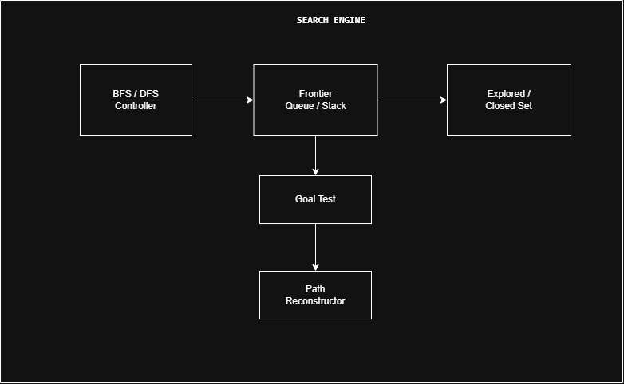
Figure 1. SLE 3 Search Engine component diagram showing the controller, frontier, explored set, goal test, and path reconstruction.

Part C AI Contribution Note
AI tools used: ChatGPT

AI assistance was used to understand the Architecture Decision Record (ADR) format, organize the written explanation, and improve the clarity of the viva preparation notes. ChatGPT also assisted in reviewing the BFS and DFS performance results and connecting the architecture decision with the SLE-3 C4 diagrams. I selected the visited-set decision from my BFS and DFS Graph Search System, reviewed the content, verified the SLE-2 profiling values, and finalized the report based on my implementation and experimental results.

Part D Viva Preparation Notes
Likely question | Short answer to prepare
Why use a visited set? | It prevents repeated exploration and ensures BFS and DFS terminate on cyclic directed graphs.
Why not use no visited set? | A node can be revisited many times. In a cycle, the search may continue indefinitely and inflate the measured work.
How did SLE 2 support this? | The comparison measured time, memory, and expanded nodes. Duplicate visits would make those metrics unreliable. I will quote my measured values.
Explain the C4 component view. | The BFS or DFS controller selects the strategy; the frontier stores pending nodes; the Explored or Closed Set records visited nodes; goal test and path reconstruction return the result.
What changes for a larger graph? | The visited set grows with explored nodes, but it avoids repeated work. BFS can use more frontier memory than DFS because it stores a whole level of nodes.

