REPORT
OF
GESTUREVOLUME: VOLUME CONTROL WITH HAND GESTURES
Submitted
To
School of Computer Science and Engineering
IILM University, Greater Noida, U.P.
In partial fulfilment of the requirement of degree of
B.Tech CSE

By
SHREYA
Roll Number of Student: CS-2341034
Batch: 2026–27
Program: B.Tech CSE (AI/ML)
Semester: VII
Section: 3CSE3
Organization: Infosys Springboard
2026–27

1. CANDIDATE’S DECLARATION
I, SHREYA, hereby declare that the internship report titled “GestureVolume: Volume Control with Hand Gestures” has been completed by me to fulfil the requirement for the award of the degree of Bachelor of Technology in Computer Science and Engineering. The report presents the work carried out during my virtual internship with Infosys Springboard and documents the development of the GestureVolume system.
I further declare that the information presented in this report is prepared for academic evaluation and that the technical sources used for the project have been appropriately acknowledged. I understand that I am responsible for ensuring that this report does not infringe copyright or other intellectual-property rights.
Signature: ______________________________
Student Name: SHREYA
Roll No.: CS-2341034

2. ACKNOWLEDGEMENT
I would like to express my sincere gratitude to everyone who supported me during my internship and helped me complete the project titled “GestureVolume: Volume Control with Hand Gestures.”
I am thankful to Infosys Springboard for providing a structured virtual internship environment through which I could apply concepts from computer science, artificial intelligence and machine learning to a practical computer-vision project. The internship provided an opportunity to work with technologies such as Python, OpenCV, MediaPipe and Flask and to understand how a real-time application can be designed around a user-facing problem.
I also express my gratitude to the School of Computer Science and Engineering, IILM University, Greater Noida, for providing the academic framework and guidance required to undertake and document this internship. I am grateful to my faculty members, mentors and peers for their guidance, feedback and encouragement throughout the work.
Finally, I express my heartfelt gratitude to my parents and family for their constant support and encouragement.
Signature: ______________________________
Student Name: SHREYA
Roll No.: CS-2341034

3. INTERNSHIP COMPLETION CERTIFICATE
Official certificate issued by Infosys Springboard
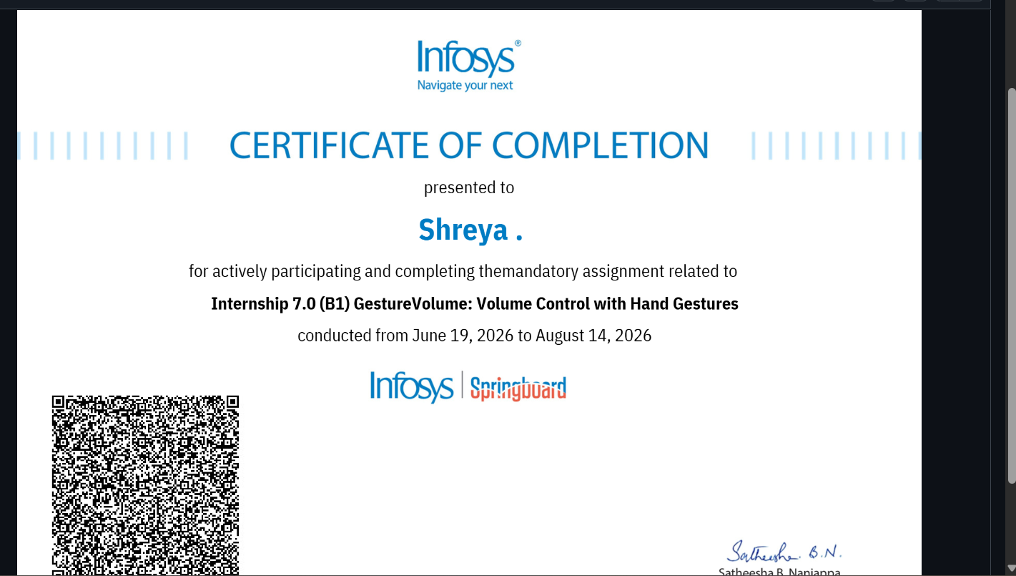

TABLE OF CONTENTS
1. Candidate’s Declaration i
2. Acknowledgement ii
3. Internship Completion Certificate iii
4. Project Description 1
4.1 Introduction 1
4.2 Organization Profile 2
4.3 Problem Statement 3
4.4 Project Objectives 3
4.5 Scope of the Project 4
4.6 Technologies and Tools Used 5
4.7 System Architecture 6
4.8 Methodology 7
4.9 Expected Outcomes 9
4.10 Certificates of Completion and Communication Proof 10
5. Bibliography / References 11

LIST OF FIGURES
Figure 4.1: System architecture of GestureVolume
Figure 4.2: Gesture-to-volume control workflow

4. PROJECT DESCRIPTION

4.1 Introduction
GestureVolume is a real-time computer-vision based system developed to control computer system volume through hand gestures captured using a webcam. The implementation uses Python, OpenCV and MediaPipe for video capture and hand-landmark detection, while a Flask web application provides a browser-based dashboard for live visualization and interaction.
The central interaction is based on the distance between the thumb and index-finger landmarks. The detected distance is mapped to a 0–100 percent volume range. To make the displayed and applied volume more stable, the implementation uses a short smoothing window before updating the volume. The system also calculates and displays frames per second (FPS), provides detection-status feedback and includes manual minimum/maximum calibration.
The project extends a basic gesture-volume controller into a more complete application by combining the computer-vision processing loop with a web dashboard. The repository contains a Python backend, HTML pages, CSS styling and JavaScript logic for dashboard interaction, volume visualization, calibration and detection controls.

4.2 Organization Profile
Infosys Limited is a global technology services and consulting company established in 1981. Infosys describes itself as a global leader in next-generation digital services and consulting, supporting clients in digital transformation across multiple countries. Its work spans areas including cloud, artificial intelligence, digital services and enterprise transformation.
Infosys Springboard is an Infosys learning and digital-skilling initiative that provides digital and life-skills learning opportunities. The platform includes courses, programming challenges, practice areas and certification-oriented assessments. The virtual internship model provides structured, fully virtual project-based learning with practical exposure and mentorship.
The internship documented in this report was the Infosys Springboard Virtual Internship 7.0 – Batch 1. The completion certificate records the project/internship period as 19 June 2026 to 14 August 2026. The project undertaken was “GestureVolume: Volume Control with Hand Gestures.”

4.3 Problem Statement
Conventional computer-volume control generally requires physical interaction with a keyboard, mouse, touch interface or dedicated hardware controls. There is an opportunity to provide a more natural and touchless interaction method in which a user can manipulate the system audio level using visible hand movements.
The problem addressed by GestureVolume is therefore to design a real-time, webcam-based system that can detect a user's hand, identify relevant hand landmarks, convert a hand gesture into a numerical volume value and provide immediate visual feedback. The solution must also remain sufficiently stable during small variations in hand position and provide a usable interface for monitoring and calibration.

4.4 Project Objectives
• To develop a real-time hand-gesture based mechanism for controlling computer system volume.
• To capture live webcam frames and process them using OpenCV.
• To detect hand landmarks using the MediaPipe hand-tracking solution.
• To calculate the distance between the thumb and index finger and map that distance to a 0–100 percent volume range.
• To apply smoothing so that small frame-to-frame variations do not cause unnecessarily unstable volume changes.
• To integrate the computer-vision processing with a Flask-powered web dashboard for live video, status and volume visualization.
• To provide manual minimum and maximum calibration controls so that the gesture range can be adapted.
• To provide user controls for enabling or pausing gesture detection and to display performance information such as FPS.

4.5 Scope of the Project
The scope of GestureVolume covers real-time hand detection from a webcam, gesture-distance measurement, volume mapping, smoothing, Windows system-volume integration and browser-based visualization. The project is designed primarily as a desktop/web-dashboard application and uses the webcam as the input device.
The current implementation supports one detected hand at a time and uses the thumb and index-finger landmarks as the principal control points. It includes manual calibration for minimum and maximum observed distances, a live video feed, volume percentage display, detection status and an FPS indicator. The dashboard also provides a volume history graph and light/dark theme support.
The current scope does not constitute a general-purpose multi-gesture operating-system control framework. The repository specifically implements volume control, and the Windows audio-control integration is conditional on a Windows environment because it uses Pycaw and the Windows audio endpoint interface.

4.6 Technologies and Tools Used
Technology / Tool | Role in Project | Evidence in Implementation
Python | Core application and computer-vision logic | Main project file is written in Python.
OpenCV (cv2) | Webcam capture, image processing, drawing and frame encoding | Camera capture, color conversion, annotations and JPEG stream encoding.
MediaPipe | Real-time hand landmark detection | MediaPipe Hands is configured for one hand with detection/tracking confidence thresholds.
Flask | Web backend and live video/status API | Routes provide dashboard pages, video streaming, status and calibration endpoints.
HTML | Dashboard structure | index.html and features.html define the web pages.
CSS | Dashboard styling and responsive presentation | style.css is included in the repository.
JavaScript | Client-side dashboard interaction and graph | script.js handles theme/detection toggles, status polling, calibration and history graph.
Pycaw / Windows Audio API | System master-volume control on Windows | Pycaw is used to access the Windows audio endpoint and set scalar volume.
Table 4.1: Technologies and tools used in GestureVolume

4.7 System Architecture
The system begins with live frames captured from the webcam. OpenCV flips and processes the image, after which the RGB frame is passed to MediaPipe Hands. When a hand is detected, the application reads the thumb-tip and index-fingertip landmarks and computes their Euclidean distance.
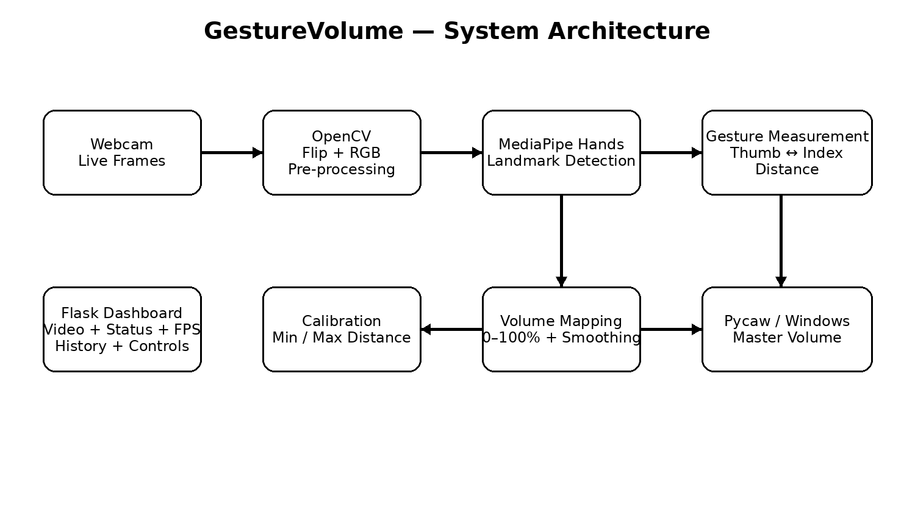
Figure 4.1: System architecture of GestureVolume
The observed distance is mapped to a 0–100 volume range and then smoothed using a rolling window. On Windows, the resulting percentage is applied to the master audio endpoint through Pycaw. In parallel, the processed frame is made available through Flask as a live MJPEG stream, while JSON status data is exposed to the browser dashboard.
The Flask application defines routes for the main dashboard, features page, live video stream, status information, detection toggling and minimum/maximum calibration.

4.8 Methodology
Method Stage | Implementation
Requirement identification | Define a touchless method for changing system volume using a webcam and hand movement.
Video acquisition | Capture frames from the default camera at a configured resolution of 640 × 480 pixels.
Pre-processing | Flip the frame horizontally and convert the BGR image to RGB before MediaPipe processing.
Hand detection | Use MediaPipe Hands with one-hand detection and tracking confidence thresholds of 0.6.
Landmark extraction | Read the thumb-tip landmark (index 4) and index-fingertip landmark (index 8).
Gesture measurement | Calculate the Euclidean distance between the two landmarks.
Calibration | Allow the user to set observed minimum and maximum distances for the gesture range.
Volume mapping | Map the calibrated distance to a 0–100 percentage range and clamp the result to that range.
Smoothing | Store recent volume values in a six-sample deque and use their average to reduce rapid fluctuations.
Audio control | On Windows, update the master endpoint volume when the smoothed value changes sufficiently and the update interval permits it.
Web integration | Run the gesture loop in a background daemon thread while Flask serves the dashboard and live stream.
Monitoring | Display current volume, detection status and FPS, and maintain a client-side volume history graph.
Table 4.2: Project methodology
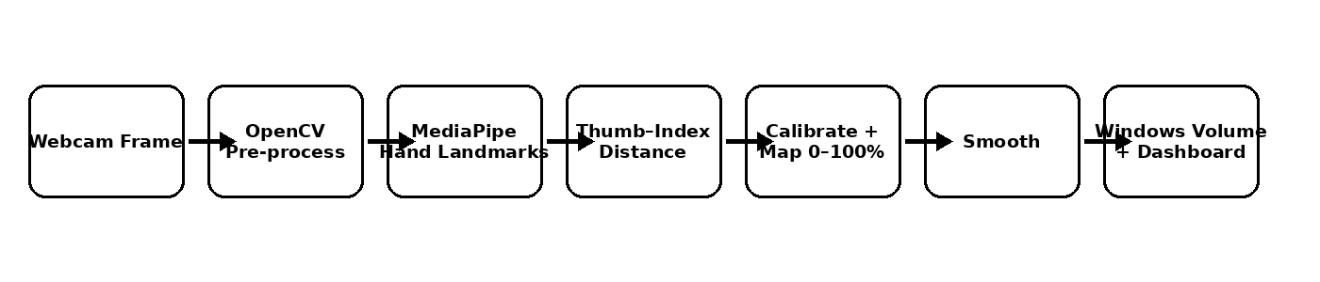
Figure 4.2: Gesture-to-volume control workflow

4.9 Expected Outcomes
• Real-time detection of a hand through a webcam.
• Continuous conversion of the detected gesture distance into a volume percentage.
• Smoother volume behavior through short-window averaging.
• Live visual feedback through a streamed camera feed, volume bar, status indicator and FPS value.
• Manual calibration of the minimum and maximum gesture distances.
• Windows system-volume control through the Pycaw audio interface.
• A structured dashboard with detection controls, volume history and theme switching.
The implemented feature set combines real-time landmark detection, distance-based volume control with smoothing, Flask video streaming, calibration, detection start/stop, FPS feedback, volume history and theme support.

4.10 Certificates of Completion and Communication Proof
The official internship completion certificate issued by Infosys Springboard is attached in Section 3 of this report. The certificate identifies the internship as “Internship 7.0 (B1) GestureVolume: Volume Control with Hand Gestures” and records the internship period as 19 June 2026 to 14 August 2026.
The IILM University report format requires certificates of completion and relevant communication-mail proof to be attached. Any additional onboarding, selection, completion or project-evaluation communication available to the student should be appended to the final submission after this report.

5. BIBLIOGRAPHY / REFERENCES
1. Infosys. “About Us – Overview.” Infosys.
https://www.infosys.com/about/overview.html
2. Infosys. “Infosys Springboard: Digital Learning and Reskilling Programs.”
https://www.infosys.com/about/springboard.html
3. Infosys. “Digital Skilling – Infosys ESG Report 2025–26.”
https://www.infosys.com/about/esg/reports/2025-26/social-digital-talent.html
4. GitHub. “shreyashreya2223/GestureVolumeControl.”
https://github.com/shreyashreya2223/GestureVolumeControl
5. GitHub. “GestureVolumeControl/milestone3_gesture_volume.py.”
https://github.com/shreyashreya2223/GestureVolumeControl/blob/main/milestone3_gesture_volume.py
6. GitHub. “GestureVolumeControl/index.html.”
https://github.com/shreyashreya2223/GestureVolumeControl/blob/main/index.html
7. GitHub. “GestureVolumeControl/features.html.”
https://github.com/shreyashreya2223/GestureVolumeControl/blob/main/features.html
8. GitHub. “GestureVolumeControl/script.js.”
https://github.com/shreyashreya2223/GestureVolumeControl/blob/main/script.js

