 Rayat Shikshan Sanstha’s
Sharadchandra Pawar Mahavidyalaya, Lonand

Department of Electronics

Project Report On

“IOT BASED CAR PARKING SYSTEM”

Submitted by

Sr. No | Name of Student | PRN No | Sign
1. | SANKET RAGHVENDRA MALDKAR | 2023039597
2. | PAVAN DATTATRAY KSHIRSAGAR | 2023039591
3. | SAKSHI BALAJI KOLEKAR | 2023039588

B.Sc. Part III Semester VI Year 2025-26

Rayat Shikshan Sanstha’s,

Sharadchandra Pawar Mahavidyalaya, Lonand

Department of Electronics

CERTIFICATE

This is to certify that project work entitled “IOT BASED CAR PARKING SYSTEM” which is being submitted herewith is submitted by
- SANKET RAGHVENDRA MALDKAR
- PAVAN DATTATRAY KSHIRSAGAR
- SAKSHI BALAJI KOLEKAR

In partial fulfilment of the requirement for the award of the degree of “Bachelor of Science in Electronics” of Shivaji University Kolhapur is the record of their own work carried out under by guidance year 2025-26.

Place: Lonand
Date:

Project Guide Examiner Head
Department of Electronics

DECLARATION

We hereby declare that the project entitled ‘’IOT BASED CAR PARKING SYSTEM” is
the original work carried out by us at the Department of Electronics. This project or part of it has not been submitted previously for any other degree of any other purpose.

Sr. No | Name of Student | PRN No | Sign
1. | SANKET RAGHVENDRA MALDKAR | 2023039597
2. | PAVAN DATTATRAY KSHIRSAGAR | 2023039591
3. | SAKSHI BALAJI KOLEKAR | 2023039588

Date:

AKNOWLEDGEMENT

It gives us great pleasure to express our sincere thanks with deep sense of gratitude to project guide Miss. P. P. Pawar for her valuable guidance, unfailing patience and constant encouragement during the course of the project work. I also express my gratitude to Head of Department Dr. S. S. Shende for his support.
I thank to all my friends for their co-operation and help which I received from them during the course of project work throughout.

Sr. No | Name of Student | PRN No | Sign
1. | SANKET RAGHVENDRA MALDKAR | 2023039597
2. | PAVAN DATTATRAY KSHIRSAGAR | 2023039591
3. | SAKSHI BALAJI KOLEKAR | 2023039588

Date:

INDEX

Sr. No. | Title Name | Page No.
1. | Abstract | 1
2. | Introduction | 2
3. | Experimental Work  3.1 Block Diagram  3.2 Circuit Diagram  3.3 Working | 3
4. | Program Code | 4
5. | Specifications/ IC Pin Description | 5
6. | Advantages and Disadvantages | 6
7. | Result and Discussion | 7
8. | Conclusion | 8
9. | Future Scope | 9
10. | References | 10

1. ABSTRACT
The IoT Based Smart Car Parking System is designed to reduce the problem of parking space in crowded areas such as malls, offices, and public places. In this system, sensors are installed in each parking slot to detect the presence of a vehicle. The sensors send data to a microcontroller such as Arduino or NodeMCU which is connected to the internet. The parking availability information is then displayed on a mobile application or web dashboard.
This system helps drivers easily find empty parking spaces, saves time, reduces traffic congestion, and improves parking management using Internet of Things technology.

2. INTRODUCTION

Parking problems are common in urban cities due to the increasing number of vehicles. Drivers spend a lot of time searching for parking spaces which leads to traffic congestion and fuel wastage.
The Internet of Things (IoT) provides smart solutions to such problems. IoT connects devices through the internet and allows them to communicate with each other.
The IoT Based Smart Car Parking System uses sensors and microcontrollers to detect parking space availability and send the data to a cloud server. Users can view available parking spaces through a mobile application or display board.

3. EXPERIMENTAL WORK

3.1 BLOCK DIAGRAM
Main components of the system:
- IR Sensors / Ultrasonic Sensors
- Arduino / NodeMCU
- WiFi Module (ESP8266)
- LCD Display
- Power Supply
- Cloud Server / Mobile Application
Working Flow:
Sensor → Microcontroller → Internet → Mobile App / Display

3.2 CIRCUIT DIAGRAM
The circuit consists of sensors connected to the microcontroller input pins.
- IR sensor output connected to Arduino digital pin
- WiFi module connected via serial communication
- LCD connected for displaying parking slots
- Power supply provides 5V to all components
The circuit detects vehicle presence and sends the data to the microcontroller.
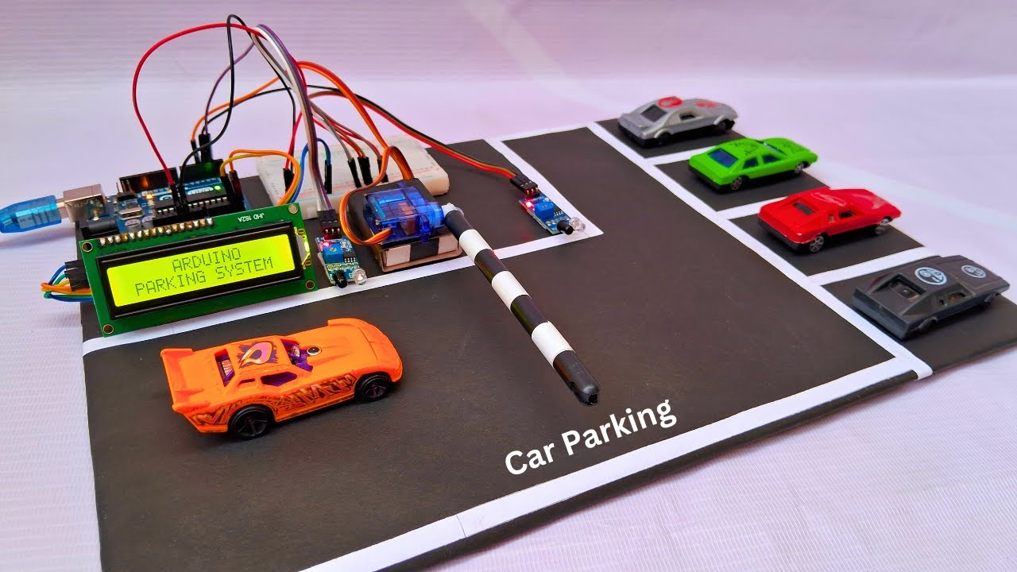
3.3 WORKING
- Sensors are installed in each parking slot.
- When a car enters the parking slot, the sensor detects the vehicle.
- The sensor sends a signal to the microcontroller.
- The microcontroller processes the data and sends it to the cloud server through WiFi.
- The mobile application updates the parking availability status.
- Drivers can check free parking slots before entering the parking area.

4. PROGRAM CODE

#include <ESP8266WiFi.h>
int sensorPin = D1;
void setup() {
pinMode(sensorPin, INPUT);
Serial.begin(9600);
}
void loop() {
int sensorValue = digitalRead(sensorPin);
if(sensorValue == HIGH) {
Serial.println("Parking Slot Occupied");
} else {
Serial.println("Parking Slot Free");
}
delay(1000);
}
- SPECIFICATIONS/ IC PIN DESCRIPTION

Component Specifications
1. Arduino uno . microcontroller board
2. IR Sensor . power/ working / detection/ pins
3. Sg 90.. servo motor..1 . Tower pro sg90 micro
4. 3.7v battery… . 3.7v lithium-ion battery
5. battery holder..1 . Single cell battery holder
6. 0pcb…1 . Printed circuit board
7. 7805 voltage regulator..1 . 5v output
- ADVANTAGES AND DISADVANTAGES

Advantages
- Saves time in searching parking space
- Reduces traffic congestion
- Real-time parking information
- Smart city application

Disadvantages
- Requires internet connection
- Initial setup cost
- Sensor maintenance required

7. RESULT AND DISCUSSION

The IoT based parking system successfully detects whether a parking slot is occupied or empty. The system sends real-time information to the server and displays the availability of parking spaces.
Testing results show that the sensors detect vehicles accurately and the system works efficiently for small parking areas.

8. CONCLUSION
The IoT Based Smart Car Parking System is an efficient solution to parking problems in cities. By using sensors and internet connectivity, the system provides real-time parking information to users.
This system helps in reducing traffic congestion, saving time, and improving parking management.

9. FUTURE SCOPE
• Integration with mobile payment systems
• AI-based parking prediction
• Automatic gate control
• Large smart city parking networks

10. REFERENCES

• IEEE Research Papers on Smart Parking Systems
• Arduino Official Documentation
• Internet of Things Technology Books
• Smart City IoT Research Articles

