SYNOPSIS
ON
“SentinelEdge: Autonomous Workplace Safety & PPE Monitor”
Submitted in
Partial Fulfillment of the requirements for the Award of the Degree
of
Bachelor of Technology
In
Computer Science and Engineering
by
(Project Id: CSE-2J-01)
Shreyash Shukla (2501640100875)
Section: CSE 2J
Under the supervision of
Shraddha Gaur
(Department of Computer Science and Engineering)

Pranveer Singh Institute of Technology
Kanpur - Agra - Delhi National Highway - 19
Bhauti, Kanpur - 209305

1. Introduction
Workplace safety in construction sites, factories, warehouses and chemical plants still depends largely on human supervisors and passive CCTV cameras. Footage is recorded but rarely watched in real time, so a worker without a helmet, high-visibility vest or gloves is usually discovered only after an accident, during an audit, or while reviewing footage long after the event. SentinelEdge: Autonomous Workplace Safety & PPE Monitor is a mini-project that converts such passive surveillance into an active, autonomous safety system that watches every frame, decides whether a situation is hazardous, and explains it in plain language.
The project lies at the intersection of Deep Learning, Computer Vision (object detection), Generative AI and Agentic AI. A Ultralytics YOLOv8 detector identifies people and their Personal Protective Equipment (PPE) in live video using OpenCV. An agentic rule layer then reasons over the detections, maintains a dynamic risk score and triggers actions on its own. Finally, a locally hosted Llama 3 model, run through Ollama and orchestrated with LangChain, turns each violation into a structured incident report. Because the language model runs on the local machine, no video or incident data leaves the premises, which keeps the system private and usable at the network edge. The entire solution is presented through a Streamlit web dashboard.
Key technical terms used in this project:
- Object Detection: locating and classifying multiple objects in an image with bounding boxes and confidence scores.
- YOLOv8: a single-stage, real-time detector from Ultralytics that predicts all boxes in one forward pass.
- PPE: Personal Protective Equipment such as helmets, vests, gloves and safety glasses.
- Agentic AI: a system that perceives, applies rules or reasoning and takes actions autonomously, rather than only returning predictions.
- Local LLM: a large language model (Llama 3) executed on-device through Ollama for privacy-preserving text generation.

2. Project Objective
The main objective of SentinelEdge is to build an end-to-end system that detects PPE non-compliance in real time, reasons about the resulting risk, and reports it automatically, so that supervisors can act before an incident occurs. The specific objectives are:
- Real-Time Object Detection with YOLOv8: detect persons and PPE items (helmet, vest, gloves) from webcam, CCTV or uploaded video streams with low latency using Ultralytics YOLOv8 and OpenCV.
- Dynamic Risk Telemetry & Agentic Rules: convert raw detections into a per-frame and per-person risk score, apply configurable safety rules (for example, “person present without helmet”), and let an autonomous agent decide when to raise an alert.
- Generative Incident Reporting via LangChain/Ollama: use a local Llama 3 model to write clear, structured incident reports that state what happened, where, when, the severity and the recommended corrective action.
- Enterprise Web Dashboard via Streamlit: provide a single interface showing the annotated live feed, risk metrics, alert history and generated reports, with controls for thresholds and input sources.
By the end of the project, the end user (a safety officer or site supervisor) will receive timely alerts and ready-to-file reports instead of watching screens continuously. This reduces manual monitoring effort, improves compliance with safety regulations, creates an auditable record of violations, and keeps sensitive footage on local hardware.

3. Feasibility Study
A feasibility study judges whether the proposed system is practical by weighing its opportunities and threats. The project was evaluated on the following five dimensions.
Technical Feasibility: All required technologies are open source, mature and well documented: Python, OpenCV, Ultralytics YOLOv8, LangChain, Streamlit and Ollama. Pre-trained YOLOv8 weights can be fine-tuned on public PPE datasets, and the nano and small model variants run in real time on modest hardware. Llama 3 (8B) runs locally through Ollama on a laptop-class machine. The project is therefore technically feasible.
Operational Feasibility: The dashboard needs only a web browser and requires no AI expertise from the end user. It works with existing webcams and CCTV streams and does not require new infrastructure. Automated alerts and written reports fit naturally into existing safety-officer routines, which makes adoption easy.
Economic Feasibility: No licence fees are involved because every library and model is free and open source. The only costs are the development computer and an ordinary webcam. Running the LLM locally removes recurring cloud and API charges. Compared with the cost of workplace injuries, penalties and downtime, the system is highly cost-effective.
Schedule Feasibility: The work is split into four independent modules, each completed in roughly two to three weeks: environment setup, vision engine, agentic logic, and dashboard integration. This fits within one academic semester with time left for testing and documentation.
Legal and Ethical Feasibility: All components use permissive open-source licences (for example, Ultralytics YOLOv8 is released under AGPL-3.0, so its terms must be respected if the system is ever distributed commercially). Video of workers is personal data, so the system processes it locally, stores only violation snapshots and logs, and is intended for safety purposes only. Deployment should follow applicable privacy rules and worker consent policies, and the system flags equipment violations rather than identifying or ranking individuals.

4. Methodology / Planning of Work
The project follows a modular, phase-wise development approach. Each phase produces a working, independently testable component, and the components are then integrated into one pipeline. The overall data flow is shown in Fig. 1 and the phases are described below.
Phase 1 – Environment Setup: Install Python 3.10+, create a virtual environment and install the dependencies (ultralytics, opencv-python, streamlit, langchain, langchain-community). Install Ollama and pull the Llama 3 model. Organise the repository into detector.py, agent.py, notifier.py and app.py, and prepare PPE datasets and sample videos for testing.
Phase 2 – Vision Engine (detector.py): Load the YOLOv8 model and fine-tune it on a PPE dataset if required. Read frames from a webcam, CCTV stream or video file with OpenCV, run inference, and return bounding boxes, class labels and confidence scores. Draw annotated frames, and measure accuracy (precision, recall, mAP) and speed (FPS).
Phase 3 – Agentic Logic (agent.py / notifier.py): In agent.py, match detected PPE to each person, compute a dynamic risk score and apply configurable safety rules, with temporal smoothing and a cooldown to avoid false and duplicate alerts. When a rule fires, the agent builds a context summary and calls Llama 3 through LangChain and Ollama to generate an incident report. In notifier.py, dispatch alerts, save snapshots and write the incident log.
Phase 4 – Dashboard (app.py): Build the Streamlit interface with source selection, the live annotated feed, risk gauges, an alert and incident history table, and a panel for the generated reports. Integrate all modules, then carry out end-to-end testing, tuning and documentation.
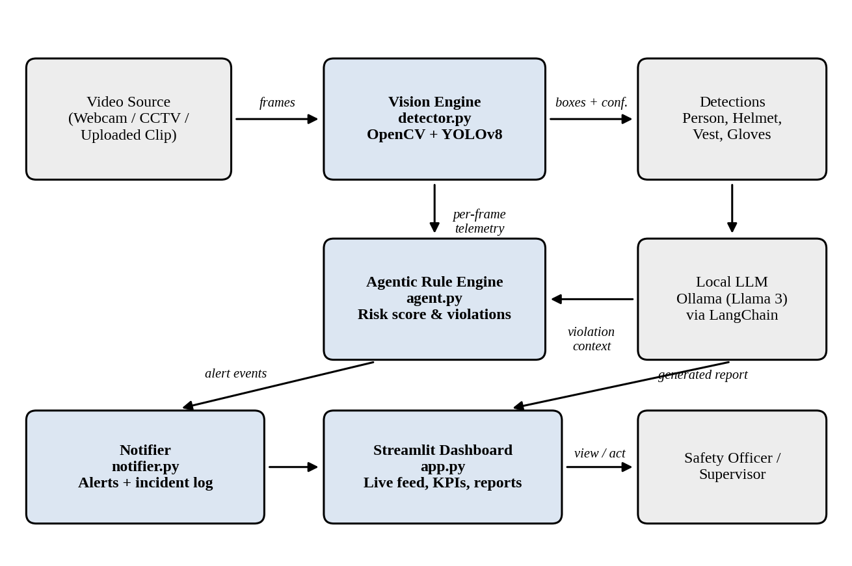
Fig. 1: System architecture and data flow of SentinelEdge
The planned schedule for the phases is summarised below.
Phase | Module / File | Main Deliverable | Duration
1 | Environment | Working toolchain, Ollama + Llama 3 | Weeks 1–2
2 | detector.py | Real-time PPE detection with YOLOv8 | Weeks 3–5
3 | agent.py, notifier.py | Risk scoring, rules, LLM reports | Weeks 6–9
4 | app.py | Streamlit dashboard and integration | Weeks 10–12

5. Tools / Technology Used
Domains: Deep Learning / Computer Vision / Object Detection, Generative AI, and Agentic AI.
Core stack: Python, Streamlit, OpenCV, Ultralytics YOLOv8 and Ollama (local Llama 3 model).

5.1 Minimum Hardware Requirements
Hardware required for the development of the project.
- CPU: Intel Core i5 (8th generation) / AMD Ryzen 5 or higher, 4 or more cores.
- RAM: 16 GB (8 GB is the bare minimum for YOLOv8 alone; the Llama 3 8B model needs roughly 8 GB more).
- GPU: NVIDIA GPU with 4 GB or more VRAM and CUDA support (for example, GTX 1650 or better) is recommended for real-time inference; the system can also run on CPU at a lower frame rate.
- HDD: At least 20 GB of free disk space (SSD preferred) for the datasets, model weights, Llama 3 model files and logs.
- Webcam / Others: 720p (HD) USB webcam or an IP/CCTV camera with an RTSP stream, plus a stable network connection for the initial downloads.

5.2 Minimum Software Requirements
Software required for the development of the project.
- OS: Windows 10/11 (64-bit), Ubuntu 20.04 or later, or macOS 12 or later.
- Python: version 3.10 or above, with pip and virtual environments.
- Ultralytics YOLOv8: object-detection framework (PyTorch based).
- OpenCV: video capture, image processing and annotation.
- Streamlit: web dashboard framework.
- LangChain: orchestration of prompts and LLM calls.
- Ollama with Llama 3: local LLM runtime and model.
- Development tools: Visual Studio Code, Git, and a modern web browser.

6. References [IEEE format]
[1] G. Jocher, A. Chaurasia, and J. Qiu, “Ultralytics YOLOv8,” Ultralytics, 2023. [Online]. Available: https://github.com/ultralytics/ultralytics
[2] J. Redmon, S. Divvala, R. Girshick, and A. Farhadi, “You Only Look Once: Unified, real-time object detection,” in Proc. IEEE Conf. Computer Vision and Pattern Recognition (CVPR), Las Vegas, NV, USA, 2016, pp. 779–788.
[3] H. Chase, “LangChain,” LangChain Inc., 2022. [Online]. Available: https://github.com/langchain-ai/langchain
[4] G. Bradski, “The OpenCV Library,” Dr. Dobb’s Journal of Software Tools, vol. 25, no. 11, pp. 120–125, 2000.
[5] Streamlit Inc., “Streamlit Documentation,” 2024. [Online]. Available: https://docs.streamlit.io
[6] Z. Zou, K. Chen, Z. Shi, Y. Guo, and J. Ye, “Object detection in 20 years: A survey,” Proc. IEEE, vol. 111, no. 3, pp. 257–276, Mar. 2023.
[7] Ollama, “Ollama: Get up and running with large language models locally,” 2024. [Online]. Available: https://ollama.com
[8] A. Dubey et al., “The Llama 3 herd of models,” arXiv preprint arXiv:2407.21783, 2024.

