Name: Shreyasi Gidmare PRN:23070521146

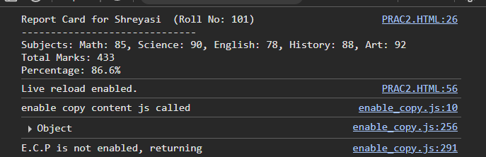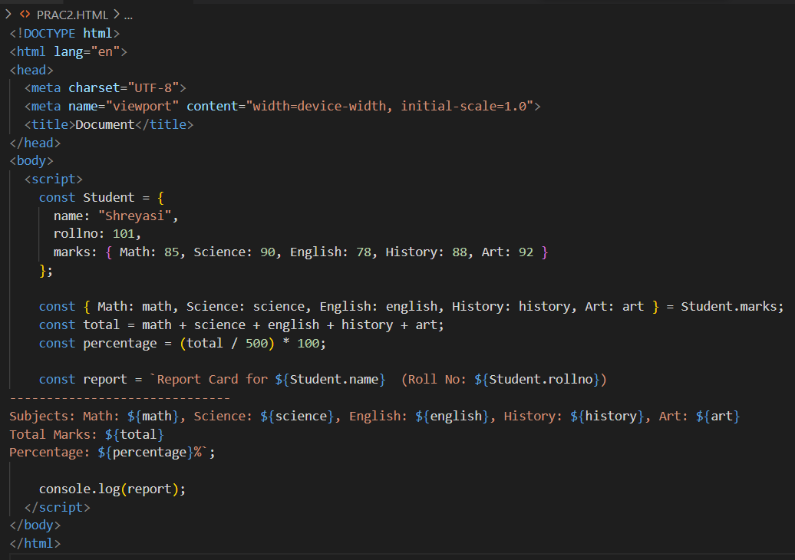Task 1: Dynamic Student Report Card Using Destructuring andTemplate Literals

Task 2: Build a Custom Greeting Generator with Default

Parameters and Arrow Functions

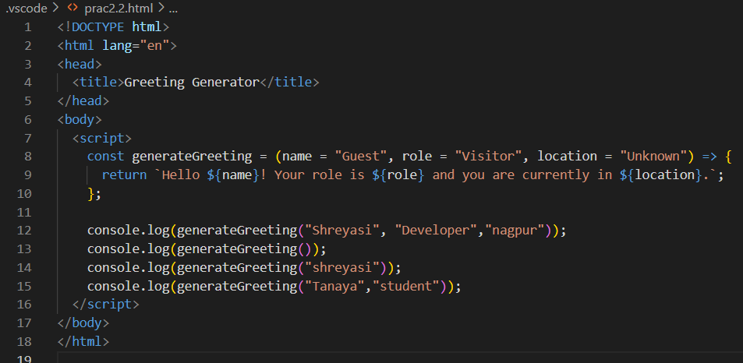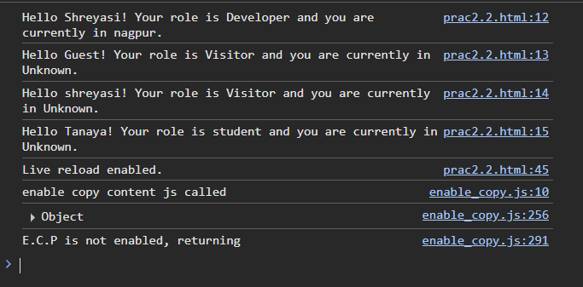

Task 3: Implement a Data Type Analyzer (without typeof)

Problem Statement:

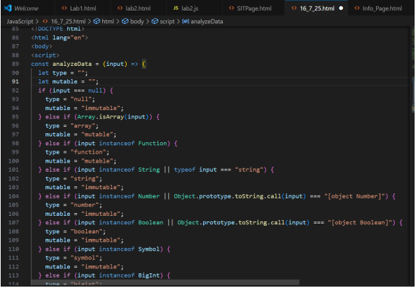

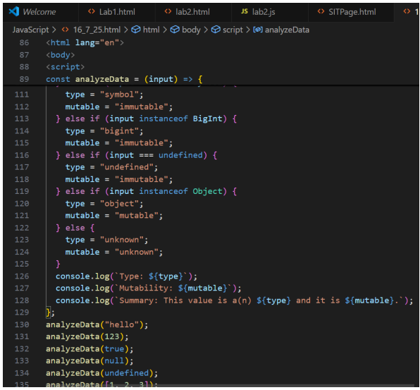

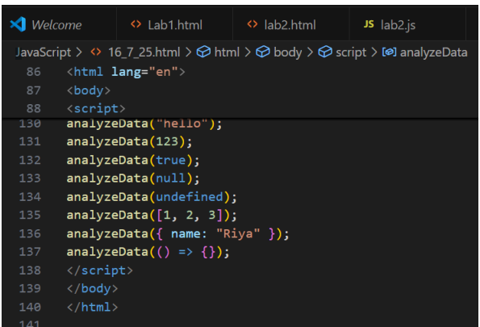

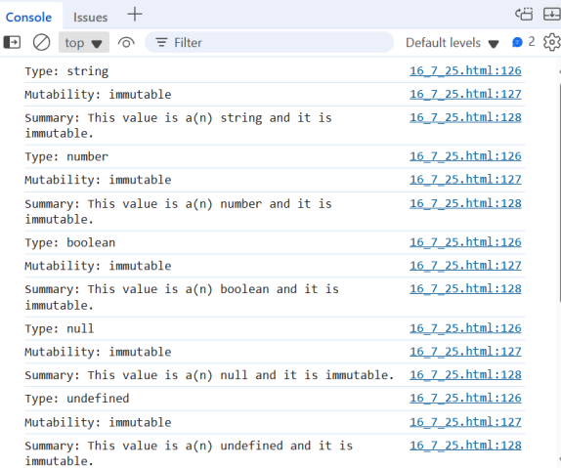

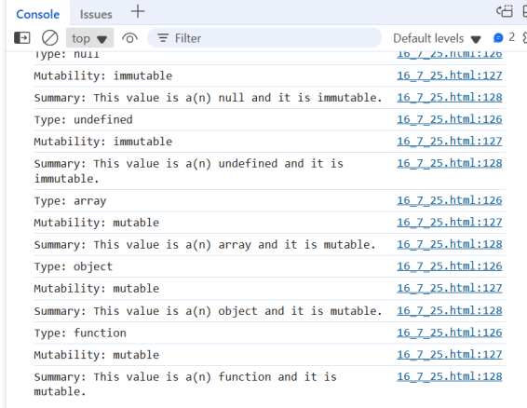

Task 4: Color Mixer using Destructuring and Spread/Rest

Operators

