Name : Shreyasi Gidmare PRN : 23070521146
CODE 1: OUTPUT
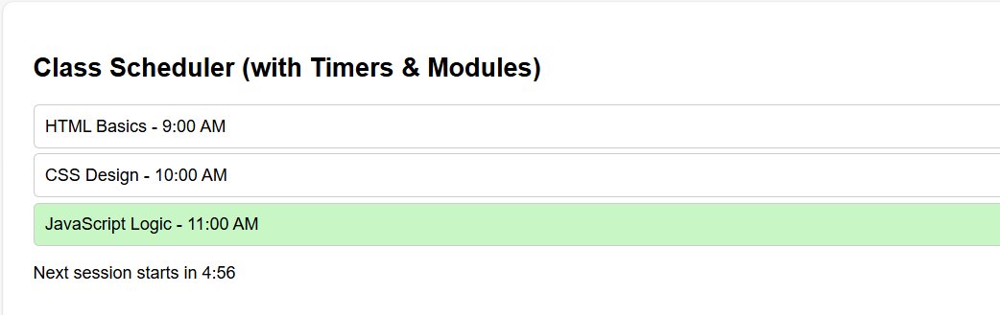
Task :
1. Add a new session dynamically using a button (“Add Session”).
2. Modify the countdown so that it changes color when time < 1 minute.
3. Use a separate module helper.js to format time or log events.
4. Add responsiveness — change font size when width < 500px.
Task | Change made in the same code
1. Add a new session dynamically using a button (“Add Session”) | Added a new button <button id="addBtn">Add Session</button> in index.html, and implemented logic in ui.js to append a new .session div dynamically when clicked.
2. Modify countdown so that it changes color when time < 1 minute | Updated timer.js — inside startCountdown() — to set display.style.color = 'red' when remaining time < 60 seconds.
3. Use a separate module helper.js to format time or log events | Added a new helper.js module with functions formatTime() and logEvent(). Imported and used these functions inside timer.js and ui.js.
4. Add responsiveness — change font size when width < 500px | Added a CSS @media (max-width: 500px) rule in index.html to reduce font size for smaller screens.

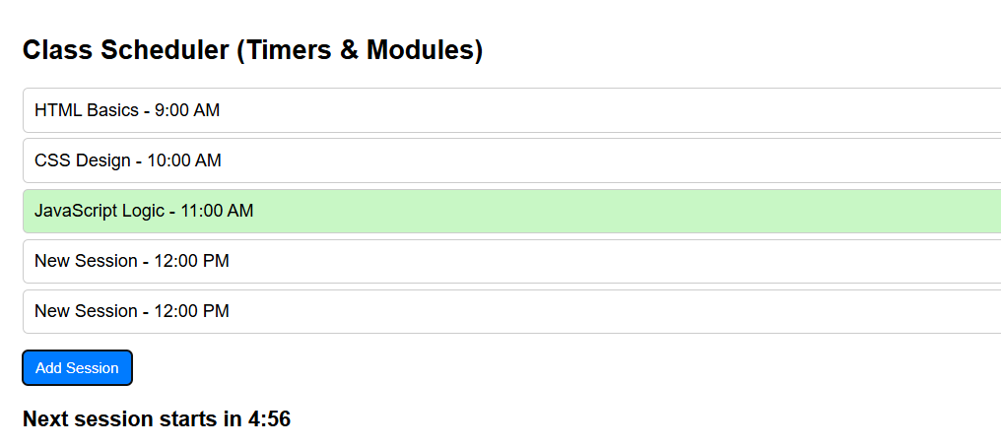
Helper.js
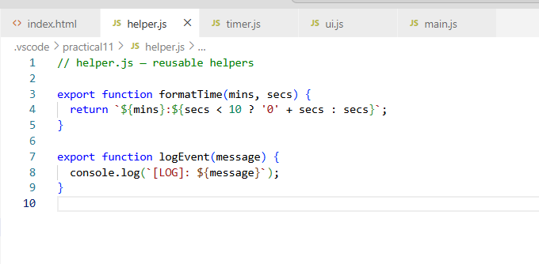
Main.js
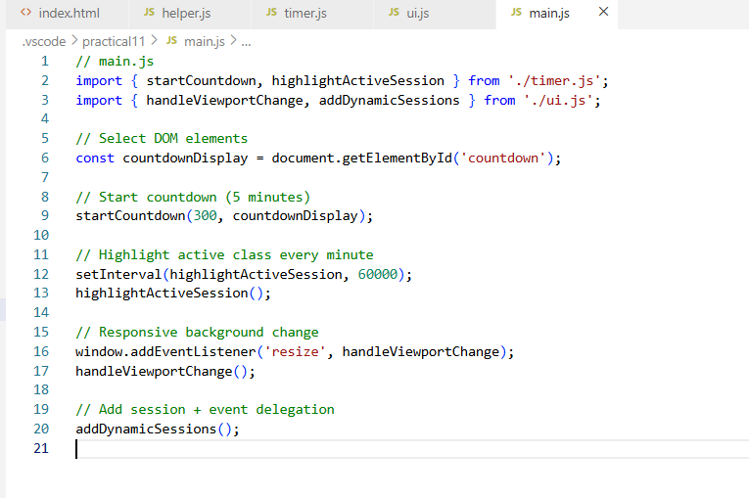
Ui.js
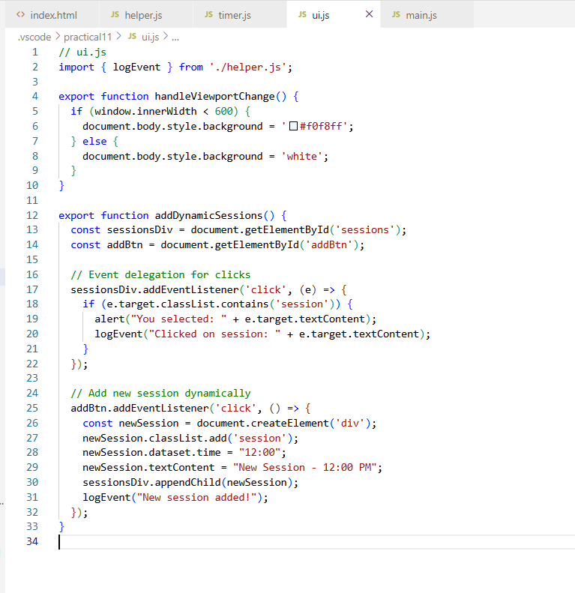
Timer.js
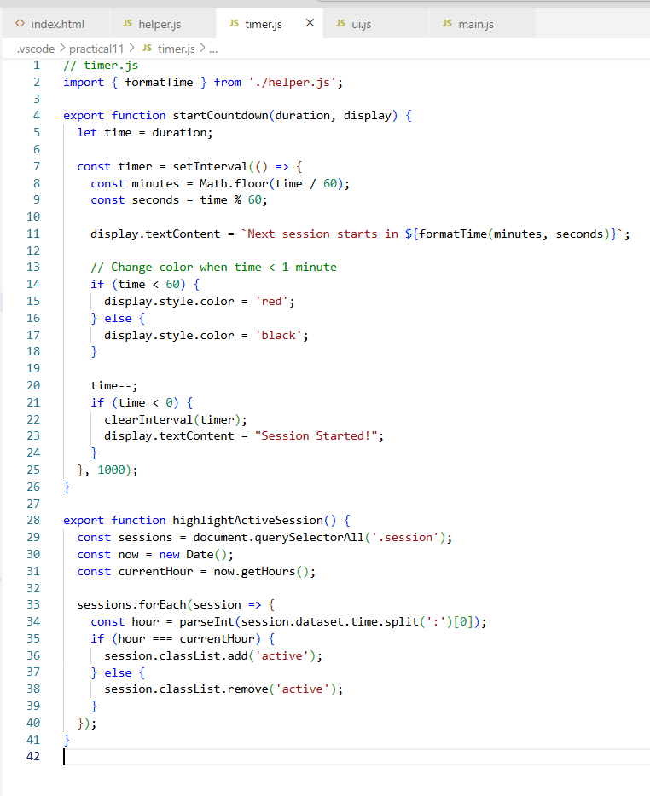
Index.html
