Assignment-2

**Steps to run**1. Execute: *python3 rep.py*

This is done to correct the tab spacing in the wikipedia.csv file. It corrects the spacing and creates a new file wiki.csv with the corrected spacing.

2. Execute ***python3 retrival.py***

This is main script of the assignment which executes the queries.

**Results**

1. Result of query 1 which displays the document IDs containing both the terms.

The document IDs are zero indexed.

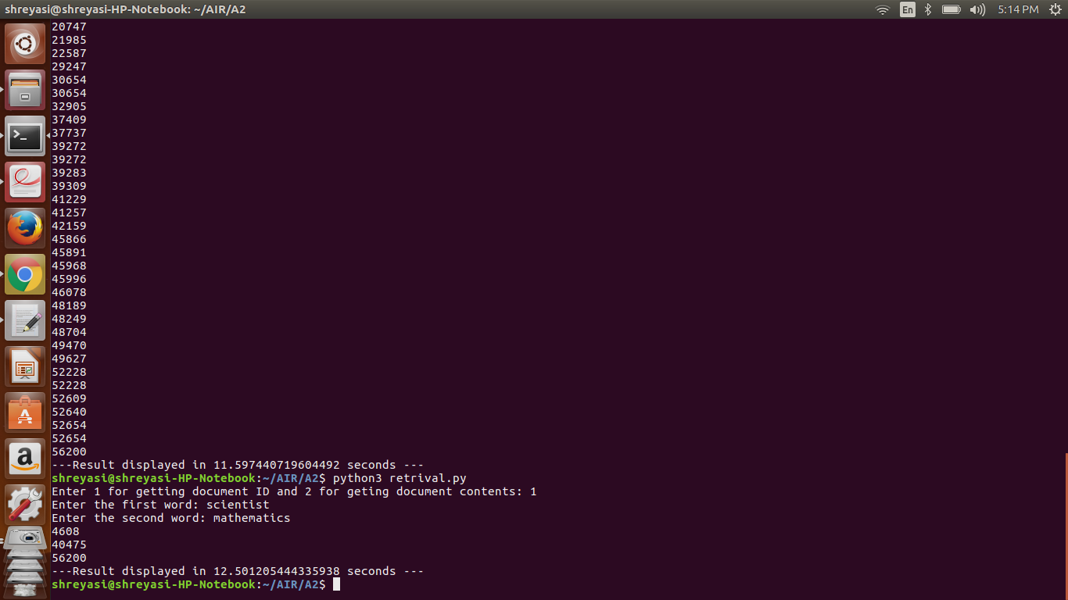

2. Results of query which displays the URL and contents of the documents containing the two words. Since k is set to 10, the first 10 documents are returned.

