HOTEL DATA ANALYSIS PROJECT REPORT
Author:
Shreyas Jaronde
Tools Used:
Python | Selenium | BeautifulSoup | Pandas | Jupyter Notebook | Power BI
Date:
08 January 2026

Table of Contents
- Executive Summary
- Project Objectives
- Data Collection (Web Scraping)
3.1 Website Used for Scraping
3.2 Why Selenium Was Used
3.3 Ethical Scraping Practices
- Data Collection Workflow
- Data Features Collected
- Data Cleaning & Preprocessing
- Exploratory Data Analysis (EDA)
- Dashboard & Visualization
- Insights
- Limitations
- Conclusion

1. Executive Summary
This project presents a comprehensive analysis of hotel listing data collected from an online travel platform to understand pricing patterns, customer preferences, hotel quality indicators, and location-based trends. Real-world hotel data was extracted using Python-based web scraping techniques and subsequently cleaned and standardized to ensure analytical accuracy.
The refined dataset enabled detailed exploratory data analysis focusing on price variation, review scores, amenities, room types, and city-wise hotel availability. Interactive dashboards were developed to visualize these insights clearly, supporting data-driven decision-making for travelers, hospitality businesses, and analysts.
Overall, the project demonstrates a complete end-to-end data analytics workflow, from raw data acquisition to insight generation.
2. Project Objectives
- Analyze hotel price variations across cities
- Study the relationship between price and customer ratings
- Identify amenities influencing hotel pricing
- Compare budget, mid-range, and premium hotels
- Clean and standardize real-world hotel data
- Perform exploratory data analysis
- Develop interactive dashboards for insights
3. Data Collection (Web Scraping)
3.1 Hotel data was collected from an online booking platform where hotel listings are dynamically loaded.
3.2 Why Selenium Was Used:
- Handles JavaScript-loaded content
- Supports scrolling and pagination
- Allows interaction with page elements
3.3 Ethical Scraping:
- Scraped only public data
- Added delays between requests
- Avoided security bypassing
4. Data Collection Workflow
- Launch Chrome WebDriver using Selenium
- Navigate to hotel listing pages
- Automate scrolling or pagination
- Capture page source HTML
- Parse hotel details using BeautifulSoup
- Append records into a Pandas DataFrame
- Export raw data to CSV format

5. Data Features Collected
- hotel_name: Name of the hotel
- city: Location of the hotel
- price_per_night: Price per night in INR
- review_score: Customer rating score (1–10)
- number_of_reviews: Total reviews count
- highlighted_review: Sentiment label (Exceptional, etc.)
- popular_facilities: Key amenities provided
- price_category: Budget / Mid-range / Premium
- rating_category: Excellent / Very Good / Good
6. Data Cleaning & Preprocessing
- Removed currency symbols and standardized prices
- Converted ratings to numeric values
- Cleaned amenities text
- Removed duplicates
- Handled missing values

7. Exploratory Data Analysis (EDA)
- Price distribution analysis
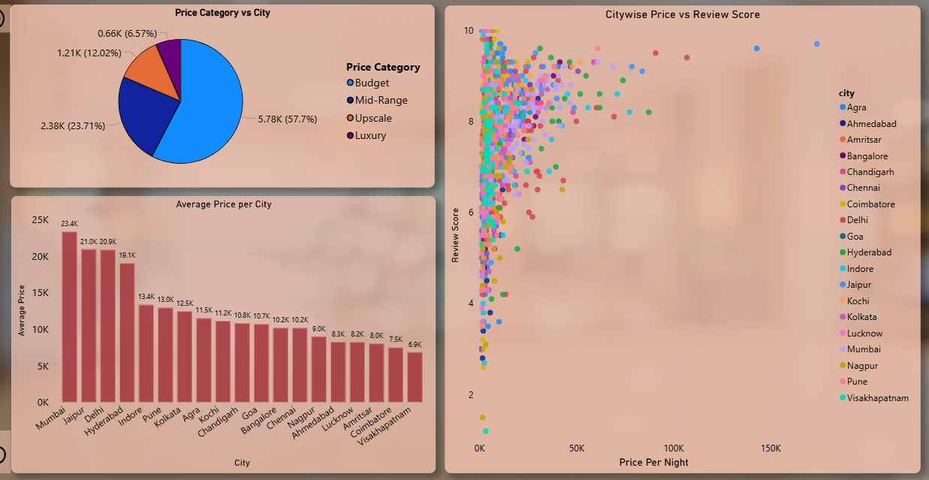

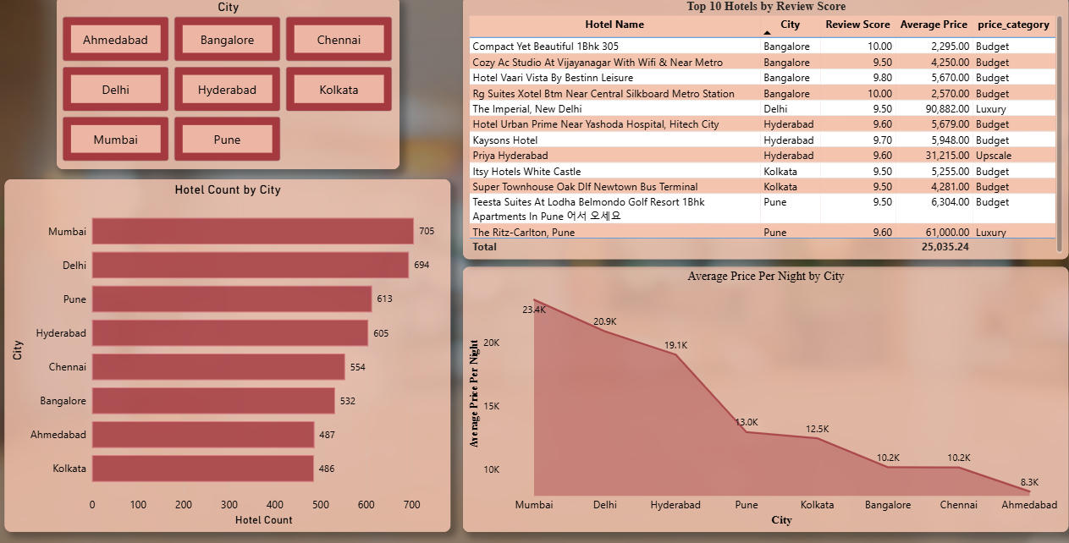
- City-wise hotel pricing

- Rating vs price comparison
- Amenities impact on price
- Room type comparison

8. Dashboard & Visualization
The dashboard includes KPI cards, city-wise pricing charts, rating vs price scatter plots, amenities comparison visuals, and interactive filters for city, price range, and rating.
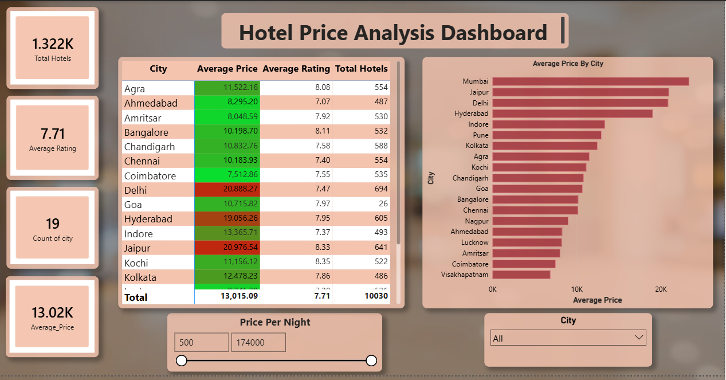

9. Insights
- Higher prices generally correlate with better ratings
- Budget hotels can still offer excellent reviews
- Amenities significantly influence pricing
- Certain cities offer better value-for-money
10. Limitations
- Single data source
- Snapshot-based data
- Inconsistent amenity descriptions

11. Conclusion
This project successfully demonstrates an end-to-end hotel data analytics workflow. It provides meaningful insights into hotel pricing and customer preferences, supporting informed decision-making.

