**Algorithmic Problem Solving [17ECSE309]**

**15 Days of DS - Submission**

**Name:** Shreyas Joshi

**SRN:** 01fe20bcs145

**School:**  **CS**

**15 Days of DS**

Marks: 05

Platform: Various Platforms

A 15 days challenge where each day you need to do an assigned task. You need to complete this before 04 March 2023. Final submission will be made via email and will have intermediate submissions on various other platforms.

**Day 01 Task**

Solve count Set Bits in an Integer problem

<https://practice.geeksforgeeks.org/problems/set-bits0143/1>

Approach1:

Checking for the last bit

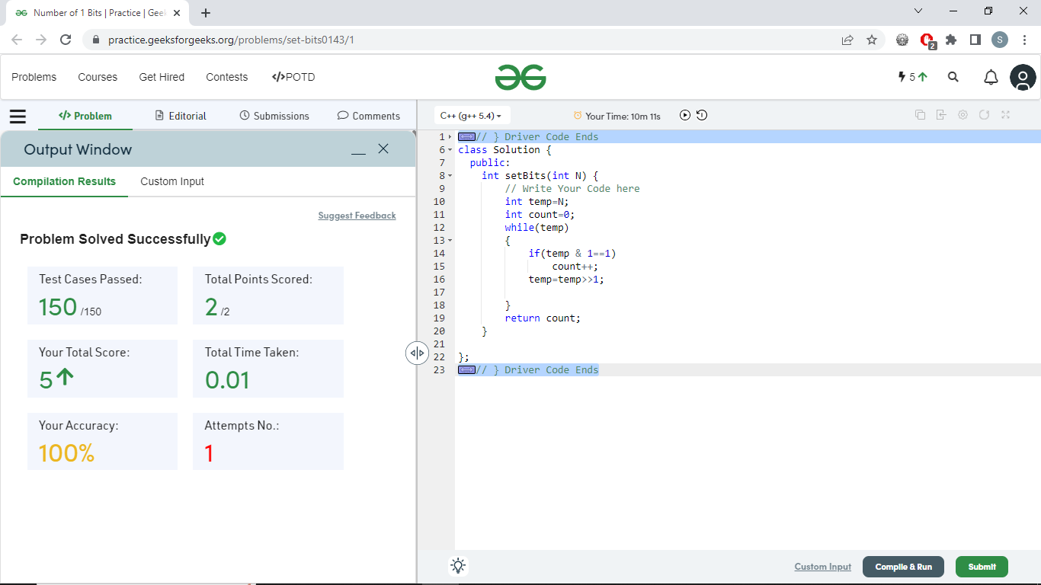

Approach 2:

**Brian Kernighan’s Algorithm**

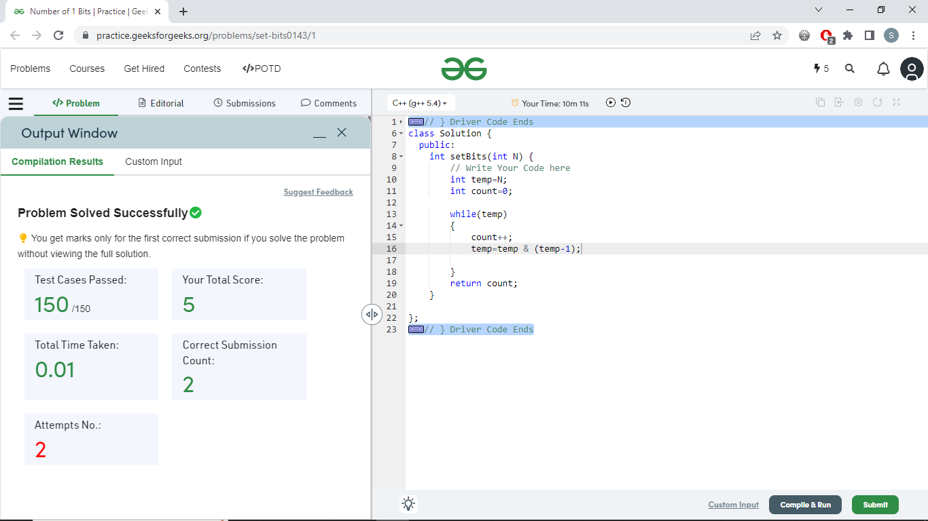

**Day 02 Task**

Complete the problem Permutations of Strings

<https://www.hackerrank.com/challenges/permutations-of-strings/>

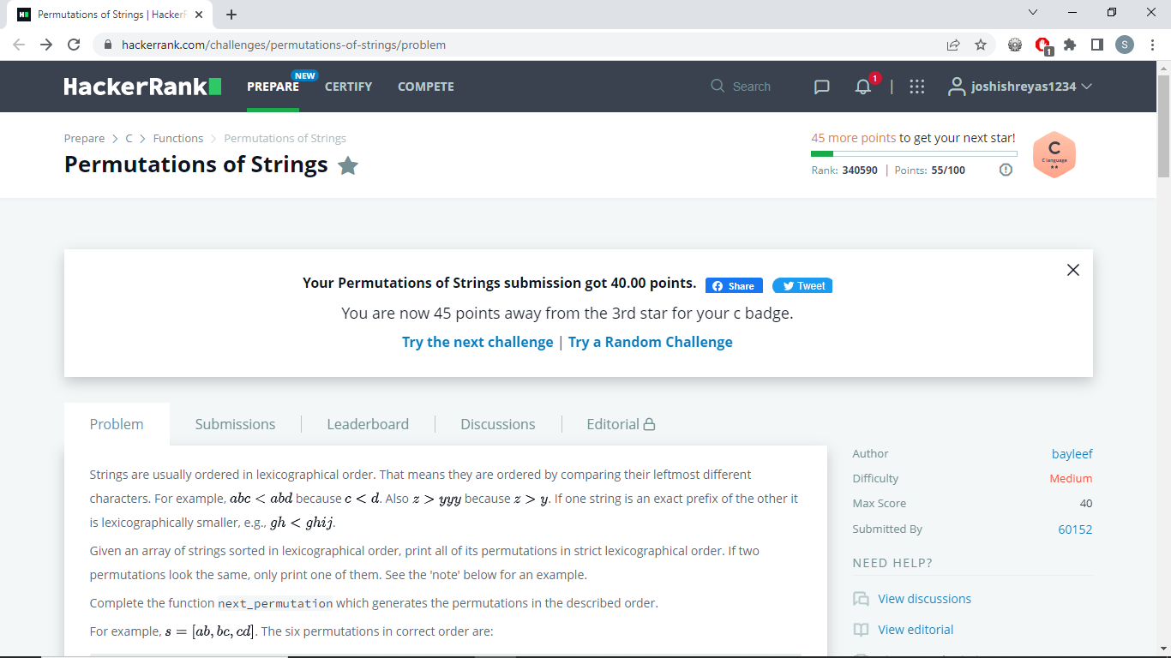

**Day 03 Task**

Solve the Pascal’s Triangle problem

<https://leetcode.com/problems/pascals-triangle/>

Screenshot of submission:

**Day 04 Task**

Solve the Circular Permutation Recovery problem

<https://www.codechef.com/problems/CIRCPRMRCVRY>

Screenshot of submission:

**Day 05 Task**

Solve the Fibonacci GCD problem

<https://www.hackerrank.com/challenges/fibonacci-gcd/>

Screenshot of submission:

**Day 06 Task**

Sort a Stack Using Recursion

<https://practice.geeksforgeeks.org/problems/sort-a-stack/1>

Screenshot of submission:

**Day 07 Task**

Solve the stable marriage problem

<https://www.codechef.com/problems/STABLEMP>

Screenshot of submission:

**Day 08 Task**

Solve the Fractional Knapsack problem

<https://practice.geeksforgeeks.org/problems/fractional-knapsack-1587115620/1>

Screenshot of submission:

**Day 09 Task**

Solve the Chopsticks problem

<https://www.codechef.com/problems/TACHSTCK>

Screenshot of submission:

**Day 10 Task**

Solve the Add Binary problem

<https://leetcode.com/problems/add-binary/>

Screenshot of submission:

**Day 11 Task**

Solve the Sherlock and Anagram problem

<https://www.hackerrank.com/challenges/sherlock-and-anagrams>

Screenshot of submission:

**Day 12 Task**

Solve the LRU Cache problem

<https://practice.geeksforgeeks.org/problems/lru-cache/1>

Screenshot of submission:

**Day 13 Task**

Solve the Tree Distance Sum problem

<https://www.codechef.com/problems/TREEDIST>

Screenshot of submission:

**Day 14 Task**

Solve the Permutations Cycle problem

<https://www.codechef.com/problems/PCYCLE>

Screenshot of submission:

**Day 15 Task**

Solve the Longest Common Prefix problem

<https://leetcode.com/problems/longest-common-prefix/>

Screenshot of submission:

[Convert to .pdf and email to prakash.hegade@kletech.ac.in]

**~*~*~*~*~*~**