**Algorithmic Problem Solving [17ECSE309]**

**Online Contests - Submission**

**Name:** Shreyas Joshi

**SRN:** 01fe20bcs145

**School:**  **CS**

**Start Date: 12 Feb 2023 End Date: 10 April 2023**

|  |  |  |  |  |  |  |  |
| --- | --- | --- | --- | --- | --- | --- | --- |
| **SI. No.** | **Platform** | **Contest Name** | **Profile ID** | **Date** | **Score** | **Rank** | **Total Participants** |
|  | LeetCode | Weekly Contest 336 | 01FE20BCS145 | Mar 12 | 3 | 11429 | 17169 |
|  | LeetCode | Biweekly Contest 99 | 01FE20BCS145 | Mar 4 | 4 | 12050 | 21264 |
|  | CodeChef | International coding league | Shreyas_702 | Mar 10 | 2 | 323 | 575 |
|  | CodeChef | Staters 82 D | Shreyas_702 | Mar 22 | 100 | 17857 | 17863 |
|  | Leetcode | Biweekly Contest 101 | 01FE20BCS145 | Apr 1 | 7 | 9641 | 22282 |
|  | CodeChef | Staters 84 D | Shreyas_702 | Apr 5 | 300 | 7698 | 15062 |
|  | CodeChef | Staters 85 D | Shreyas_702 | Apr 12 | 300 | 10994 | 21000 |
|  | Hacker Earth | Python interview for coding | joshishreyas1234 | Apr 9 | 0 | NA | NA |
|  | Hacker Earth | Facebook Coding Test | joshishreyas1234 | Apr 20 | 100 | NA | NA |
|  | Hacker Earth | Facebook Coding Test | joshishreyas1234 | Apr 20 | 170/200 | NA | NA |

Attach your Leader board screenshots performance of all above contests in the order as listed. If any field is not applicable fill **NA**. (There must be 10 screenshots, one each)

1)

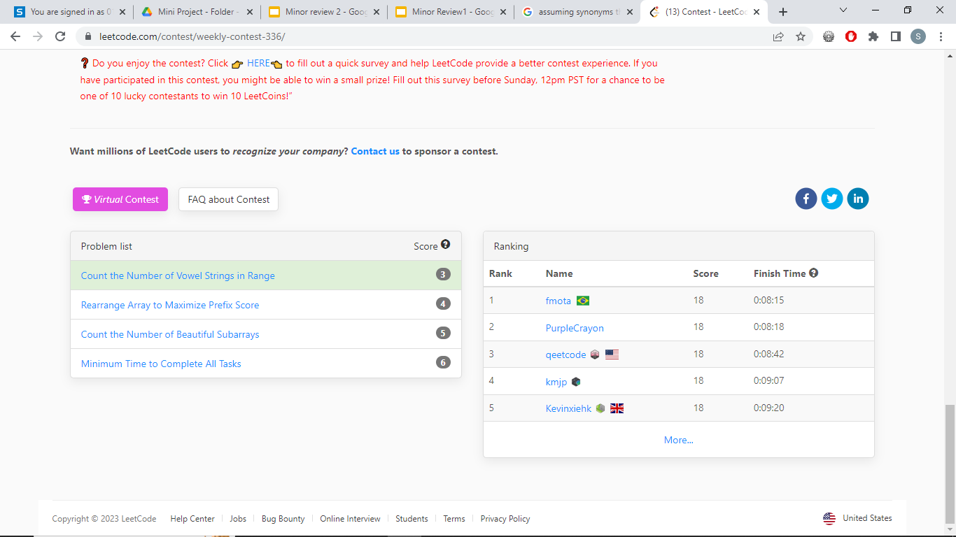

2)

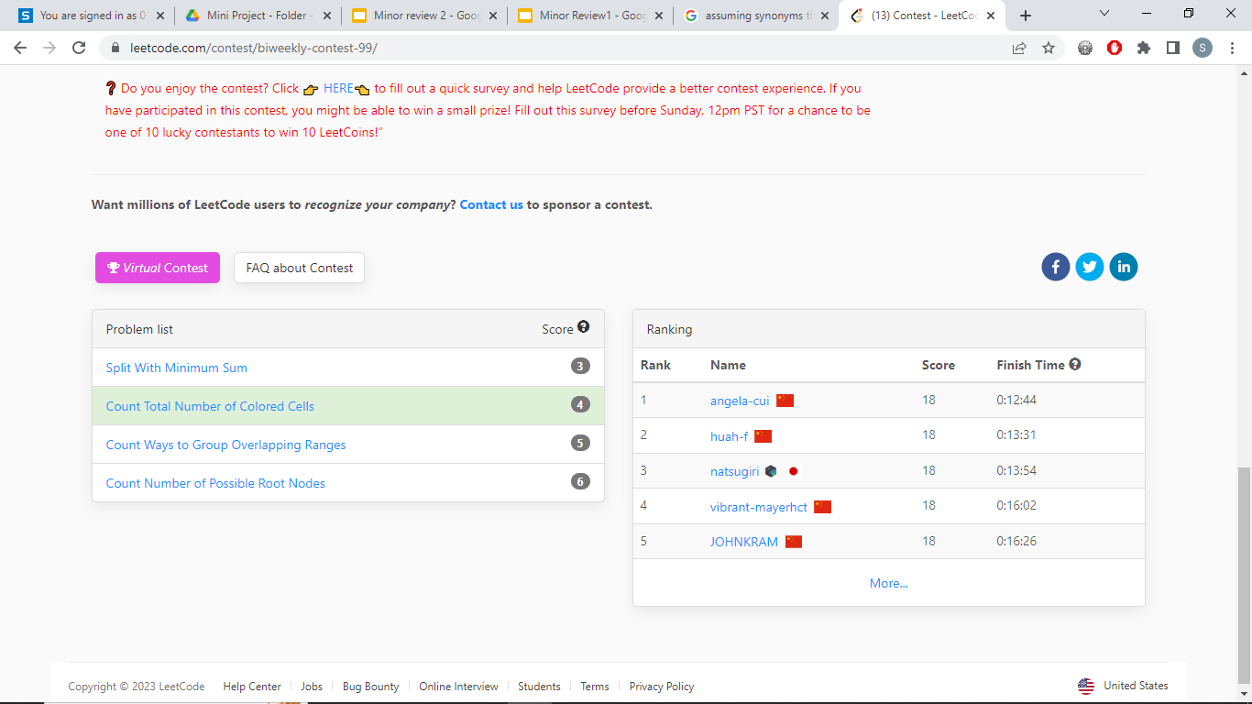

3)

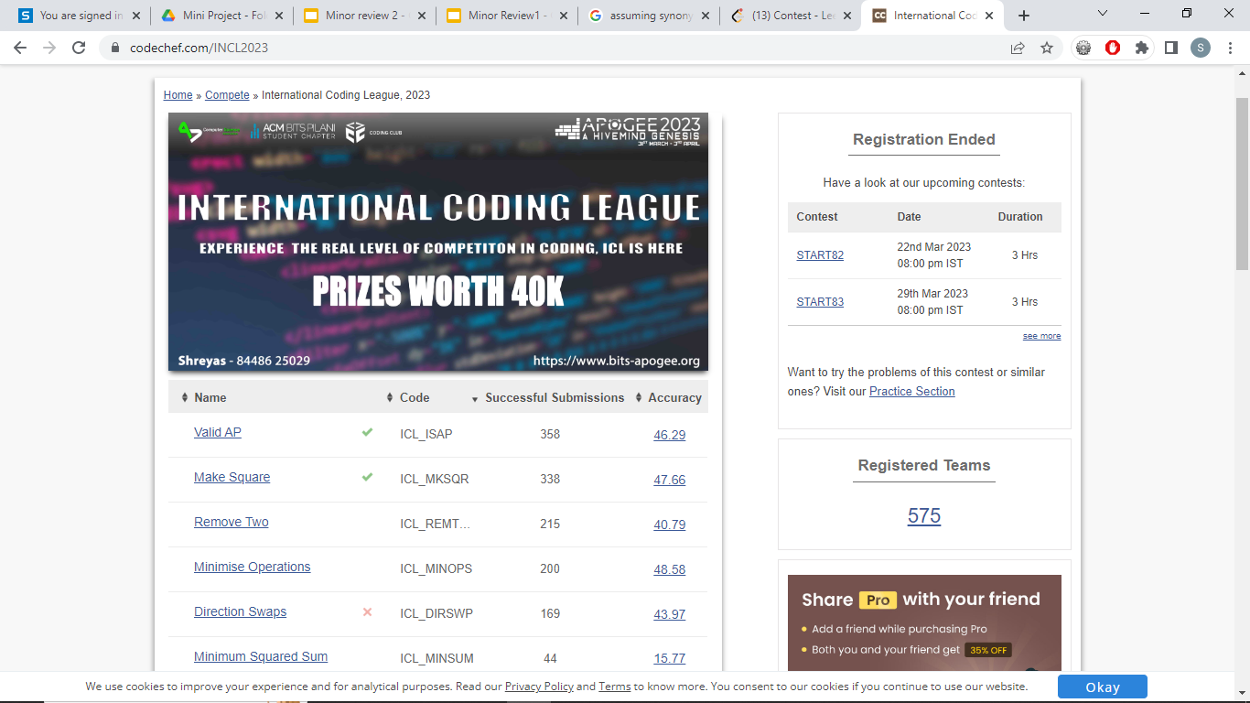

4)

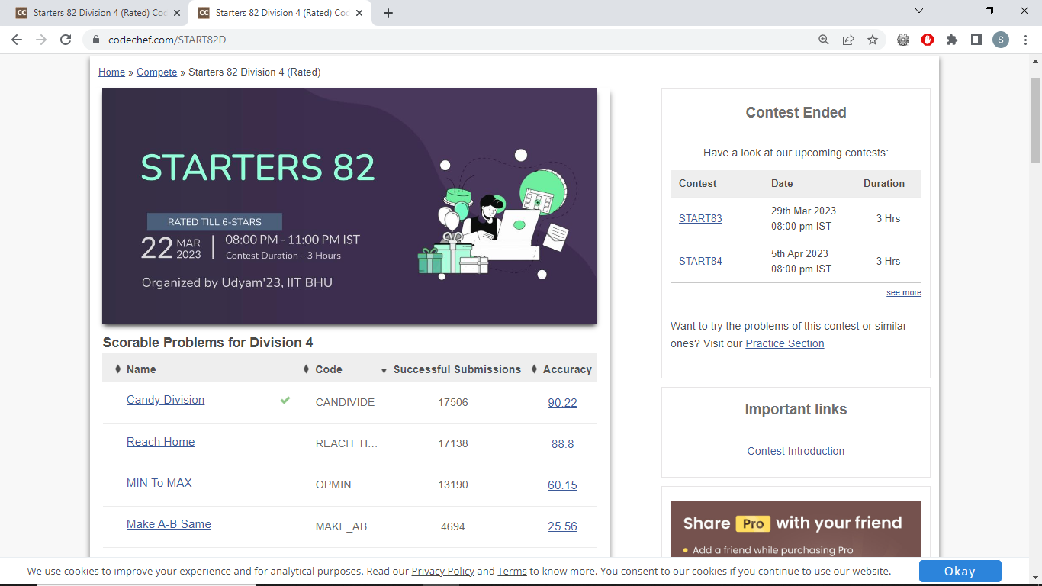

5)

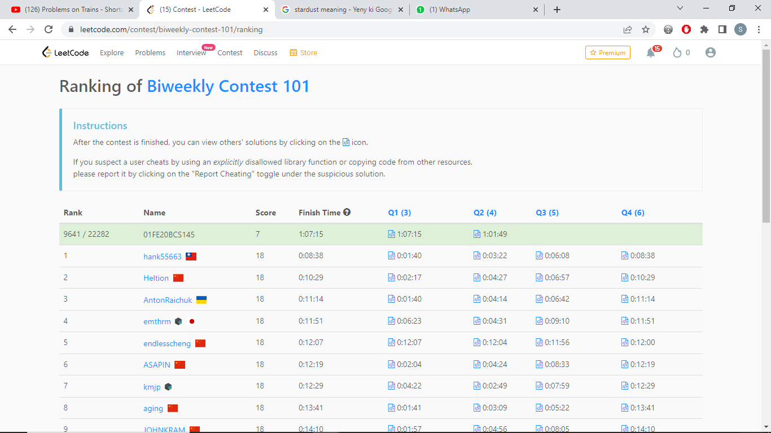

6)

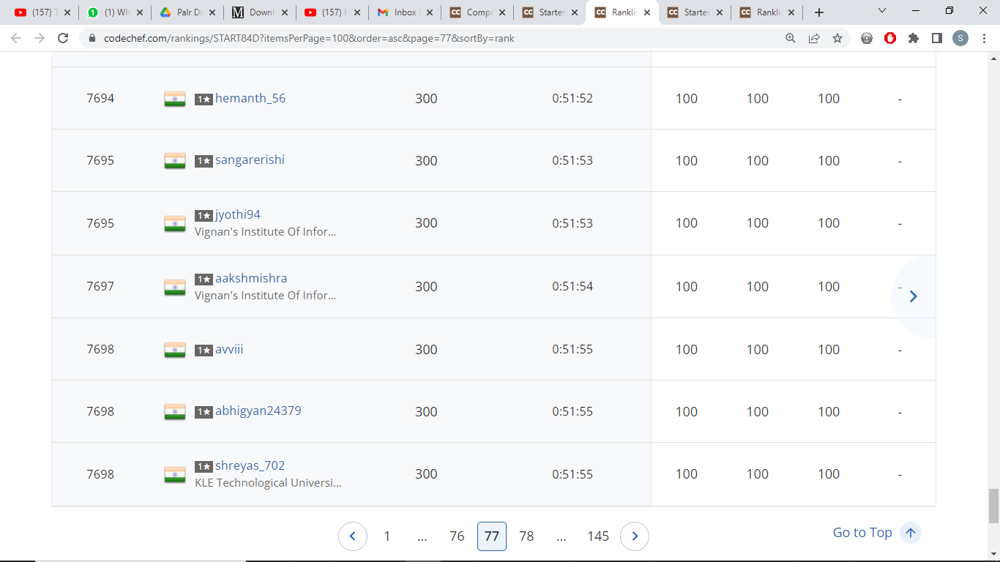

7) 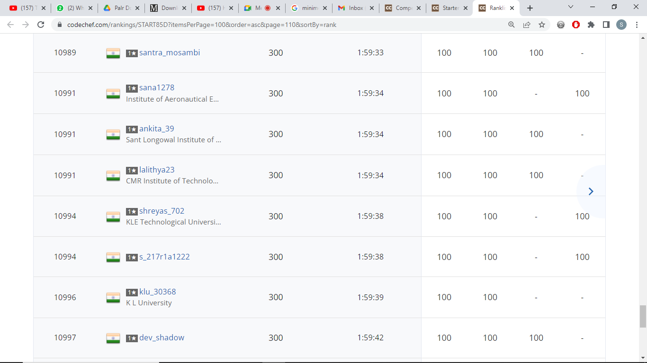

8)

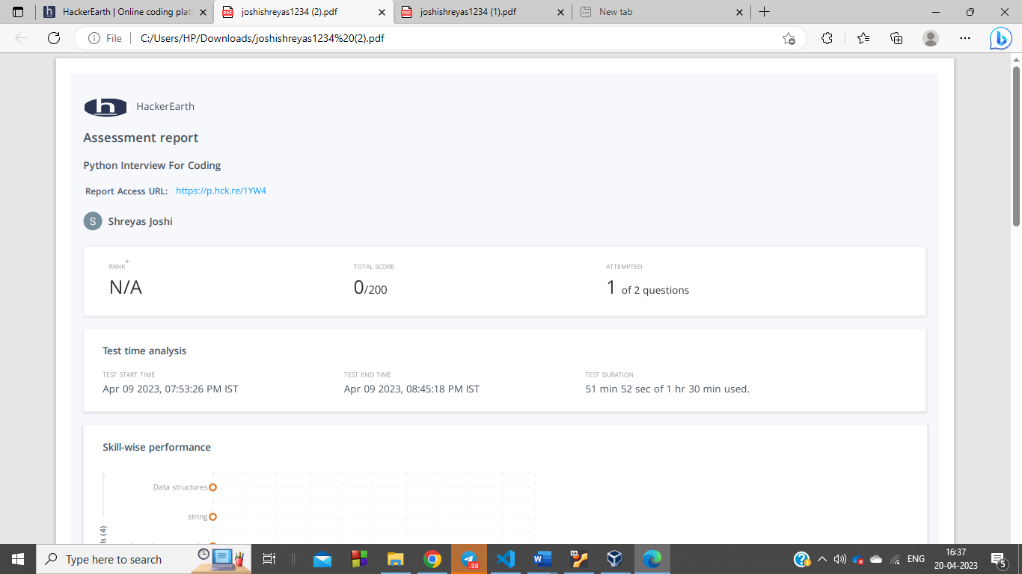

9)

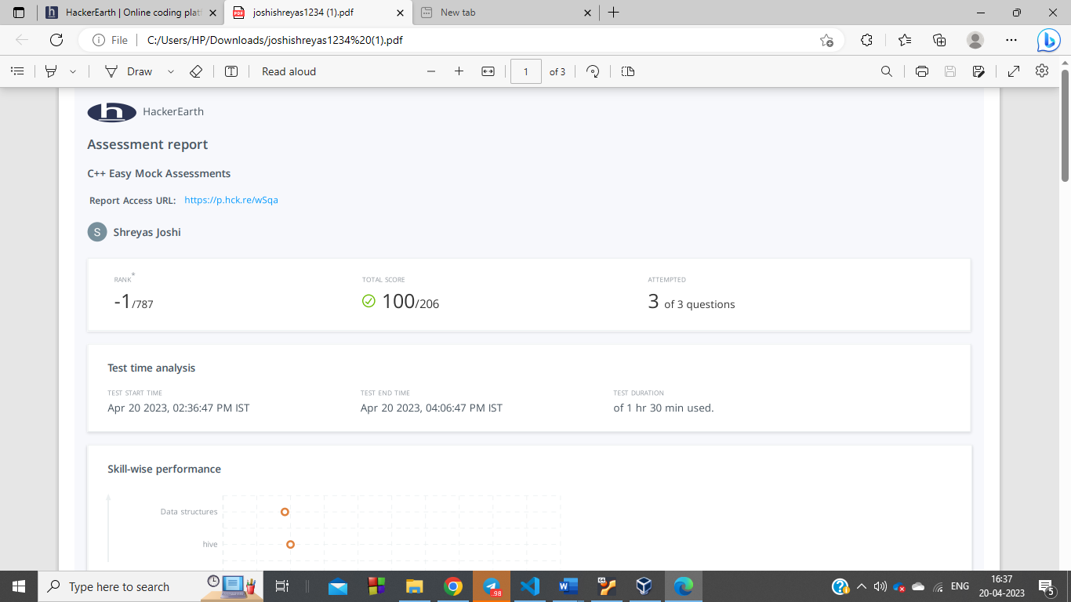

10)



