# Software Requirements Specification (SRS)

### Mask Detection and Social Distancing

### Authors:

### 1. Shreyas Kumbhar

### 2. Rohan Zinjurke

3. Ashutosh Dhabekar

4. Tanishq Kulthe

**Customer:**

**Instructor: Prof. Bhagyashri Vyas**

1. **Introduction**

## Presented that coronavirus disease 2019 (COVID-19) has globally infected over2.7 million people and caused over 180,000 deaths. In addition, there are several similar large scale serious respiratory diseases, such as severe acute respiratory syndrome (SARS) and the Middle East respiratory syndrome (MERS), which occurred in the past few years Liu et al. reported that the reproductive number of COVID-19 is higher compared to the SARS. Therefore, more and more people are concerned about their health,and public health is considered as the top priority for governments . Fortunately, Leung et al. showed that the surgical face masks could cut the spread of coronavirus. At the moment, WHO recommends that people should wear facemasks if they have respiratory symptoms, or they are taking care of the people with symptoms Furthermore, many public service providers require customers to use the service only if they wear masks Therefore,face mask detection has become acrucial computer vision task help the global society, but research related to face mask detection is limited to.

## Purpose

The system's multilevel and modular software architecture enables it to be suitable for implementation in existing cameras. It can be deployed in various places such as shop floors, traffic junctions, construction sites, airports, manufacturing units and business parks. In the fight against COVID-19, this system helps the authorities in enforcing public safety norms. Enabling the coverage of wide areas in less time leads to time efficiency and cost saving.

AI Techniques derived Face Mask Module helps in the real-time detection of whether or not a person is wearing a face mask, the live stream from the cameras helps in monitoring social distancing and Geo tagging and AI algorithms allows the traffic personnel to move a step further in detecting and tracking vehicles which violate the traffic enforcement rules.

## Scope

Social distancing is a recommended solution by the World Health Organisation (WHO) to minimise the spread of COVID-19 in public places. The majority of governments and national health authorities have mask & set the 2-meter physical distancing as a mandatory safety measure in shopping centres, schools and other covered areas. In this research, we develop a generic Deep Neural Network-Based model for automated people detection, mask detection, tracking, and inter-people distances estimation in the crowd, using common CCTV security cameras.

* 1. **Organization**

This Software Requirements Specification document is divided in to multiple subsections. The first section includes explanations of the Purpose, Scope and Organization of the document. The second section of the document is Assumptions and Dependencies. The third section is an enumerated listing of all of the requirements described for this system. The fourth section encompasses all of the Use-case, Sequence, State and Class diagrams that model the system.The fifth section contains a listing of all related reference materials used in this document.

## Overall Description

This section includes details about what is and is not expected of the system in addition to which cases are intentionally unsupported and assumptions that will be used in the creation of the system.

## Assumptions and Dependencies

I want to build a tool that can potentially detect where each person is in real-time, and return a bounding box that turns red if the distance between two people is dangerously close. This can be used by governments to analyze the movement of people and alert them if the situation turns serious.The current study is focused on discussing various root cause of the disease spread and the contributions of the technological systems to control it. One of the common steps need to be taken to avoid the transit immediately is wearing the mask and maintaining the social distancing.CCTV cameras connectivity in the public places, public transports, and hospitals are helpful to gather the required data for monitoring and analysis. Keras and TensorFlow tools used for image processing steps are discussed here.

## Specific Requirements

**3.1 USER INTERFACE**

Application Based On Social Distancing and Mask Detection.

**3.2 HARDWARE INTERFACES**

RAM : 8 GB

As we are using Machine Learning Algorithm and Various High Level Libraries Laptop RAM minimum required is 8 GB.

Hard Disk : 40 GB

Data Set of CT Scan images is to be used hence minimum 40GB Hard Disk memory is required.

Processor : Intel i5 Processor

Pycharm IDE that Integrated Development Environment is to be used and data loading should be fast hence Fast Processor is required

IDE : spyder

Best Integrated Development Environment as it gives possible suggestions at the time of typing code snippets that makes typing feasible and fast.

Coding Language : Python Version 3.5

Highly specified Programming Language for Machine Learning because of availability of High Performance Libraries.

Operating System : Windows 10

Latest Operating System that supports all type of installation and development Environment

**3.3 SOFTWARE INTERFACES**

Operating System: Windows 10

IDE: Spyder

Programming Language : Python

**4 Modeling Requirements**

The purpose of this diagram is to demonstrate how objects will interact with system and map out the basic functionality of the system. Below is a list of the elements that you will see in the diagram on the next page as well what is included in the use case templates that follow.

|  |  |
| --- | --- |
| Actors | Shown in the diagram as stick figures with a name underneath. They represent elements that will be directly  interacting with the system. |
| Use Cases | Oval shapes that have their names in the center. These  represent direct functionality within the system that must be implemented. |
| Interactions | Lines that connect the actors with the different Use Cases. These show that there is some form of direct interaction  between the actor and that specific functionality. |
| Includes | Dotted lines labeled “<<include>>” that connect two use cases and have an arrow pointing towards one. This means that the use case without the arrow calls on the  functionality of the use case with the arrow. |
| Extends | Dotted lines labeled “<<extend>>” that connect two use cases and have an arrow pointing towards one. This means that the use case without the arrow takes all of the  functionality of the use case with the arrow and adds extra functionality. |
| The System Boundary | The large rectangle that contains the Use Cases. Everything within the rectangle is what the system is  responsible for implementing |
| Use Case Template | Describes the basic functionality and features of each use  case and the can be found in the pages following the use case diagram. |
| Type | A field in the use case template that states whether or not the use case is directly interacted with by an actor (Primary) or not (Secondary) as well as whether or not it is  essential to having a functioning system. |
| Cross Ref | A field in the use case templates that states which one of  the original requirements that particular use case satisfies. |
| Use-Cases | A field in the use case templates that state which other use  cases must be executed prior to that particular use case. |

# Use Case Diagram

Unified Modeling Language is a standard language for writing software blueprints.The UML may be used to visualize,specify,construct and document the artifacts of a software intensive system.UML is process independent,although optimally it should be used in process that is use case driven, architecture- centric ,iterative,and incremental.The Number of UML Diagram is available

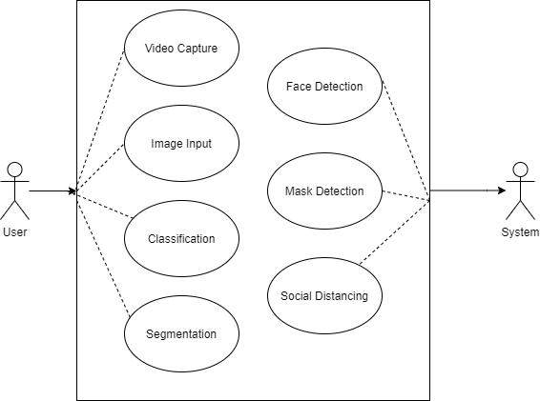

### Use Case : User

**Description:** Initiated when a user on vedio camera. Camera capture images as an input.

### Use Case: System

**Description :** System will perform preprocessing and segmentation on input images. In classification by using cnn algorithm ,system can detect face, mask and social distancing.

# Class Diagram

The purpose of this diagram is to show how objects within the system will interact with each other in order to achieve the functionality required by the Use Case diagram.

Below is a list of what you will see in the diagram itself as well as the class descriptions that follow.

|  |  |
| --- | --- |
| Classes | Rectangles in the diagram that are split into three parts. The top section is the name of the class, the middle section is the list of variables that are stored in the class and the bottom section is the list of functions in the class. These rectangles  represent objects within the system. |
| Variables | These have a name followed by a semicolon and then a type. The type denotes what kind of data can be stored in the  variable. |
| Functions | These have a name followed by a list of any variable that the function receives in-between the parenthesis “()”. After that there is a semicolon and any variables that the function may  return, if none it will be void. |
| Generalizations | Shown using a line from one object to the other with an unfilled triangle on one end. The object without the triangle inherits the functionality and variables from the object that has  the triangle pointing towards it. |
| Aggregations | Lines that have an unfilled diamond on one end. This means  the object with the diamond contains the object(s) without the diamond. This may have numbers on the ends (multiplicities). |
| Associations | Lines connecting two classes that can have a name beside it, may point in one direction, and may have numbers at the ends (multiplicities). These designate some relationship between the objects. Arrows are simply there to assist you in recognizing which direction the name of the association is  read. |
| Multiplicities | Numbers that may be on the ends of Aggregations and Associations. They state how many of the one object can be |
|  | related to the other. The first number is the minimum and the second number is the maximum. An asterisk ‘*’ means many, so “1..*” can be read as 1 to many. If no number exists it is  assumed to be 1. |

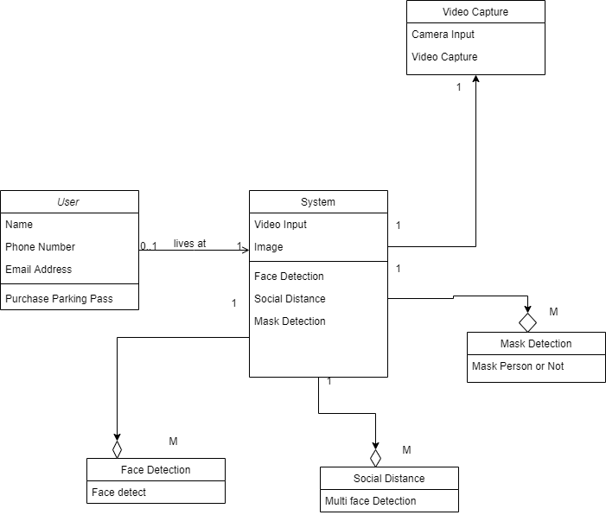

**Explanation :**

User : User can Parches Parking Pass (name, phone number, email address)

System : System capture images as an input then detect face ,mask or not and social distancing .

# Sequence Diagrams

The sequence diagrams use the class diagram and demonstrate specific sequences of actions in the system. The purpose is to ensure that the system runs in an expected way and that the class structure is sufficient to accomplish the tasks needed. Below is a list of the items that you will see in the diagram and their definitions.

|  |  |
| --- | --- |
| Axis’s | The x-axis identifies movement between objects and the y- axis identifies time. |
| Comments | These are the boxes that are along the left side. These explain the actions that are occurring in the sequence and  other helpful information. |
| Instances | Solid boxes along the top that have dotted lines that stretch vertically below them. These are specific instances of an object. The first part of the title is the name of that specific instance and the object it is an instance of follows it. (Special Note: If there are multiple instances that have the same title then they are actually the same instance and are only there to diagram calls onto themselves.) |
| Calls | Lines that have filled triangles at the ends. These are transitions from one instance to another and have a label above them that is a function call, a variable being set, or both. It can also have a guard statement that precedes it. |
| Variable being set | Have a variable name followed by either a ‘:=’, ‘+=’, or ‘-=’ and then another variable name with the first being set to the later. |

|  |  |
| --- | --- |
| := | means that its being set directly to the variable that follows. |
| += | means that the variable that follows is being added to the  current value. |
| -= | means that the variable that follows is being subtracted from  the current value. |
| Guard Statements | These are located between brackets ([])and come before the  function in a call. This means that the condition must be true in order to make that call. |
| Returns | These are represented by dotted lines with an arrow at the end. These simply represent a return from a function call. |
| Object Execution Time | This is shown with the solid white boxes that run vertically along the dotted lines. These simply represent the execution time for the objects. (Special Note: the first object has a solid box all the way down this is a special case and should not be  there and is due to the application used to create the diagram). |

The sequence diagrams use the class diagram and demonstrate specific sequences of actions in the system.

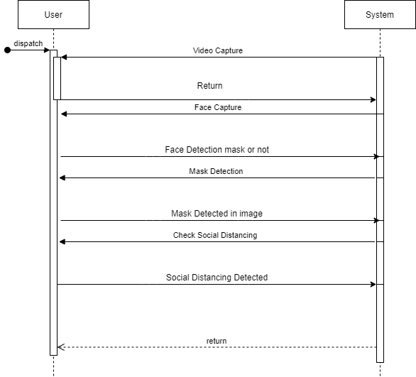

## References

## [1] Chamola et al., “A Comprehensive Review of the COVID19 Pandemic and the Role of IoT, Drones, AI, Blockchain, and 5G in Managing its Impact,” IEEE Access, vol. 8, 2020, pp. 90225–65.

## [2] Y. Zhang et al., “Edge Intelligence in the Cognitive Internet of Things: Im- proving Sensitivity and Interactivity,” IEEE Network, vol. 33, no. 3, May/June 2019, pp. 58–64.

## [3] M. A Rahman et al., “B5G and Explainable Deep Learning Assisted Health- care Vertical at the Edge-COVID-19 Perspective,” IEEE Network, vol. 34, no. 4, July/August 2020. DOI: 10.1109/MNET.011.2000353, pp. 1–8.

## [4] G. Muhammad, M. F. Alhamid, and X. Long, “Computing and Processing on the Edge: Smart Pathology Detection for Connected Healthcare,” IEEE Net- work, vol. 33, no. 6, Nov.- Dec. 2019, pp. 44–49.

## [5] S. M. Lundberg et al., “From Local Explanations to Global Understanding with Explainable AI for Trees,” Nat. Mach. Intell. 2, 2020, pp. 56–67.

[6] Mon Arjay Malbog “MASK R-CNN for Pedestrian Crosswalk Detection and Instance Segmentation” 2019 6th IEEE International Conference on Engineering Technologies and Applied Sciences (ICETAS)

[7] Md. Abdur Rahman, Senior Member, IEEE and M. Shamim Hossain, Senior Member, IEEE, Nabil A. Alrajeh, Fawaz Alsolami “”Adversarial Examples – Security Threats to COVID-19 Deep Learning Systems in Medical IoT Devices” IEEE

[8] S. Andreev et al., “Future of Ultra-Dense Networks Beyond 5G: Harnessing Heterogeneous Moving Cells,” IEEE Commun. Mag., vol. 57, no. 6, June 2019, pp. 86–92.