Documentation

This code is similar to code in [flask-sqlite](https://github.com/shreyaskn72/Flask_Rest_API_codes/tree/master/2/flask-sqlite) folder. However in this case sqlalchemy (object relational mapper) is used.

POST method:

Endpoint: <http://127.0.0.1:5000/product>

Method:POST

Example 1:

Request:

{

"name": "colgate1",

"description": "This is for brushing teeth",

"price": 40,

"qty": 2

}

Response:

{

"description": "This is for brushing teeth",

"name": "colgate1",

"price": "40",

"qty": "2"

}

Database:

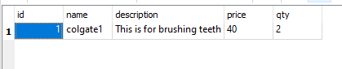

Example 2:

Request:

{

"name": "Ujala",

"description": "This is for cleaning",

"price": 15,

"qty": 2

}

Response:

{

"description": "This is for cleaning",

"name": "Ujala",

"price": "15",

"qty": "2"

}

Database before adding:



Database after adding:

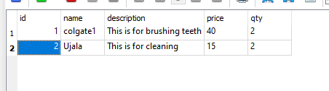

GET method 1: Get resource by id

Endpoint: http://127.0.0.1:5000/product/<id>

Example of endpoint:<http://127.0.0.1:5000/product/2>

Method: GET

Response:

{

"description": "This is for cleaning",

"name": "Ujala",

"price": "15",

"qty": "2"

}

GET method 2: Get all resources inside the database

Endpoint: <http://127.0.0.1:5000/product>

Method: GET

Response:

[

{

"description": "This is for brushing teeth",

"name": "colgate1",

"price": "40",

"qty": "2"

},

{

"description": "This is for cleaning",

"name": "Ujala",

"price": "15",

"qty": "2"

}

]

Delete method:

Endpoint: <http://127.0.0.1:5000/product/1>

Method: DELETE

Response will display the deleted item

Response:

{

"description": "This is for brushing teeth",

"name": "colgate1",

"price": "40",

"qty": "2"

}

Database before delete operation:

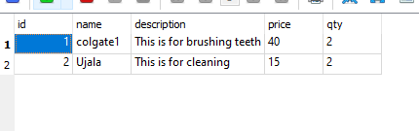

Database after delete operation:

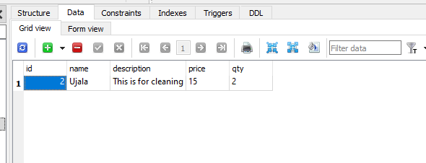

PUT method:

Endpoint: <http://127.0.0.1:5000/product/2>

Method: PUT

Request:

{

"id": 2,

"name": "Ujala2",

"description": "This is a new version of ujala. Its used for cleaning clothes",

"price": 30,

"qty": 5

}

Response:

{

"description": "This is a new version of ujala. Its used for cleaning clothes",

"name": "Ujala2",

"price": "30",

"qty": "5"

}

Database before update:

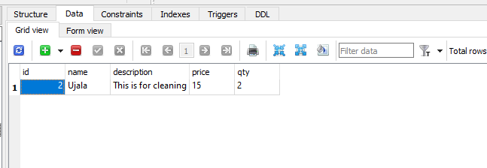

Database after update

