Documentation

Authentication credentials:

* username = shreyaskn72
* Password = secret

Case1 - Unauthorized case:

You give no credentials or false credentials in this case.

Endpoint: <http://127.0.0.1:8080/product>

Method:POST

Example 1:

Request:

{

"name": "colgate",

"description": "This is for brushing teeth",

"price": 40,

"qty": 2

}

Response:

{

"error": "Unauthorized access"

}

In the upcomming cases you give correct credentials as:

* username = shreyaskn72
* Password = secret

POST method:

Endpoint: <http://127.0.0.1:8080/product>

Method:POST

Example 1:

Request:

{

"name": "colgate",

"description": "This is for brushing teeth",

"price": 40,

"qty": 2

}

Response:

{

"1": {

"description": "This is for brushing teeth",

"name": "colgate",

"price": 40,

"qty": 2

}

}

Database:

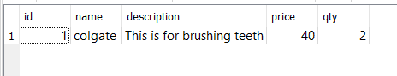

Example 2:

Request:

{

"name": "Ujala",

"description": "This is for cleaning",

"price": 15,

"qty": 2

}

Response:

{

"2": {

"description": "This is for cleaning",

"name": "Ujala",

"price": 15,

"qty": 2

}

}

Database before adding:



Database after adding:

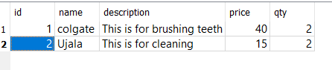

GET method:

Endpoint: http://127.0.0.1:8080/product/<id>

Example of endpoint: <http://127.0.0.1:8080/product/2>

Method: GET

Response:

{

"2": {

"description": "This is for cleaning",

"id": 2,

"name": "Ujala",

"price": 30,

"qty": 5

}

}

PUT method:

Endpoint: <http://127.0.0.1:8080/product/update>

Method: PUT

Request:

{

"id": 2,

"name": "Ujala2",

"description": "This is a new version of ujala. Its used for cleaning clothes",

"price": 30,

"qty": 5

}

Response:

{

"2": {

"description": "This is a new version of ujala. Its used for cleaning clothes",

"id": 2,

"name": "Ujala2",

"price": 30,

"qty": 5

}

}

Database before update:

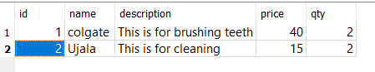

Database after update

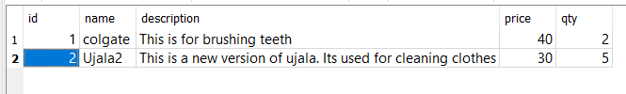

Delete method:

Endpoint: <http://127.0.0.1:8080/product/delete>

Method: DELETE

Request:

{

"id": 1

}

Response:

"User deleted successfully!"

Database before delete operation:

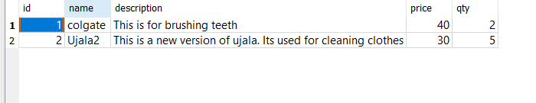

Database after delete operation:

