Assignment 7

#### Names:

Shrinidhi Bhagavath: PES1201701525

Shreyas Sreenath Mavanoor : PES1201700837

Kaustubh Raghavan : PES1201700916

#### Problem Statement :

To implement collaborative filtering method for a recommender system.

#### Screenshots of Output:

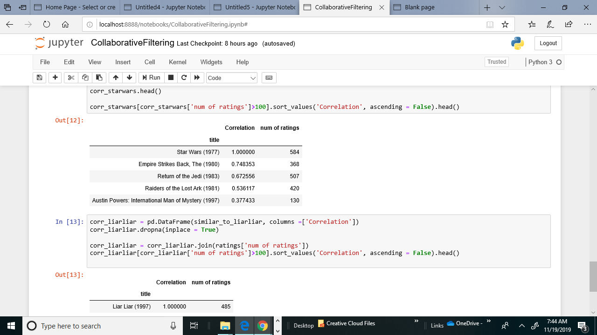Movies Similar to Starwars -

Movies Similar to Liar Liar -

