Concordia University



Department of Applied Computer Science

Project - I
COMP-6231

Software Failure Tolerant CORBA DRS using Crash-Free Replica

Design Document
1.0

 | Name | Date  <mm/dd/yyy>
Prepared by | Swapnil Warke (6451101)  Safan Maredia (6549535)  Prateek Mehta (6438733)  Kamrinderpal Singh(6403840) | 11/30/2012
Demo Delivered | Swapnil Warke (6451101)  Safan Maredia (6549535)  Prateek Mehta (6438733)  Kamrinderpal Singh(6403840) | 11/30/2012
Approved by | Shridhar Mohan | 11/30/2012

Table of contents

1.0 Introduction 3
2.0 Design Approach 3
2.1 Assumptions and Constraints 3
2.2 Design Principles 3
3.0 High-Level Design 3
3.1 Data Model 3
3.1.1 E-R Diagram / Use-Case Model 3
3.1.2 Database Design / Class Model 4
3.1.3 Data Flow Diagrams / Sequence, Activity Diagrams 4
4.0 Development Environment 5
5.0 Test Scenarios 7

Introduction
In this project, a simple distributed retail store is developed to tolerate the single software failure using Active Replication. This project is based on Software Failure Tolerant CORBA DRS using Crash Free Replica. This system is used by customers (with unique 6-character customerIDs — the first character identifies a store and the remaining 5-digit customer number identifies thecustomer in that store) to buy or return or exchange items (with unique 4-digit itemIDs) from/to theDistributed Retail Store.

This system contains 3 different online stores, Montreal, Vancouver and Toronto grouped under one Replica Manager. Two more copies of such online replicas and RMs are replicated. Each of these stores will have their own stock of items. These stores will allow client to purchase items, return items or check availability of items in all stores.
This application is user friendly for online shopping.

Design Approach

Assumptions and Constraints
- There will be 3 different stores – Toronto, Vancouver and Montreal.
- Each of these stores will have their own items and available quantities.
- All 3 servers connect with each other through UDP protocol.

Design Principles
User will connects to the nearer server based on customer’s initial character. (M - Montreal, T – Toronto and V - Vancouver). When client connects to the server, based on client’s Id, request will be forwarded to respective stores. CORBA interface is used for communication between client and server.

High-Level Design

Data Model

E-R Diagram / Use-Case Model

Use Case Model –
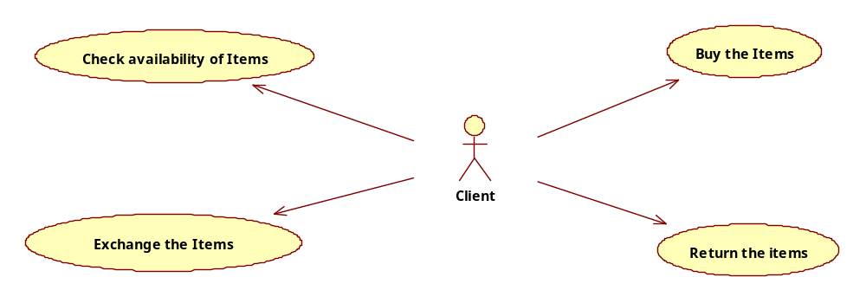

User can prtform 3 different operations –
- Purchase the item
- Return the item
- Check availability of items
- Exchange the items

Database Design / Class Model

In this assignment, no database is used for storing customer information. However to maintain customer data, file system is used. All these files will follow the below conventions –
- Naming – File for a customer is created with his own Customer Id and all transactions are maintained in the same file. File format will text(*.txt)
- Content – Each row will depict the transaction performed by client. Each row will have following format –
<Customer_Id|Item_Id|Quantity>
Ex. M64511|A101|2 : For purchase
Or M64511|A102|-2 : For return
Moreover, the item data is stored in hashmap and will be initialized every time when server is restarted.

Data Flow Diagrams / Sequence, Activity Diagrams
Following is the architecture of the project –

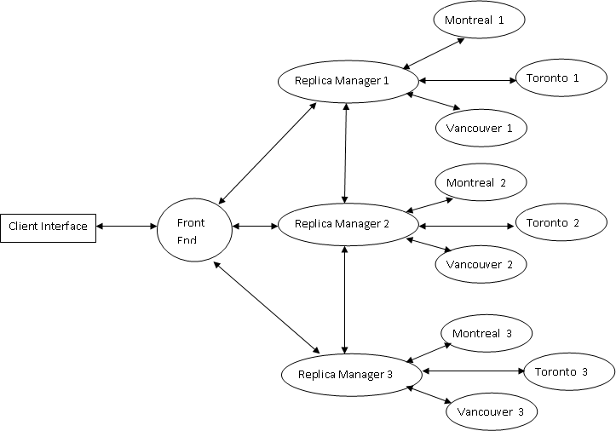
Architecture Specifications –
- CORBA implementations –
CORBA architecture is using for communication between Client to Front End (FE) and Front End (FE) to individual Replica Servers.
- UDP Communication –
UDP protocol is used to communicate between Front End (FE) to Replica Manager (RM) and Replica Manager (RM) to Replica Servers.

Following is the flow of the application –
- Client will be shows all four options to buy, return, exchange or check stock. User will enter the required option let’s say buy. Then User will be prompted for his customer number, item Code and quantity to be purchased.
- This request will be send to Front End (FE) and in turn to the available server instance (of the store nearer to the customer) by invoking proper interface method.
- When this request arrives at server side, server first checks for the required availability of item quantity.
- If Item quantity > = requested quantity, then server will directly place the order in that store.
- Else server will check with the other servers for the item.
- If another server have item in its store, then place an order in that store and return successful message back to original server.
- If another server is not having that item in stock, then returns the unsuccessful message to server.
- If order is placed at another server then client will be shown a successful message. Otherwise repeat steps from point no 5.
- Appropriate message will be displayed to the customer as per the execution.

Development Environment
Following are the Algorithms for respective components of the system –
- Client Implementation –
- Show options to user.
- Call the CORBA interface of FE and send all the parameters.(executeOperations())

- Front End –
- Generate sequence id for each request.
- Add this request id as key and parameters as values (“|” separated) in Request Buffer.
- Add request id as key and empty string as value in Response Buffer.
- On each request, FE will poll to all RMs. Wait for response for 3 sec and update the list of active Replica Managers.
- Send the request to all Server Replicas atomically. Wait for Reply.
(If ACK is not received, message is sent again upto 3 times. After 3 attempts, if ACK not received, then consider RM is failed.)
- Get the response from appropriate servers.
- Compare the results and update the response buffer accordingly.
- Based on comparison, reply back to RM if replica produced wrong result.
- Send the single correct result back to client.

- Replica Managers –
- Listen for polling from FE.
- Get the request from FE on UDP. (Message will be “|” separated along with request id)
- If request for polling is received, then send message to the server replica.
- If replica message is arrived, then send Active flag to FE.
- Listen for request from FE to replace the replica.
- Based on request received from FE regarding failed replica, RM will replace that replica (based on customer id, this will be decided) as –
- Send request to other RM asking the status information of replica to be replaced (such as Montreal or Vancouver or Toronto)
- Another RM will get the status from appropriate replica (Item id n Qty)
- Get the reply and call the replica’s to update the Item details.

- Replica Servers –
- Get the operation from RM.
- Perform it.
- If required communicate with other store replicas through UDP.
- Send results back to RM.
- Moreover, if Replica Manager asks to get the context data or update the context data, then performs requests accordingly.

Critical Logics in project –
- Synchronization of increment and decrement of the quantity from global variables.
In a project, implement items and their available quantity are initialized in static block which will be invoked once when server starts.
All the items and their quantities are stored in HashMap so that items can work as key and values will be available Item quantity for that item.
To achieve synchronization, manual lock functionality is implemented. A new hash map is created to maintain the row lock status.
Following is the pseudo code for item increment (in case of return) functionality implementation –
Variables:
itemLockMap : HashMap – key => Item Code & value => lock flag
itemCode : Item Id available in the store.

Code:
while(itemLockMap.get(itemCode) != 0){
// means Item is currently used by other Thread. So wait till it completes.
System.out.println("Waiting for other thread to close..");
}
//Just cross check if quantity is not 0 because of the last thread execution
itemQty = itemMap.get(itemCode);
if((itemQty-numberOfItem) < 0 ){
status = false;
}else{
// Now access the lock map and update the quantity
itemLockMap.put(itemCode, 1); //Lock the resource
itemQty = itemMap.get(itemCode); // Get the Item Quantity
itemQty += numberOfItem;
itemMap.put(itemCode, itemQty); // Update the Item Quantity
itemLockMap.put(itemCode, 0); //Unlock the resource
}

- Sequencing Logic –
Define a global variable –
private static int sequence;
int sequenceId = 0;
sequenceId=incrementSequence();

Moreover the incrementSequence() method is –
private synchronized int incrementSequence() {
return sequence++;
}

- Comparison Logic –

if(replyFromReplicas.get(1).equalsIgnoreCase(replyFromReplicas.get(2))){
firstCondition = true;
}
if(replyFromReplicas.get(2).equalsIgnoreCase(replyFromReplicas.get(3))){
secondCondition = true;
}
if(replyFromReplicas.get(1).equalsIgnoreCase(replyFromReplicas.get(3))){
thirdCondition = true;
}
//By defaults, lets put the reply from from 1st replica, considering all replicas are in sync
reply = replyFromReplicas.get(1);
if(firstCondition == false && secondCondition == true && thirdCondition == false){
// Means reply from 1st is wrong
}
if(firstCondition == false && secondCondition == false && thirdCondition == true){
// Means reply from 2nd is wrong
}
if(firstCondition == true && secondCondition == true && thirdCondition == false){
// Means reply from 3rd is wrong
}
if(firstCondition == true && secondCondition == true && thirdCondition == true){
//All 3 servers gave the same reply.
}

Test Scenarios
In this project, many test scenarios can be constructed. However, as multithreading is implemented, following test cases are designed in order to cover them.
- Purchase and Item Test Cases -
Test Case – 1 Buy an item with single client.
Steps:
- Client will select the purchase option from menus.
- User will select the 1 option for single user.
- Provide item code and quantity.
Expected Result:
User should be returned a proper message based on Order successful or failure.
(This scenario also can be tested for the item which are not available in nearer store. So that order wil l be placed in another store internally and a message will be displayed.)

Test Case – 2 Buy an item with multiple clients.
Steps:
- Client will select the purchase option from menus.
- User will select the 2 option for multiple users.
- Provide item code and quantity.
- Provide the number of clients to be executed (such as 5 or 7 or 10)
Expected Result:
Messages for all clients should be returned and displayed to the client console.
(This scenario also can be tested for the item which are not available in nearer store. So that order will be placed in another store internally and a message will be displayed.)

- Return an Item Test cases -
Same test steps can be executed for return and item for single/multiple users with modification of option selections.

- Check available quantity Test Cases -
For check availability test scenario, it can be executed with users directly.

- Exchange the Items –
Steps involved in exchanging earlier purchased items –
- Client will select Exchange option from Menu.
- User will be prompted for earlier purchased Item Code.
- Enter quantity to be exchanged.
- New Item code to be purchased.
- Quantity of the new Item Code.

