Error: Reference source not found

Author: Sumit Kumar

Document History
Document Location
This is a snapshot of an on-line document. Paper copies are valid only on the day they are printed. Refer to the author if you are in any doubt about the currency of this document.
The source of the document will be found in /tmp/lo/0000.doc
Revision History
Date of next revision (date)

Revision Number | Revision Date | Summary of Changes | Changes marked
 |  |  | (N)
 |  |  | (N)
Approvals
This document requires following approvals. Signed approval forms are filed in the Quality section of the PCB.
Name | Title
(name) | (title)
Distribution
This document has been distributed to
Name | Title
(name) | (title)
Contents
1. DBS Account 5
1.1 Leadership Message 5
1.2 Projects 6
1.3 Awards 7
1.4 Articles 7
1.5 Be Informed! 8
2. Leisure 10
2.1 Cartoons 10
2.2 Celebrations 11
2.3 Offsite 11
2.4 Hi-Tech Zone 11
3. Somebody New 12
3.1 New Joiners 12
3.2 Newly Weds 12
3.3 New Certifications 13
4. Respondez 14

DBS Account

Leadership Message

Projects

Project Lantern (CST):

Project Lantern one of the key projects for DBS was implemented successfully. Our role was to support project lantern and the scope included migrating of ANZ customers & products to DBS for Singapore geography, CIS (customer info) migration, CA account creation and balance migration , FCCA account creation and balance migration,
Fixed deposits (both SGD & Foreign currency) are the major areas which were supported by IBM from requirement analysis till implementation.

Testing is also one of the area which was supported by IBM , as testing with ANZ data was a challenge.
Team Members:
ANSP : Sreeni, Hari, Bhupati Kiran, Leela Madhavi
CA : Rohit Kumar, Manjunadh, Anantha
CST Testing : Mallik, Mounika, Revathi, Chandra, Susheel, Murali, Srinivas, Mrudula, Vasanthi,
Suresh Babu Chinthapalli, Suresh B Vilasagaram

Lantern Appreciation from Client 

Project Lantern (CBG) : 05th - 06th Aug

Acquiring ANZ’s wealth and consumer banking business for Singapore. Implemented on 05th - 06th Aug. The scope included development and L2/L3 support.

Key Members : Bala Bhaskar, Devi S Galla, Harika Boppudi, Murali Kasa, Garima Gupta

Lantern Appreciation from Client (CBG) 

Awards

Articles
OCBC Bank to pilot artificial intelligence to counter money laundering

Singapore-based OCBC Bank has started a pilot project to test artificial intelligence-based (AI)
tools to counter money laundering. The bank has partnered with BlackSwan Technologies and
Silent Eight for the testing of AI solutions. The collaboration is part of the second Fintech Accelerator Programme conducted by OCBC Bank’s Fintech unit, The Open Vault. The pilot project claims to increase the bank’s competency in countering not only money laundering but also terrorist financing. The companies use artificial intelligence to conduct research on individuals and artificial entities who are suspected of illegal financing. The research includes scanning of individual profiles, and mapping how suspicious transactions may be linked to one another to examine if they are fraudulent or illegal. Presently, this process is conducted manually, but introducing artificial intelligence is expected to enhance an analyst’s productivity by up to 100%. Increase in productivity is achieved by speeding up the process of research on computer, where for example, a research which takes about one hour to complete, can be completed within one minute. As per the bank, the process begins when a suspicious transaction from an individual’s account shows an unusual activity. The bank’s internal private investigation will look at the individual’s history and will determine whether or not such a transaction is usual or typical of the individual or is it really unusual. Analysts will also scan the individual’s social media accounts, search engines, databases to create a profile of the individual, to get a comprehensive understanding of banking patterns, associates and behaviors. Silent Eight's solution, which is one of the fintech solutions piloted, helps to automate the desktop research process by enabling Banking Horizon analysts to put together the suspicious individual’s dossier within just a minute. The solution provided by the second company BlackSwan Technologies uses artificial intelligence to analyses suspicious transactions and map them to a network of related transactions.

London Stock Exchange partners with IBM to develop securities data blockchain
Solution for SMEs

Borsa Italiana, a subsidiary of London Stock Exchange Group has entered into a collaboration with IBM for the development of securities data blockchain solution for European small and medium enterprises (SMEs). The blockchain solution to be developed by IBM will simplify the tracking and management of shareholding information. The new system is aimed at
creating a distributed shared registry that contains records of all the shareholder transactions. This new implementation is expected to open up new avenues for trading and investment. For unlisted SMEs in Europe, the new blockchain solution will be designed to replace paper
trading certificates that are commonly issued to private companies. The project will result in providing a highly digitised, streamlined and transparent process build by using blockchain technology to allow several parties, including from issuers, regulators and investors, to gain insight into company information. As privately owned SMEs do not have access to public stock exchange networks or are formalised credit structures, the new blockchain solutions is claimed to help SMEs in gaining improved access to credit and link into a broader and more mature investor ecosystem. LSEG is testing the use of blockchain technology in a financial business network where data segregation and confidentiality is vital. By working with IBM, a pioneer in building enterprise-class blockchain solutions, they are committed to building, testing and scaling our capabilities in emerging technologies over time. Sharing secure and transparent critical network data across shareholder networks is difficult using traditional system. “Blockchain is poised to help remove some of these barriers in traditional methods for the transfer of value – much as the Internet did for the exchange of information in the late 1990s.

Account number portability in India
A senior Reserve Bank of India official asked banks to work towards Account Number portability
in line with the telecom industry whereby a customer can retain their account number even if
they switch to another bank. Deputy governor SS Mundra said this "will be a far-reaching step
towards enhancing competition and improving customer service." Mundra had earlier said
technological innovation and linking accounts to Aadhaar can make it easier for this to happen.
For unhappy banking customers, this could be a relief as it will save them the trouble of going
through the process of opening a new bank account each time they want to switch banks. This
will also help you do away with multiple bank accounts. The enhanced competition could lead to better services too. Taking this step is not going to be an easy task for banks as there are many loopholes that need to be addressed on the technology and data-integration front. Adhil Shetty, Banking Horizon CEO of Bankbazaar, says, "Banks will have to restructure their account numbering systems. Many of them have different methods and streamlining these will take time. This will also involve changes in their software integration systems." Another roadblock could come in the form of know your customer (KYC) procedures. The KYC and the due diligence done vary between banks and may not be accepted uniformly. Experts believe that there are chances that some people may switch banks too often to escape the net of the Prevention of Money Laundering Act. So, banks need to have a secure KYC norm in place to distinguish the genuine customers from the fraudsters. A report on bank account number portability by Finacle, the banking solutions product of Infosys Technologies, states that this facility is already present in Europe and Australia in different forms. In the United States, every bank account number indicates the bank and pin code of the branch owning the account. However, the mechanism to handle subsequent bank switches is still not in place.

Be Informed!

Requirements

TESTERS:
CST:

Events

Leisure

Cartoons

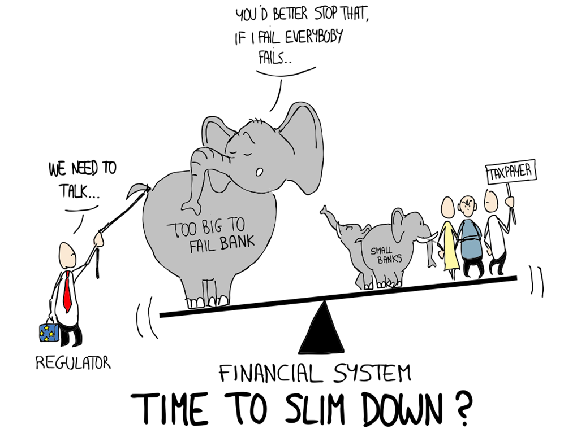

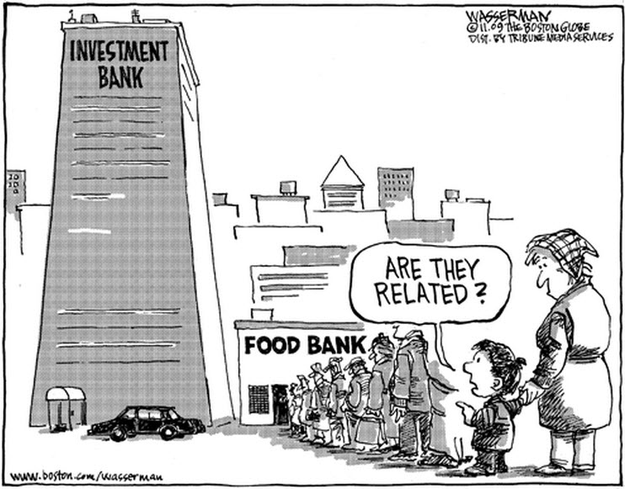

Celebrations

Offsite
Omni testing team testing themselves @5k and 10K Run.


Hi-Tech Zone

Test data & its management - A overview presented by Krishna Kasavaraju from testing team



Somebody New

New Joiners

Newly Weds
OMNI AUTOMATION 
Newly Wedded Couple:
Shashank and Uma

Um

OMNI AUTOMATION 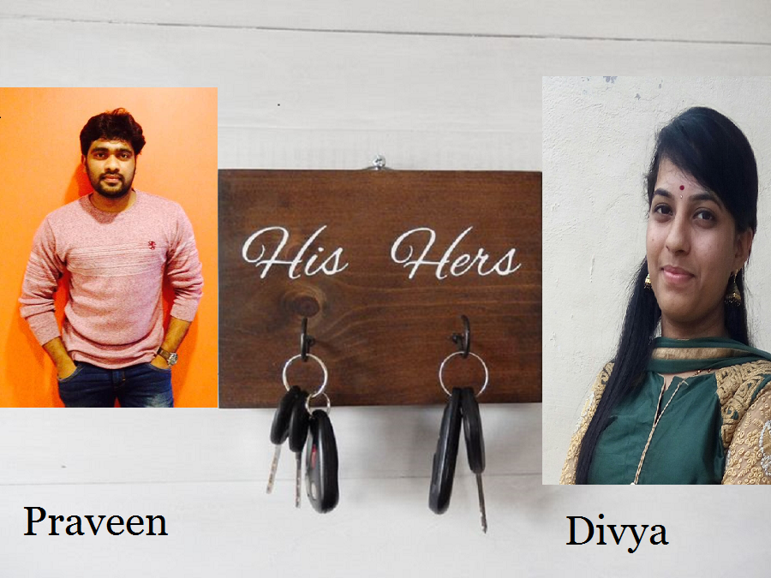
Newly Wedded Couple:
Divya and Praveenn

Um

New Certifications

Congratulations AMIT SRIVASTAVA for completing ‘Scrum master accredited certification’

Respondez

