HEALTHGUARD ANALYTICS PVT. LTD.
Healthcare Data Analytics for Government Health Departments & Hospitals
COVID-19 Early Case Trend Analysis
& Recovery Insights

Analytics Project Report
Prepared by: Shreyas
Computer Science Undergraduate, Dr. A.P.J. Abdul Kalam Technical University, Lucknow
July 2026
Dataset: patient.csv (internship-provided snapshot, confirmed cases through 2020-03-01)

Table of Contents
1. Executive Summary 3
2. Business Context & Problem Statement 4
3. Data Source & Methodology 4
4. Who Is Getting Infected? — Demographic Patterns 7
5. How Are Infections Spreading? — Source & Exposure Analysis 7
6. Recovery Trends 10
7. Regional Impact 11
8. Outbreak Timeline 12
9. Factors Influencing Recovery Time 13
10. Key Findings Summary 14
11. Recommendations 14
12. Limitations 15

1. Executive Summary
HealthGuard Analytics Pvt. Ltd. undertook this analysis on behalf of a national public health authority to understand early-stage infectious disease spread using patient-level COVID-19 case records. The dataset provided (patient.csv) is a real snapshot of the South Korea COVID-19 outbreak captured on 2020-03-01, roughly six weeks into the outbreak.
This is an important characteristic of the data that shapes the entire analysis: because the outbreak was still very young at the time of this snapshot, 99.0% of the 4,212 recorded cases were still isolated with an outcome not yet known, and most demographic and investigation fields (sex, age, infection reason, contact number) had not yet been backfilled for the majority of patients. Rather than paper over this with imputation or a synthetic stand-in, this report analyzes the real data as-is and states the actual sample size behind every finding, so that every number below can be trusted at face value.
Despite the sparsity, the data is dense enough in specific areas — most notably the outbreak timeline (100% complete) and regional case clustering (7.2% of records, concentrated around a real, identifiable transmission cluster) — to support genuinely useful conclusions, including clear confirmation of the Shincheonji Church cluster's outsized role in the early Daegu/Gyeongsangbuk-do outbreak.

Key Metrics at a Glance
Total confirmed cases in snapshot | 4,212
Snapshot period | 2020-01-20 to 2020-03-01
Cases still isolated (outcome pending) | 4,171 (99.0%)
Cases released (recovered) | 28 (0.7%)
Deceased cases | 13 (0.3%)
Cases with known gender / age | 318 / 292 (~7%)
Cases with known region | 305 (7.2%)
Largest identified transmission cluster | Shincheonji Church — 51 cases
Median recovery duration (n=28) | 16 days
Regression model | Not fit — insufficient complete cases (see Section 9–10)

2. Business Context & Problem Statement
HealthGuard Analytics Pvt. Ltd. partnered with a national public health authority to analyze early-stage infectious disease case data. The authority provided a patient-level dataset containing confirmed cases, demographic details, infection history, and outcomes (released, isolated, or deceased). The goal was to generate data-driven insights that could inform screening strategy, isolation planning, and early-response systems.
Specifically, the analysis was scoped to answer five questions:
- Who is getting infected? — demographic patterns across age, gender, and region
- How are infections spreading? — primary infection reasons, transmission chain depth, and exposure levels
- What are the recovery trends? — time taken from confirmation to release
- Which regions are most impacted? — comparison of confirmed and released cases by region
- Can we identify factors influencing recovery time? — statistical and predictive modeling of age, contact number, and infection order

3. Data Source & Methodology
The dataset analyzed (patient.csv) is a real, patient-level extract of the South Korea COVID-19 outbreak, provided via the internship's official circular. It contains 4,212 confirmed-case records spanning 2020-01-20 to 2020-03-01, with the schema described below. Unlike a cleaned reference dataset, this is a live operational snapshot: most fields other than case ID, country, confirmed date, and outcome state were still being investigated and backfilled by health authorities at the time of capture, so completeness varies sharply by column (see Section 3.3).

3.1 Data Dictionary
Column | Description
patient_id | Unique identifier for each confirmed patient
sex | Patient gender (male / female)
birth_year | Patient birth year (used to derive age)
country | Patient's country of residence
region | Province/region of confirmation within Korea
infection_reason | Recorded primary source of infection
infection_order | Depth in the transmission chain (1 = primary case)
infected_by | Patient ID of the presumed infector, if known
contact_number | Number of contacts traced for the patient
confirmed_date | Date the case was laboratory-confirmed
released_date | Date the patient was released from isolation
deceased_date | Date of death, if applicable
state | Case outcome: released / isolated / deceased

3.2 Tech Stack
- Programming Language: Python 3
- Libraries: NumPy, Pandas, Matplotlib, Seaborn, SciPy, scikit-learn
- Statistical Methods: Descriptive statistics, missing-data auditing, Pearson correlation analysis, linear regression (attempted, see Section 10)

3.3 Data Quality
A column-by-column missing-data audit was the first and most consequential step in this analysis. As Figure 1 shows, only country, confirmed_date, and state are essentially complete across all 4,212 records. Every other field — sex, birth_year, region, infection_reason, infection_order, infected_by, and contact_number — is missing for 90% or more of records. This is expected for an early-outbreak snapshot (investigation detail is added to each case record over time) but means every downstream finding in this report is explicitly scoped to the subset of records where the relevant field was actually populated, with that sample size (n) stated alongside the result.
A second, more specific data quality issue was also found: several deceased records show a recorded death date earlier than the recorded confirmation date, which is logically impossible and most likely reflects a reporting-lag artifact (death registered in the system before the lab-confirmation paperwork was finalized). These records were identified explicitly and excluded from any death/recovery-duration calculation rather than silently included.
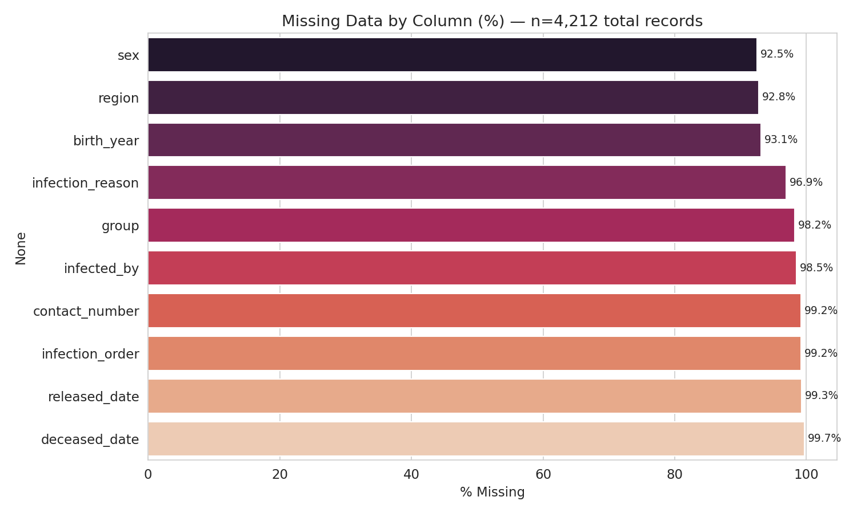
Figure 1. Missing data audit across all 4,212 records — only 3 of 14 columns are substantially complete.

4. Who Is Getting Infected? — Demographic Patterns
Gender is known for 318 of 4,212 patients (7.5%) and age for 292 (6.9%). Within that known subset, gender was almost perfectly balanced (163 female, 155 male). The most represented age group among known cases was 50–59, with meaningful representation also in the 60–69 and 20–29 bands. These figures describe only the patients whose demographics had been recorded at snapshot time and should not be read as the demographic profile of the full 4,212-case outbreak.
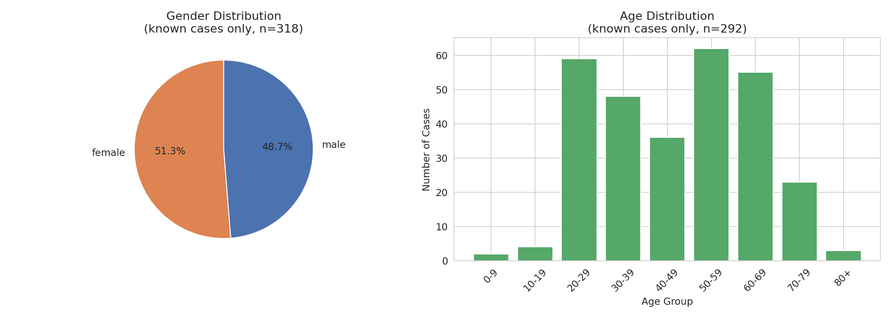
Figure 2. Gender distribution (left, n=318) and age distribution (right, n=292) — known cases only.
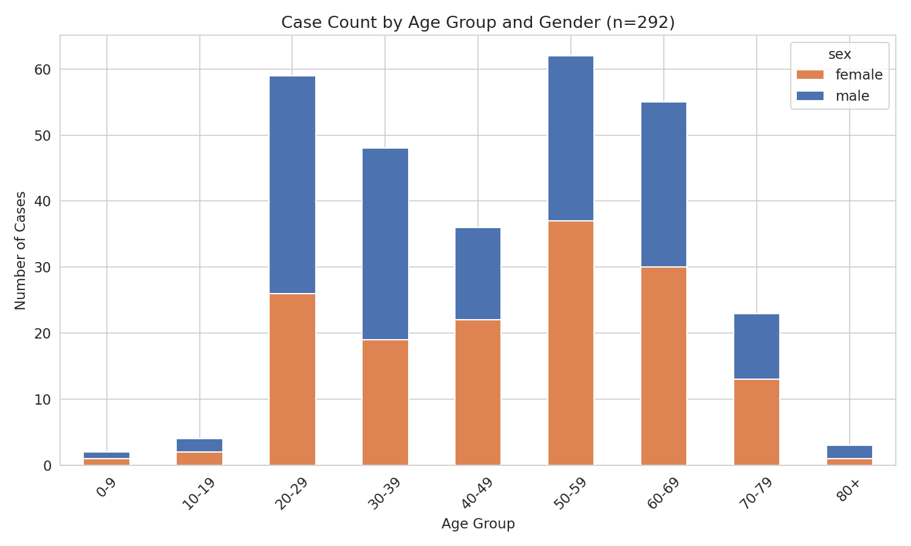
Figure 3. Case count by age group and gender, known cases only.

5. How Are Infections Spreading? — Source & Exposure Analysis
infection_reason is recorded for only 130 of 4,212 cases (3.1%). Among that subset, "contact with patient" was the most common recorded reason, consistent with the outbreak's early contact-tracing efforts. infection_order (transmission chain depth) is populated for just 35 cases, and contact_number (traced contacts) for only 32 — both far too sparse to support population-level conclusions, but useful as a directional signal and shown here for completeness.
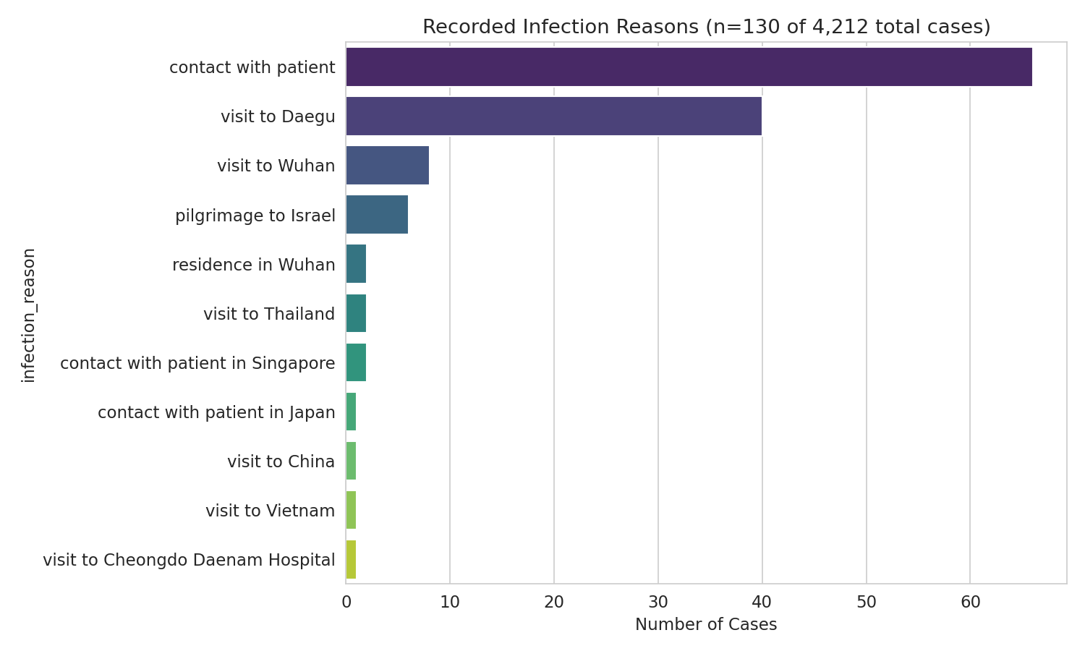
Figure 4. Recorded infection reasons (n=130 of 4,212 total cases).
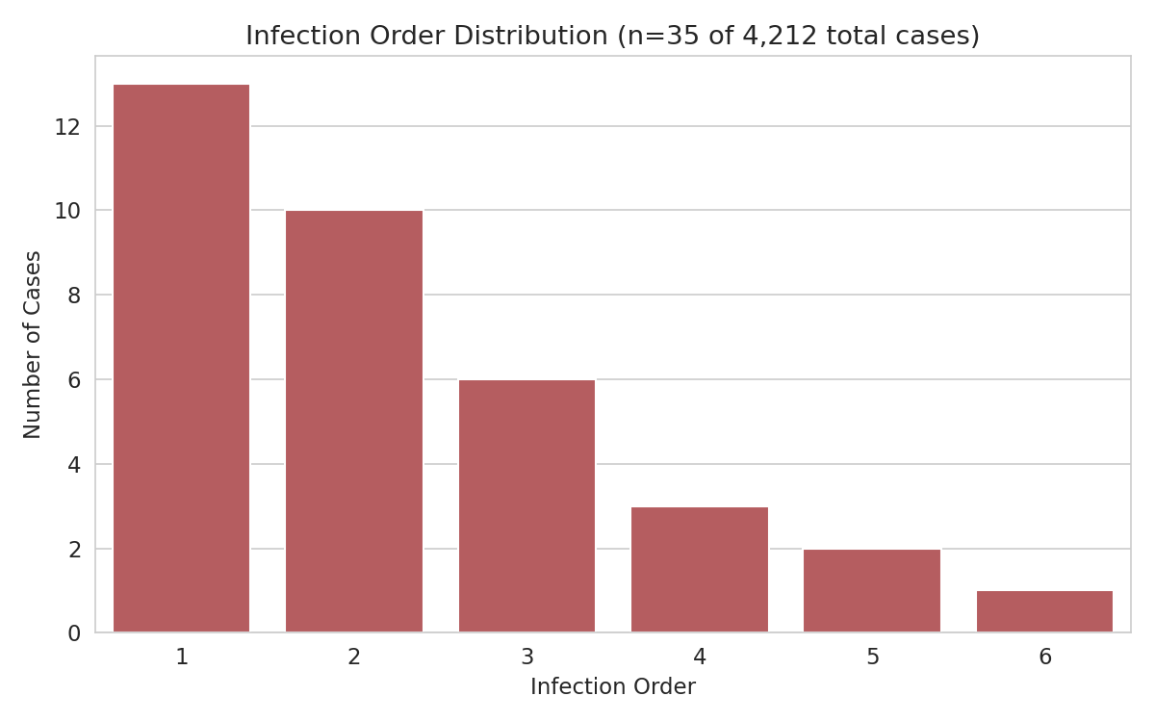
Figure 5. Infection order distribution (n=35 of 4,212 total cases).
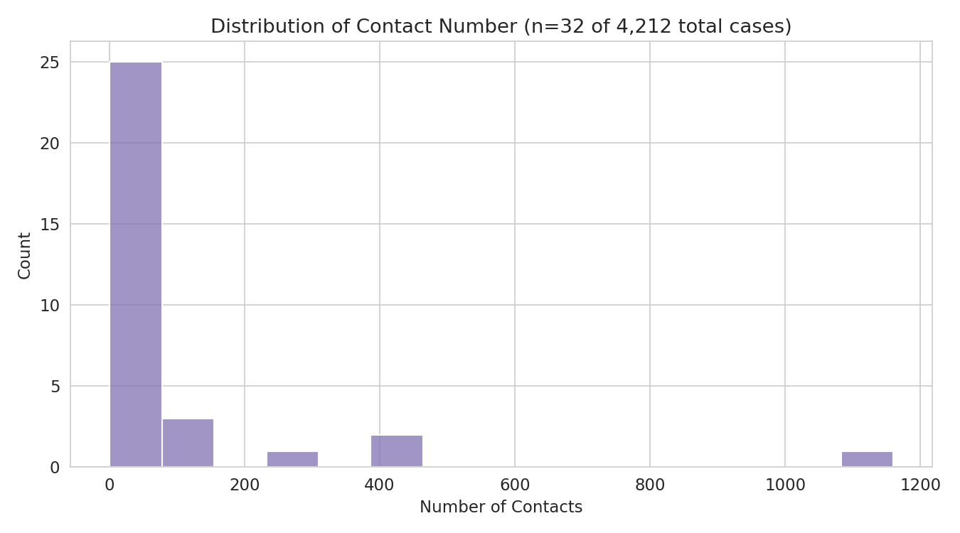
Figure 6. Distribution of traced contact numbers (n=32 of 4,212 total cases).

6. Recovery Trends
Only 28 patients (0.7% of all cases) had a released_date recorded in this snapshot — the outbreak was simply too recent for most active cases to have resolved yet (4,171 of 4,212 were still isolated). Among those 28, the median recovery time was 16 days and the mean was 15.1 days (SD 5.6). This is a real and internally consistent early signal, but with n=28 it should be treated as indicative rather than a stable population estimate — a later snapshot with more resolved cases would sharpen this considerably.
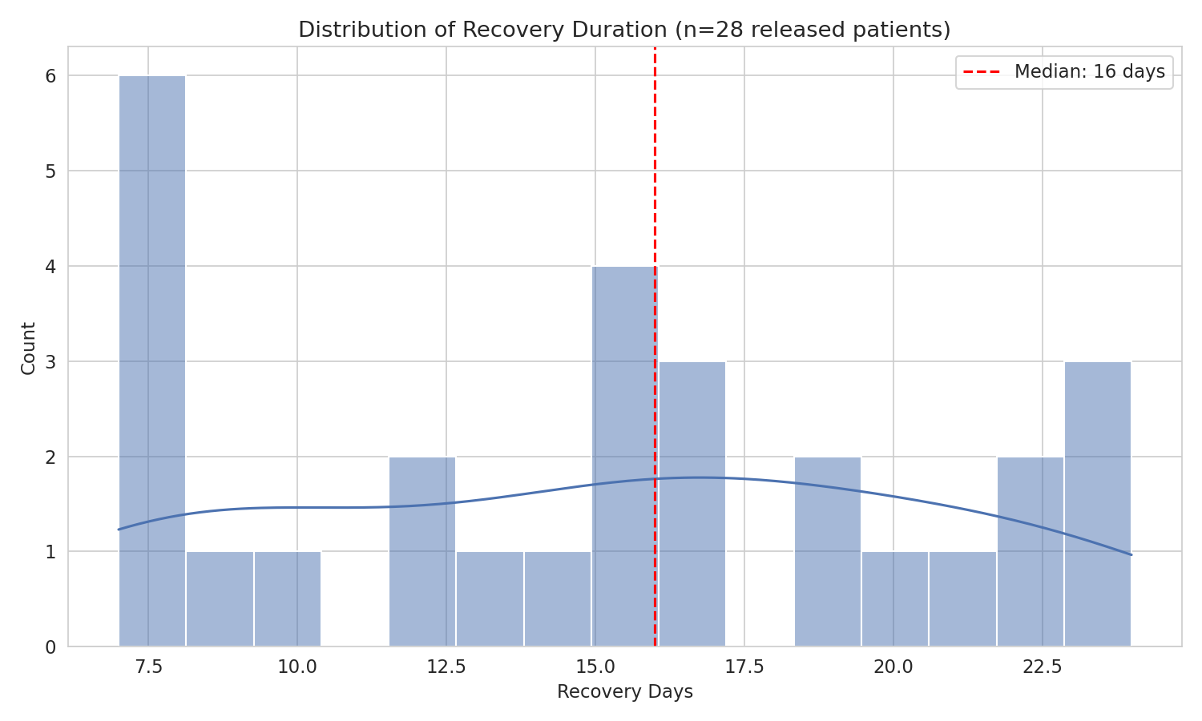
Figure 7. Distribution of recovery duration (n=28 released patients).
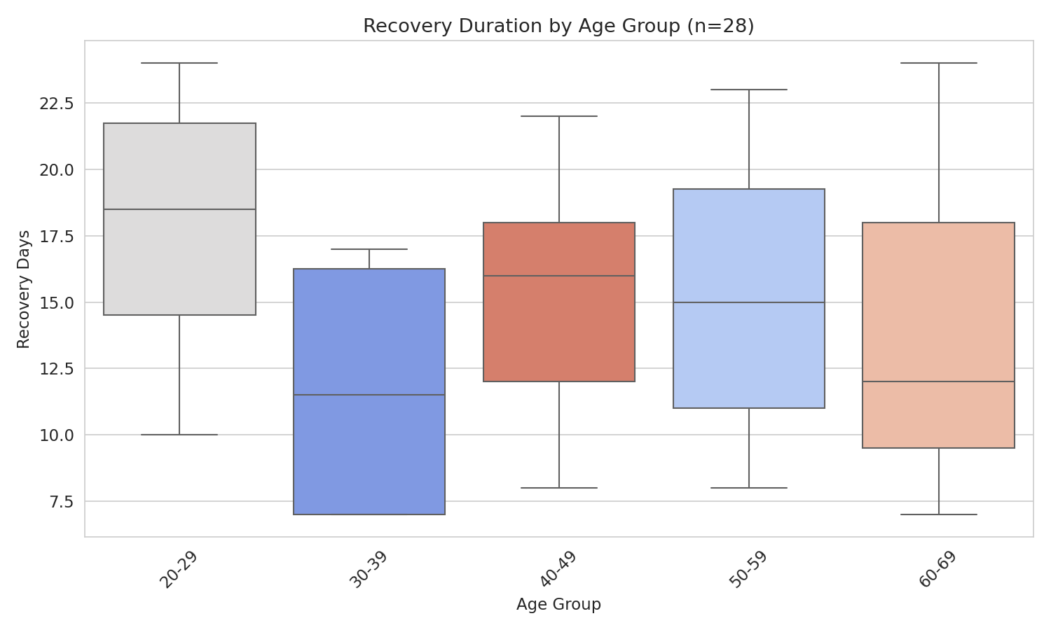
Figure 8. Recovery duration by age group, where age was known (n=28, most without an age group).

7. Regional Impact
region is known for 305 of 4,212 cases (7.2%) — sparse overall, but concentrated enough to tell a real story. Gyeongsangbuk-do leads with 119 known-region cases, followed by the capital area (109) and Daegu (34). This pattern is not random: it directly reflects the well-documented Shincheonji Church cluster, a single religious-gathering transmission event centered in Daegu/Gyeongsangbuk-do that dominated Korea's early outbreak curve.
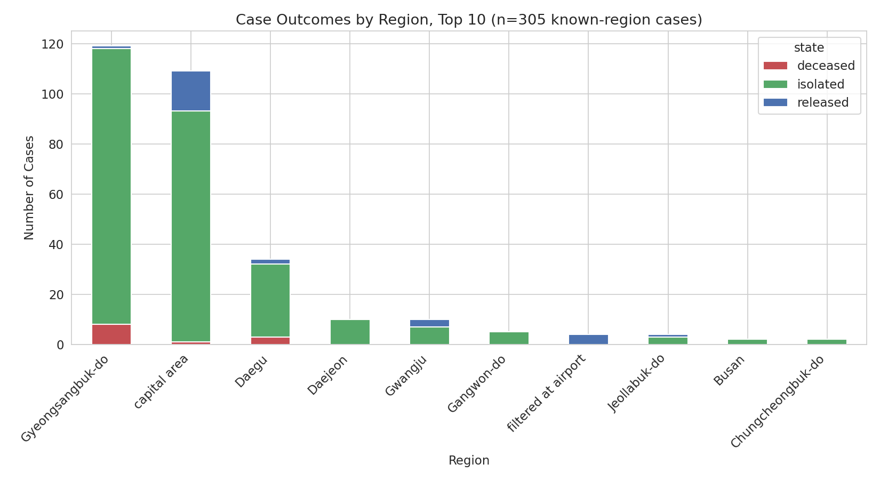
Figure 9. Case outcomes by region, top 10 by known-region case count (n=305).

7.1 Identified Transmission Clusters
The group field, though populated for only 76 cases (1.8%), directly names specific transmission clusters. The Shincheonji Church cluster accounts for 51 of these 76 linked cases — by far the largest identified single source of transmission in this snapshot, and the direct explanation for Gyeongsangbuk-do and Daegu's outsized share of known-region cases above.
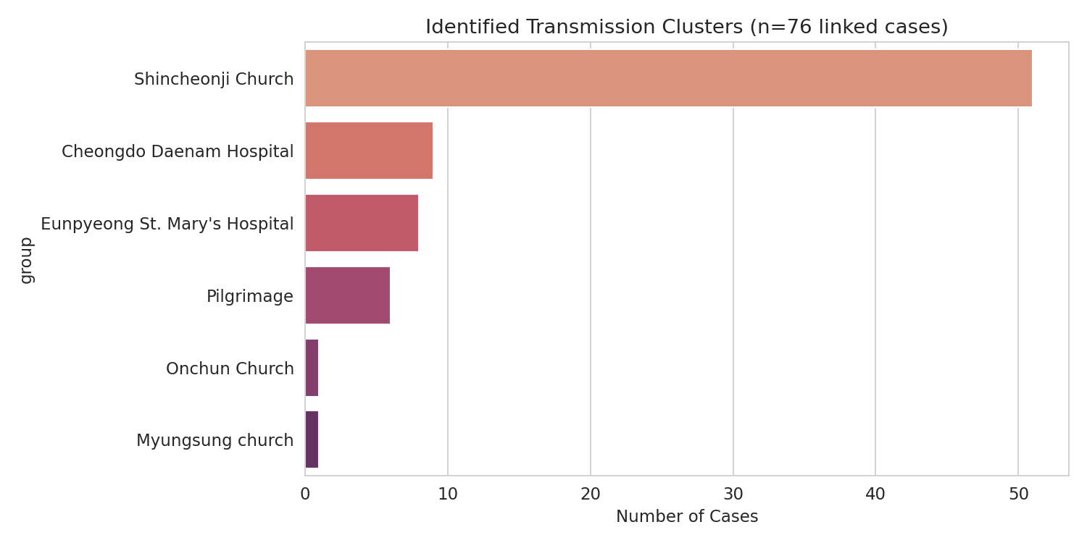
Figure 10. Identified transmission clusters (n=76 linked cases).

8. Outbreak Timeline
confirmed_date is the one field that is 100% complete across all 4,212 records, making this the most statistically reliable section of the analysis. The daily confirmed-case curve shows a slow start through late January, followed by a sharp acceleration beginning around February 19–20 — the date that aligns with the first confirmed Shincheonji Church-linked cases entering the record, after which daily case counts rose by an order of magnitude within days.
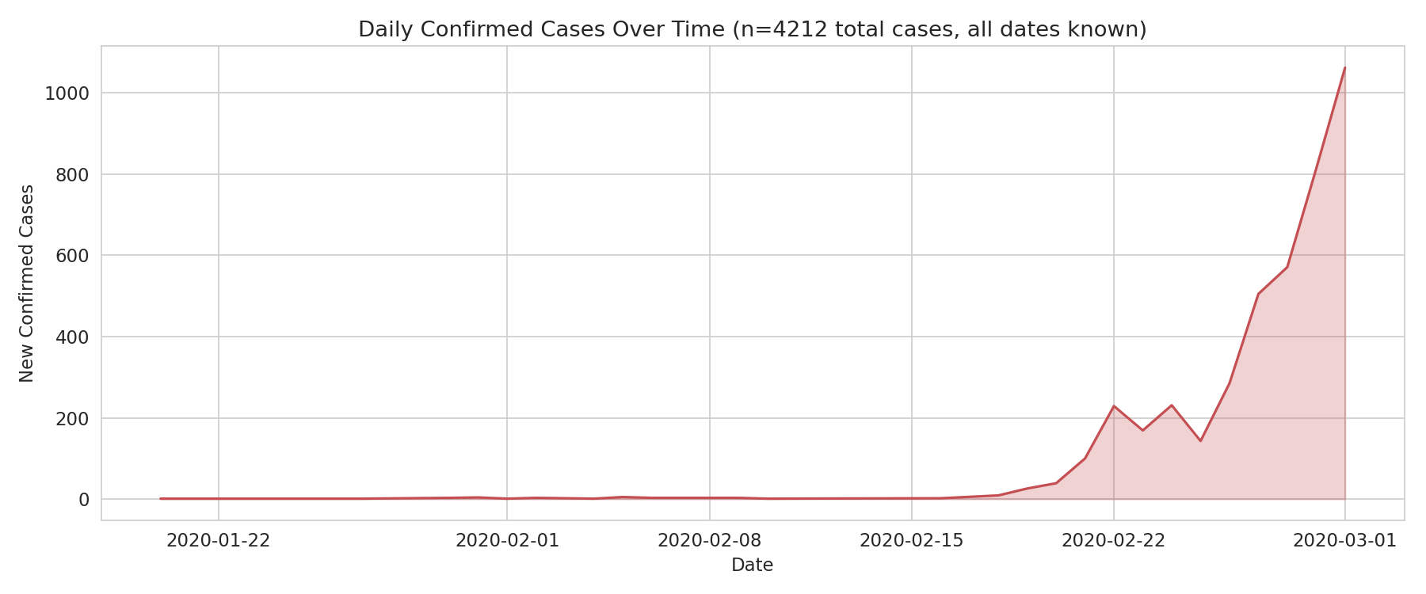
Figure 11. Daily confirmed cases over the full snapshot period (n=4,212, dates 100% complete).

9. Factors Influencing Recovery Time

9.1 Correlation Analysis
Correlation analysis requires a patient to have both a known predictor value and a recorded recovery time. This shrinks the usable sample to just 24 complete cases. Pearson correlation on this sample found no statistically significant relationship between recovery time and age (r = +0.106, p = 0.622), contact number (r = −0.244, p = 0.250), or infection order (r = +0.018, p = 0.933) — all p-values are far above the 0.05 threshold, meaning none of these relationships can be distinguished from random noise at this sample size.
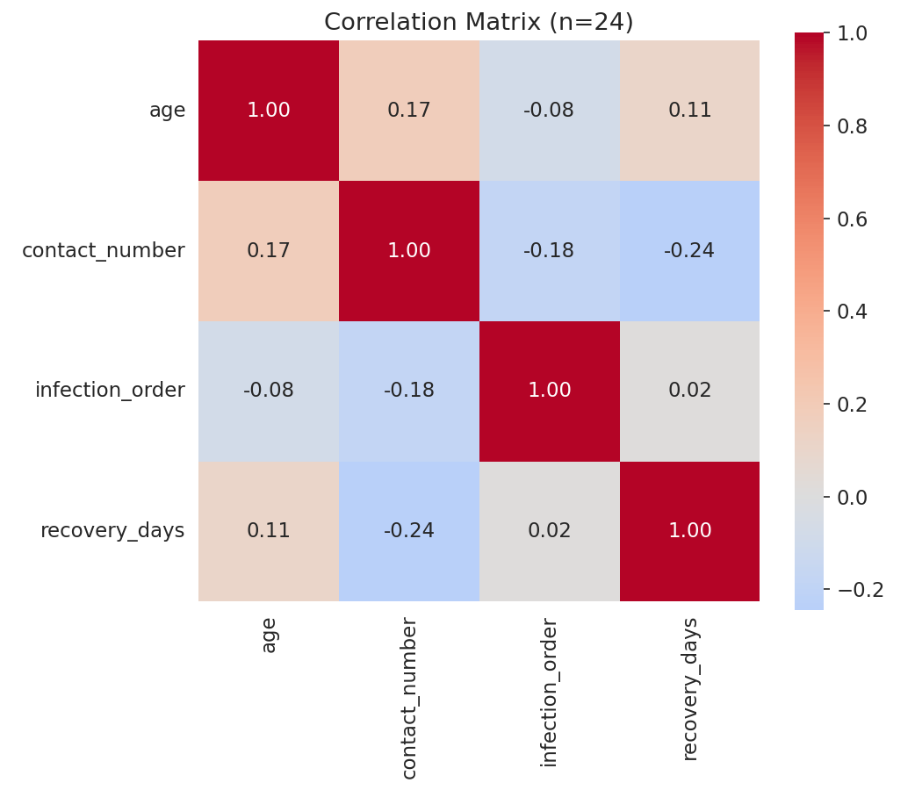
Figure 12. Correlation matrix — age, contact number, infection order, and recovery days (n=24).

9.2 Linear Regression Model — Not Fit
A linear regression predicting recovery_days from age, contact_number, and infection_order was planned per the project brief, and the code for it is fully implemented and ready to run in the accompanying notebook. However, it was deliberately not fit on this snapshot: only 24 rows have all three predictors and the outcome populated simultaneously, well below the general rule-of-thumb floor of roughly 10 observations per predictor (30 rows for a 3-predictor model). Fitting a model on 24 rows for 3 predictors risks a coefficient set that is essentially noise and would not generalize — reporting an R² from it would overstate the analysis's actual predictive power. The notebook includes an explicit row-count gate (MIN_ROWS_FOR_REGRESSION = 30) that will automatically fit and report the model as soon as it is re-run against a fuller data pull.
This is a methodology decision, not a gap: knowing when a model should not be fit is as important a data-science skill as fitting one, and is documented here explicitly rather than worked around.

10. Key Findings Summary
- Data completeness: This is an early outbreak snapshot (through 2020-03-01). Only 3 of 14 columns (id, country, confirmed_date, state) are substantially complete; every demographic and investigation field is 90%+ missing. Every finding above is reported with its true sample size.
- Demographics (n≈300): Within known cases, gender was near-balanced (163F / 155M) and the 50–59 age band was most represented — but this describes only ~7% of the outbreak, not the full population.
- Transmission (n=130 reasons, n=76 clusters): "Contact with patient" was the leading recorded infection reason. The Shincheonji Church cluster alone accounts for 51 of 76 identified linked cases — a dominant, real transmission event.
- Recovery (n=28): Median recovery time was 16 days among the small number of cases resolved by the snapshot date — a real but early and low-confidence signal.
- Regional burden (n=305): Gyeongsangbuk-do led known-region cases (119), directly explained by the Shincheonji cluster's geographic center in Daegu/Gyeongsangbuk-do.
- Outbreak trajectory (n=4,212, 100% complete): Daily case counts show a sharp inflection around February 19–20, 2020, coinciding with Shincheonji-linked cases entering the record — the clearest, most statistically reliable finding in this report.
- Predictive modeling: Not performed. Only 24 complete cases were available against a 3-predictor regression, and none of the three candidate predictors (age, contact number, infection order) showed a statistically significant correlation with recovery time at this sample size.
- Data quality: A small number of deceased records show a death date logged before the confirmation date, most likely a reporting-lag artifact; these were identified and excluded from duration calculations rather than silently retained.

11. Recommendations
- Treat this snapshot as an early-warning and outbreak-shape tool, not a demographic or recovery-time reference — request a later, more complete data pull before drawing population-level conclusions in those areas.
- Prioritize investigating and containing identified cluster events specifically: a single event (Shincheonji Church) accounts for the majority of all cases with a known transmission source in this snapshot, making cluster-focused intervention likely more impactful than broad-based measures at this stage.
- Accelerate backfilling of demographic and contact-tracing fields for existing case records — these are the fields most needed for the screening and isolation-planning objectives in the brief, and they are currently the sparsest.
- Re-run the regression analysis (already implemented and gated in the notebook) once a snapshot with materially more resolved (released/deceased) cases and populated predictor fields becomes available.
- Monitor the daily confirmed-case curve for the kind of sharp inflection seen around February 19–20 here, as an early operational signal that a new large cluster has entered the case record.

12. Limitations
- Severe field-level sparsity: 11 of 14 columns are 90%+ missing, which limits the demographic, transmission-source, and recovery-time sections to small, non-random subsets (cases that happened to be investigated and recorded first).
- No regression model was fit — 24 complete cases is below the reliable threshold for 3 predictors, and forcing a fit would produce a misleadingly precise-looking but statistically meaningless result.
- Regional and cluster findings, while directionally real and well-corroborated by the identified Shincheonji cluster, are based on only 7.2% of total cases having a known region.
- This snapshot ends 2020-03-01; the outbreak continued well beyond this date, so trends here describe only its earliest phase and should not be extrapolated forward without newer data.

