First Meeting |Minutes

## Date *29th August 2017 |* Time allotted *6-7pm* | Venue *SMU SIS GSR 3-5*

|  |  |  |  |  |  |  |  |  |  |  |  |
| --- | --- | --- | --- | --- | --- | --- | --- | --- | --- | --- | --- |
| |  |  | | --- | --- | | Meeting called by | Name: Joel | | Type of meeting | Team Meeting - Planning, Admin & Updates | | Facilitator | Name: Joel | | Note taker | Name: Amanda | | Timekeeper | Name: Ming Xuan and Shreyas | | Attendees: Amanda, Ming Xuan, Joel, Shreyas  Absent: Joleen |

# Agenda topics

## Time allotted | *6-7pm* | Agenda topic *Discussion on Project requirements and iterative approach* | Presenter *Joel*

**Discussion Conversation**

1. We discussed and sieved out important aspects from the project outline.
2. We brainstormed on the User-Interface (UI) of this project and came up with a rough schematic of the UI. (diagram 1.1)
3. We discussed on which iterative approach to use for the project.

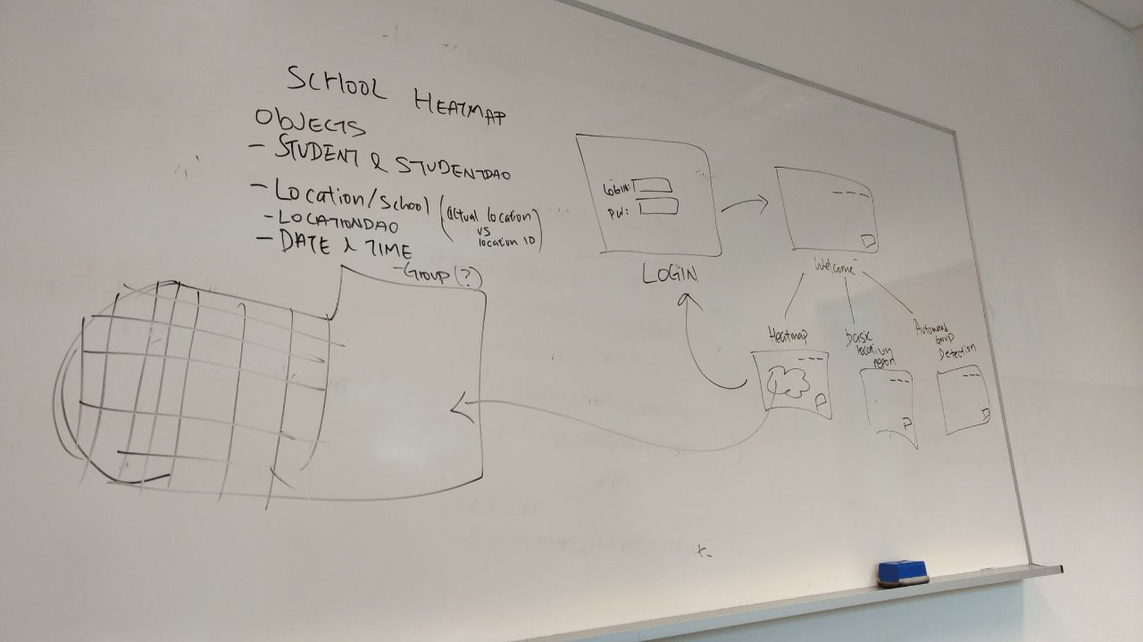

Diagram 1.1

**Conclusion Closing**

1. We decided that our project schedule would be based on iterative time-boxing (Duration to be decided on next meeting).
2. We came to a consensus to have our weekly project meetings to be held every Monday from 3.30pm to 6.45pm.

|  |  |  |
| --- | --- | --- |
| Action items | Person responsible | Deadline |
| Topic 1: Everyone to watch the videos (week 1-5) of Software Engineering before the next meeting. | Joel | 3rd September, 2359 |
| Topic 2: Briefly read up on HTML before the next meeting. | Joel | 3rd September, 2359 |