Second Meeting |Minutes

## Date 1st September 2017 | Time allotted *12.30 - 4.30pm* | Venue *SMU Labs Level 3 Discussion Zone*

|  |  |  |  |  |  |  |  |  |  |  |  |
| --- | --- | --- | --- | --- | --- | --- | --- | --- | --- | --- | --- |
| |  |  | | --- | --- | | Meeting called by | Joel | | Type of meeting | Project Management and Team meeting | | Facilitator | Joel | | Note taker | Ming Xuan | | Timekeeper | Amanda | | **Attendees:**  Joel  Joleen  Amanda  Shreyas  Ming Xuan  **Absent:**  None |
|  |  |

# Agenda topics

## Time allotted | *1230 - 1400* | Agenda topic *Project Use-Case* | Presenter *Joel*

**Discussion Conversation**

1. We attempted to visualise the web-app through breaking down the IS203 wiki.
2. We mapped out a use-case diagram based on the functionalities stated on the IS203 wiki. (Diagram 1)

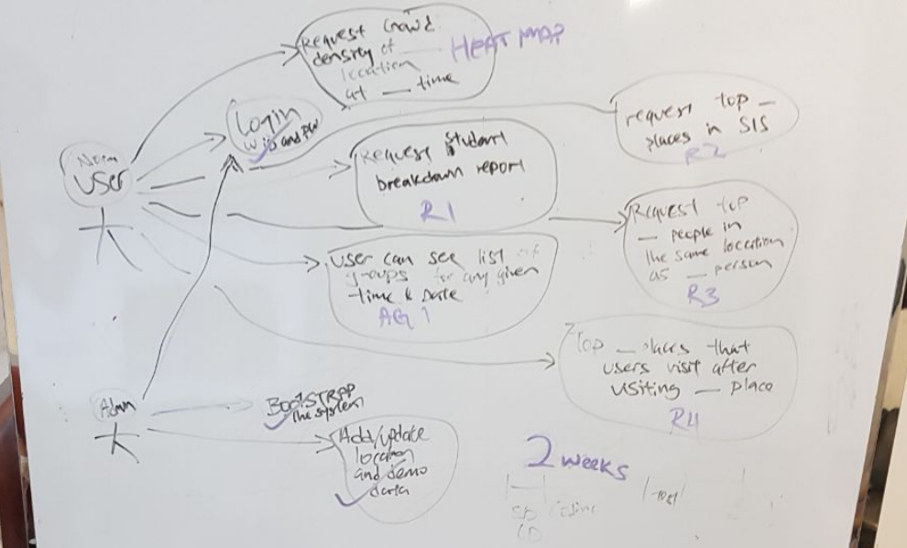

Diagram 1

**Conclusion Closing**

1. Simple and clear use case will help us breakdown detailed functions mapping in our next meeting.

|  |  |  |
| --- | --- | --- |
| Action items | Person responsible | Deadline |
| Mapping out the Use-Case into soft copy document | Ming Xuan | 3 Sept 2359 |

## Time allotted | *1400-1500* | Agenda topic *Broad project iteration scheduling* | Presenter *Joel*

**Discussion Conversation**

1. We mapped out our functionalities into our iterations from week 2 to week 14, giving acronyms to different functionalities help us better identify and breakdown our desired workflow.(Diagram 2)

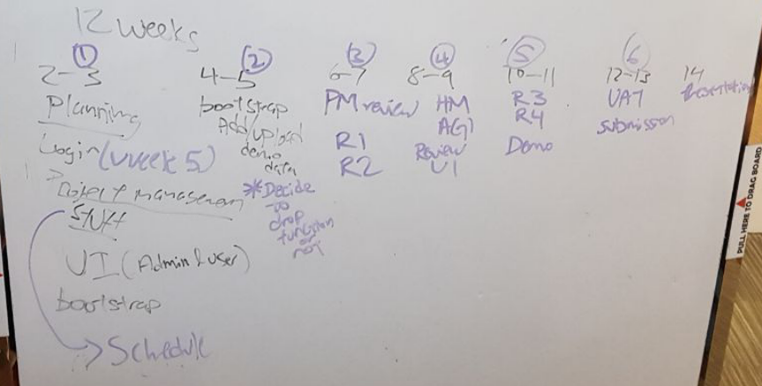

Diagram 2

1. We determined the iterative time box flow to adopt for each iteration.
2. Each iteration will span for 2 weeks.
3. We will follow the flow of documentation, coding, testing and leave a buffer duration of 2 to 3 days for each iteration. This buffer will help the PM to facilitate wrap-up of their own cycle as well as hand-take over to the next member due to be PM. (Diagram 3)

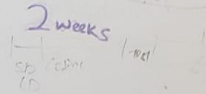

Diagram 3

1. Settled the PM rotation cycle for the entire SE project

|  |  |  |  |  |
| --- | --- | --- | --- | --- |
| Iteration | Week duration | Project Manager | Pair Programming 1 | Pair Programming 2 |
| 1 | 2-3 | Joel | Amanda, Shreyas | Joleen, Ming Xuan |
| 2 | 4-5 | Shreyas | Amanda, Joleen | Ming Xuan, Joel |
| 3 | 6-7 | Amanda | Joel, Joleen | Ming Xuan, Shreyas |
| 4 | 8-9 | Ming Xuan | Joel, Amanda | Shreyas, Joleen |
| 5 | 10-11 | Joleen | Joel, Ming xuan | Shreyas, Amanda |
| 6 | 12-13 | Shreyas | Amanda, Joel | Ming Xuan, Joleen |
| 7 | 14 | Joel | Amanda, Joleen | Shreyas, Ming xuan |

**Conclusion Closing**

1. We will need to come up with a critical path for each iteration to determine how fast we can complete our functionalities.
2. We will review our project progress at the end of week 5 to see if there is a need to drop functionalities after seeking advice from Rajesh or Hong Seng.

|  |  |  |
| --- | --- | --- |
| Action items | Person responsible | Deadline |
| Detailed critical path for each iteration | Joel | 4 Sept 2359 |

## Time allotted | *1500-1530* | Agenda topic *Break* | Presenter *Nil*

## Time allotted | *1530-1630* | Agenda topic *HTML, CSS, JSP sharing* | Presenter *Joel*

**Discussion Conversation**

1. We went through the basic components of HTML page.
2. Briefly touched on how CSS changes the design of our HTML pages and shared with each other some of our past works.
3. We covered how JSP works together with HTML on a webpage.
4. We covered some useful methods and classes that will be used in Java EE7.

**Conclusion Closing**

1. There was an evident knowledge gap on JSP and how it works. We will need to keep up to speed on how JSP works before embarking on Bootstrap as one of our first and important functionality to conquer.

|  |  |  |
| --- | --- | --- |
| Action items | Person responsible | Deadline |
| To familiarise with JSP and how it works on NetBeans IDE | Joel | End of week 3 |
| To familiarise with week 5 JSP videos | Joel | End of week 3 |