Fourth Meeting |Minutes

Date 11th September 2017 | Time allotted *3.30-6.30* | Venue *Library GSR 5-1*

|  |  |  |  |  |  |  |  |  |  |  |  |
| --- | --- | --- | --- | --- | --- | --- | --- | --- | --- | --- | --- |
| |  |  | | --- | --- | | Meeting called by | Joel | | Type of meeting | Design, Team meeting and Project Management | | Facilitator | Joel | | Note taker | Amanda | | Timekeeper | Shreyas | | **Attendees:**  Joel  Joleen  Amanda  Shreyas  Ming Xuan (Left at 4.30pm)  **Absent:**  None |
|  |  |

**Agenda topics**

Time allotted | *1530 - 1615* | Agenda topic *Create database ER diagram* | Presenter *Joel*

**Discussion Conversation**

1. We discussed the entities required for logical diagrams by breaking down the IS203 wiki.
2. Diagram 1: We came up with a draft of the logical diagrams and eventually the Entity Relationship diagrams for the following entities:
   1. Student
   2. Location
   3. Location lookup

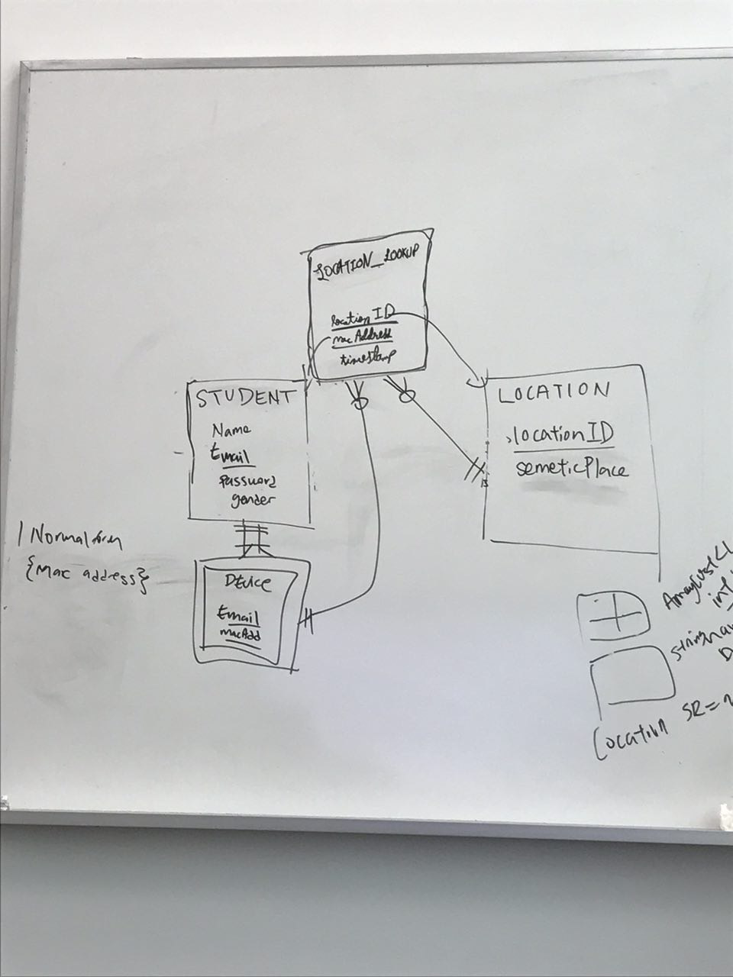

Diagram 1

**Conclusion Closing**

1. By having these diagrams, it gives us the direction and aids us in coming up with our SQL code after we have completed our bootstrap.

|  |  |  |
| --- | --- | --- |
| **Action items** | **Person responsible** | **Deadline** |
| **Mapping out the logical diagram into soft-copy on Visio** | **Shreyas** | **13 Sept 2359** |

Time allotted | *1615-1815* | Agenda topic *HTML, JSP sharing II* | Presenter *Shreyas*

**Discussion Conversation**

1. We went through the basic login function and discussed the linkage between the HTML and JSP for this particular function.
2. We also touched on certain CSS code to beautify the login page, as well as some additional “animation” functions to make the login page more user-friendly.

**Conclusion Closing**

1. Despite being able to understand the logic flow behind the code on how the login page works, we still need to understand and research more on bootstrap in order for us to proceed forward in this project.

|  |  |  |
| --- | --- | --- |
| **Action items** | **Person responsible** | **Deadline** |
| **To familiarise with the week 6 JSP videos** | **Amanda and Joleen** | **End of week 4** |
| **To familiarise with bootstrap** | **Joel and Ming Xuan** | **End of week 4** |

Time allotted | *1815 - 1845*| Agenda topic *Bug Metric Preparation* | Presenter *Shreyas*

**Discussion Conversation**

1. We created a bug metrics excel that will be used to track bugs identified during unit/integration testing.

**Conclusion Closing**

1. All bugs are to be logged in the bug metrics excel file.

Time allotted | *1845 - 1945*| Agenda topic *Test Plan Preparation* | Presenter *Shreyas*

**Discussion Conversation**

1. We went up with an overall test plan document for each functionality in our project.
2. We also created a test cases excel to collate and execute these test cases in each iteration.

**Conclusion Closing**

1. We have to constantly update test plans in each iteration and create test cases for each function at the start of the iteration. Perform the necessary follow up actions if bugs are deemed as critical
2. Fix all bugs during debugging session