Third Meeting|Minutes

## Date | 4/9/2017| *Time* 330 - 630pm | Meeting location *Library GSR 5-1*

|  |  |  |  |  |  |  |  |  |  |  |  |
| --- | --- | --- | --- | --- | --- | --- | --- | --- | --- | --- | --- |
| |  |  | | --- | --- | | Meeting called by | Joel | | Type of meeting | Team meeting, Design | | Facilitator | Joel | | Note taker | Joleen | | Timekeeper | Shreyas | | **Attendees:**  Joel  Joleen  Amanda  Shreyas  Ming Xuan  **Absent:**  None |

# **Agenda topics**

## Time allotted | *1530 - 1630* | Agenda topic *Iteration breakdown*| Presenter *Joel*

**Discussion Conversation**

1. We went through the scope of the project
2. Define coding standards (Eg: Naming convention, Comments, Indentations)
3. Confirm on the documents to submit for SE project and rank them according to how our team will do it. (LD > UC > SEQ> CLASS> CRITICAL)
4. Planned out task for each iteration and specify the milestone we are going to achieve
5. Planned a rough timeline for each iteration of the project
6. Planning design (1.5 days)
7. Coding (3 days)
8. Integration (0.5 days)
9. Testing (1 day)
10. Deployment (1.5 days)

**Conclusion Closing**

1. PM to push team to hit iteration plans.
2. In the event we fall behind of iteration plans, PM to reorganise schedule and notify team of shortfall.
3. PM to decide on probability of speeding up iteration if ahead of schedule.

|  |  |  |
| --- | --- | --- |
| Action items | Person responsible | Deadline |
| Topic 1  Come out with the class diagram of the login function from the draft sequence diagram we have created | Joleen, Ming Xuan | Date | time  11 Sep 2017 |
| Topic 2  Research more on bootstrap | Amanda, Shreyas | Date | time  11 Sep 2017 |

## Time allotted | *1630 - 1715* | Agenda topic *Functionalities breakdown and logic sequence sketching*| Presenter *Joel*

**Discussion Conversation**

1. Came up with usage of the system based on functionalities in use case diagram.
2. Mapped out logic flow in each functionality with reference to requirements stated on IS 203 wiki.

**Conclusion Closing**

1. Logic flow will serve as main point of reference when in doubt.
2. To be changed accordingly should there be logic mismatch when coding application.
3. In the event wiki is updated. Always double check to ensure main logic flow has no disruptive changes.
4. In the event of disruptive change, PM to reorganise and call for emergency meeting to rectify flow.
5. Yet to complete: Heatmap, AGI, 2 basic location reports

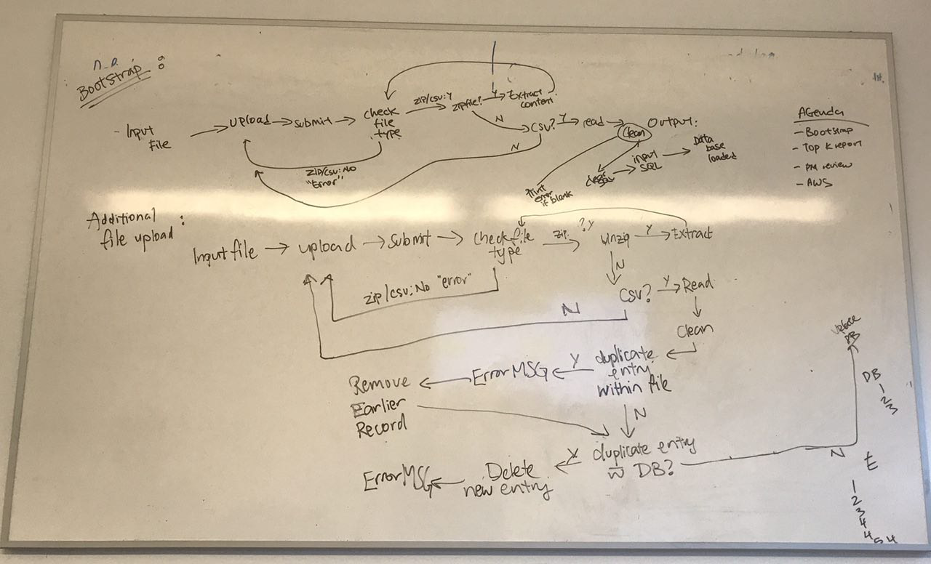

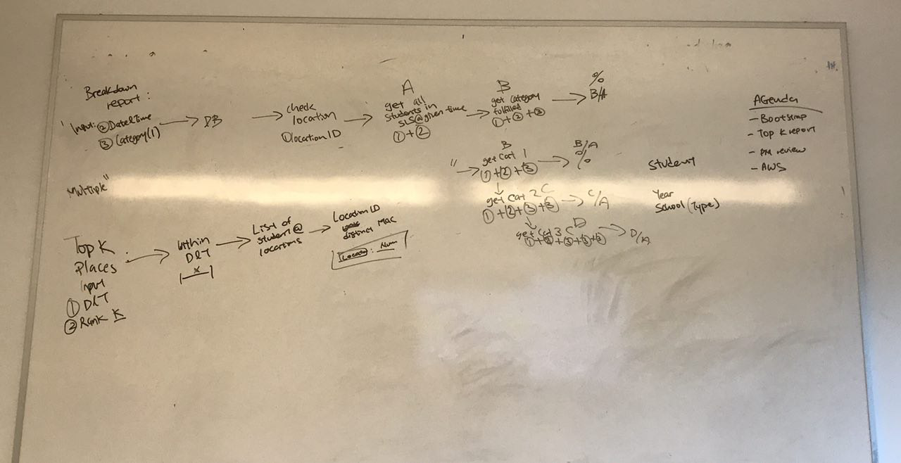

## Time allotted | *1715 - 1815* | Agenda topic *Create basic class diagrams*| Presenter *Joel*

**Discussion Conversation**

1. Mapped out basic class diagrams based on the flow brainstormed.

**Conclusion Closing**

1. Class diagram to follow logic flow of functions and functionalities.
2. To be changed accordingly should there be class mismatch when coding application.
3. In the event wiki is updated. Always double check to ensure class diagram matches logic flow.
4. In the event of mismatch, PM to reorganise and call for emergency meeting to rectify class.

## Time allotted | *1815 - 1900* | Agenda topic *Sequence diagram drawing for Login Feature*| Presenter *Joel*

**Discussion Conversation**

1. Mapped out basic sequence diagram for login feature based on class diagram.
2. Need to double confirm logic for servlet functions.

**Conclusion Closing**

1. Sequence diagram to follow class diagram functions and functionalities.
2. To be changed accordingly should there be sequence mismatch when coding application.
3. In the event wiki is updated. Always double check to ensure sequence diagram matches classes and logic flow.
4. In the event of mismatch, PM to reorganise and call for emergency meeting to rectify sequence diagram.