BRACT’s

Vishwakarma Institute of Technology, Pune

Practical Implementation Sheet

Department: CSE-AI Semester: 5 Academic Year: 2026-27

Division: E Batch: 1 Practical No: 1

Roll no: 11 PRN No: 12413071 Name of Student: Patil Shreyas Prashant

Subject Name : Deep Learning

Problem Statement :
Install and configure TensorFlow/Keras in Google Colab. Perform data preprocessing, normalization, train-test splitting, and data visualization on a sample dataset.

Algorithm :

Algorithm
- Start the program.
- Import the required libraries:
  - TensorFlow
  - Keras
  - NumPy
  - Matplotlib
- Load the MNIST Handwritten Digits dataset.
- Separate the dataset into:
  - Training data
  - Testing data
- Display the dataset information:
  - Number of training images
  - Number of testing images
  - Shape of images
  - Sample labels
- Visualize sample handwritten digit images.
- Normalize the pixel values by dividing each pixel value by 255.
- Create a Sequential Neural Network consisting of:
  - Flatten Layer
  - Hidden Layer 1 (128 neurons, ReLU activation)
  - Hidden Layer 2 (64 neurons, ReLU activation)
  - Output Layer (10 neurons, Softmax activation)
- Compile the model using:
  - Adam Optimizer
  - Sparse Categorical Crossentropy Loss Function
  - Accuracy Metric
- Train the model using the training dataset with a validation split.
- Evaluate the trained model using the testing dataset.
- Predict the class labels for sample test images.
- Display the predicted and actual digit labels.
- Save the trained model in .keras format.
- Stop the program.

Code :

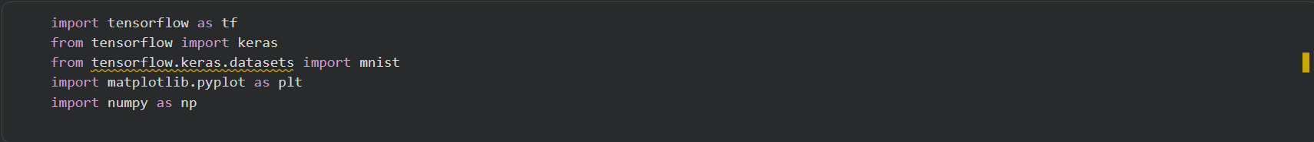
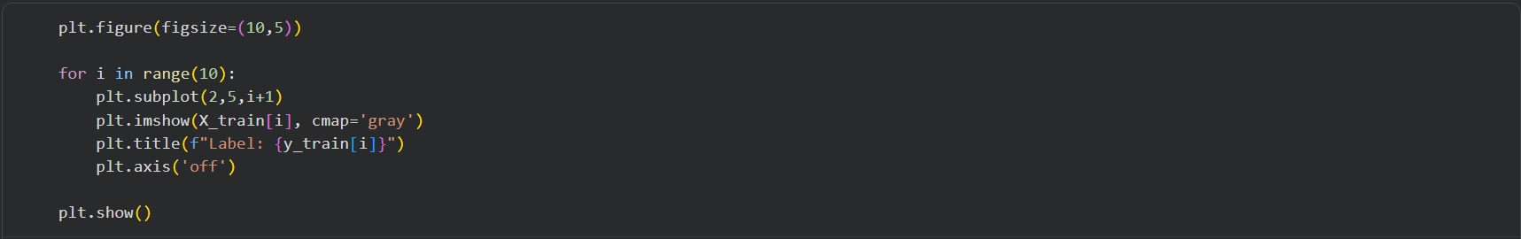
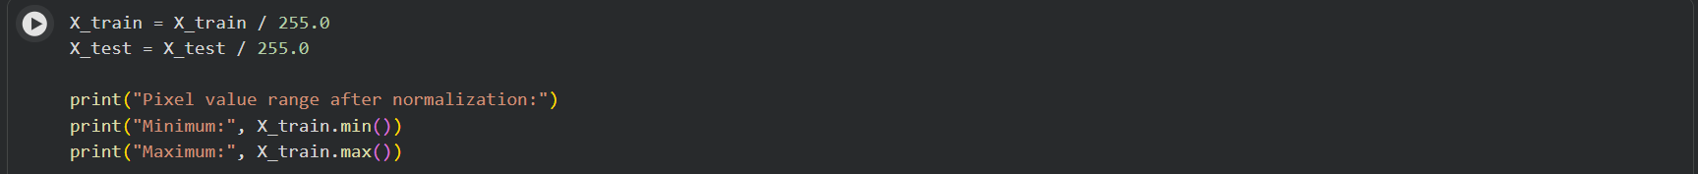
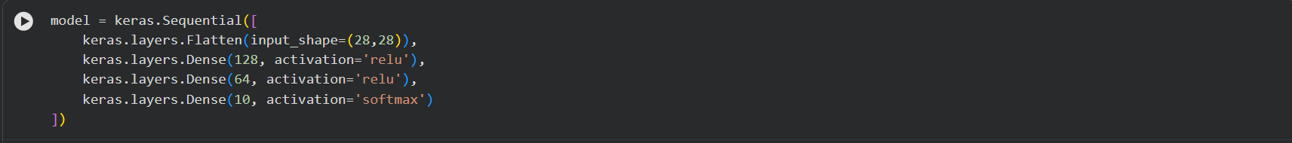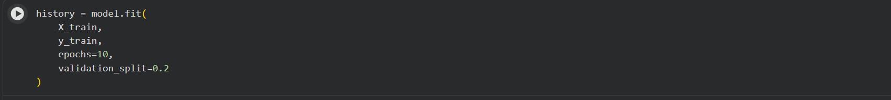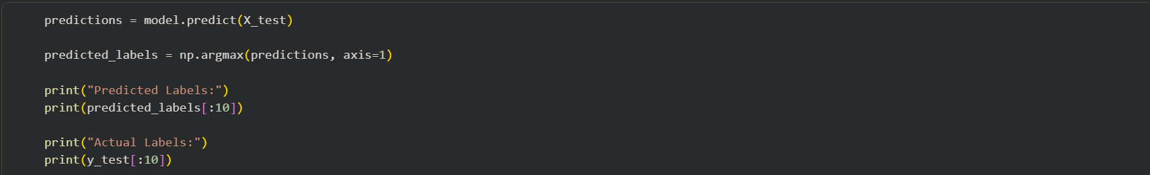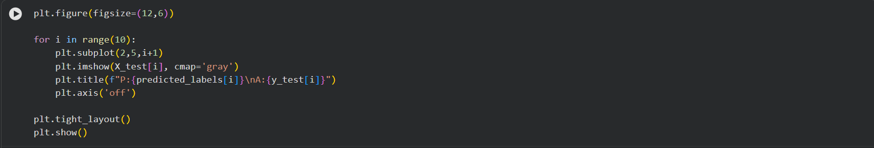

Output :

