BRACT’s

Vishwakarma Institute of Technology, Pune

Practical Implementation Sheet

Department: CSE-AI Semester: 5 Academic Year: 2026-27

Division: E Batch: 1 Practical No: 2

Roll no: 11 PRN No: 12413071 Name of Student: Patil Shreyas Prashant

Subject Name : Deep Learning

Problem Statement :
Design and implement a Multilayer Perceptron (MLP) for classification of the Iris or Wine dataset, and evaluate its performance using accuracy and a confusion matrix.

Algorithm :
- Start the program.

- Import the required libraries:

  - Numpy
  - Matplotlib
  - Pandas
  - Seaborn
  - Scikit-learn
  - TensorFlow/Keras

- Load the Iris dataset (Iris.csv) into a Pandas DataFrame.Separate the dataset into:

  - Training data
  - Testing data

- Display the dataset information such as:

  - Shape of the dataset
  - Column names
  - First five records

- Preprocess the dataset:

  - Remove the Id column (if present).
  - Separate the input features (X) and target labels (y).
  - Convert categorical target labels into numerical values using LabelEncoder.

- Split the dataset into training and testing sets using an 80:20 ratio.
- Normalize the input features using StandardScaler.
- Train the MLP model using the training dataset for 50 epochs with a batch size of 8.
- Evaluate the trained model using the testing dataset.
- Visualize the Confusion Matrix using a heatmap.

Code :
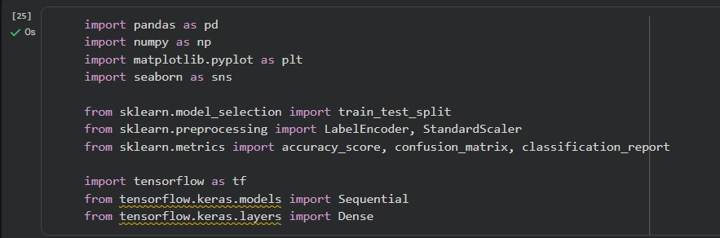
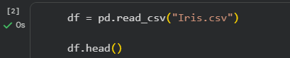
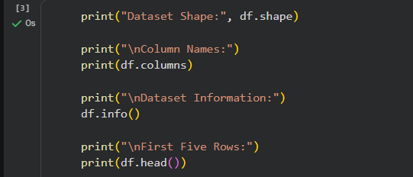

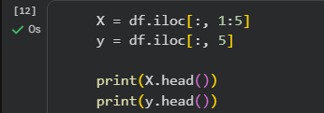
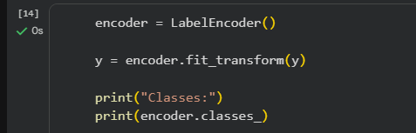

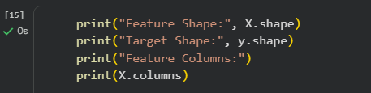

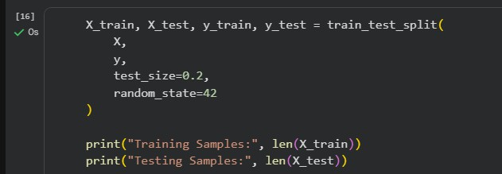

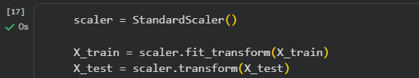
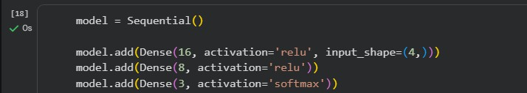
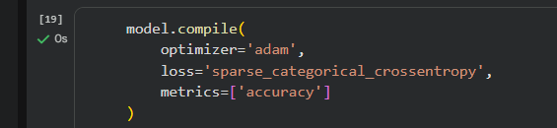
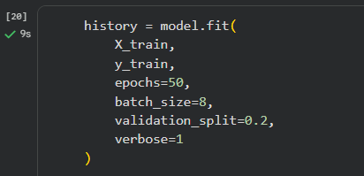
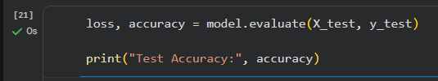

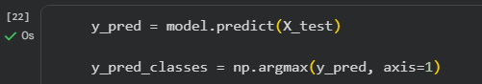

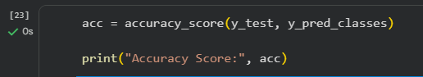
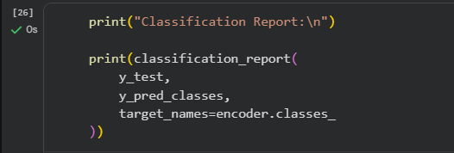
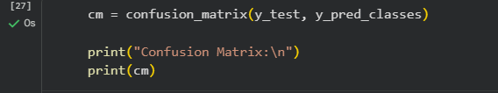
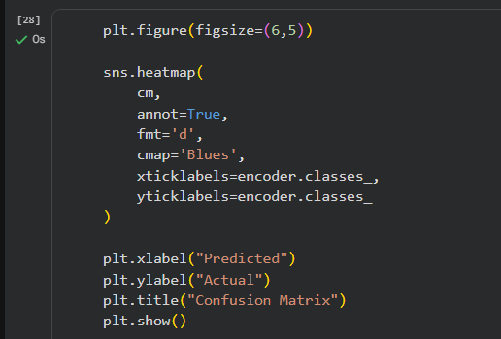
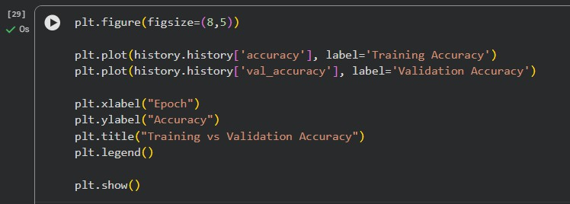

Output :

