Q. Write a C++ program to perform Sequential Search.

#include<iostream>
#include<conio.h>
using namespace std;

int main()
{
int a[10],n,i,x;
int flag=0;
cout<<"Enter 10 elements:\n";
for(i=0;i<10;i++)
{
cin>>a[i];
}
cout<<"\nWhich element you want to search -\n";
cin>>x;
for(i=0;i<10;i++)
{
if(x==a[i])
{
flag=1;
break;
}
}
if(flag==1)
{
cout<<"Number is found.\n";
}
else
{
cout<<"The number is not in this array.\n";
}
return 0;
}

Output –

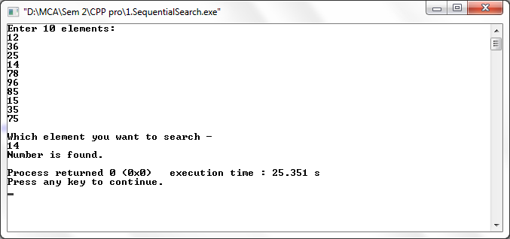

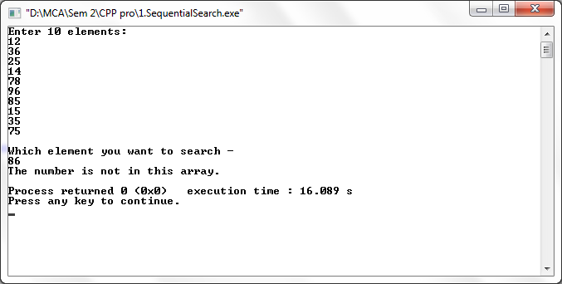

Q. Write a C++ program to perform Binary search.

#include<iostream>
#include<conio.h>

using namespace std;

int main()
{
int i,n,a[10],st=0,ed=9,mid;

cout<<"Enter 10 elements:\n";
for(i=0;i<10;i++)
{
cin>>a[i];
}
cout<<"\nEnter the number you want to search :\n";
cin>>n;

mid=(st+ed)/2;
while(n!=a[mid]&&st<=ed)
{
if(n>a[mid])
st=mid+1;
else
ed=mid-1;
mid=(st+ed)/2;
}
if(n==a[mid])
cout<<"Element found at position "<<mid<<".\n";
if(st>ed)
cout<<"Element not found.\n";
}

Output –

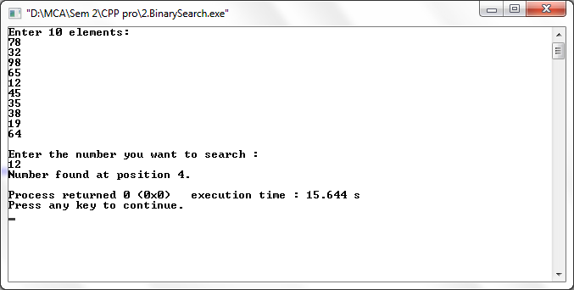

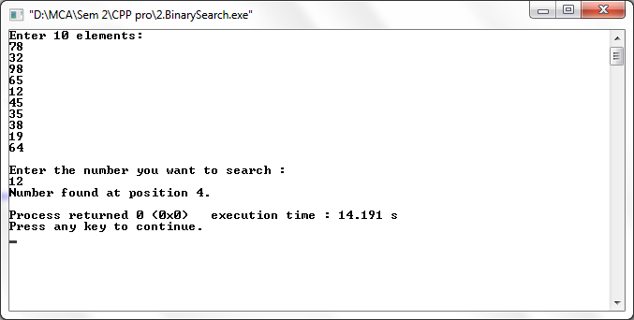

Q. Write a C++ program to perform Selection Sort.

#include<iostream>
using namespace std;
int main()
{
int a[10], i, j, n, temp;
cout<<"Selection Sort\n\n";
cout<<"Enter 10 values :\n";
for(n=0;n<10;n++)
{
cin>>a[n];
}
cout<<"\nBefore Selection sort values :\n";
for(n=0;n<10;n++)
{
cout<<"Iteration "<<n<<"\t"<<a[n]<<"\n";
}
cout<<"\nAfter Selection sort values :\n";

for(i=0;i<=n-1;i++)
{
for(j=i+1;j<=n;j++)
{
if(a[i]>a[j])
{
temp=a[i];
a[i]=a[j];
a[j]=temp;
}
}
cout<<"Iteration "<<i<<"\t"<<a[i]<<"\n";
}
return 0;
}
Output –

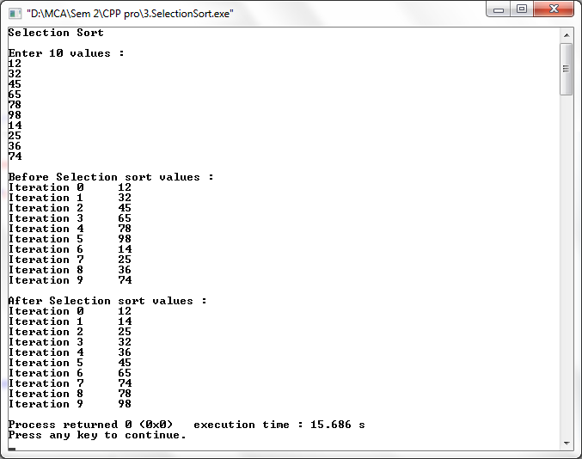

Q. Write a C++ program to perform Bubble Sort.

#include<iostream>
using namespace std;
int main()
{
int a[10], i, j, n, temp;
cout<<"Bubble Sort:\n\n";
cout<<"Enter 10 values :\n";
for(n=0;n<10;n++)
{
cin >> a[n];
}

cout<<"\nBefore Bubble sort values :\n";
for(n=0;n<10;n++)
{
cout<<"Iteration "<<n<<"\t"<<a[n]<<"\n";
}

cout<<"\nAfter Bubble sort values :\n";
for(i=0;i<=n-1;i++)
{
for(j=0;j<=n-i-1;j++)
{
if(a[j]>a[j+1])
{
temp = a[j];
a[j] = a[j+1];
a[j+1] = temp;
}
}
}
for(i=0; i<n;i++)
{
cout<<"Iteration "<<i<<"\t"<<a[i]<<"\n";
}
return 0;
}

Output –

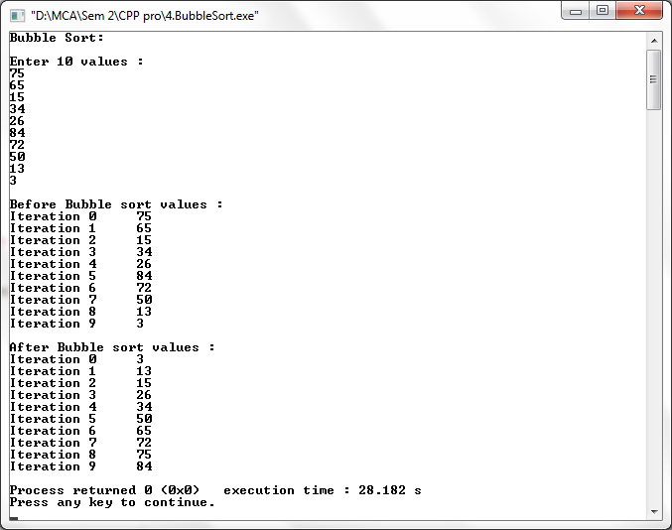

Q. Write a C++ program to perform Insertion Sort.

#include<iostream>
using namespace std;
int main()
{
int a[10], i, j, x;
cout<<"Insertion Sort\n\n";
cout<<"Enter 10 values :\n";
for(i=0;i<10;i++)
{
cin>>a[i];
}

cout<<"\nBefore Insertion sort values :\n";
for(i=0;i<10;i++)
{
cout<<"Iteration "<<i<<"\t"<<a[i]<<"\n";
}

cout<<"\nAfter Insertion sort values :\n";
for(j=1;j<10;j++)
{
x=a[j];
for(i=j-1;i>=0&&x<a[i];i--)
{
a[i+1]=a[i];
}
a[i+1]=x;
}
for(i=0;i<10;i++)
{
cout<<"Iteration "<<i<<"\t"<<a[i]<<"\n";
}
return 0;
}

Output –

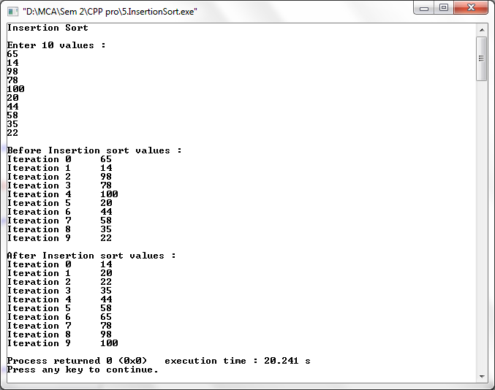
Q. Write a C++ program to perform Merge Sort.

#include<iostream>
using namespace std;
int main()
{
int i;
int j;
int k;
int a[10], b[10],c[25], m, n,l;
cout<<"Merge Sort :\n\n";
cout<<"Enter the size of Array 1 :\n";
cin>>m;
cout<<"Enter values for Array 1 :\n";
for(i=0;i<m;i++)
{
cin>>a[i];
}

cout<<"\nEnter the size of Array 2 :\n";
cin>>n;
cout<<"Enter values for Array 2 :\n";
for(j=0;j<n;j++)
{
cin>>b[j];
}

cout<<"\nBefore Merge sort values :\n";
for(i=0;i<m;i++)
{
cout<<a[i]<<"\n";
}
for(j=0;j<n;j++)
{
cout<<b[j]<<"\n";
}

l=m+n;
i=j=k=0;
while((i<m) && (j<n))
{
if(a[i]<b[j])
{
c[k]=a[i];
i++;
}
else if(a[i]>b[j])
{
c[k]=b[j];
j++;
}
else
{
c[k]=a[i];
i++;
j++;
}
k++;
}
while(i<m)
{
c[k]=a[i];
i++;
k++;
}
while(j<n)
{
c[k]=b[j];
j++;
k++;
}

cout<<"\nAfter Merge sort values :\n";
for(k=0; k<l;k++)
{
cout<<"Iteration "<<k<<"\t"<<c[k]<<"\n";
}
return 0;
}

Output –

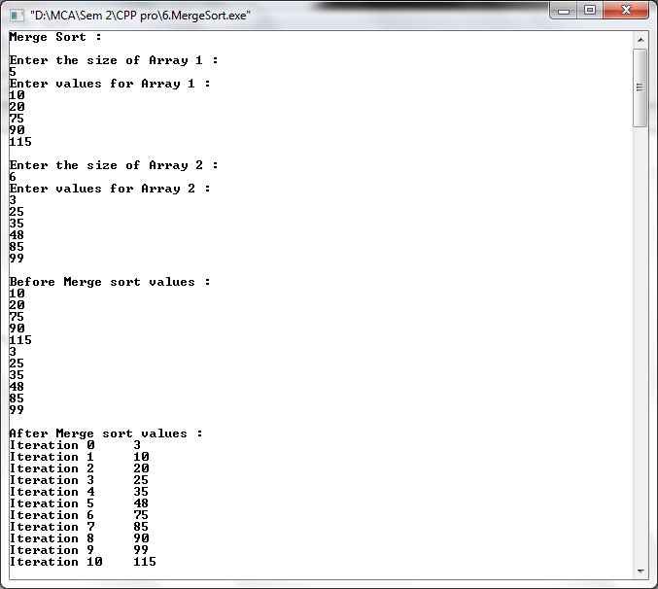

Q. Write a C++ program to perform Quick Sort.

#include<iostream>
using namespace std;
int partition1(int a[], int p,int r);
void quicksort(int a[],int p,int r)
{
int q;
if(p<r)
{
q= partition1(a,p,r);
quicksort(a,p,q-1);
quicksort(a,q+1,r);
}
}
int partition1(int a[],int p, int r)
{
int t,j,k,y,i,x;
x=a[r];
i=p-1;
for(j=p;j<r;j++)
{
if(a[j]<=x)
{
i=i+1;
t=a[i];
a[i]=a[j];
a[j]= t;
}
}
k=a[i+1];
a[i+1]=a[r];
a[r]=k;
y = i+1;
return y;
}

int main()
{

int a[10],i,n;
cout<<"Quick Sort\n\n";
cout<<"Enter the size of Array :\n";
cin>>n;
cout<<"Enter the values :\n";
for(i=0;i<n ;i++)
{
cin>>a[i];
}
cout<<"\nBefore Quick sort values :\n";
for(i=0;i<n;i++)
{
cout<<"Iteration "<<i<<"\t"<<a[i]<<"\n";
}
quicksort(a,0,n);
cout<<"\nAfter Quick sort values :\n";

for(i=0;i<n;i++)
{
cout<<"Iteration "<<i<<"\t"<<a[i]<<"\n";
//cout<<"Iteration "<<i<<""<<a[i]<<"\n";
}
return 0;
}

Output –

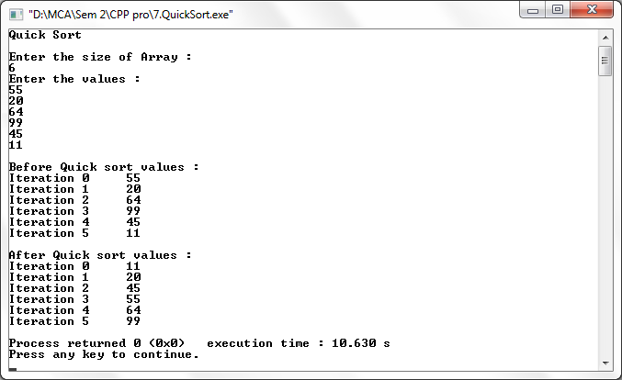

Q. Write a C++ program to perform Radix Sort.

#include<iostream>
#include<conio.h>
using namespace std;
class radix
{
public:
void sort()
{
int arr[6],i,j,k,large,noofpasses=0,temp[10][10],divisor=1,arrcount[10],n;
cout<<"Radix Sort\n\n";
cout<<"Enter the size of Array :\n";
cin>>n;
cout<<"\nEnter values :\n";
for(i=0;i<n;i++)
{
cin>>arr[i];
}
cout<<"\nBefore Radix sort values :\n";
for(i=0;i<n;i++)
{
cout<<"Iteration "<<i<<"\t"<<arr[i]<<"\n";
}
large=arr[0];
for(i=0;i<n;i++)
{
if(arr[i]>large)
large=arr[i];
}
while(large>0)
{
noofpasses++;
large/=10;
}
for(i=0;i<noofpasses;i++)
{
for(j=0;j<10;j++)
arrcount[j]=0;

for(j=0;j<n;j++)
{
k=(arr[j]/divisor)%10;
temp[k][arrcount[k]++]=arr[j];
}
int u=0;
for(int p=0;p<10;p++)
{
for(j=0;j<arrcount[p];j++)
{
arr[u++]=temp[p][j];
divisor*=10;
}
}
}
cout<<"\nAfter Radix sort values :\n";
for(i=0;i<n;i++)
{
cout<<"Iteration "<<i<<"\t"<<arr[i]<<"\n";
}
}
};
int main()
{
radix r;
r.sort();
return 0;
}

Output –

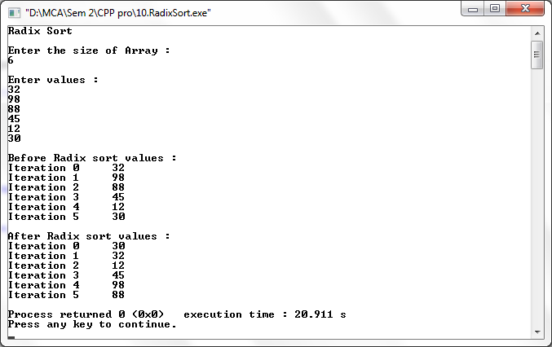

Q. Write a C++ program to perform Shell Sort.

#include<iostream>
using namespace std;
int main()
{
int a[10], i, j, n,temp;
cout<<"Enter values :\n";
for(i=0;i<10;i++)
{
cin>>a[i];
}
cout<<"\nBefore Shell sort values: \n";
for(i=0; i<10; i++)
{
cout<<"Iteration "<<i<<"\t"<<a[i]<<"\n";
}
cout<<"\nAfter Shell sort values: \n";
for(i=10/2;i>0;i/=2)
{
int flag=1;
while(flag==1)
{
flag=0;
for(j=0;j<10-i;j++)
{
if(a[j]>a[j+i])
{
temp=a[j];
a[j]=a[j+i];
a[j+i]=temp;
flag=1;
}
}
}

}
for(i=0;i<10;i++)
{
cout<<"iteration "<<i<<"\t"<<a[i]<<"\n";
}
return 0;
}

Output –

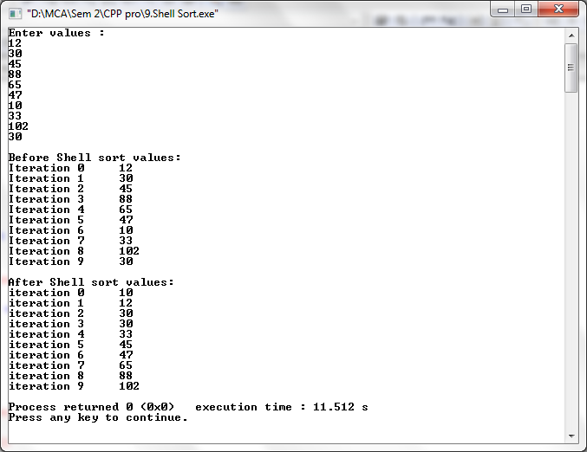

Q. Write a C++ program to perform Stack operations using Array.

#include<iostream>
#define MAX 5
using namespace std;

class stack
{
public:
int top=-1;
int x, stk[5],i;
int push(int x)
{
if(top == MAX - 1)
{
cout<<"Stack Overflow\n\n";
}
else
{
cout<<"Enter the number to push to the stack :\n";
cin>>x;

stk[++top]=x;
stk[top]=x;
}
}

int pop()
{
if(top==-1)
{
cout<<"Stack Underflow\n\n";
}
cout<<"Popped value : ";
x=stk[top];
top--;
cout<<x<<"\n";
}

void display()
{
if(top==-1)
{
cout<<"Stack is empty.\n\n";
}
else
cout<<"Stack :\n";
for(i=top;i>=0;i--)
{
cout<<stk[i]<<"\n";
}
}
};

int main()
{
stack s;
int ch,x;

while(ch!=4)
{
cout<<"1.Push\n2.Pop\n3.Display\n4.Exit\n";
cout<<"Enter the value for operation :\n";
cin>>ch;

switch(ch)
{
case 1:
s.push(x);
break;

case 2:
s.pop();
break;

case 3:
s.display();
break;

case 4:
break;
default:
cout<<"\nWrong choice.\n\n";
}

}
return 0;
}
Output –

Stack Empty

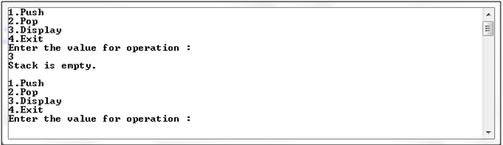

Push operation

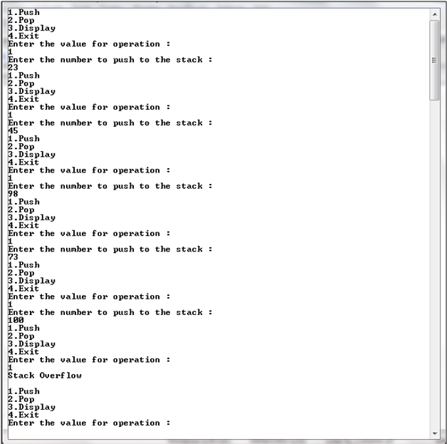
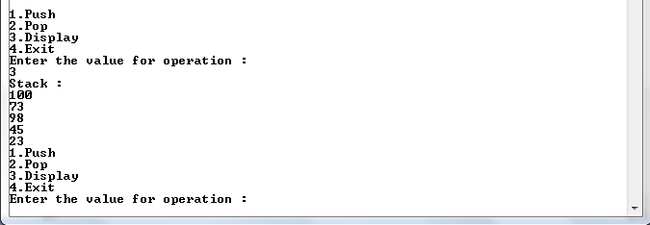

Pop operation

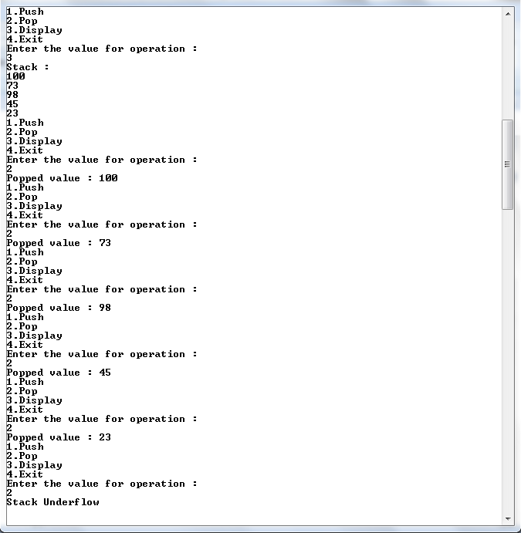

Q. Write a C++ program to perform Stack operations using Link List.

#include<iostream>
using namespace std;
//Creating a NODE Structure
struct node
{
int data;
struct node *next;
};
//Creating a class STACK
class stack
{
public:
struct node *top=NULL;

int push(int x) //to insert an element
{
struct node *ptr;
ptr=new node;
ptr->data=x;
ptr->next=NULL;
if(top!=NULL)
ptr->next=top;
top=ptr;
}
void pop() //to delete an element
{
struct node *temp;
if(top==NULL)
{
cout<<"\nStack is empty.\n";
}
else
{
temp=top;
top=top->next;
cout<<"Popped value : "<<temp->data<<"\n";
delete temp;
}
}
void display() //to show the stack
{
struct node *ptr1=top;
if(top==NULL)
{
cout<<"Stack is empty.\n\n";
}
else
{
cout<<"Stack :\n";
while(ptr1!=NULL)
{
cout<<ptr1->data<<"\n";
ptr1=ptr1->next;
}
}
}
};

int main()
{
stack s;
int ch,x;
while(ch!=4)
{
cout<<"1.Push\n2.Pop\n3.Display\n4.Exit\n";
cout<<"Enter the value for operation :\n";
cin>>ch;
switch(ch)
{
case 1:
cout<<"Enter the value :\n";
cin>>x;
s.push(x);
break;
case 2:
s.pop();
break;
case 3:
s.display();
break;
case 4:
break;
default:
cout<<"\nWrong choice.\n\n";

}
}
return 0;
}

Output –

Stack Empty

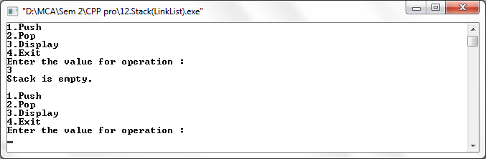

Push operation

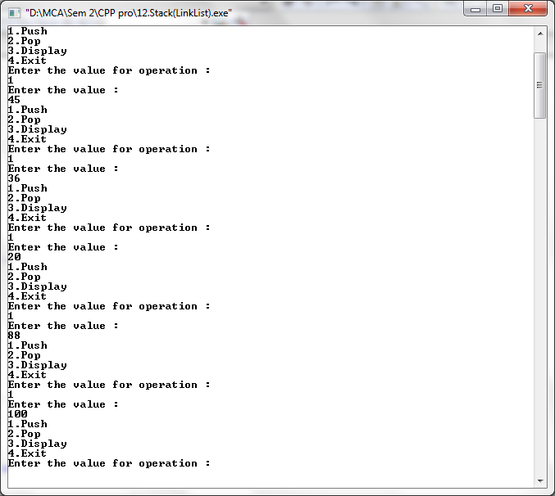

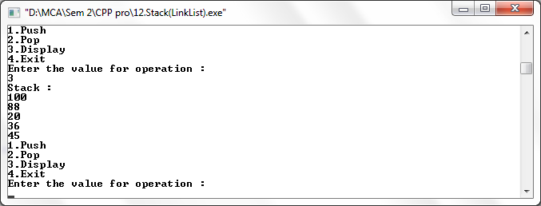

Pop operation

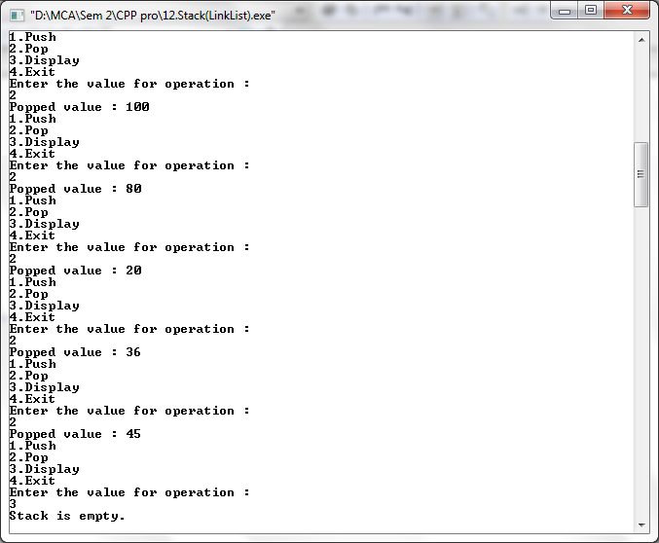

Q. Write a C++ program to perform Stack operations for balancing of parenthesis.

#include<iostream>
#include<string.h>
#include<conio.h>
using namespace std;

struct node
{
int data;
struct node *next;
};
struct node *tmp=NULL;
struct node *tmp1=NULL;
struct node *top=NULL;
struct node *ptr=NULL;
int push(char x)
{
tmp = new node;
tmp->data=x;
tmp->next=NULL;
if(top == NULL)
{
top=tmp;
}
else
{
tmp1=top;
top=tmp;
tmp->next=tmp1;
}
}

char pop()
{
if(top==NULL)
{
cout<<"Stack is empty.\n";
}
else
{
ptr=top;
top=top->next;
return(ptr->data);
delete(ptr);
}
}

int main()
{
int len,i;
char c,d,e;
char a[30];
cout<<"Enter expression :\n";
cin>>a;
len=strlen(a);

for(i=0;i<len;i++)
{
if(a[i]=='{' || a[i]=='[' || a[i]=='(')
{
push(a[i]);
}
else
{
switch(a[i])
{
case ')':
c=pop();
if(c=='{' || c=='[')
{
cout<<"Invalid";
getch();
}
break;

case ']':
d=pop();
if(d=='{' || d=='(')
{
cout<<"Invalid";
getch();
}
break;

case '}':
e=pop();
if(e=='(' || e=='[')
{
cout<<"Invalid";
getch();
}
break;
default:
cout<<"Enter the correct choice";
getch();
}
}
}
if(top==NULL)
cout<<"Balanced\n";
else
cout<<"Unbalanced\n";
getch();
return 0;
}

Output –

Balanced

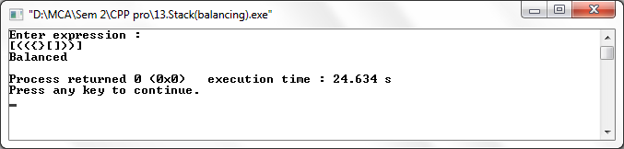

Unbalanced

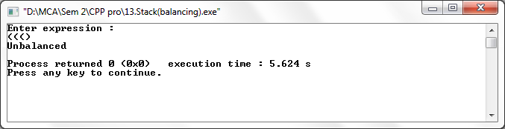

Q. Write a C++ program to perform Priority Queue.

#include<iostream>
using namespace std;

class priority
{
public:
struct node
{
int pr;
int data;
struct node *next;
};
node *front=NULL;

void insert(int item, int pr)
{
node *tmp, *q;
tmp=new node;
tmp->data=item;
tmp->pr=pr;
if(front==NULL || pr < front->pr)
{
tmp->next=front;
front=tmp;
}
else
{
q=front;
while(q->next!=NULL && q->next->pr<=pr)
q=q->next;

tmp->next = q-> next;
q->next=tmp;
}
}

void del()
{
node *tmp,*q;
if(front==NULL)
cout<<"Queue is Empty";
else
{
tmp=front;
cout<<tmp->data<<" is deleted \n";
front=front->next;
}
}

void display()
{
if(front==NULL)
{
cout<<"Queue is Empty.\n\n";
}
else
{
node *ptr;
ptr=front;
cout<<"Item\t"<<"Priority\n";
while(ptr!=NULL)
{
cout<<ptr->data<<"\t";
cout<<ptr->pr<<"\t";
cout<<"\n";
ptr=ptr->next;
}
}
}
};

int main()
{
priority p;
int ch,x,y;

while(ch!=0)
{
cout<<"1.Insert\n2.Delete\n3.Display\n";
cout<<"Enter the choice :\n";
cin>>ch;
switch(ch)
{
case 1:
cout<<"Enter the Item :\n";
cin>>x;
cout<<"Enter the Priority :\n";
cin>>y;
p.insert(x,y);
break;
case 2:
p.del();
break;
case 3:
p.display();
break;
default:
cout<<"Enter the correct choice";
break;
}

}
return 0;
}

Output –

Queue is empty

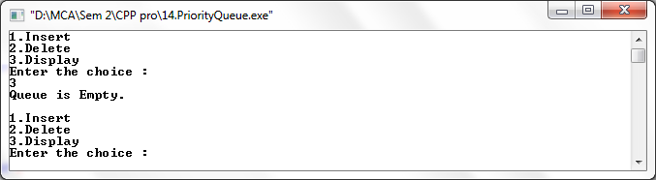

Insert

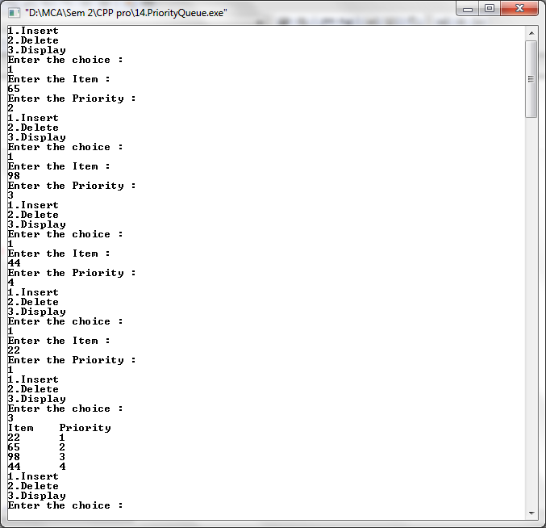

Delete

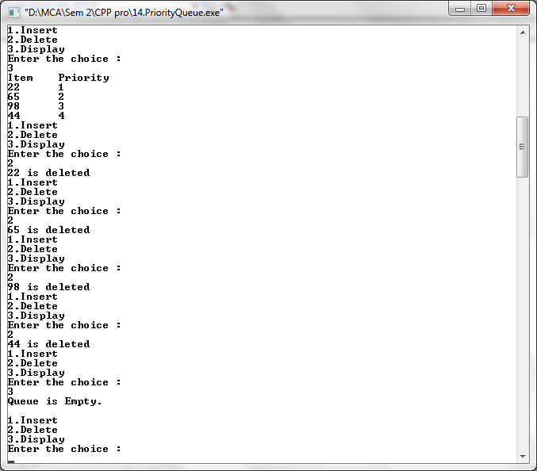

Q. Write a C++ program to perform Queue using Array.

#include<iostream>
#include<conio.h>
#include<stdlib.h>
using namespace std;
class queue
{
public:
int q[4],x,result;
int front=-1;
int rear=-1;
int maxsize=4;
void enqueue(int x)
{
if(rear==maxsize-1)
{
cout<<"Queue full.\n\n";
}
else
{
rear++;
q[rear]=x;
}
}
void dequeue()
{
if(rear==-1)
{
cout<<"Queue empty.\n\n";
}
else
{
cout<<"Deleted.\n";
if(front==rear)
{
front=-1;
rear=-1;
}
else
{
x=q[front];
front++;
}
}
}
void display()
{
if(rear==-1)
{
cout<<"Queue empty.\n\n";
}
else
{
cout<<"Queue :\n";
for(int i=front+1;i<=rear;i++)
{
cout<<q[i]<<"\n";
}
}
}
};

int main()
{
int ch,x;
queue q;
do
{
cout<<"1.Enqueue\n2.Dequeue\n3.Display\n4.Exit\n";
cout<<"Enter your choice :\n";
cin>>ch;
switch(ch)
{
case 1:
cout<<"Enter the value :\n";
cin>>x;
q.enqueue(x);

break;
case 2:
q.dequeue();
break;
case 3:
q.display();
break;
case 4:
break;
default:
cout<<"\nInvalid choice!!\n";
}
}
while(ch<4);
return 0;
}

Output –

Queue Empty

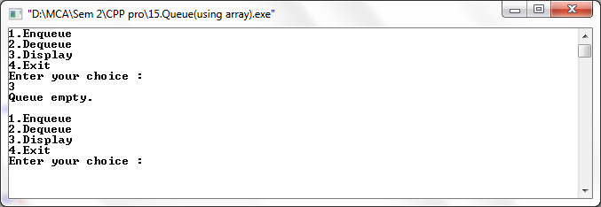

Insert

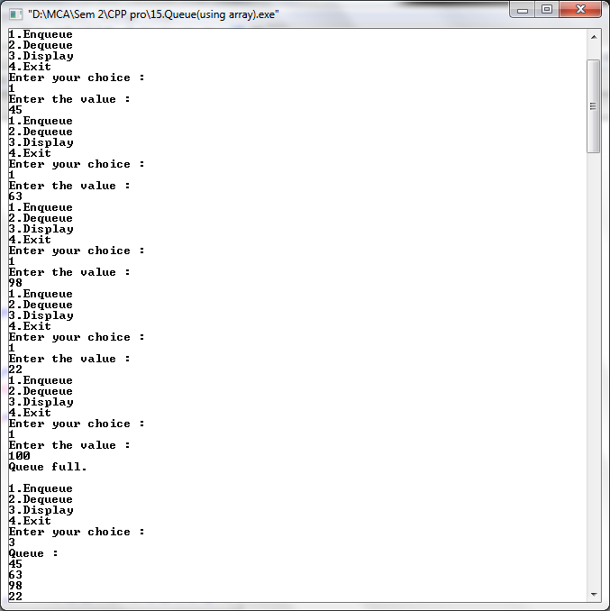
Delete

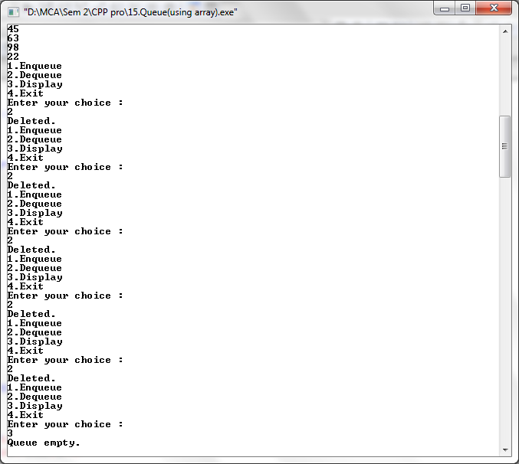

Q. Write a C++ program to perform Queue using Link List.

#include<iostream>
using namespace std;
class linkqueue
{
public:
struct node
{
int data;
struct node *next;
};
node *front = NULL;
node *rear = NULL;
void enqueue(int x)
{
node *tmp, *q;
tmp=new node;
tmp->data=x;
tmp->next=NULL;
if(front==NULL && rear==NULL)
{
front=rear=tmp;
}
else
{
rear->next=tmp;
rear=tmp;

}
}
void dequeue()
{
struct node *tmp=front;
if(front==NULL)
{
cout<<"Queue is empty\n\n";
}
cout<<"Deleted\n";
if(front==rear)
{
front=rear=NULL;
}
else
{
front=front->next;
}
}
void display()
{
if(front==NULL)
{
cout<<"Queue is empty.\n\n";
}
else
{
node *ptr;
ptr=front;
cout<<"Queue :\n";
while(ptr!=NULL)
{
cout<<ptr->data<<"\t";
cout<<"\n";
ptr=ptr->next;
}
}
}
};

int main()
{
linkqueue q;
int ch,x,n;
do
{
cout<<"1.Enqueue\n2.Dequeue\n3.Display\n4.Exit\n";
cout<<"Enter the value for operation :\n";
cin>>ch;
switch(ch)
{
case 1:
cout<<"Enter the value :\n";
cin>>x;
q.enqueue(x);
break;
case 2:
q.dequeue();
break;
case 3:
q.display();
break;
case 4:
break;
default:
cout<<"\nWrong choice.\n\n";
}
}
while(n!=4);
return 0;
}

Output –

Queue Empty

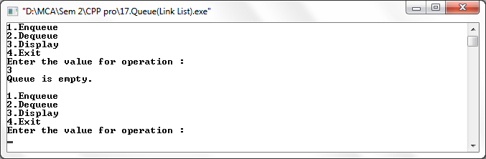

Insert

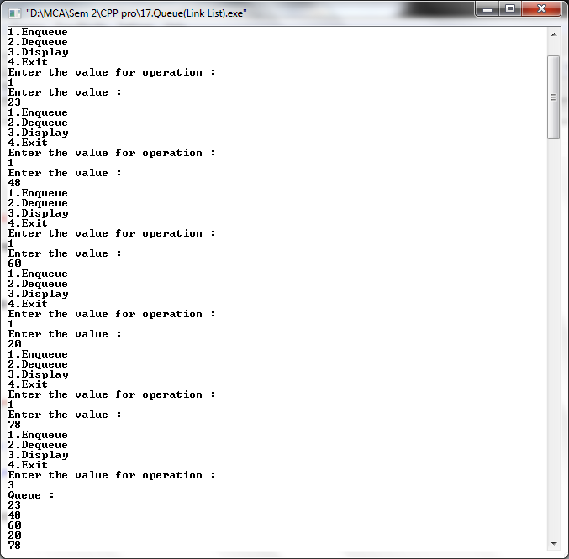

Delete

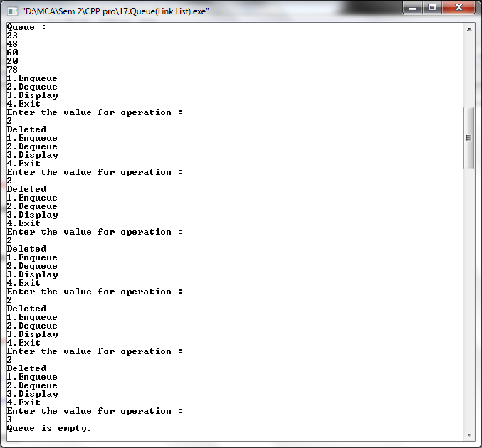

Q. Write a C++ program to perform Singly Linked List.

#include<iostream>
using namespace std;
class linklist
{
public:
int flag=true;
int pos, i, value, count=0;
struct node
{
int data;
struct node *next;
};
struct node *tmp=NULL;
struct node *tmp1=NULL;
struct node *start=NULL;
struct node *p=NULL;
struct node *ptr=NULL;
struct node *ptr1=NULL;
struct node *ptr2=NULL;
struct node *ptr3=NULL;

int insert_at_beg(int x)
{
tmp = new node;
tmp->data=x;
tmp->next=NULL;
if(start == NULL)
{
start=tmp;
start->next=NULL;
}
else
{
tmp1=start;
start=tmp;
start->next=tmp1;
}
}

int insert_at_end(int x)
{
tmp = new node;
tmp->data=x;
tmp->next=NULL;
p=start;
while(p->next!=NULL)
{
p=p->next;
}
p->next=tmp;
tmp->next=NULL;
}

int insert_at_pos(int x)
{
cout<<"Insert the position :\n";
cin>>pos;
tmp = new node;
tmp->data=x;
tmp->next=NULL;
p=start;
while(p!=NULL)
{
p=p->next;
count++;
}
if(pos==1)
{
start=tmp;
start->next=NULL;
}
else if(pos > 1 && pos<count)
{
p=start;
for(i=1;i<pos;i++)
{
ptr=p;
p=p->next;
}

ptr->next=tmp;
tmp->next=p;
}
else
{
cout<<"Invalid position.\n";
}
}

int search_pos()
{
cout<<"Insert the value:\n";
cin>>value;
count=0;
flag=false;
if(start==NULL)
{
cout<<"List is empty\n";
}
else
{
p=start;
while(p!=NULL)
{
count++;
if(p->data == value)
{
flag==true;
cout<<"Value found at "<<count<<"
position.\n";
}
p=p->next;
}
}
}

void del()
{
cout<<"Delete the position:\n";
cin>>pos;
if(start==NULL)
{
cout<<"List is empty.\n";
}
else
{
if(pos==1)
{
tmp=start;
start=start->next;
delete (tmp);
}
else
{
while(p!=NULL)
{
count++;
p=p->next;
}
}
if(pos>1 && pos<count)
{
p=start;
for(i=1;i<pos;i++)
{
ptr=p;
p=p->next;
}
ptr->next=p->next;
}
}
}
int sort()
{
int x;
if(start==NULL)
{
cout<<"List is empty.\n";
}
ptr=start;
while(ptr!=NULL)
{
for(p=ptr->next;p!=NULL;p=p->next)
{
if(ptr->data>p->data)
{
x=ptr->data;
ptr->data=p->data;
p->data=x;
}
}
ptr=ptr->next;
}
}
int rev()
{
if(start==NULL)
{
cout<<"List is empty.\n";
}
if(start->next==NULL)
{
cout<<"only one.\n";
}
ptr1=start;
ptr2=ptr1->next;
ptr3=ptr2->next;
ptr1->next=NULL;
ptr2->next=ptr1;
while(ptr3!=NULL)
{
ptr1=ptr2;
ptr2=ptr3;
ptr3=ptr3->next;
ptr2->next=ptr1;
}
start=ptr2;
}
void display()
{
if(start==NULL)
{
cout<<"List is empty.\n";
}
else
{
p=start;
cout<<"\nSingly Linked List :\n";
while(p!=NULL)
{
cout<< p->data<<" -> ";
p=p->next;
}
cout<<"\n";
}
}
};
int main()
{
linklist l;
int ch,x;

while(ch!=0)
{
cout<<"\n1.Insert at beginning\n2.Insert at end\n3.Insert at position\n4.Delete\n5.Search\n6.Display\n7.Sort\n8.Reverse\n9.Exit";
cout<<"\nEnter the choice:\n";
cin>>ch;
switch(ch)
{
case 1:
cout<<"Enter the value\n";
cin>>x;
l.insert_at_beg(x);
l.display();
break;

case 2:
cout<<"Enter the value\n";
cin>>x;
l.insert_at_end(x);
l.display();
break;

case 3:
cout<<"Enter the value\n";
cin>>x;
l.insert_at_pos(x);
l.display();
break;

case 4:
l.del();
l.display();
break;

case 5:
l.search_pos();
l.display();
break;

case 6:
l.display();
break;

case 7:
l.sort();
l.display();
break;

case 8:
l.rev();
l.display();
break;

case 9:
break;
default:
cout<<"Wrong choice\n";
}
}
return 0;
}

Output –

List Empty

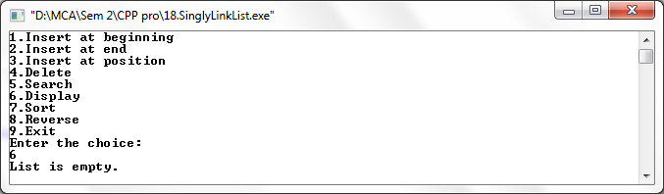

Insert at beginning

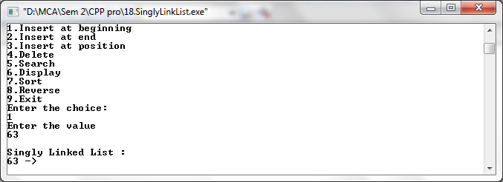

Insert at end

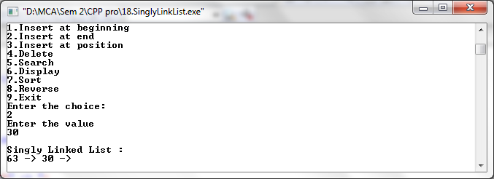

Insert at position

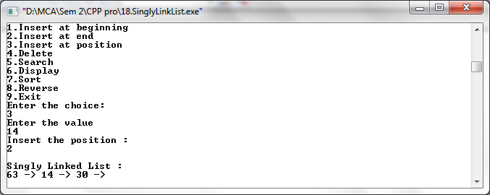

Delete

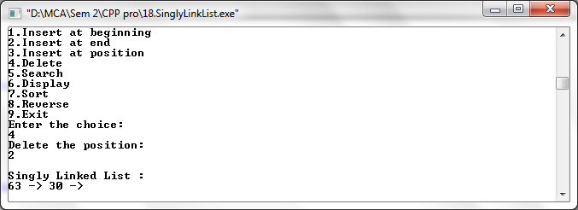

Search

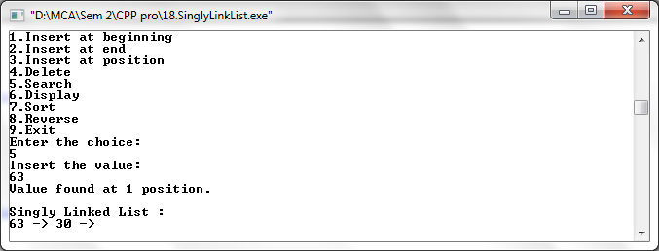

Display

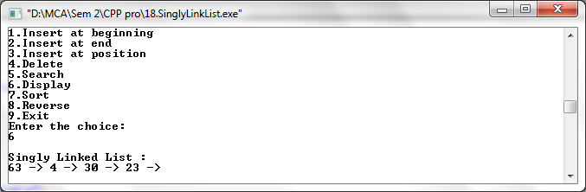

Sort

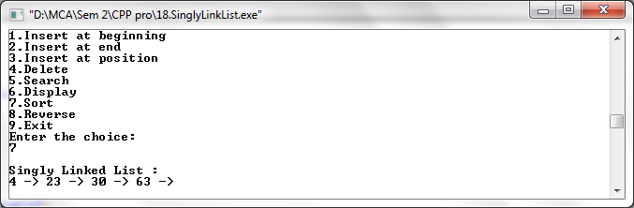

Reverse

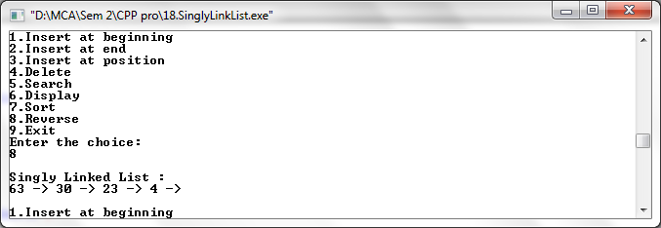

Q. Write a C++ program to perform Doubly Linked List.

#include<iostream>
using namespace std;
class doubly
{
public:

struct node
{
int data;
struct node *next;
struct node *prev;
};
struct node *tmp=NULL;
struct node *ptr=NULL;
struct node *start=NULL;
struct node *p=NULL;
struct node *p1=NULL;
struct node *p2=NULL;
void create(int x)
{
tmp=new node;
tmp->data=x;
tmp->next=NULL;
if(start==NULL)
{
tmp->prev=NULL;
start=tmp;
}
else
{
p=start;
while(p->next!=NULL)
{
p=p->next;
}
p->next=tmp;
tmp->prev=p;
}
}
void add_atbegin(int x)
{
if(start==NULL)
{
cout<<"List is empty.\n\n";
}
tmp=new node;
tmp->data=x;
tmp->next=start;
start->prev=tmp;
start=tmp;
}
void add_after(int x,int pos)
{
if(start==NULL)
{
cout<<"List is empty.\n\n";
}
p=start;
for(int i=0;i<pos-1;i++)
{
p=p->next;
if(p==NULL)
{
cout<<"Position does not exist.\n\n";
}
}
tmp=new node;
tmp->data=x;
if(p->next==NULL)
{
p->next=tmp;
tmp->next=NULL;
tmp->prev=p;
}
else
{
tmp->next=p->next;
tmp->next->prev=tmp;
p->next=tmp;
tmp->prev=p;
}
}
void del(int x)
{
if(start->data==x) //deleting first element
{
tmp=start;
start=start->next;
start->prev=NULL;
delete(tmp);
}
p=start;
while(p->next->next!=NULL) //deleting element in between
{
if(p->next->data==x)
{
tmp=p->next;
p->next=tmp->next;
tmp->next->prev=p;
delete(tmp);
}
p=p->next;
}
if(p->next->data==x) //last element deleted
{
tmp=p->next;
delete(tmp);
p->next=NULL;
}
}
void reverse()
{
p1=start;
p2=p1->next;
p1->next=NULL;
p1->prev=p2;
while(p2!=NULL)
{
p2->prev=p2->next;
p2->next=p1;
p1=p2;
p2=p2->prev;
}
start=p1;
cout<<"List reversed.\n";
}
void count()
{
p=start;
int cnt=0;
while(p!=NULL)
{
p=p->next;
cnt++;
}
cout<<"Number of element are "<<cnt<<".\n";
}
void search()
{
int count=0,value;
int flag=0;
cout<<"Enter the element to be searched :\n";
cin>>value;
if(start==NULL)
{
cout<<"List is empty.\n\n";
}
else
{
p=start;
while(p!=NULL)
{
count++;
if(p->data==value)
{
flag=1;
cout<<"Element found at position "<<count<<".\n";
}
p=p->next;
}
}
}
void sort()
{
if(start==NULL)
{
cout<<"list is empty.\n\n";
}
ptr=start;
while(ptr!=NULL)
{
for(p=ptr->next;p!=NULL;p=p->next)
{
if(ptr->data > p->data)
{
int x=ptr->data;
ptr->data = p->data;
p->data = x;
}
}
ptr=ptr->next;
}
}
void display()
{
if(start==NULL)
{
cout<<"List is empty.\n\n";
return;
}
else
{
p=start;
cout<<"\nDoubly Linked List :\n";
while(p!=NULL)
{
cout<<p->data<<" -> ";
p=p->next;
}
cout<<"\n\n";
}
}
};
int main()
{
doubly d;
int x,ch;
int pos;

while(ch!=0)
{
cout<<"1.Create a list\n2.Add at begin\n3.Add after\n4.Search\n5.Reverse\n6.Count\n7.Sort\n";
cout<<"8.Display\n9.Delete\n10.Exit";
cout<<"\nEnter the choice:\n";
cin>>ch;

switch(ch)
{
case 1:
cout<<"Enter the value :\n";
cin>>x;
d.create(x);
d.display();
break;

case 2:
cout<<"Enter the value :\n";
cin>>x;
d.add_atbegin(x);
d.display();
break;

case 3:
cout<<"Enter the position :\n";
cin>>pos;
cout<<"Enter the value :\n";
cin>>x;
d.add_after(x,pos);
d.display();
break;

case 4:
d.search();
d.display();
break;

case 5:
d.reverse();
d.display();
break;

case 6:
d.count();
d.display();
break;

case 7:
cout<<"Before sorting -";
d.display();
d.sort();
cout<<"After sorting -";
d.display();
break;

case 8 :
d.display();
break;

case 9:
cout<<"Enter the element to be delete :\n";
cin>>x;
d.del(x);
d.display();
break;

case 10:
break;

default:
cout<<"Wrong choice.\n";
}
}
return 0;
}

Output –

List is empty

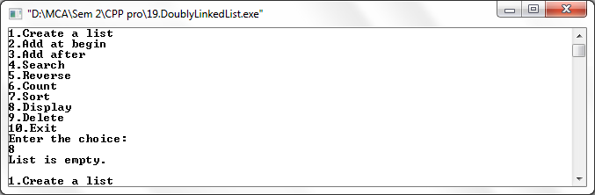

Create List

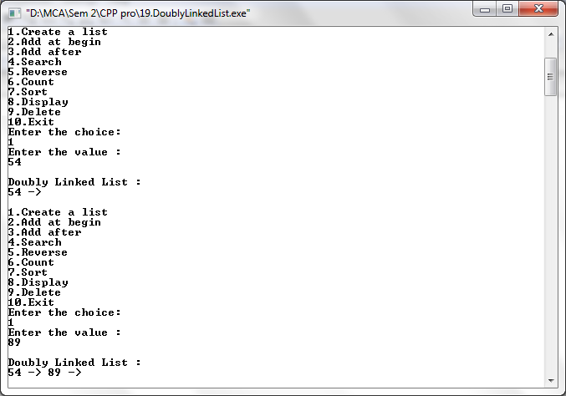

Add at beginning

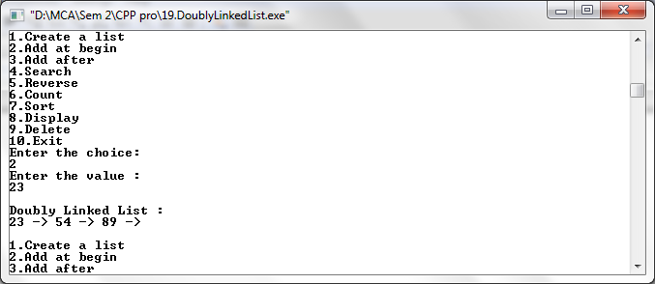

Add after

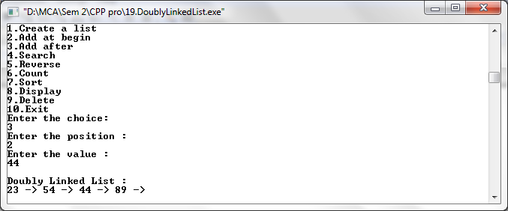

Search

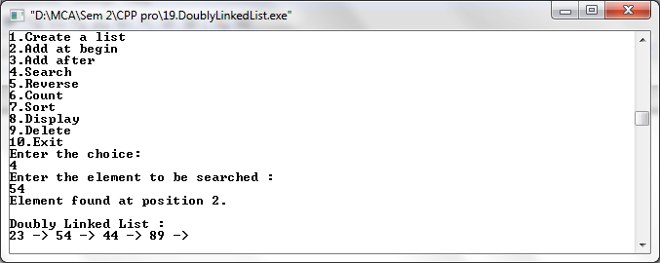

Reverse

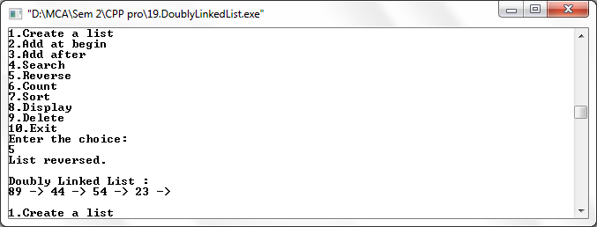

Count

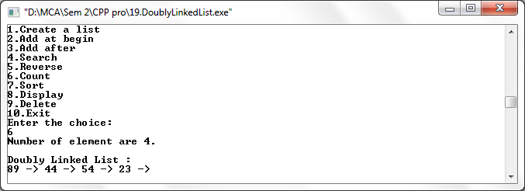

Sort

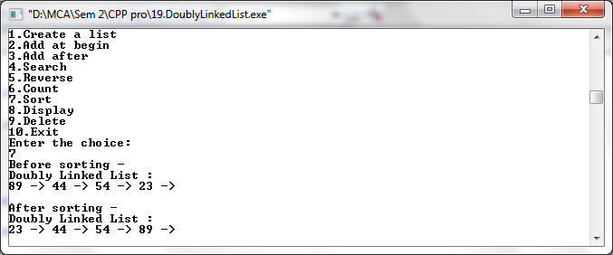

Display

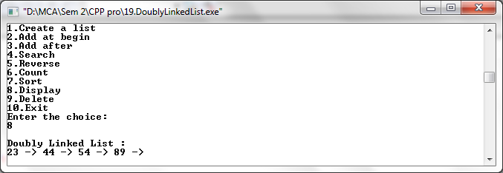

Delete

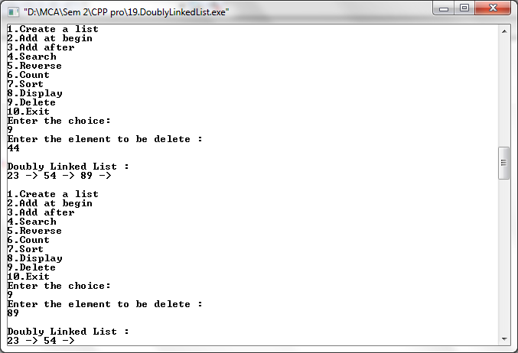

Q. Write a C++ program to perform Singly Circular Linked List.

#include<iostream>

using namespace std;

class singly_circular
{
public:
int flag=true;
int pos, i, value, count=0;
struct node
{
int data;
struct node *next;
struct node *prev;
};
struct node *tmp=NULL;
struct node *start=NULL;
struct node *last=NULL;
struct node *p=NULL;
struct node *ptr=NULL;

void create(int x)
{
tmp=new node;
tmp->data=x;
if(last==NULL)
{
last=tmp;
tmp->next=last;
}
else
{
tmp->next=last->next;
last->next=tmp;
last=tmp;
}
}
void add_atbegin(int x)
{
if(last==NULL)
{
cout<<"List is empty.\n";
}
tmp=new node;
tmp->data=x;
tmp->next=last->next;
last->next=tmp;
}
void add_after(int x,int pos)
{
if(last==NULL)
{
cout<<"List is empty.\n";
}
p=last->next;
for(int i=0;i<pos-1;i++)
{
p=p->next;
if(p==last->next)
{
cout<<"Position does not exist.\n";
//break;
}
}
tmp=new node;
tmp->next=p->next;
tmp->data=x;
p->next=tmp;
if(p==last)
{
last=tmp;
}
}
void del(int x)
{
//p=last->next;
if(last->next==last && last->data==x) // for only one node
{
tmp=last;
last=NULL;
delete(tmp);
return;
}
p=last->next;
if(p->data==x) //first element deleted
{
tmp=p;
last->next=p->next;
delete(tmp);
return;
}
while(p->next!=last)
{
if(p->next->data==x)
{
tmp=p->next;
p->next=tmp->next;
delete(tmp);
//cout<<"Deleted item "<<x;
return;
}//delete element in between
p=p->next;
}
if(p->next->data==x)
{
tmp=p->next;
p->next=last->next;
delete(tmp);
last=p;
return;
}//last element deleted
cout<<"Element not found.\n";
}
void search1(int x)
{
int pos=1;
while(p->next!=last)
{
if(p->data==x)
{
cout<<"Element found at position "<<pos-1<<".\n";
}
p=p->next;
pos++;
}
if(p==NULL)
cout<<"Item not found.\n";
}

void sort()
{
int x;
if(last==NULL)
{
cout<<"List is empty.\n\n";
}
p=last->next;

while(p!=last)
{
ptr=p->next;
while(ptr!=last->next)
{
if(ptr!=last->next)
{
if(p->data>ptr->data)
{
x=p->data;
p->data=ptr->data;
ptr->data=x;
}
}
ptr=ptr->next;
}
p=p->next;
}
}
int count1()
{
if(last==NULL)
{
cout<<"List is empty.\n\n";
}
else
{
p=last->next;

while(p!=last)
{
count++;
p=p->next;
}
count++;
cout<<"Number of element are "<<count<<"\n";
}
}

void display()
{
if(last==NULL)
{
cout<<"List is empty.\n\n";
return;
}
p=last->next;
cout<<"\nSingly Circular Linked List :\n";
while(p!=last)
{
cout<<p->data<<" -> ";
p=p->next;
}
cout<<last->data<<"\n\n";
}

};
int main()
{
singly_circular d;
int x,ch;
int pos;

while(ch!=9)
{
cout<<"1.Create a list\n2.Add at begin\n3.Add after\n4.Search\n";
cout<<"5.Sort\n6.Count\n7.Display\n8.Delete\n9.Exit\n";
cout<<"Enter the choice:\n";
cin>>ch;

switch(ch)
{
case 1:
cout<<"Enter the value :\n";
cin>>x;
d.create(x);
d.display();
break;

case 2:
cout<<"Enter the value :\n";
cin>>x;
d.add_atbegin(x);
d.display();
break;

case 3:
cout<<"Enter the position :\n";
cin>>pos;
cout<<"Enter the value :\n";
cin>>x;
d.add_after(x,pos);
d.display();
break;

case 4:
cout<<"Enter element to be searched:\n";
cin>>x;
d.search1(x);
d.display();
break;

case 5:
cout<<"Before sorting -";
d.display();
d.sort();
cout<<"After sorting -";
d.display();
break;

case 6:
d.count1();
d.display();
break;

case 7:
d.display();
break;

case 8:
cout<<"Enter the element to be delete :\n";
cin>>x;
d.del(x);
d.display();
break;

case 9:
break;

default:
cout<<"Wrong choice.\n";
}
}
return 0;
}

Output –

List is Empty

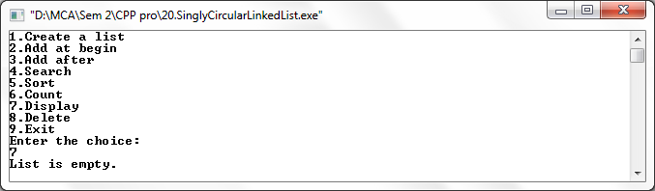

Create a list

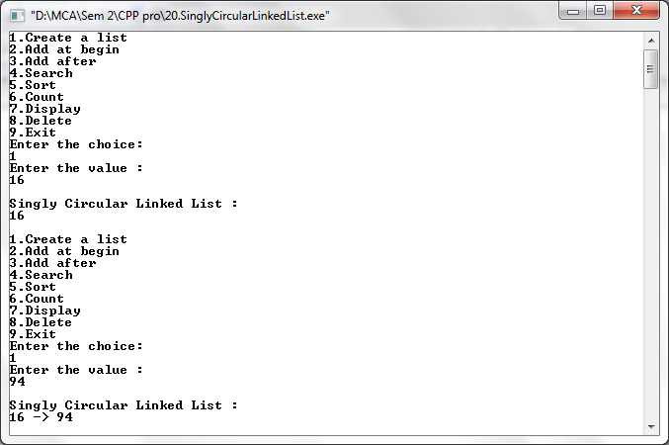

Add at beginning

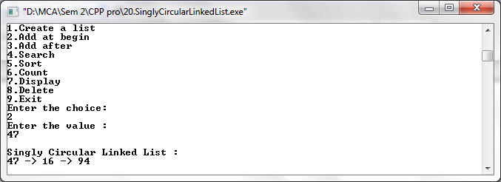

Add after

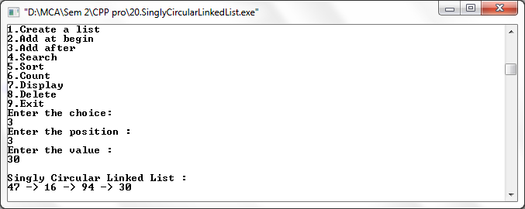

Search

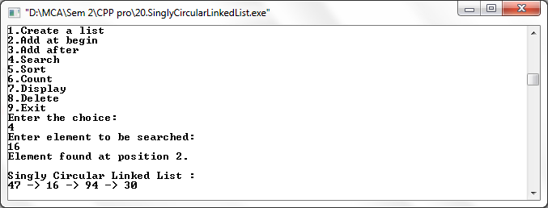

Sort

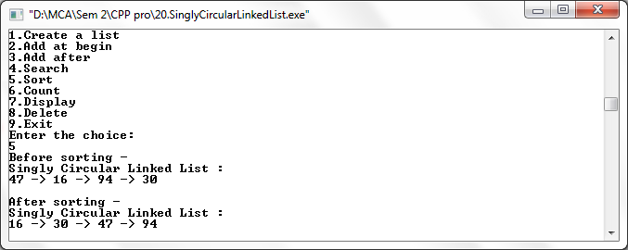

Count

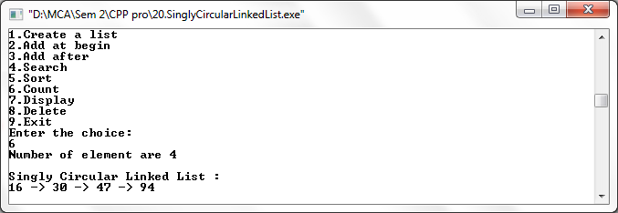

Display

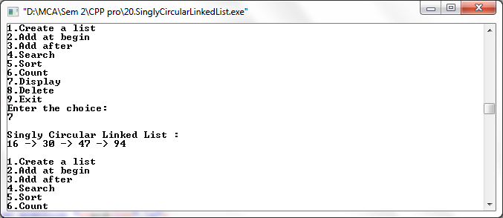

Delete

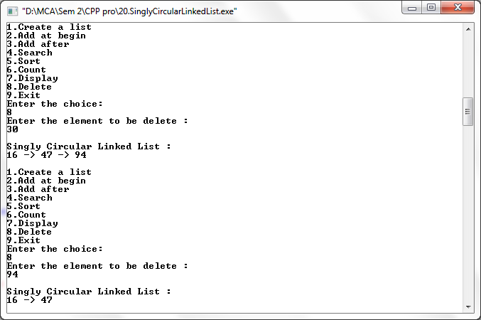

Q. Write a C++ program to perform Circular Queue using Array.

#include<iostream>
#include<stdio.h>
#include<conio.h>

using namespace std;
class queue
{
public:
int n=4;
int que[4],front=-1,rear=-1,ch,x;

int enqueue(int x)
{
if(rear==n-1)
{
cout<<"Queue full.\n";
}
else
if(front==-1 && rear==-1)
front=rear=0;
else
{
rear=(rear+1)%n;
}
que[rear]=x;
cout<<"Element is inserted.\n";
}
int dequeue()
{
if(front==rear)
{
cout<<"Queue Empty.\n\n";
}
else
{
x=que[front];
if(front==rear)
{
front=-1; rear=-1;
}
else
front=(front+1) % n;

cout<<x<<" is deleted from queue.\n";
}
}
int display()
{
if(front==rear)
{
cout<<"Queue Empty.\n\n";
}
else
{
cout<<"Circular Queue :";
for(int i=rear;i>=front;i--)
cout<<"\n"<<que[i];
cout<<"\n";
}
}
};
int main()
{
queue q;
int a[5],front=-1,rear=-1,ch,x;

while(ch!=0)
{
cout<<"\n1.Enqueue\n2.Dequeue\n3.Display\n";
cout<<"Enter your choice\n";
cin>>ch;
switch(ch)
{
case 1:
cout<<"Enter an element\n";
cin>>x;
q.enqueue(x);
break;
case 2:
q.dequeue();
break;
case 3:
q.display();
break;
default:
cout<<"You entered a wrong choice\n";
break;
}

}
}

Output –

Queue empty

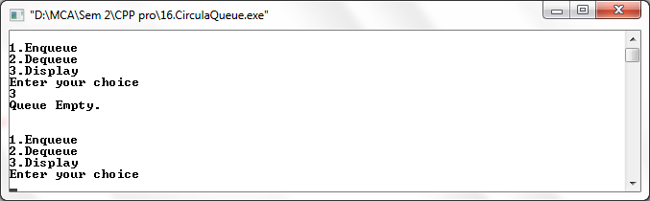

Enqueue

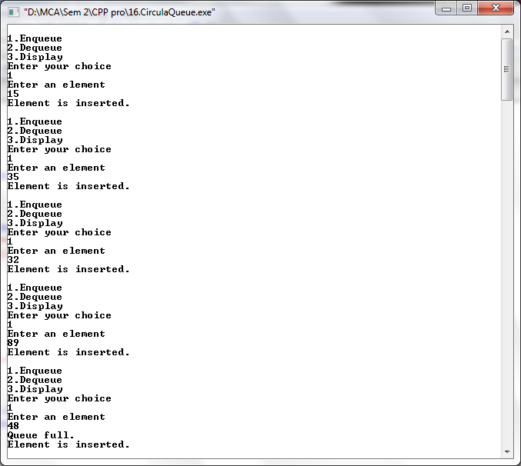

Display

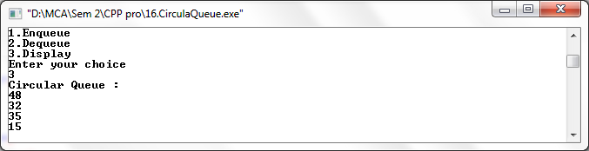

Dequeue

