.Practicle No -1
1 .write a node js application to create arithmatic operation(addition,substraction,multipication,division)
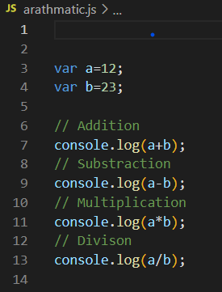
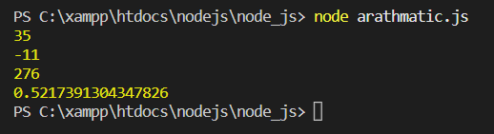

Practicle No -2
2. write a application to demonstrate callback function
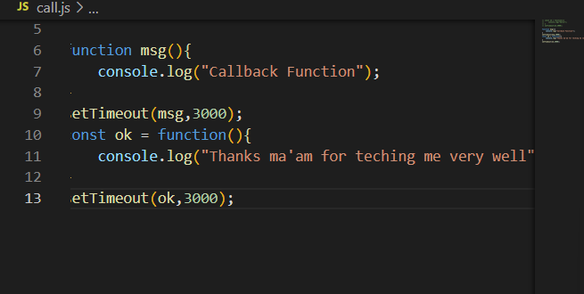
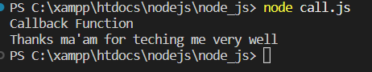

Practicle No -3
3. write a application to demonstrate arrow function
setTimeout(()=>{
console.log("Calling From arrow function");
},3000)

Output-
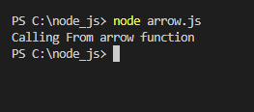

Practicle No -4
4 .write a application to demonstrate to display fibonacci series
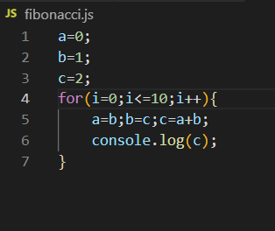
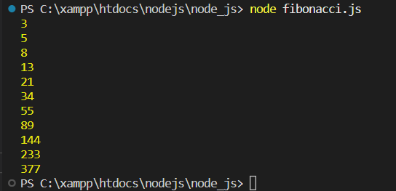

Practicle No -5
5. write an application to demonstrate to display 10(1-10)prime number
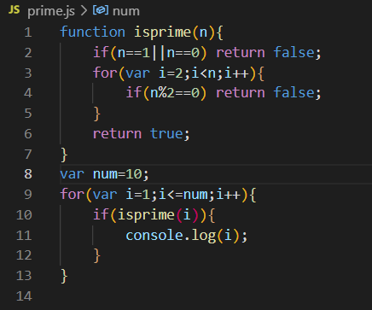
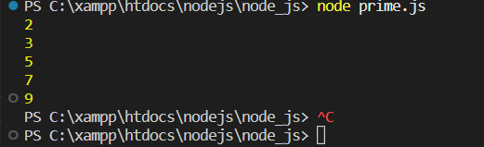

Practicle No -6
6. write an application to demonstrate module.
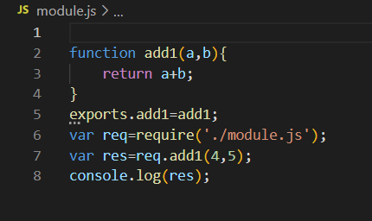
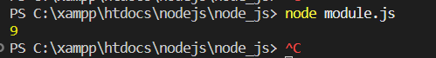

Practicle No -7
7 .write a node js application to find area of circle,square,rectangle using module

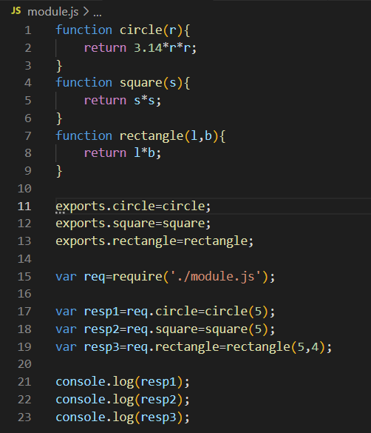
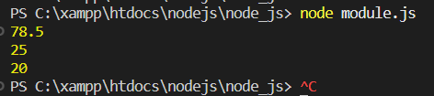

Practicle No -8
8. write a application to demonstrate events module
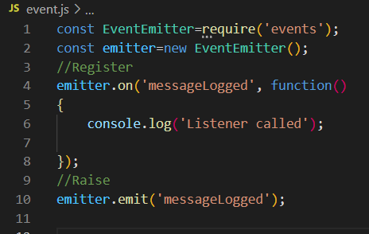
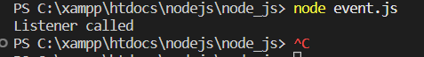

Practicle No -9
9. write a application to demonstrate events functions(remove listener, listenerCount)
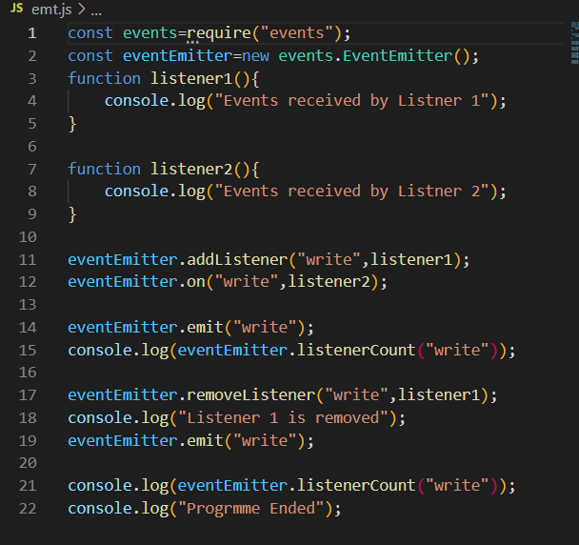
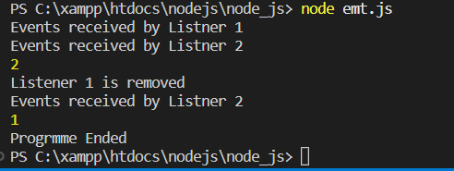

Practicle No -10
Create an application in nodejs to create event emmiter.
Code:
var emitter=require('events').EventEmitter;
function LoopProcessor(num){
var e=new emitter();
setTimeout(function(){
for(var i=1;i<=num;i++){
e.emit('BeforeProcess',i);
console.log('Processing number:',i);
e.emit('AfterProcess',i);
}
},2000)
return e;
}
var ip=LoopProcessor(3);
ip.on('BeforeProcess',function(data){
console.log('About start the process for' + data);
});
ip.on('AfterProcess',function(data){
console.log('complete processing' + data)
});

Output :
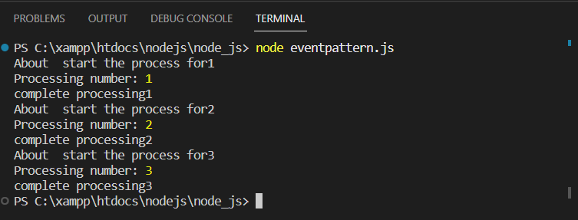

Practical No : 11
Create an application in nodejs to create extend event emmiter
Code:
var emitter=require('events').EventEmitter;
var util=require('util');
function LoopProcessor(num){
var me=this;

setTimeout(function(){
for(var i=1;i<=num;i++){
me.emit('BeforeProcess',i);
console.log('Processing number:',i);
me.emit('AfterProcess',i);
}
},2000)
return this;
}
util.inherits(LoopProcessor,emitter)
var lp=new LoopProcessor(3);
lp.on('BeforeProcess',function(data){
console.log('About to start the process for' + data);
});
lp.on('AfterProcess',function(data){
console.log('complete processing' + data)
});

Output:
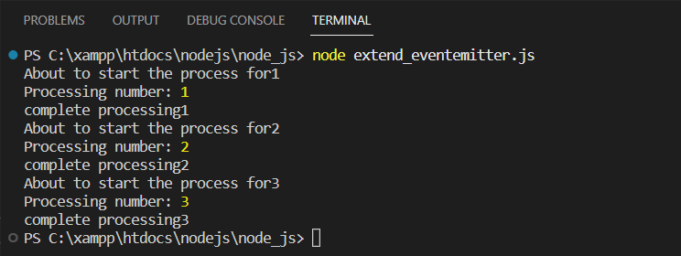

Practical No : 12
Create in application to display message after 5 sec and 10 sec.
const myfunction=delay=>{
console.log('hello after '+delay+' seconds');
};
setTimeout(myfunction,5000,'five');
setTimeout(myfunction,10000,'ten');

Output:
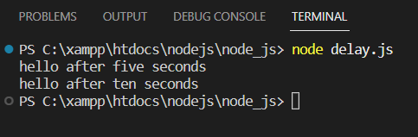

Practical No : 13
Create in application to demonstrate set Interval function.
setInterval(
()=> console.log('hello after 4 seconds'),4000
);

Output :
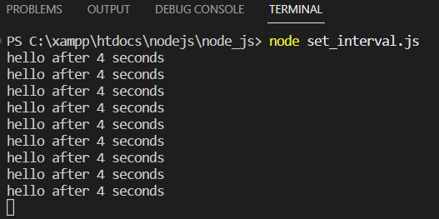

Practical No : 14
Create in application in Node Js to display factorial of a number.
function factorial(no){
factorial=1;
for(i=1;i<=no;i++){
factorial=factorial*i;
}
console.log(factorial);
}
factorial(6);

Output :
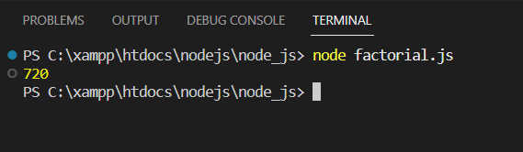

Practical No : 15
Write in application to create HTTP server and display message.
var http = require ('http');
var server = http.createServer(function(req,res){
res.write("Hello Server");
res.end();

});
server.listen(5000);
console.log('Node.js web server at port 5000 is running...')

Output :
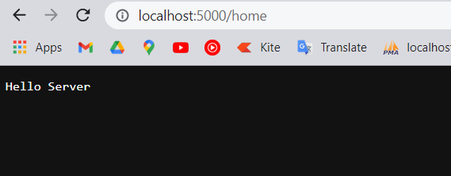

Practical No : 16
Write in application to create form,Prathamesh and admin pages using HTTP server.
Code:
const { getEventListeners } = require('events');
var http = require('http');
var server = http.createServer(function(req,res)
{
if(req.url == '/'){ // check the URL of the current rwquest
res.writeHead(200, {'Content-Type': 'text/html'});
res.write('<html><body><p>This is root page</p></body></html>');
res.end();
}
if(req.url == '/form'){ // check the URL of the current rwquest
res.writeHead(200, {'Content-Type': 'text/html'});
res.write('<html><head><head><link rel="stylesheet" href="https://cdn.jsdelivr.net/npm/bootstrap@4.0.0/dist/css/bootstrap.min.css" integrity="sha384-Gn5384xqQ1aoWXA+058RXPxPg6fy4IWvTNh0E263XmFcJlSAwiGgFAW/dAiS6JXm" crossorigin="anonymous"></head></head><body><form style="padding:20px;"> <div class="form-row"> <div class="form-group col-md-6"> <label for="inputEmail4">Email</label> <input type="email" class="form-control" id="inputEmail4" placeholder="Email" required> </div> <div class="form-group col-md-6"> <label for="inputPassword4">Password</label> <input type="password" class="form-control" id="inputPassword4" placeholder="Password" required> </div> </div> <div class="form-group"> <label for="inputAddress">Address</label> <input type="text" class="form-control" id="inputAddress" placeholder="At/po-Ardal,Tal-Ajara/" required> </div> <div class="form-group"> <label for="inputAddress2">Address 2</label> <input type="text" class="form-control" id="inputAddress2" placeholder="Apartment, studio, or floor" required> </div> <div class="form-row"> <div class="form-group col-md-6"> <label for="inputCity">City</label> <input type="text" class="form-control" id="inputCity" placeholder="Kolhapur" required> </div> <div class="form-group col-md-4"> <label for="inputState">State</label> <select id="inputState" class="form-control" required> <option selected>Choose...</option> <option>Maharashtra</option> <option>Delhi</option> <option>Goa</option> </select> </div> <div class="form-group col-md-2"> <label for="inputZip">Zip</label> <input type="text" class="form-control" id="inputZip" required> </div> </div> <div class="form-group"> <div class="form-check"> <input class="form-check-input" type="checkbox" id="gridCheck" required> <label class="form-check-label" for="gridCheck"> Check me out </label> </div> </div> <button type="submit" class="btn btn-primary" >Sign in</button> <button type="submit" class="btn btn-primary" onclick="alt()" >Click Me! After Submitting Form </button> <button type="submit" class="btn btn-primary" onclick="document.getElementById("demo").innerHTML=Date()" >Click here to get current time and Date</button> <p id="demo"></p> </form> <script> function alt(){ console.log(alert("Hey buddy.......Thanks for sending me your email id and password. I am hacked your Google Account.")); } </script></body></html>');
res.end();
}

else if(req.url == '/prathamesh'){ // check the URL of the current rwquest
res.writeHead(200, {'Content-Type': 'text/html'});
res.write('<html><head><style>body {background-color:pink;}</style></head><body><h1><b>This is Student Page</b></h1><p>This page consists of student information</p></body></html>');
res.end();
}
else if(req.url == '/admin'){ // check the URL of the current rwquest
res.writeHead(200, {'Content-Type': 'text/html'});
res.write('<html><head><style>body {background-color:yellow;}</style></head><body><h1><b>This is Admin Page</b></h1><p>This page consists of admin information</p></body></html>');
res.end();
}
else{
res.end('Invalid Request!');
}
});
server.listen(5000);
console.log('Node.js web server at port 9000 is running...')

Output :
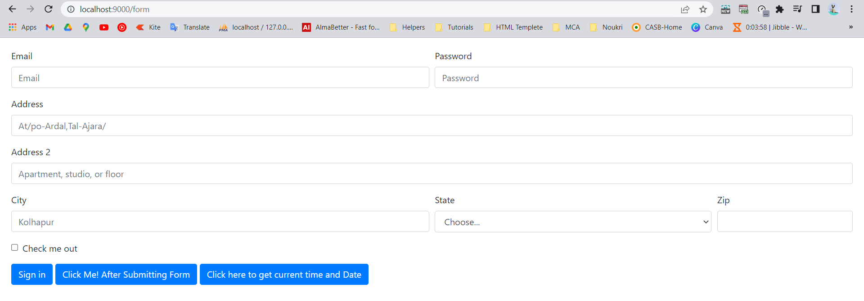
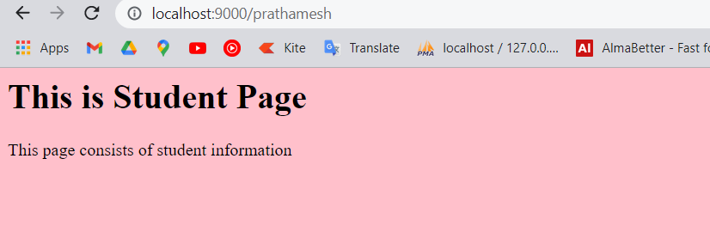
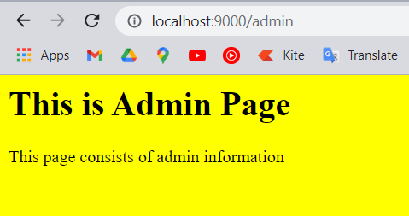

Practical No : 17
Write in application to display details of the current file.
Code :
const path = require("path");
const pathobj = path.parse("home.js");
console.log(pathobj);

Output :
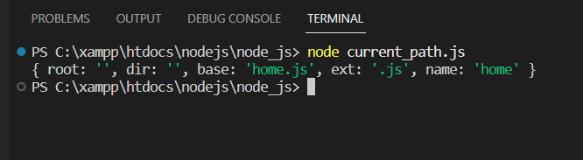

Practical No : 18
Create an application to read a file.
Code :
const fs=require('fs');
fs.readFile('data.txt',function(err,data){
console.log(data.toString());
});

// const fs=require('fs');
fs.readFile('new.txt','utf-8',function(err,data){
console.log(data);
});

Output :
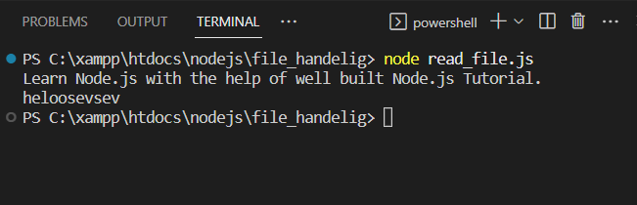

Practical No : 19
Create an application to write into a file.
Code :
const fs = require('fs');

let data = "This is a file containing a collection of books.";

fs.writeFile("m.txt", data, (err) => {
if (err)
console.log(err);
else {
console.log("File written successfully\n");
// console.log("The file has the following contents:");
// console.log(fs.readFileSync("books.txt", "utf8"));
}
});

Output :
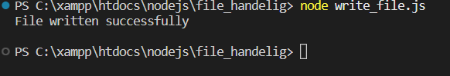

Practical No : 20
Create an application to add data into a existing file.
Code
var fs = require('fs');

var data = "\nLearn Node.js with the help of well built Node.js Tutorial.";
fs.appendFile('books.txt',data, 'utf8',
function(err) {
if (err) throw err;
console.log("Data is appended to file successfully.")
});

Output :
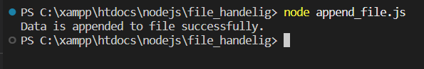

Practical No:21
Create an application to delete a file
var fs = require('fs');
var filePath = './books.txt';
fs.unlinkSync(filePath);
console.log("deleted success");

Output:
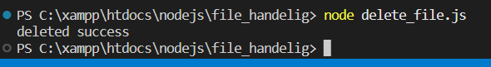

Practical No : 22
Create an application to rename a file.
Code :
var fs = require('fs');

fs.rename('data.txt', 'new.txt', function (err) {
if (err) throw err;
console.log('File Renamed.');
});

Output :

Practical No : 23
Create an application to create database using mysql and xampp.
Code :
var mysql = require('mysql')

var con = mysql.createConnection({
host: 'localhost',
user: 'root',
password: ''
});

con.connect(function(err) {
if (err) throw err;
console.log("Connected!");
con.query("CREATE DATABASE collage", function (err, result) {
if (err) throw err;
console.log("Database created");
});
});

Output :
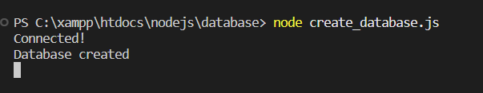

Practical No : 24
Create an application to create faculty table with column as faculty name,faculty design, faculty mobile, faculty salary.
Code:
var mysql = require('mysql');
var con = mysql.createConnection({
host: 'localhost',
user: 'root',
password: '',
database: 'collage'
});
con.connect(function(err) {
if (err) throw err;
console.log("Connected!");
var sql = "CREATE TABLE faculty_table (id INT(10) PRIMARY KEY AUTO_INCREMENT, f_name VARCHAR(255), f_design VARCHAR(255), f_mobile int(10),f_salary int(20))";
con.query(sql, function (err, result) {
if (err) throw err;
console.log("Table created");
});
});

// create prathamesh table

Output :
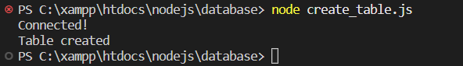

Practical No : 25
Create an application to insert rows in faculty table.
var mysql = require('mysql');

var con = mysql.createConnection({
host: 'localhost',
user: 'root',
password: '',
database: 'collage'
});

con.connect(function(err) {
if (err) throw err;
console.log("Connected!");
var sql = "INSERT INTO faculty_tab (name,design,mobile,salary) VALUES ('sagarsir', 'ovel','7878787878','23232323')";
con.query(sql, function (err, result) {
if (err) throw err;
console.log("Thanks for copying my code ... your record inserted successful");
});
});

Output :

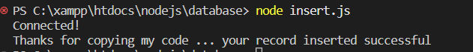

Practical No : 26
Create an application to display records.
var mysql = require('mysql')

var con = mysql.createConnection({
host: 'localhost',
user: 'root',
password: '',
database: 'collage'
});

con.connect(function(err) {
if (err) throw err;
con.query("SELECT * FROM faculty_tab", function (err, result, fields) {
if (err) throw err;
console.log(result);
});
});

Output:
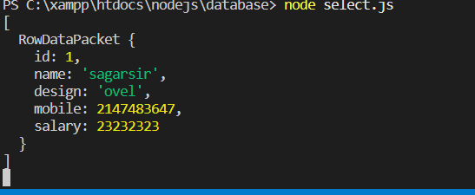

Practical No : 27
Create an application to update a row.
var mysql = require('mysql');

var con = mysql.createConnection({
host: 'localhost',
user: 'root',
password: '',
database: 'collage'
});

con.connect(function(err) {
if (err) throw err;
var sql = "UPDATE faculty_tab SET name = 'seema'";
con.query(sql, function (err, result) {
if (err) throw err;
console.log(result.affectedRows + " record(s) updated");
});
});

Output:

Practical No : 28
Create an application to add a column address to faculty_tab.
var mysql = require('mysql');

var con = mysql.createConnection({
host: 'localhost',
user: 'root',
password: '',
database: 'collage'
});

con.connect(function(err) {
if (err) throw err;
var sql = "ALTER TABLE `faculty_tab` ADD `address` VARCHAR(255);";
con.query(sql, function (err, result) {
if (err) throw err;
console.log(result.affectedRows + " record(s) Altered");
});
});

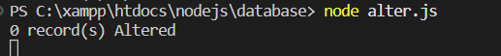
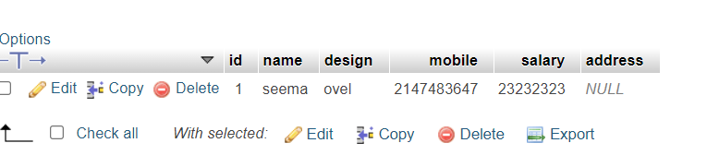

Practical No:29
Create an application to delete a record in faculty_tab.
const mysql = require("mysql");

let db_con = mysql.createConnection({
host: "localhost",
user: "root",
password: '',
database: 'collage'
});

db_con.connect((err) => {
if (err) {
console.log("Database Connection Failed !!!", err);
return;
}

console.log("We are connected faculty_tab database");

// here is our query
let query = 'DELETE FROM faculty_tab WHERE id=1';

db_con.query(query, (err, rows) => {
if(err) throw err;

console.log('Cleared users Table');
});
});

Output:
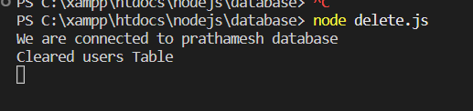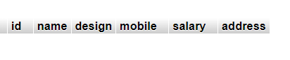
Practical 30:
Create an application to demonstrate an array.
<!DOCTYPE html>
<html lang="en">
<head>
<meta charset="UTF-8">
<meta http-equiv="X-UA-Compatible" content="IE=edge">
<meta name="viewport" content="width=device-width, initial-scale=1.0">
<title>Document</title>
<script src="angular.min.js"></script>
</head>
<body>
<div ng-app="" ng-init="points=[11,22,33,44]">
</div>
</body>
</html>

Practical No:31
Create an application to create an array and display the element in order list.
<!DOCTYPE html>
<html lang="en">
<head>
<meta charset="UTF-8">
<meta http-equiv="X-UA-Compatible" content="IE=edge">
<meta name="viewport" content="width=device-width, initial-scale=1.0">
<title>Document</title>
<script src="angular.min.js"></script>
</head>
<body>
<div ng-app="" ng-init="points=[11,22,33,44]">
<p>the points are{{points}}</p>

</div>
</body>
</html>

Output:
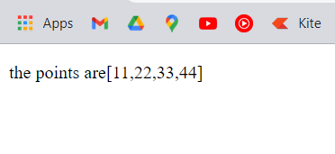

Practical No:32
Create an application to display marksheet of a student.
<!DOCTYPE html>
<html lang="en">
<head>
<style>
body, html {
height: 100%;
margin: 0;
font-family: Arial, Helvetica, sans-serif;
}
* {
box-sizing: border-box;
}
.bg-image {
background-image: url("https://tse1.mm.bing.net/th?id=OIP.SNLPlCBmKmP7IJMVsU8tzgHaE8&pid=Api&rs=1&c=1&qlt=95&w=153&h=102");
filter: blur(8px);
-webkit-filter: blur(8px);
height: 100%;
background-position: center;
background-repeat: no-repeat;
background-size: cover;
}
.bg-text {
background-color: rgb(0,0,0);
background-color: rgba(0,0,0, 0.4);
color: white;
font-weight: bold;
border: 3px solid #f1f1f1;
position: absolute;
top: 50%;
left: 50%;
transform: translate(-50%, -50%);
z-index: 2;
width: 80%;
padding: 20px;
text-align: center;
}
</style>
<meta charset="UTF-8">
<meta http-equiv="X-UA-Compatible" content="IE=edge">
<meta name="viewport" content="width=device-width, initial-scale=1.0">
<title>root DEv</title>
<script src="angular.min.js"></script>
</head>
<body ng-app="">
<div align="center">
<h1>NCRD's Sterling Institute of Management Studies</h1>
<h3 style="color:blue">Student Name : Prathamesh Shelake</h3>
<marquee behavior="alternate" scrollamount="20">Roll No:52</marquee>
<div ng-init="marks=[{maths:67,java:89,dbms:67,spm:89}]">
<ol >
<li ng-repeat='x in marks'>

{{"Mathematics marks are: " + x.maths}}
<br>
{{"Java marks are: " + x.java}}
<br>
{{"DBMS marks are: " + x.dbms}}
<br>
{{"SPM marks are: " + x.spm}}
</li>
</ol>
</div>
</div>
<hr>
<div align="center">
<h1>NCRD's Sterling Institute of Management Studies</h1>
<h3 style="color:blue">Student Name : Abhishek Sakpal</h3>
<h3>Roll No:47</h3>
<div ng-init="Student=[{Subject:'Maths',Marks:'77'},
{Subject:'Java',Marks:'54'},{Subject:'DBMS',Marks:'65'},{Subject:'SPM',Marks:'77'}]"></div>
<ul>
<li ng-repeat='x in Student'>
{{x.Subject+ ' : ' + x.Marks}}
</li>
</ul>
</div>
</body>
</html>

Output:
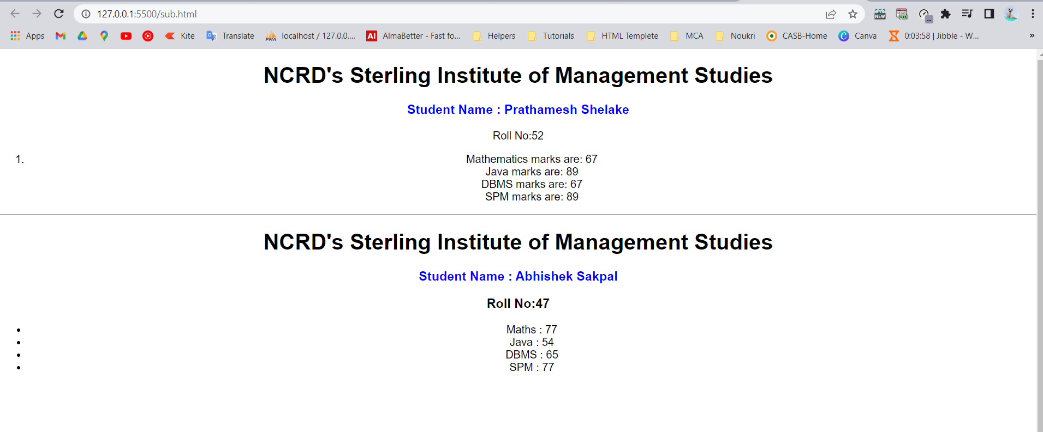

Practical 33:
Create and application in angular to change the diagram color of a textbox as written in the text box.
<!DOCTYPE html>
<html lang="en">
<head>
<meta charset="UTF-8">
<meta http-equiv="X-UA-Compatible" content="IE=edge">
<meta name="viewport" content="width=device-width, initial-scale=1.0">
<title>Document</title>
<script src="angular.min.js"></script>
</head>
<body>
<div ng-app="" ng-init="color='yellow'">
Name<input type="text" style="background-color:{{color}}" ng-model="color">
</div>
</body>
</html>

Output:
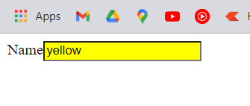

Practical No 34:
create an angular js application and calculate simple interst.
<!DOCTYPE html>
<html>
<head>
<title></title>
<script src="https://ajax.googleapis.com/ajax/libs/angularjs/1.6.9/angular.min.js"> </script>
</head>
<body>
<div ng-app="myApp" ng-controller="myCtrl">
<input type="text" ng-model="p" />
<br>
<br>
<input type="text" ng-model="r" />
<br>
<br>
<input type="text" ng-model="t" />
<br>
<br>
<input type="button" value="calculate" ng-click="fun()">
<br>
{{res}}

</div>

<script type="text/javascript">

var app = angular.module('myApp',[]);
app.controller("myCtrl",function($scope)
{
$scope.p=0;
$scope.r=0;
$scope.t=0;
$scope.fun=function(){
$scope.res = (eval($scope.p)*eval($scope.r)*eval($scope.t))/100;

}

})

</script>

</body>
</html>

OutPut:
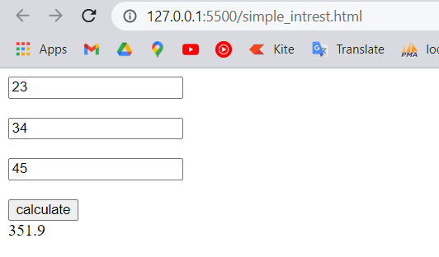

Practical No:35
Create an application In angular Js to demonstrate controller.
<!DOCTYPE html>
<html>
<script src="https://ajax.googleapis.com/ajax/libs/angularjs/1.6.9/angular.min.js"></script>
<body>

<div ng-app="myApp" ng-controller="myCtrl">

First Name: <input type="text" ng-model="firstName"><br>
Last Name: <input type="text" ng-model="lastName"><br>
<br>
Full Name: {{firstName + " " + lastName}}

</div>

<script>
var app = angular.module('myApp', []);
app.controller('myCtrl', function($scope) {
$scope.firstName = "Prathamesh";
$scope.lastName = "Shelake";
});
</script>

</body>
</html>

Output:
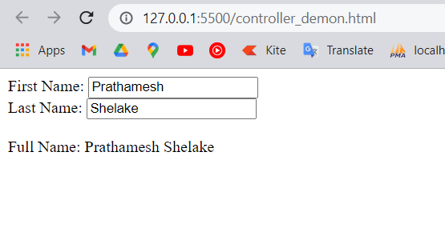

Practical No:36
Create an application in Angular to display list of programming languages (Any 4) in a table format, provide the button for like and dislike and increment the value of like and dislike when the respective buttons are clicked.

<!DOCTYPE html>
<html lang="en">
<head>
<meta charset="UTF-8">
<meta http-equiv="X-UA-Compatible" content="IE=edge">
<meta name="viewport" content="width=device-width, initial-scale=1.0">
<title>Document</title><script src="angular.min.js"></script>
<style>
table {
border-collapse: collapse;
font-family:Arial;
}
td {
border: 1px solid black;
padding: 5px;
}
th {
border: 1px solid black;
padding: 5px;
text-align: left;
}
</style>
</head>
<body ng-app="myModule">
<div ng-controller="myController">
<table>
<thead>
<tr>
<th>Name</th>
<th>Likes</th>
<th>Dislikes</th>
<th>Like/Dislike</th>
</tr>
</thead>
<tbody>
<tr ng-repeat="technology in technologies">
<td> {{technology.name}} </td>
<td style="text-align:center"> {{technology.likes}} </td>
<td style="text-align:center"> {{technology.dislikes}} </td>
<td>
<input type="button" ng-click="incrementLikes(technology)" value="Like" />
<input type="button" ng-click="incrementDislikes(technology)" value="Dislike" />
</td>
</tr>
</tbody>
</table>
</div>
</body>
<script>
var app = angular
.module("myModule", [])
.controller("myController", function ($scope) {
var technologies = [
{ name:"C#", likes:0, dislikes:0 },
{ name: "ASP.NET", likes: 0, dislikes: 0 },
{ name: "SQL", likes: 0, dislikes: 0 },
{ name: "AngularJS", likes: 0, dislikes: 0 }
];
$scope.technologies = technologies;

$scope.incrementLikes = function (technology) {
technology.likes++;
};
$scope.incrementDislikes = function (technology) {
technology.dislikes++;
};
});

</script>
</html>

Output:
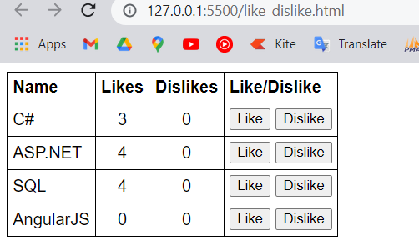

Practical No:37
Create an application to display employee details in table using filters.
<!DOCTYPE html>
<html xmlns="http://www.w3.org/1999/xhtml">
<head>
<title></title>
<script src="angular.min.js"></script>
<script src="seven.js"></script>
<link href="seven2.css" rel="stylesheet" />
<style>
body {
font-family: Arial;
}
table {
border-collapse: collapse;
}
td {
border: 1px solid black;
padding: 5px;
}
th {
border: 1px solid black;
padding: 5px;
text-align: left;
}

</style>
</head>
<body ng-app="myModule">
<div ng-controller="myController">
Rows to display : <input type="number" step="1"
ng-model="rowCount" max="5" min="0" />
<br /><br />
<table>
<thead>
<tr>
<th>Name</th>
<th>Date of Birth</th>
<th>Gender</th>
<th>Salary (number filter)</th>
<th>Salary (currency filter)</th>
</tr>
</thead>
<tbody>
<tr ng-repeat="employee in employees | limitTo:rowCount">
<td> {{ employee.name | uppercase }} </td>
<td> {{ employee.dateOfBirth | date:"dd/MM/yyyy" }} </td>
<td> {{ employee.gender }} </td>
<td> {{ employee.salary | number:2 }} </td>
<td> {{ employee.salary | currency : "₹" : 1 }} </td>
</tr>
</tbody>
</table>
</div>
</body>
<script>
var app = angular
.module("myModule", [])
.controller("myController", function ($scope) {

var employees = [
{
name: "Prathamesh", dateOfBirth: new Date("August 22, 2000"),
gender: "Male", salary: 99000
},
{
name: "abhishek", dateOfBirth: new Date("december 11, 2000"),
gender: "male", salary: 68000
},
{
name: "prarthana", dateOfBirth: new Date("August 15, 2000"),
gender: "feMale", salary: 57000
},
{
name: "gayatri", dateOfBirth: new Date("december ,02 2001"),
gender: "Female", salary: 53000
},
{
name: "rutuja", dateOfBirth: new Date("February 04, 2002"),
gender: "female", salary: 60000
}
];

$scope.employees = employees;
$scope.rowCount = 3;
});

</script>
</html>

Output:
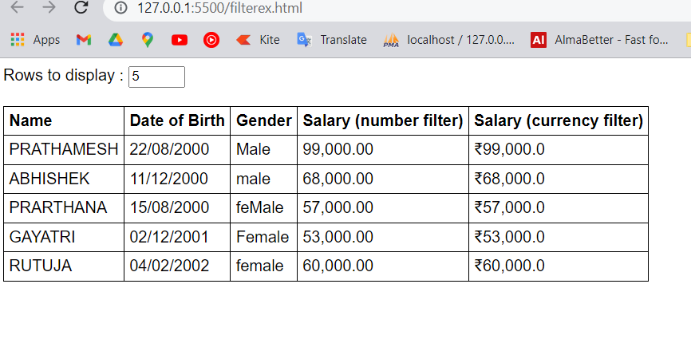

Practical No:38
Create an application to change the background color of a division using ng-switch directive.
<!DOCTYPE html>
<html lang="en">
<head>
<meta charset="UTF-8">
<meta http-equiv="X-UA-Compatible" content="IE=edge">
<meta name="viewport" content="width=device-width, initial-scale=1.0">
<title>Document</title>
<script src="angular.min.js"></script>
</head>
<body ng-app="">
<div> <form> Select Color:
<select ng-model="myVar">
<option value="pink">Pink</option>
<option value="skyblue">skyblue</option>
<option value="lav">Lavender</option>
</select>
</form>
</div>
<div ng-switch="myVar">
<div ng-switch-when-> </div>
<div ng-switchmyVar>
<div ng-switch-when="pink" style="background-color: pink;">
<h1>Pink</h1>
<p>Pink Color</p>
</div></div>
<div ng-switch="myVar">
<div ng-switch-when="skyblue" style="background-color: rgb(19, 165, 214);">
<h1>Sky Blue</h1>
<p>Sky Blue Color.</p>
</div> </div>
<div ng-switch="myVar">
<div ng-switch-when="lav" style="background-color: rgb(226, 184, 253)">
<h1>Lavender</h1>
<p>Lavender Color</p>
</div></div>
<p>The ng-switch directive hides and shows HTM sections depending on the value of the dropdown list.</p>
</body></html>

Output:
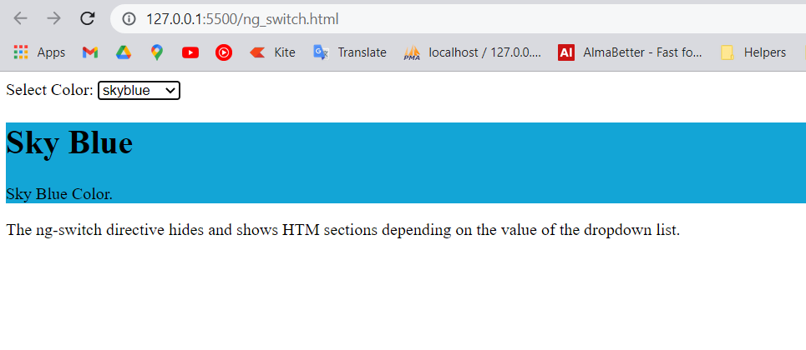

Practical No:39
Create an angular application to demonstrates Mouse event directives- ng-mouseenter and ng-mouseleave.
<!DOCTYPE html>
<html lang="en">
<head>
<meta charset="UTF-8">
<meta http-equiv="X-UA-Compatible" content="IE=edge">
<meta name="viewport" content="width=device-width, initial-scale=1.0">
<title>Document</title>
<script src="angular.min.js"></script>
</head>
<body ng-app="">
<p>
<body bgcolor="yellow">
<font size="20" color="red"> Switch Statement</p>
<div>
<form>Select Color :
<select ng-model="myVar">
<option value="pink">Pink</option>
<option value="sky">Sky Blue</option>
<option value="lav">Lavender</option>
<option value="re">Red</option>
<option value="yel">Yellow</option>

</select>
</form>
</div>
<div ng-switch="myVar">
<div ng-switch-when="sky" style="background-color: lightblue;">
<h1>Sky Blue</h1>
<p>Sky Blue Color.</p>
</div>
</div>
<div ng-switch="myVar">
<div ng-switch-when="pink" style="background-color: pink;">
<h1>Pink</h1>
<p>Pink Color.</p>
</div>
</div>
<div ng-switch="myVar">
<div ng-switch-when="lav" style="background-color: rgb(226, 184, 253);">
<h1>Lavender</h1>
<p>Lavender Color</p>
</div>
</div>

<div ng-switch="myVar">
<div ng-switch-when="re" style="background-color: Red;">
<h1>Pink</h1>
<p>Red Color.</p>
</div>
</div>

<div ng-switch="myVar">
<div ng-switch-when="yel" style="background-color: yellow;">
<h1>Pink</h1>
<p>Yellow Color.</p>
</div>
</div>
</body>
</html>

Output:
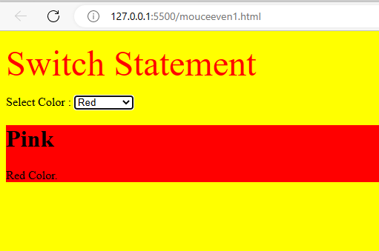

Practical No: 40
To create a Registration form with username, email-address gender, and save button.
<!DOCTYPE html>
<html lang="en">
<head>
<meta charset="UTF-8">
<meta http-equiv="X-UA-Compatible" content="IE=edge">
<meta name="viewport" content="width=device-width, initial-scale=1.0">
<title>Document</title>
<script src="angular.min.js"></script>
</head>
<body ng-app="formExample">
<div ng-controller="formController">
<form novalidate>
<label>Name: <input type="text" ng-model="user.name" /></label><br />
<label>E-mail: <input type="email" ng-model="user.email" /></label><br />
Gender: <label><input type="radio" ng-model="user.gender" value="Male" />Male</label>
<label><input type="radio" ng-model="user.gender" value="Female" />Female</label><br />
<input type="submit" ng-click="update(user)" value="Save" />
</form>
<pre>user = {{user | json}}</pre>
<pre>master = {{master | json}}</pre>
</div>
<script>
angular.module('formExample', [])
.controller('formController', ['$scope', function($scope) {
$scope.master = {};
$scope.update = function(user) {
$scope.master = angular.copy(user);
};
}]);
</script>
</body>
</html>

Output:

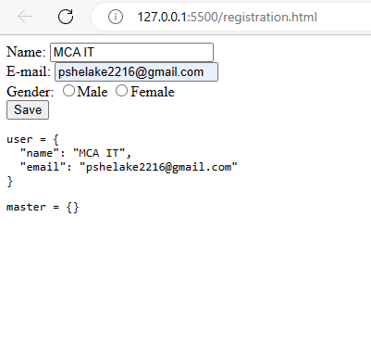

Practical No – 41
Create an application in angular JS to demonstrate single page appplication (SPA).
Code:
Spa.html
<!DOCTYPE html>
<html ng-app="myApp">
<head>

<link rel="stylesheet" href= "//netdna.bootstrapcdn.com/bootstrap/3.0.0/css/bootstrap.min.css" />
<link rel="stylesheet" href= "//netdna.bootstrapcdn.com/font-awesome/4.0.0/css/font-awesome.css" />

<script src= "https://ajax.googleapis.com/ajax/libs/angularjs/1.2.25/angular.min.js"></script>
<script src="//ajax.googleapis.com/ajax/libs/angularjs/1.2.25/angular-route.js"></script>
<script src="angular.min.js"></script>
<script src="scriptEX.js"></script>

</head>
<body ng-controller="mainController">
<header>
<nav class="navbar navbar-default">
<div class="container">
<div class="navbar-header">
<a class="navbar-brand" href="/">Angular Routing Example</a>
</div>

<ul class="nav navbar-nav navbar-right">
<li><a href="#"><i class="fa fa-home"></i> Home</a></li>
<li><a href="#about"><i class="fa fa-shield"></i> About</a></li>
<li><a href="#contact"><i class="fa fa-comment"></i> Contact</a></li>
</ul>
</div>
</nav>
</header>

<div id="main">

<div ng-view></div>
</div>

</body>
</html>

__________________________________________________________
scriptEX.js
Code:-

var myApp = angular.module('myApp', ['ngRoute']);
// configure our routes
myApp.config(function($routeProvider) {
$routeProvider

// route for the home page
.when('/', {
templateUrl : 'home.html',
controller : 'mainController'
})

// route for the about page
.when('/about', {
templateUrl : 'about.html',
controller : 'aboutController'
})

.when('/contact', {
templateUrl : 'contact.html',
controller : 'contactController'
});
});

// create the controller and inject Angular's $scope
myApp.controller('mainController', function($scope) {
// create a message to display in our view
$scope.message = 'Everyone come and see how good I look!';
});

myApp.controller('aboutController', function($scope) { $scope.message = 'Look! I am an about page.';
});
myApp.controller('contactController', function($scope) {
$scope.message = 'Contact us! This is just a demo.';
});

home.html

<div class="jumbotron text-center">
<h1>Home Page</h1>
<h3>We can build Single Page Application (SPA) with AngularJS.
It is a web app that loads a single HTML page and dynamically
updates that page as the user interacts with the web app.
AngularJS supports SPA using routing module ngRoute.
This routing module acts based on the url. When a user prathamesh request a specific url,
the routing engine captures that url and renders the view based on the
defined routing rules. </h3>

<p>{{ message }}</p>

</div>

_________________________________________________________

About page:-
<div class="jumbotron text-center">
<h1>About Page</h1>
<img src="1.jpg" alt="Nature" height='350' width='550'\>
<p>{{ message }}</p>
</div>

_________________________________________________________

CONTACT.hmtl

<div class="jumbotron text-center">
<h1>Contact Page</h1>
<p> You can contact us on 9021391145 </p>
<p>{{ message }}</p>
</div>

Output :
