PRACTICAL NO:1 ASSIGNMENT ON JAVA GENERICS

Practical No. 1a Assignment on Java Generics

1a. Write a Java Program to demonstrate a Generic Class. Code :-
class Test<T, U{ T obj1;
U obj2;
Test(T obj1, U obj2)
{
this.obj1 = obj1;
this.obj2 = obj2;
}
public void print()
{
System.out.println(obj1);
System.out.println(obj2);
}
}
class Main// Driver class to test above
{
public static void main (String[] args)
{
Test <String, Integer>obj =
new Test<String, Integer>("Riya", 74); obj.print();
}

}

Output:-
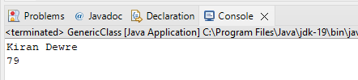

Practical No. 1b Assignments on Java Generics

1b. Write a Java program to demonstrate Generic Methods. Code :-
public class genericmethod
{
static <T> void genericDisplay(T element)
{
System.out.println(element.getClass().getName()+ " = " + element);
}
public static void main(String[] args)
{
genericDisplay(130); genericDisplay("Generic Method"); //
genericDisplay(3.0);
}
}

Output:-

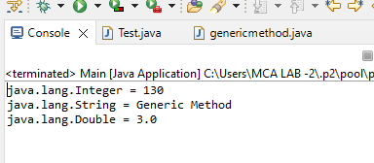

Practical No. 1c Assignments on Java Generics

1c. Write a Java program to demonstrate Wildcards in java. Upper bound wildcard
Code :-
import java.util.Arrays; import java.util.List; class Wildcards {
public static void main(String[] args)
{
List<Integer> list1 = Arrays.asList(1,2,4,5, 6, 7); System.out.println("Sum of the elements in int_list:" + sum(list1)); List<Double> list2 = Arrays.asList(4.1, 5.1, 6.1,7.1,8.1); System.out.print("Sum of the elements in int_list:" + sum(list2)); }
private static double sum(List<? extends Number> list)
{
double sum = 0.0;
for (Number i : list) {
sum += i.doubleValue();
}
return sum;
}
}

Output:-
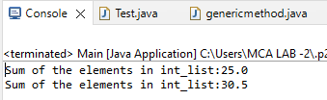

Lower bound wildcard Code:-
import java.util.Arrays; import java.util.List; class LowerWildcard {
public static void main(String[] args)
{
List<Integer> list1 = Arrays.asList(2,8,9,3,5); printOnlyIntegerClassorSuperClass(list1); List<Number> list2 = Arrays.asList(10,8,7,3); printOnlyIntegerClassorSuperClass(list2); }
public static void printOnlyIntegerClassorSuperClass( List<? super Integer> list)
{
System.out.println(list);
}
}

Output:-

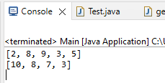

Unbounded wildcard
Code :-
import java.util.Arrays;
import java.util.List;
class UnboundedWildcard {
public static void main(String[] args)
{ // Integer List
List<Integer> list1 = Arrays.asList(8,9,10); List<Double> list2 = Arrays.asList(1.7, 3.2, 6.3); printlist(list1);
printlist(list2);
}
private static void printlist(List<?> list)
{
System.out.println(list);
}
}

Output:-

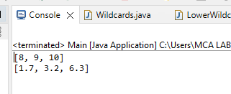

PRACTICAL NO: 2 ASSIGNMENT ON LIST INTERFACE

Practical No. 2a Assignment on List Interface

2a. Write a Program in Java to demonstrate for-each loop in List interface. Code:-
import java.util.*;
public class List1
{
public static void main(String args[])
{ //Creating a List
List<String> list=new ArrayList<String>(); //Adding elements in the List list.add("Strawberry");
list.add("Peach");
list.add("Banana");
list.add("Apple"); //Iterating the List element using for-each loop
for(String fruit:list) System.out.println(fruit);
}
}

Output:-

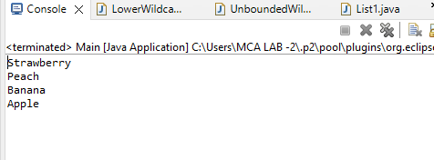

Practical No. 2b Assignments on List Interface

2b. Write a Program in Java to demonstrate ListIterator interface in List interface.
import java.util.*;
public class ListIterators {
public static void main(String[] args)
{ // list of names
List<String> names = new LinkedList<>(); names.add("LOVE");
names.add("is");
names.add("WASTE");
// Getting ListIterator
ListIterator<String> listIterator = names.listIterator();
// Traversing elements System.out.println("Forward Iteration:"); while (listIterator.hasNext()) {
System.out.println(listIterator.next());
} // Traversing elements, the iterator is at the end // at this point System.out.println("Backward Iteration:");
while (listIterator.hasPrevious()) { System.out.println(listIterator.previous());} }}
Output:-
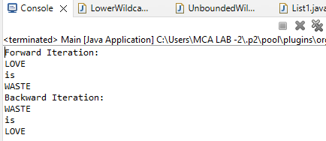

PRACTICAL NO:3 ASSIGNMENT ON SET INTERFACE

Practical No. 3a Assignments on Set Interface

3a. WAP in Java to print the items in the list.
import java.util.*;

class XYZ

{public static void main(String[] args) { TreeSet<String> treeadd = new TreeSet<String>();
treeadd.add("CHAIR"); treeadd.add("TABLE"); treeadd.add("ROAD"); treeadd.add("WINDOW"); System.out.println("TreeSet: " + treeadd); NavigableSet<String>
treereverse = treeadd.descendingSet(); Iterator<String> iterator = treereverse.iterator(); System.out.println("\nValues using DescendingSet:"); while (iterator.hasNext())
{System.out.println("Value : "+ iterator.next());}}

}

Output:-
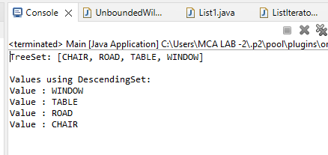

Practical No. 3b Assignments on Set Interface

3b. WAP in Java to perform various operations of Set interface.
import java.util.*;
public class Sets
{
public static void main(String[] args)
{
HashSet set1=new HashSet(); set1.add(145);
set1.add(085); set1.add(765); set1.add(154); set1.add(null); set1.add(258);
System.out.println("Elements in set1:"+set1); HashSet set2=new HashSet(); set2.addAll(set1); System.out.println("Elements in set1:"+set2); set1.clear();
System.out.println("Element in set1:"+set1); System.out.println("Does set 2 contains 99?:"+set2.contains(765)); System.out.println("Does set 2 contains 100?:"+set2.contains(258));
}
}
Output:-

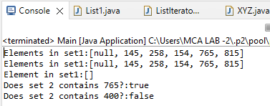

PRACTICAL NO:4
Assignment On Map Interface

Practical No. 4 Assignments on Map Interface

(a) WAP in Java to perform operations on Map interface.

import java.util.*;

import java.util.HashSet;

public class MapPracticals

{public static void main(String[] args) { Map map1=new HashMap();
map1.put (55, 25);

map1.put (12, 32);

map1.put (78, 157);

map1.put (587, 321);

map1.put (251, 147);

Set set=map1.entrySet();

System.out.println("Elements in map1: "+map1); Iterator itr=set.iterator();
System.out.println("Elements in map1 are, ");

while (itr.hasNext()){

Map.Entry entry= (Map.Entry)itr.next();

System.out.println(entry.getKey()+" "+entry.getValue());} map1.remove(12, 32);
Iterator itr1=set.iterator();

System.out.println("Elements after deleting 12,32 are: ");

while(itr1.hasNext()) {

Map.Entry entry=(Map.Entry) itr1.next();

System.out.println(entry.getKey()+" "+entry.getValue());} System.out.println("Does mapl contains 55?"+map1.containsValue (55)); System.out.println("Does mapl contains 01?"+map1.containsValue (01)); Map map2= new HashMap();
map2.putAll(map1);

System.out.println("Elements in map2: "+map2); Iterator itr2=set.iterator();
System.out.println("Elements in map2 are, ");

while (itr2.hasNext()){

Map.Entry entry=(Map.Entry) itr2.next();

System.out.println(entry.getKey()+" "+entry.getValue());}}}

Output:-
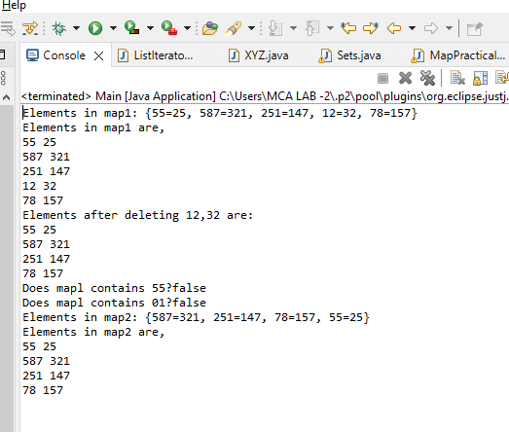

PRACTICAL NO:5
Assignment On Lambda Expression

Practical No. 5a Assignments on Lambda Expression

5a.WAP in Java using Lambda Expression with single parameters..

interface Kiran
{ public String say(String name); }
public class Lambda{
public static void main(String[] args) { Riya s1=(name)->{
return "HEYY, "+name; }; System.out.println(s1.say("Kiran")); Sayable s2= name ->{
return "Hello, "+name;
};
System.out.println(s2.say("Dewre"));
}
}

Output:-

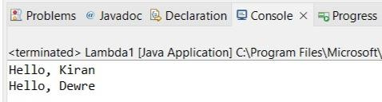

Practical No. 5b Assignments on Lambda Expression

5b.WAP in Java using Lambda Expression with multiple parameters to add two numbers.

interface Add
{ int add(int a,int b); }
public class Lambda{
public static void main(String[] args) {
// Multiple parameters in lambda expression Add ad1=(a,b)->(a+b); System.out.println(ad1.add(100,210));
// Multiple parameters with data type in lambda expression Add ad2=(int a,int b)->(a+b); System.out.println(ad2.add(174,975));
}
}

Output:-

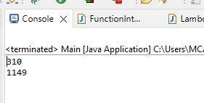

Practical No. 5c Assignments on Lambda Expression

5C.Write a Java program using Lambda Expression to show temperature conversion.

Convert Fahrenheit to Celcius

import java.util.function.Function;
public class Apple{
public static void main(String[] args) {
Function<Integer,Double> centToFahrenheitInt = x -> new Double((x*94/10)+12); double fahrenheit = centToFahrenheitInt.apply(100); System.out.println("Centigrade to Fahrenheit: "+fahrenheit);
}
}

Output:-
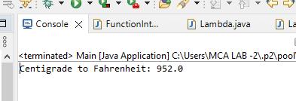

- Convert Kilometers to Miles.

import java.util.function.Function;
public class Ball{
public static void main(String[] args) {
Function<Integer,Double> FahrenheitIntTocent = x -> new Double((x-76)*8)/5;
double fahrenheit = FahrenheitIntTocent.apply(100); System.out.println(" Fahrenheit to Celcius : "+fahrenheit);
}
}

Output:-
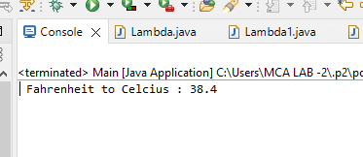

Practical No. 5d Assignments on Lambda Expression
5d.Write a Java program using Lambda Expression with or without return keyword.

package Riys_74;
interface Addable{
int add(int a,int b); }
class Lambda3 {
public static void main(String[] args)
{ // Lambda expression without return keyword.
Addable ad1=(a,b)->(a+b); System.out.println(ad1.add(29,51));
// Lambda expression with return keyword. Addable ad2=(int a,int b)->{ return (a+b); }; System.out.println(ad2.add(300,250));
}
}

Output:-

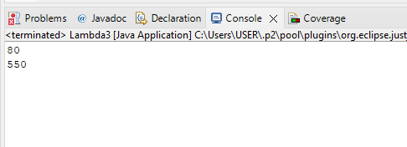

Practical No. 5e Assignments on Lambda Expression

5e.Write a Java program using Lambda Expression to concatenate two strings.
package Kiran_79; import java.util.*; import java.util.stream.*; public class C {
public static void main(String[] args) { List<String> list = new ArrayList<>(); list.add("Kir");
list.add("tee");
list.add("shu"); String result = list
.stream()
.map(s -> s.substring(0, 3))
.collect(Collectors.joining()); System.out.println(result);
}
}
Output:-

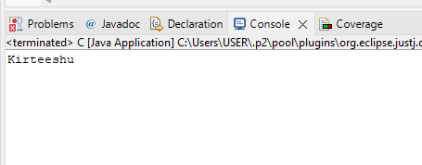

PRACTICAL NO:6
Assignments based on web application development using JSP

Practical No : 6a
Assignments based on web application development using JSP

6a. Design a webpage using JSP to demonstrate the telephone directory
<%@page import="java.sql.*"%>
<%@ page import="java.io.PrintWriter"%>
<%@page import="java.sql.SQLException"%>
<%@page import="java.sql.DriverManager"%>
<%@page import="java.sql.Connection"%>
<%@page import="java.sql.PreparedStatement"%>
<%@ page language="java" contentType="text/html; charset=ISO-8859-1"
pageEncoding="ISO-8859-1"%>
<!DOCTYPE html>
<html>
<head>
<meta charset="ISO-8859-1">
<title>Insert title here</title>
</head>
<body>
<form name="A" method="post" action="index.jsp">

<table>

<tr><td>Enter Name:</td>
<td><input type="text" name="T2" placeholder="Enter Your Name">
</td>

</tr>
<tr><td>Enter Number:</td>
<td><input type="tel" name="T3" placeholder="Enter Mobile No">
</td>
</tr>
<input type="text" name="task" value="insert" hidden>
<tr><td>
<button type="reset">Reset</button>
</td>

</form>
<%

</tr>
<td> <button type="submit">Insert</button>
</td>

String task = request.getParameter("task");

if (task != null) {
if (task.equals("insert")) {

String nm = request.getParameter("T2"); String nu = request.getParameter("T3"); System.out.print(task); Class.forName("com.mysql.cj.jdbc.Driver");

String username = "root"; String password = "";
String url = "jdbc:mysql://localhost:3306/studentdb1";
Connection con = DriverManager.getConnection(url, username, password);
//Connection con= DriverManager.getConnection("sd_db","root","root");
try {
String q = "insert into user values(?,?)"; PreparedStatement ps = con.prepareStatement(q);

ps.setString(1, nm); ps.setString(2, nu);

int a = ps.executeUpdate();
if (a <= 0) {
out.print("Error in Record Insertion");

} else {

}

out.print(a + " contact is Inserted");

ps.close();
//con.close();
} catch (SQLException e) { out.print(e);
} catch (Exception e) { out.print(e);
} finally {

try {

//ps.close();
con.close();

} catch (Exception e) {
out.print("I an finally block");
}
}
out.print("inserted successfully");
}

if (task.equals("show")) {

Class.forName("com.mysql.cj.jdbc.Driver"); String username = "root";
String password = "";
String url = "jdbc:mysql://localhost:3306/studentdb1";
Connection con = DriverManager.getConnection(url, username, password); ResultSet rs;
String query = "select * from user";
try {
Statement s = con.createStatement(); PrintWriter pw = response.getWriter(); rs = s.executeQuery(query);
%>

<table border="1" cellspacing=0; cellpadding="10" align="center">

<thead>
<tr><th>NAME</th>
<th>PHONE NUMBER</th>
</tr>
</thead>
<tbody>
<%
while (rs.next()) {
%>

<tr><th><%=rs.getString(1)%></th>
<th><%=rs.getString(2)%></th>
</tr>
<%
}
%>

</tbody>
</table>
<%
} catch (Exception e) { e.printStackTrace();
}

}
}
%>

</body>
</html>

Output:-

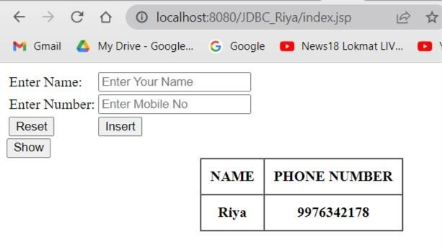

Practical No : 6b

Assignments based on web application development using JSP 6b. Design a webpage using JSP to display the Registration form
<%@ page language="java" contentType="text/html; charset=ISO-8859-1"
pageEncoding="ISO-8859-1"%>
<!DOCTYPE html>
<html>
<head>
<meta charset="ISO-8859-1">
<title>Insert title here</title>
</head>
<body>
<h1>Register Form - Practical form</h1>
<form action="guru_register" method="post">
<table style="with: 50%">
<tr>

</tr>
<tr>

</tr>
<tr>

</tr>

</tr>
<tr>

</tr>
<tr>
<td>First Name</td>
<td><input type="text" name="first_name" /></td>

<td>Last Name</td>
<td><input type="text" name="last_name" /></td>

<td>UserName</td>
<td><input type="text" name="username" /></td>

<tr>
<td>Password</td>
<td><input type="password" name="password"
/></td>

<td>Address</td>
<td><input type="text" name="address" /></td>

<td>Contact No</td>
<td><input type="text" name="contact" /></td>

</tr></table>
<input type="submit" value="Register" /></form>

</body>
</html>

Output:-

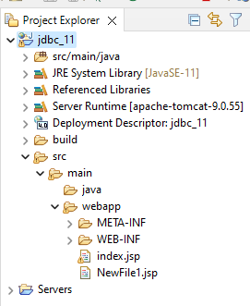

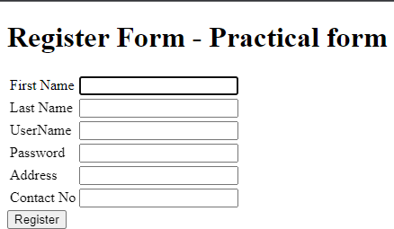

Practical No : 6c

Assignments based on web application development using JSP

6c.Write a JSP program to add, delete and display the records from a table.

Insert.jsp

<%@page import="java.sql.*"%>
<%@ page language="java" contentType="text/html; charset=ISO-8859-1"
pageEncoding="ISO-8859-1"%>
<!DOCTYPE html>
<html>
<head>
<meta charset="ISO-8859-1">
<title>Insert title here</title>
</head>
<body>
<form name="b" method="post" action="insert.jsp">

<table>
<tr>

</tr>
<tr>

</tr>
<tr>

</tr>
<tr>

</tr>

<td>Roll No:</td>
<td><input type="number" name="T1" placeholder="Enter Your Roll No"></td>

<td>Name:</td>
<td><input type="text" name="T2" placeholder="Enter Your Name">
</td>

<td>Semester:</td>
<td><input type="text" name="T3" placeholder="Enter Semester">
</td>

<td>Course:</td>
<td><input type="text" name="T4" placeholder="Enter Your Course"></td>

<input type="text" name="task" value="insert" hidden>

<tr>

</tr>

<td><input type="reset"></td>
<td><input type="submit"></td>

</form>
<th><a href="show.jsp">show</a></th>
</table>

<%
String task = request.getParameter("task");
if (task != null) {
if (task.equals("insert")) {

String rn = request.getParameter("T1"); String nm = request.getParameter("T2"); String sem = request.getParameter("T3"); String cour = request.getParameter("T4"); System.out.print(task); Class.forName("com.mysql.cj.jdbc.Driver"); String username = "root";
String password = "";
String url = "jdbc:mysql://localhost:3306/studentdb1"; Connection con = DriverManager.getConnection(url, username, password);
//Connection con= DriverManager.getConnection("SM_db","root","root"); try {
String q = "insert into student1 values(?,?,?,?)"; PreparedStatement ps = con.prepareStatement(q);

ps.setString(1, rn); ps.setString(2, nm); ps.setString(3, sem); ps.setString(4, cour);

int a = ps.executeUpdate();
if (a <= 0) {
out.print("Error in Record Insertion");
} else {
out.print(a + " contact is Inserted");
}
ps.close();
//con.close();
} catch (SQLException e) { out.print(e);
} catch (Exception e) {

out.print(e);
} finally {

try {

//ps.close();
con.close();

} catch (Exception e) {
out.print("I an finally block");
}
}
out.print("inserted successfully");
}

if (task.equals("update")) {

String rn = request.getParameter("T1"); String nm = request.getParameter("T2"); String sem = request.getParameter("T3"); String cour = request.getParameter("T4"); System.out.print(task); Class.forName("com.mysql.cj.jdbc.Driver"); String username = "root";
String password = "";
String url = "jdbc:mysql://localhost:3306/studentdb1"; Connection con = DriverManager.getConnection(url, username, password);
//Connection con= DriverManager.getConnection("SM_db","root","root"); try {
//String q = "insert into student values(?,?,?,?)";
String q = "update student1 set name=?,sem=?,course=? where id=?";

PreparedStatement ps = con.prepareStatement(q);
ps.setString(4, rn); ps.setString(1, nm); ps.setString(2, sem);
ps.setString(3, cour);

int a = ps.executeUpdate();
if (a <= 0) {
out.print("Error in Record updation");
} else {
//out.print(a + " data is Inserted");
}
ps.close();
//con.close();
} catch (SQLException e) {

out.print(e);
} catch (Exception e) { out.print(e);
} finally {

try {

//ps.close();
con.close();

} catch (Exception e) {
out.print("I an finally block");
}
}
out.print("updated successfully");
}
if (task.equals("delete")) {

String rn = request.getParameter("roll_no"); Class.forName("com.mysql.cj.jdbc.Driver"); String username = "root";
String password = "";
String url = "jdbc:mysql://localhost:3306/studentdb1"; Connection con = DriverManager.getConnection(url, username, password);
//Connection con= DriverManager.getConnection("SM_db","root","root"); try {
String q = "delete from student where id="+rn; PreparedStatement ps = con.prepareStatement(q);

int a = ps.executeUpdate();
if (a <= 0) {
out.print("Error in deletion");
} else {
out.print(a + " data is deleted");
}
ps.close();
//con.close();
} catch (SQLException e) { out.print(e);
} catch (Exception e) { out.print(e);
} finally {

try {

//ps.close();
con.close();

} catch (Exception e) {
out.print("I an finally block");}}}}%

</body>
</html>

Show.jsp:-

<%@ page import="java.io.PrintWriter"%>
<%@page import="java.sql.*"%>
<%@ page language="java" contentType="text/html; charset=ISO-8859-1"
pageEncoding="ISO-8859-1"%>
<!DOCTYPE html>
<html>
<head>
<meta charset="ISO-8859-1">
<title>Insert title here</title>
</head>
<body>
<%
Class.forName("com.mysql.cj.jdbc.Driver");
String username = "root"; String password = "";
String url = "jdbc:mysql://localhost:3306/studentdb1"; Connection con = DriverManager.getConnection(url, username, password);
ResultSet rs;
String query = "select * from student1";

try {
Statement s = con.createStatement(); PrintWriter pw = response.getWriter(); rs = s.executeQuery(query);
%>

<table border="1" cellspacing=0; cellpadding="10" align="center">
<thead>
<tr>

<th>Roll No</th>
<th>Name</th>
<th>Semester</th>
<th>Course</th>
<th colspan="2">ACTION</th>

</tr>
</thead>
<tbody>
<%
while (rs.next()) {

%>

<tr>

<th><%=rs.getString(1)%></th>
<th><%=rs.getString(2)%></th>
<th><%=rs.getString(3)%></th>
<th><%=rs.getString(4)%></th>
<th><form action="update.jsp" method="post">
<input name="roll_no" value="<%=rs.getString(1)%>" hidden>
<input type=submit value="edit" />

</form></th>
<th><form action="insert.jsp" method="post">
<input name="roll_no" value="<%=rs.getString(1)%>" hidden>
<input name="task" value="delete" hidden>
<input type=submit value="delete" />

</form></th>

</tr>
<% } %>

</tbody>
</table >
<table align="center">
<th ><a href="insert.jsp">home</a></th>
</table>
<%
} catch (Exception e) { e.printStackTrace();
}

%>

</body>
</html>

Update.jsp:-

<%@ page import="java.io.PrintWriter"%>
<%@page import="java.sql.*"%>
<%@ page language="java" contentType="text/html; charset=ISO-8859-1"
pageEncoding="ISO-8859-1"%><!DOCTYPE html>
<html>
<head>
<meta charset="ISO-8859-1">
<title>Insert title here</title>
</head>
<body>

<form name="b" method="post" action="insert.jsp">
<%
String roll_no = request.getParameter("roll_no");
if (roll_no != null) { Class.forName("com.mysql.cj.jdbc.Driver"); String username = "root";
String password = "";
String url = "jdbc:mysql://localhost:3306/studentdb1"; Connection con = DriverManager.getConnection(url, username, password);
ResultSet rs;
String query = " select * from student1 where Roll no=" + roll_no;

try {

%>
<%

Statement s = con.createStatement(); PrintWriter pw = response.getWriter(); rs = s.executeQuery(query);

while (rs.next()) {
%>

<table>
<tr>

</tr>
<tr>

<td>Roll No:</td>
<td><input type="number" name="T1" value="<%=rs.getString(1)%>">
</td>

<td>Name:</td>

</tr>
<tr>

</tr>
<tr>

</tr>
<td><input type="text" name="T2" value="<%=rs.getString(2)%>">
</td>

<td>Semester:</td>
<td><input type="text" name="T3" value="<%=rs.getString(3)%>">
</td>

<td>Course:</td>
<td><input type="text" name="T4" value="<%=rs.getString(4)%>">
</td>

<input type="text" name="task" value="update" hidden>
<tr>

</form>

</tr>

</table>
<td><input type="reset"></td>
<td><input type="submit"></td>

<%
}
} catch (Exception e) { e.printStackTrace();
}
}
%>
</body>
</html>

Output:-
- Insert

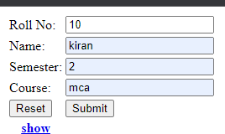

- Show

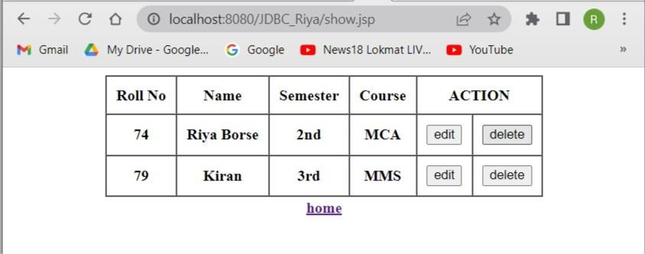

- Update

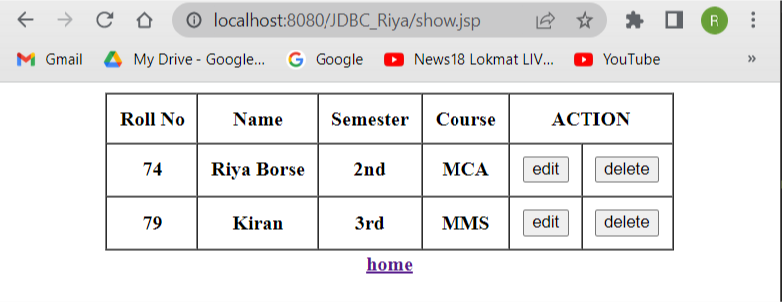

2) Delete

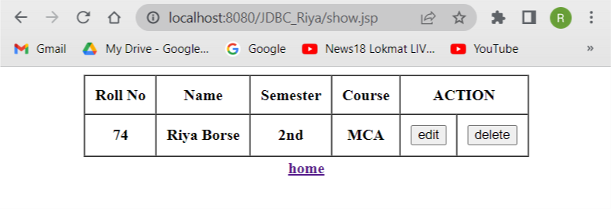

Practical No : 6d

Assignments based on web application development using JSP

6d.Design loan calculator web page using JSP Index.jsp

<%@ page language="java" contentType="text/html; charset=ISO-8859-1" pageEncoding="ISO-8859-1"%>
<!DOCTYPE html>
<html>
<head>
<meta charset="ISO-8859-1">
<title>Insert title here</title>
</head>
<body>
<form action="prac3-1.jsp" method="post">
<table style="with: 50%">

<tr>

</tr>
<tr>

</tr>
</table>

<td>Enter Principal amount</td>
<td><input type="number" name="pa" /></td>

<td>Enter time period (In years)</td>
<td><input type="number" name="ti" /></td>
<td><input type="text" name="task" value="cal" hidden /></td>

</form>

<%
<input type="submit" value="Calculate" />
String task = request.getParameter("task"); if (task != null) {
float pa = Float.parseFloat(request.getParameter("pa")); float ti = Float.parseFloat(request.getParameter("ti")); float rate;
if (ti < 8f && ti >= 1f) { rate = 5.35f;
} else if (ti <= 15f && ti >= 8f) { rate = 5.5f;
} else {
rate = 6.5f;}
float r = rate / (12 * 100); // one month interest float t = ti * 12; // one month period
float emi = (pa * r * (float) Math.pow(1 + r, t)) / (float) (Math.pow(1 + r, t) - 1); out.println("Principal amount : " + pa);
%><br>
<%
out.println("Time in years : " + ti);
%><br>
<%
out.println("Rate of interest : " + rate);
%><br>
<%
out.println("EMI is : " + emi);
}
%>
</body>
</html>

Output:-

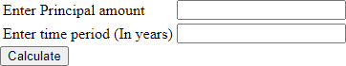

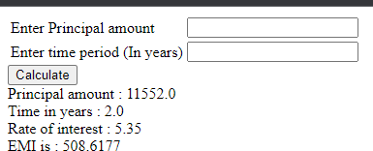

Practical No : 6e

Assignments based on web application development using JSP

6e.Design a webpage using JSP to display a webpage for change of Study Center

Index.jsp

<%@page import="java.sql.*"%>
<%@ page language="java" contentType="text/html; charset=ISO-8859-1"
pageEncoding="ISO-8859-1"%>
<!DOCTYPE html>
<html>
<head>
<meta charset="ISO-8859-1">
<title>Insert title here</title>
</head>
<body>
<form name="b" method="post" action="p5.jsp">

<table>
<tr>

</tr>
<tr>

</tr>
<tr>

</tr>
<tr>

</tr>

<td>Roll No:</td>
<td><input type="number" name="T1" placeholder=""></td>

<td>Name:</td>
<td><input type="text" name="T2" placeholder=""></td>

<td>Previous exam center:</td>
<td><input type="text" name="T3" placeholder=""></td>

<td>New exam center:</td>
<td><input type="text" name="T4" placeholder=""></td>

<input type="text" name="task" value="insert" hidden>
<tr>

</tr>

</table>
<td><input type="submit" value="Send Request"></td>
<br>

</form>
<br>
<form action="prac5.jsp" method="post">
<input name="task" value="show_student" hidden> <input type=submit value="Show Students Record" /><br>

</form>
<form action="prac5.jsp" method="post">
<input name="task" value="show_Requests" hidden><br> <input type=submit value="Show exam center changing requests" />

</form>

<%
String task = request.getParameter("task"); Class.forName("com.mysql.jdbc.Driver"); String username = "root";
String password = "";

Connection con = DriverManager.getConnection("jdbc:mysql://localhost/studentdb1", "root", "");

if (task != null) {
if (task.equals("insert")) {

String rn = request.getParameter("T1"); String nm = request.getParameter("T2"); String pc = request.getParameter("T3"); String nc = request.getParameter("T4");

//Connection con= DriverManager.getConnection("SM_db","root","root");
try {
String q = "insert into requests(id,name,p_center,n_center) values(?,?,?,?)"; PreparedStatement ps = con.prepareStatement(q);

ps.setString(1, rn); ps.setString(2, nm); ps.setString(3, pc); ps.setString(4, nc);

int a = ps.executeUpdate();
if (a <= 0) {
out.print("Error in Record Insertion");
} else {

out.print("Request sent successfully");

}
ps.close();
//con.close();
} catch (SQLException e) {

out.print(e);
} catch (Exception e) { out.print(e);
}

}
if (task.equals("show_student")) { ResultSet rs;
String query = "select * from student";
try {
Statement s = con.createStatement();

rs = s.executeQuery(query);
%>

<h1 style="text-align: center;">All Students</h1>

<table border="1" cellspacing=0; cellpadding="10" align="center">
<thead>
<tr>
<th>Roll No</th>
<th>Name</th>
<th>Exam center</th>
</tr>
</thead>
<tbody>
<%
while (rs.next()) {
%>
<tr>
<th><%=rs.getString(1)%></th>
<th><%=rs.getString(2)%></th>
<th><%=rs.getString(3)%></th>
<!-- <th>
<form action="update.jsp" method="post">
<input name="roll_no" value="" hidden>
<input type=submit value="edit" />
</form>
</th> -->

</tr>
<%
}
%>

</tbody>
</table>

<%

} catch (Exception e) { e.printStackTrace();
}
}
if (task.equals("show_Requests")) { ResultSet rs;
String query = "select * from requests";
try {
Statement s = con.createStatement();

rs = s.executeQuery(query);
%>

<h1 style="text-align: center;">Exam center Changing requests</h1>

<table border="1" cellspacing=0; cellpadding="10" align="center">
<thead>
<tr>
<th>Sr No</th>
<th>Roll No</th>
<th>Name</th>
<th>Previous center</th>
<th>New center</th>
<th>Status</th>
</tr>
</thead>
<tbody>
<%
while (rs.next()) {
%>
<tr?
<th><%=rs.getString(1)%></th>
<th><%=rs.getString(2)%></th>
<th><%=rs.getString(3)%></th>
<th><%=rs.getString(4)%></th>
<th><%=rs.getString(5)%></th>

<th>

<form action="prac5.jsp" method="post">
<input name="task" value="approve_req" hidden>
<input

name="roll_no" value="<%=rs.getString(2)%>" hidden>
<input
name="nc" value="<%=rs.getString(5)%>" hidden> <input
name="request_id" value="<%=rs.getString(1)%>" hidden>
<input

type=submit value="Approve" />

</form>
</th>

</tr>
<%
}
%>

</tbody>
</table>

<%
} catch (Exception e) { e.printStackTrace();
}
}

if (task.equals("approve_req")) {

String rn = request.getParameter("roll_no"); String ri = request.getParameter("request_id"); String nc = request.getParameter("nc");

String q = "update student set center=? where id=?"; PreparedStatement ps = con.prepareStatement(q);
ps.setString(1, nc); ps.setString(2, rn);

int a = ps.executeUpdate();
if (a <= 0) {
out.print("Error in Record updation");
} else {
out.print(" data updated successfully");
}

String q2 = "delete from requests where req_id=" + ri; PreparedStatement ps2 = con.prepareStatement(q2);

int a2 = ps2.executeUpdate();
if (a2 <= 0) { out.print("Error in deletion");
} else {
System.out.print(" data is deleted");
}}%>
<%
}

%>

</body>

Output:-

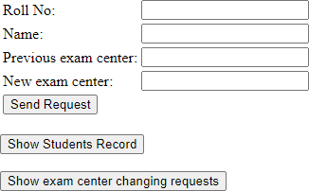

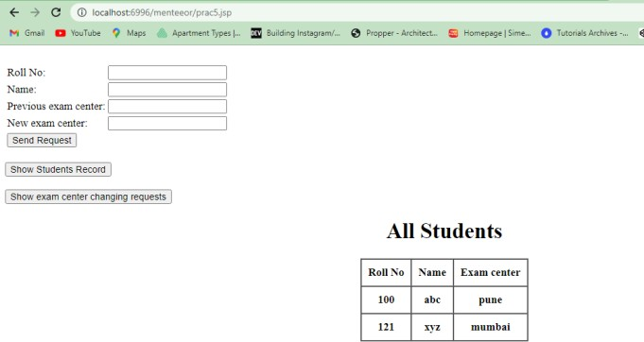

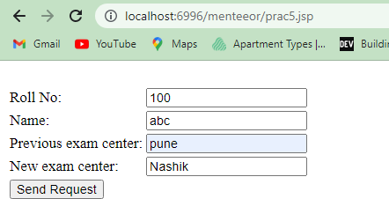

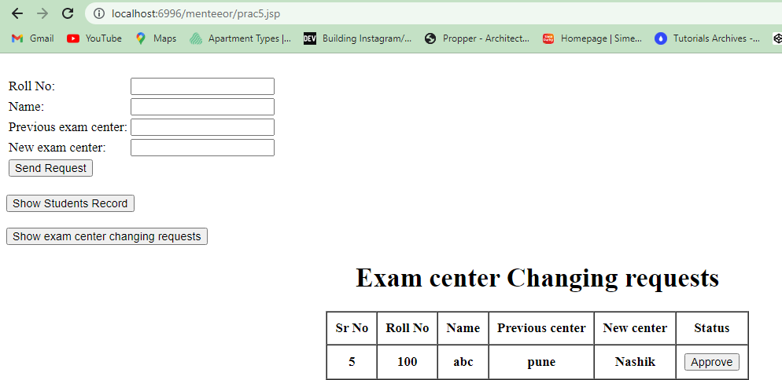

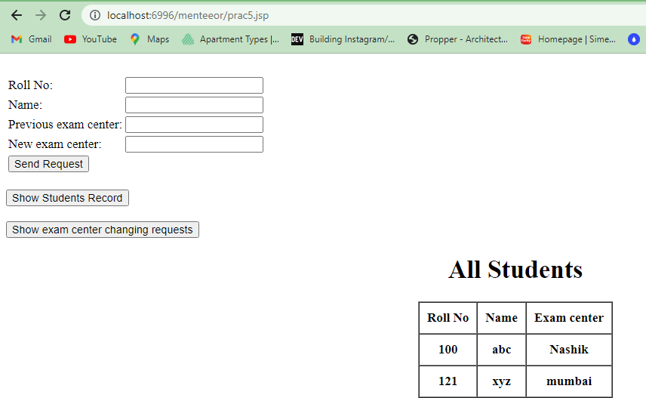

Practical No : 6f

Assignments based on web application development using JSP

6f.Write a JSP program that demonstrates the use of various JSP tags..
<%@ page import="java.util.Date"%>
<%@ page language="java" contentType="text/html; charset=ISO-8859-1"
pageEncoding="ISO-8859-1"%>
<!DOCTYPE html>
<html>
<head>
<meta charset="ISO-8859-1">
<title>Insert title here</title>
</head>
<body>
<%@ include file="header.jsp"%>
<!-- scriplet tag -->
<%!String name = "Rohit";%>
<%
out.print("welcome " + name);
%>
<!-- expression tag -->
<%="welcome to jsp"%>
<br>
<br>
<!-- declaration tag -->

<%!int data = 50;%>
<%="Value of the variable is:" + data%>
<br>
<br>
<%@ include file="footer.jsp"%>
</body>
</html>
Output:-

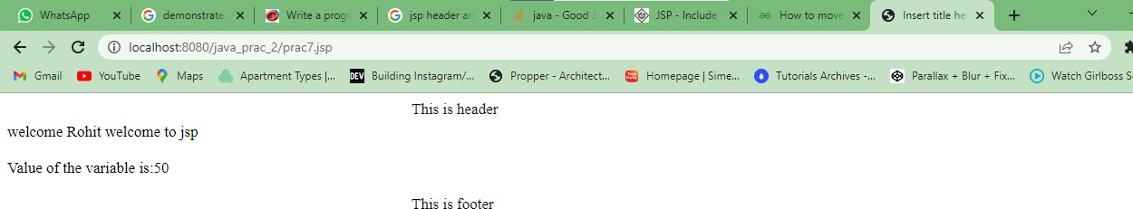

PRACTICAL NO:7
Assignment based Spring Framework

Practical No : 7a Assignment based Spring Framework

7a.WAP in Java using spring to demonstrate dependency injection via setter method .

Student.java File:-
package Animal;

public class Student {

private String studentName;
private String studentCourse;

public String getStudentName()
{
return studentName;
}

public void setStudentName(String studentName)
{
this.studentName = studentName;
}

public String getStudentCourse()
{
return studentCourse;
}

public void setStudentCourse(String studentCourse)
{
this.studentCourse = studentCourse;
}

@Override public String toString()
{
return "Student{"
+ "studentName= Robert" + studentName +
", studentCourse= MCA" + studentCourse + '}';
}
}

Main1.java File:-

package Animal;

import java.io.*;
import org.springframework.context.ApplicationContext;
import org.springframework.context.support.ClassPathXmlApplicationContext;
public class Main1 {
public static void main(String[] args)
{
ApplicationContext context = new ClassPathXmlApplicationContext("config.xml"); Student student= (Student)context.getBean("stud");
System.out.println(student);
}
}

Config.xml File
<?xml version="1.0" encoding="UTF-8"?>
<beans xmlns="http://www.springframework.org/schema/beans" xmlns:xsi="http://www.w3.org/2001/XMLSchema-instance"
xmlns:context="http://www.springframework.org/schema/context" xsi:schemaLocation="http://www.springframework.org/schema/beans
https://www.springframework.org/schema/beans/spring-beans.xsd http://www.springframework.org/schema/context http://www.springframework.org/schema/context/spring-context.xsd">

<bean class="Animal.Student" name="stud">

</bean>
</beans>

Output:-

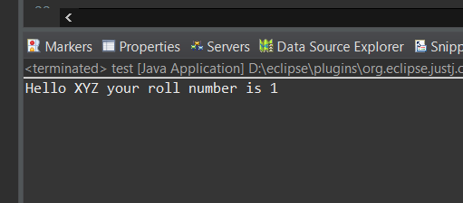

Practical No : 7b Assignment based Spring Framework

7b.WAP in Java using spring to demonstrate dependency injection via Constructor.

Main2.java File:-

package Animal;

import org.springframework.context.ApplicationContext;
import org.springframework.context.support.ClassPathXmlApplicationContext;
public class Main2 {
public static void main(String[] args) {
ApplicationContext context = new ClassPathXmlApplicationContext("Beans1.xml");

TextEditor te = (TextEditor) context.getBean("textEditor"); te.spellCheck();
}
}

TextEditor.java File:-

package Animal;
public class TextEditor {
private SpellChecker spellChecker;
public TextEditor(SpellChecker spellChecker) { System.out.println("Inside TextEditor constructor." ); this.spellChecker = spellChecker;
}
public void spellCheck() { spellChecker.checkSpelling();
}
}

SpellChecker.java File:-

package Animal;
public class SpellChecker {
public SpellChecker(){
System.out.println("Inside SpellChecker constructor." );
}
public void checkSpelling() { System.out.println("Inside checkSpelling." );
}}

Beans1.xml File:-

<?xml version = "1.0" encoding = "UTF-8"?>

<beans xmlns = "http://www.springframework.org/schema/beans" xmlns:xsi = "http://www.w3.org/2001/XMLSchema-instance" xsi:schemaLocation = "http://www.springframework.org/schema/beans http://www.springframework.org/schema/beans/spring-beans-3.0.xsd">

<!-- Definition for textEditor bean -->
<bean id = "textEditor" class = "Animal.TextEditor">
<constructor-arg ref = "spellChecker"/>
</bean>

<!-- Definition for spellChecker bean -->
<bean id = "spellChecker" class = "Animal.SpellChecker"></bean>

</beans>

Output:-

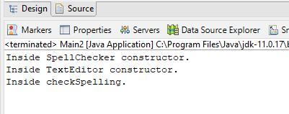

Practical No : 7b Assignment based Spring Framework

7c.WAP in Java using spring to demonstrate Autowiring. B.java File:-
package Animal;
public class B { B(){System.out.println("b is created");}
void print(){System.out.println("hello b");}
}

A1.java File:-

package Animal; public class A1 { B b;
A1(){System.out.println("a is created");}
public B getB() {
return b;
}
public void setB(B b) {
this.b = b;
}
void print(){System.out.println("hello a");}
void display(){ print();
b.print();
}
}

Cont.xml:-

<?xml version="1.0" encoding="UTF-8"?>
<beans
xmlns="http://www.springframework.org/schema/beans" xmlns:xsi="http://www.w3.org/2001/XMLSchema-instance" xmlns:p="http://www.springframework.org/schema/p"

xsi:schemaLocation="http://www.springframework.org/schema/beans http://www.springframework.org/schema/beans/spring-beans-3.0.xsd">

<bean id="b" class="org.sssit.B"></bean>
<bean id="a" class="org.sssit.A" autowire="byName"></bean>

</beans>

Test2.java File :-

package Animal;
import org.springframework.context.ApplicationContext;
import org.springframework.context.support.ClassPathXmlApplicationContext;
public class Test2 {
public static void main(String[] args) {
ApplicationContext context=new ClassPathXmlApplicationContext("cont.xml"); A a=context.getBean("a",A.class);
a.display();
}
}

Output:-

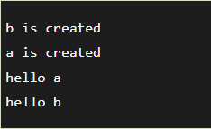

PRACTICAL NO:8
Assignment based Aspect Oriented Programming

Practical No. 8a
Assignment based Aspect Oriented Programming 8a.WAP to demonstrate Spring AOP – before advice.

A.java File:-

package Animal;
public class A
{
public void m()
{ System.out.println("actual business logic"); System.out.println("Additional concern before actual logic"); }
}

BeforeAdvisor.java File:-

package Animal;
import java.lang.reflect.Method;
import org.springframework.aop.MethodBeforeAdvice;
public class BeforeAdvisor implements MethodBeforeAdvice
{ @Override public void before(Method method, Object[] args, Object target) throws Throwable
{
System.out.println("actual business logic"); System.out.println("Additional concern before actual logic");
}
}

applicationContext.xml File:-

<?xml version="1.0" encoding="UTF-8"?>
<beans xmlns="http://www.springframework.org/schema/beans" xmlns:xsi="http://www.w3.org/2001/XMLSchema-instance" xmlns:p="http://www.springframework.org/schema/p"
xsi:schemaLocation="http://www.springframework.org/schema/beans http://www.springframework.org/schema/beans/spring-beans-3.0.xsd">

<bean id="obj" class="Animal.A"> </bean>
<bean id="ba" class="Animal.BeforeAdvisor"> </bean>
<bean id="proxy" class="org.springframework.aop.framework.ProxyFactoryBean">
<property name="target" ref="obj"> </property>
<property name="interceptorNames">
<list>

</list>
</property>
</bean>
</beans>

ProxyFactoryBean File:-

package Animal;
import java.util.List;
public class ProxyFactoryBean
{
private Object target;
private List interceptorNames;
//getters and setters
public Object getTarget() {
return target;
}
public void setTarget(Object target) {
this.target = target;
}
public List getInterceptorNames() {
return interceptorNames;
}
public void setInterceptorNames(List interceptorNames) {
this.interceptorNames = interceptorNames;
}
}

Test.java File:-

package Animal;
import org.springframework.beans.factory.BeanFactory;
import org.springframework.beans.factory.xml.XmlBeanFactory;
import org.springframework.core.io.ClassPathResource;
import org.springframework.core.io.Resource;
public class Test
{
public static void main(String[] args)

{
Resource r=new ClassPathResource("applicationContext.xml"); BeanFactory factory=new XmlBeanFactory(r);
A a=factory.getBean("proxy",A.class); a.m();
}
}

Output:-

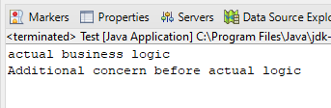

Practical No. 8b

Assignment based Aspect Oriented Programming

8b.WAP to demonstrate Spring AOP – after advice. Operation.java File:-
package Animal;
public class Operation
{
public void msg(){System.out.println("msg method invoked");} public int m(){System.out.println("m method invoked");return 2;} public int k(){System.out.println("k method invoked");return 3;}
}

applicationContext.xml File:-
<?xml version="1.0" encoding="UTF-8"?>
<beans xmlns="http://www.springframework.org/schema/beans". xmlns:xsi="http://www.w3.org/2001/XMLSchema-instance" xmlns:aop="http://www.springframework.org/schema/aop" xsi:schemaLocation="http://www.springframework.org/schema/beans http://www.springframework.org/schema/beans/spring-beans.xsd http://www.springframework.org/schema/aop http://www.springframework.org/schema/aop/spring-aop.xsd">
<bean id="opBean" class="Animal.Operation"> </bean>
<bean id="trackMyBean" class="Animal.TrackOperation"></bean>
<bean class="org.springframework.aop.aspectj.annotation.AnnotationAwareAspectJAutoP proxyCreator"> </bean>
</beans>

Test1.java File:-
package Animal;
import org.springframework.context.ApplicationContext;
import org.springframework.context.support.ClassPathXmlApplicationContext;
public class Test1
{
public static void main(String[] args)
{
ApplicationContext context = new ClassPathXmlApplicationContext("applicationContext.xml"); Operation e = (Operation) context.getBean("opBean");

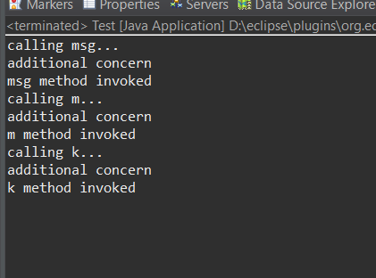
System.out.println("calling msg..."); e.msg();

System.out.println("calling m..."); e.m();

System.out.println("calling k..."); e.k();
}
}

TrackOperation.java File:-
package Animal;

//import org.aspectj.lang.JoinPoint;
//import org.aspectj.lang.annotation.After;
//import org.aspectj.lang.annotation.Pointcut;
//@Aspect
public class TrackOperation
{
//@Pointcut("execution(* Operation.*(..))")
public void k(){} //pointcut name
// @After("k()") //applying pointcut on after advice
//public void myadvice(JoinPoint jp) //it is advice (after advice)
{
System.out.println("additional concern");
//System.out.println("Method Signature: " + jp.getSignature());
//}

Output:

Practical No. 8c

Assignment based Aspect Oriented Programming 8c.WAP to demonstrate Spring AOP – around advice.
A.javavFile:-
package Animal;

public class A
{

public void m()
{ System.out.println("actual business logic"); System.out.println("Additional concern before actual logic"); }
}

AroundAdvisor.java File :-
package Animal;
import org.aopalliance.intercept.MethodInterceptor;
import org.aopalliance.intercept.MethodInvocation;
public class AroundAdvisor implements MethodInterceptor
{
@Override
public Object invoke(MethodInvocation mi) throws Throwable
{
Object obj;
System.out.println("additional concern before actual logic"); obj=mi.proceed();
System.out.println("additional concern after actual logic");
return obj;
}
}

applicationContext.xml File :-
<?xml version="1.0" encoding="UTF-8"?>
<beans xmlns="http://www.springframework.org/schema/beans" xmlns:xsi="http://www.w3.org/2001/XMLSchema-instance" xmlns:p="http://www.springframework.org/schema/p"
xsi:schemaLocation="http://www.springframework.org/schema/beans http://www.springframework.org/schema/beans/spring-beans-3.0.xsd">

<bean id="obj" class="Animal.A"> </bean>
<bean id="ba" class="Animal.AroundAdvisor"> </bean>
<bean id="proxy" class="org.springframework.aop.framework.ProxyFactoryBean">
<property name="target" ref="obj"> </property>
<property name="interceptorNames">
<list>
<value> ba </value>
</list>
</property>
</bean>
</beans>

Test1.java File:-
package Animal;
import org.springframework.context.ApplicationContext;
import org.springframework.context.support.ClassPathXmlApplicationContext;
public class Test1
{
public static void main(String[] args)
{
ApplicationContext context = new ClassPathXmlApplicationContext("Appcontextt.xml"); Operation e = (Operation) context.getBean("opBean"); System.out.println("calling msg...");
e.msg(); System.out.println("calling m..."); e.m();
System.out.println("calling k..."); e.k(); } }

Output:-



Practical No. 8d

Assignment based Aspect Oriented Programming 8d.WAP to demonstrate Spring AOP – after returning advice.
A.java File:-
package Animal;

public class A
{

public void m()
{ System.out.println("actual business logic"); System.out.println("Additional concern before actual logic"); }
}

AfterAdvisor.java File:-
package Animal;
import java.lang.reflect.Method;
import org.springframework.aop.AfterReturningAdvice;
public class AfterAdvisor implements AfterReturningAdvice
{
@Override
public void afterReturning(Object returnValue, Method method, Object[] args, Object target) throws Throwable
{ System.out.println("additional concern after returning advice"); }
}

Context.xml File:-
<?xml version="1.0" encoding="UTF-8"?>
<beans xmlns="http://www.springframework.org/schema/beans" xmlns:xsi="http://www.w3.org/2001/XMLSchema-instance" xmlns:p="http://www.springframework.org/schema/p"
xsi:schemaLocation="http://www.springframework.org/schema/beans>

<bean id="obj" class="Animal.A"> </bean>
<bean id="ba" class="Animalt.AfterAdvisor"> </bean>
<bean id="proxy" class="org.springframework.aop.framework.ProxyFactoryBean">
<property name="target" ref="obj"> </property>
<property name="interceptorNames">

<list>
</list>
</property>
</bean>
</beans>

Test1.java File :-
package Animal
import org.springframework.context.ApplicationContext;
import org.springframework.context.support.ClassPathXmlApplicationContext; public class Test1
{
public static void main(String[] args)
{
ApplicationContext context = new ClassPathXmlApplicationContext("context.xml"); Operation e = (Operation) context.getBean("opBean");
System.out.println("calling msg..."); e.msg();
System.out.println("calling m..."); e.m();
System.out.println("calling k..."); e.k(); }}

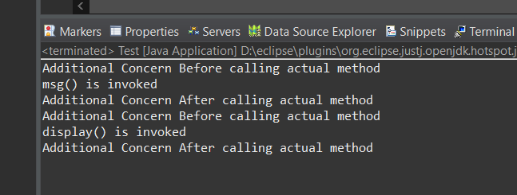
Output:-

PRACTICAL NO:9
Assignment based Spring JDBC

Practical No. 9a Assignment based Spring JDBC

9a.Write a program to insert, update and delete records from the given table.

Employee.java File:- package com.javatpoint; public class Employee { private int id;
private String name; private float salary; public Employee() {}
public Employee(int id, String name, float salary) {
super(); this.id = id;
this.name = name;
this.salary = salary;}
public int getId() {
return id;}
public void setId(int id) {
this.id = id;}
public String getName() {
return name;}
public void setName(String name) {
this.name = name;}
public float getSalary() {
return salary;}
public void setSalary(float salary) {
this.salary = salary;}}

EmployeeDao.java File:- package com.javatpoint;
import org.springframework.jdbc.core.JdbcTemplate;
public class EmployeeDao {
private JdbcTemplate jdbcTemplate;
public void setJdbcTemplate(JdbcTemplate jdbcTemplate) {
this.jdbcTemplate = jdbcTemplate;}
Public int saveEmployee(Employee e){
String query="insert into employee values('"+e.getId()+"','"+e.getName()+"','"+e.getSalary()+"')";
return jdbcTemplate.update(query);}
public int updateEmployee(Employee e){
String query="update employee set name='"+e.getName()+"',salary='"+e.getSalary()+"' where id='"+e.getId()+"' ";
return jdbcTemplate.update(query);}
public int deleteEmployee(Employee e){
String query="delete from employee where id='"+e.getId()+"' ";
return jdbcTemplate.update(query);}}

applicationContext.xml File:-

<?xml version="1.0" encoding="UTF-8"?>
<beans
xmlns="http://www.springframework.org/schema/beans" xmlns:xsi="http://www.w3.org/2001/XMLSchema-instance" xmlns:p="http://www.springframework.org/schema/p" xsi:schemaLocation="http://www.springframework.org/schema/beans
http://www.springframework.org/schema/beans/spring-beans-3.0.xsd">
<bean id="ds" class="org.springframework.jdbc.datasource.DriverManagerDataSource">

<property name="driverClassName" value="com.mysql.jdbc.Driver" />
<property name="url" value="jdbc:mysql://localhost/employee" />
<property name="username" value="root" />
<property name="password" value="" />
</bean>
<bean id="jdbcTemplate" class="org.springframework.jdbc.core.JdbcTemplate">
<property name="dataSource" ref="ds"></property>
</bean>
<bean id="edao" class="com.javatpoint.EmployeeDao">
<property name="jdbcTemplate" ref="jdbcTemplate"></property>
</bean>
</beans>

Test.java File:-

package com.javatpoint;
import java.util.Scanner;
import org.springframework.context.ApplicationContext;
import org.springframework.context.support.ClassPathXmlApplicationContext;
public class Test {
public static void main(String[] args) {
ApplicationContext ctx=new ClassPathXmlApplicationContext("applicationContext.xml");
EmployeeDao dao=(EmployeeDao)ctx.getBean("edao");
// int status=dao.saveEmployee(new Employee(102,"Amit",35000)); System.out.println("Type 1 to insert record"); System.out.println("Type 2 to update record"); System.out.println("Type 3 to delete record");
Scanner sc =new Scanner(System.in);

int op=sc.nextInt(); while(op!=4) { if(op==1) {
System.out.println("enter id"); int id=sc.nextInt(); System.out.println("enter name"); String name=sc.next();
System.out.println("enter salary");
int sal=sc.nextInt();
int status=dao.saveEmployee(new Employee(id,name,sal));
if (status>0) {
System.out.println("Data inserted successfully");}
}else if(op==2) {
System.out.println("enter id"); int id=sc.nextInt(); System.out.println("enter name"); String name=sc.next();
System.out.println("enter salary");
int sal=sc.nextInt();
int status=dao.updateEmployee(new Employee(id,name,sal));
if (status>0) {
System.out.println("Data updated successfully");}
}else if(op==3){
System.out.println("enter id");
int id=sc.nextInt();
int status=dao.deleteEmployee(new Employee(id,"",0)); System.out.println("Data deleted successfully");
}else {System.out.println("wrong input3");}

System.out.println("Type 1 to insert record"); System.out.println("Type 2 to update record"); System.out.println("Type 3 to delete record"); op=sc.nextInt();} }}

Output :-

Insert data
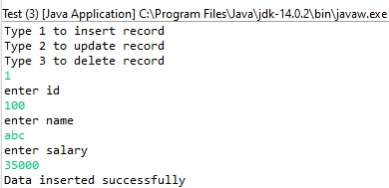

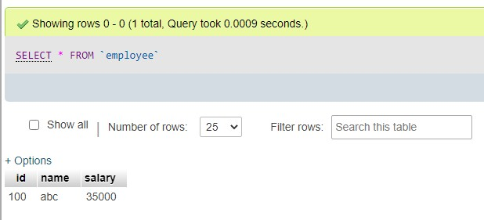

Update:-

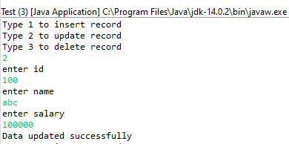

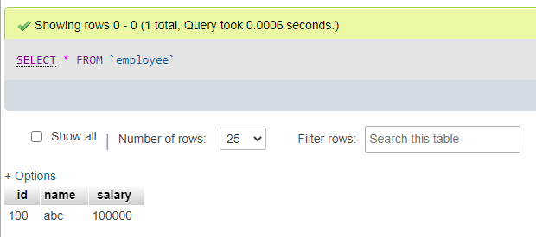

Delete :-

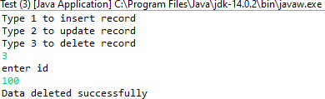

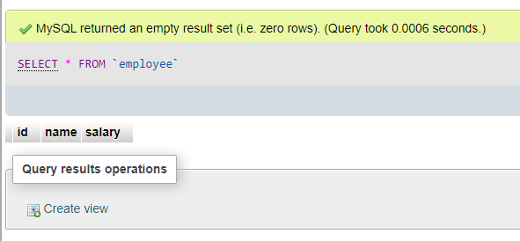

Practical No. 9b Assignment based Spring JDBC

9b.Write a program to demonstrate PreparedStatement in Spring JdbcTemplate

Employee.java File:-
package com.javatpoint; public class Employee { private int id; private String name; private float salary; public Employee() {}
public Employee(int id, String name, float salary) {
super(); this.id = id;
this.name = name;
this.salary = salary;}
public int getId() {
return id;}
public void setId(int id) {
this.id = id;}
public String getName() {
return name;}
public void setName(String name) {
this.name = name;}
public float getSalary() {
return salary;}
public void setSalary(float salary) {
this.salary = salary;}
}

applicationContext.xml File:-

<?xml version="1.0" encoding="UTF-8"?>
<beans
xmlns="http://www.springframework.org/schema/beans" xmlns:xsi="http://www.w3.org/2001/XMLSchema-instance" xmlns:p="http://www.springframework.org/schema/p"
xsi:schemaLocation="http://www.springframework.org/schema/beans http://www.springframework.org/schema/beans/spring-beans-3.0.xsd">
<bean id="ds" class="org.springframework.jdbc.datasource.DriverManagerDataSource">
<property name="driverClassName" value="com.mysql.jdbc.Driver" />
<property name="url" value="jdbc:mysql://localhost/employee" />
<property name="username" value="root" />
<property name="password" value="" />
</bean>
<bean id="jdbcTemplate" class="org.springframework.jdbc.core.JdbcTemplate">
<property name="dataSource" ref="ds"></property>
</bean>
<bean id="edao" class="com.javatpoint.EmployeeDao">
<property name="jdbcTemplate" ref="jdbcTemplate"></property>
</bean>
</beans>

EmployeeDao.java File:-

package com.javatpoint;
import java.sql.PreparedStatement;
import java.sql.SQLException;
import org.springframework.dao.DataAccessException;
import org.springframework.jdbc.core.JdbcTemplate;
import org.springframework.jdbc.core.PreparedStatementCallback;

public class EmployeeDao {
private JdbcTemplate jdbcTemplate;
public void setJdbcTemplate(JdbcTemplate jdbcTemplate) {
this.jdbcTemplate = jdbcTemplate; }
public Boolean saveEmployeeByPreparedStatement(final Employee e){ String query="insert into employee values(?,?,?)";
return jdbcTemplate.execute(query,new PreparedStatementCallback<Boolean>(){ @Override
public Boolean doInPreparedStatement(PreparedStatement ps)
throws SQLException, DataAccessException { ps.setInt(1,e.getId()); ps.setString(2,e.getName()); ps.setFloat(3,e.getSalary());
return ps.execute(); } })} }

Test.java File:-

package com.javatpoint;
import org.springframework.context.ApplicationContext;
import org.springframework.context.support.ClassPathXmlApplicationContext;
public class Test {
public static void main(String[] args) { ApplicationContext ctx=new
ClassPathXmlApplicationContext("applicationContext.xml");
EmployeeDao dao=(EmployeeDao)ctx.getBean("edao"); dao.saveEmployeeByPreparedStatement(new Employee(108,"Suresh",35000)); System.out.println("Data inserted successfully using PreparedStatement");
}
}

Output:-

