PRODUCT SALES – REGION 1
POWER BI DATA ANALYTICS PROJECT
Final Project Report

1. Problem Statement
The business needs a clear, interactive view of sales performance across regions, products, stores, customer types, payment methods and promotions. The project objective is to clean the raw transaction dataset, analyze the sales and operational KPIs, and design a Power BI dashboard that helps management monitor performance and identify areas requiring attention.

2. Dataset Information
The source workbook contains 1,500 spreadsheet rows, including 10 completely blank rows. After cleaning, 1,490 valid sales transactions remain. The analysis period is 2023-01-01 to 2025-06-30.
Category | Fields | Purpose
Identifiers | OrderID, CustomerName | Transaction/customer identification
Dates | OrderDate, DeliveryDate | Trend and delivery analysis
Sales | Quantity, UnitPrice, TotalPrice, Discount, ShippingCost | Revenue and commercial analysis
Dimensions | Region, Product, StoreLocation, CustomerType | Performance segmentation
Commercial | Promotion, PaymentMethod, Salesperson | Channel and promotion analysis
Operations | Returned, DeliveryDays | Returns and service analysis
Management | RegionManager | Regional accountability

3. Data Cleaning Process
- Removed 10 completely blank rows.
- Converted Excel date/time-formatted numeric values back to their intended numeric values for Quantity, UnitPrice, Discount, TotalPrice and ShippingCost.
- Converted Returned into a numeric ReturnFlag (1 = returned, 0 = not returned).
- Converted Promotion value `NA` to a blank/no-promotion value.
- Created DeliveryDays, Year, Quarter, Month and MonthName fields.
- Checked duplicates: no duplicate retained transactions were found.
- Checked numeric fields for negative values: none were found.
- Kept the source TotalPrice as the authoritative SalesAmount. A reconciliation test showed that TotalPrice does not consistently equal Quantity × UnitPrice × (1 – Discount), so recomputing sales would alter the source measure.

4. Analysis
Total sales were ₹4,345,074.42 across 1,490 transactions, with 16,998 units sold. Average transaction value was ₹2,916.16. The dataset contains 370 returned transactions, producing an overall return rate of 24.83%. Average delivery time was 6.04 days.
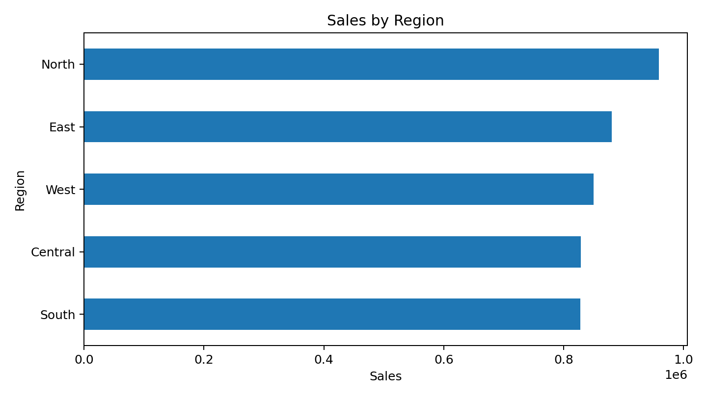
North recorded the highest regional sales at ₹958,480.21; East followed at ₹880,089.03.
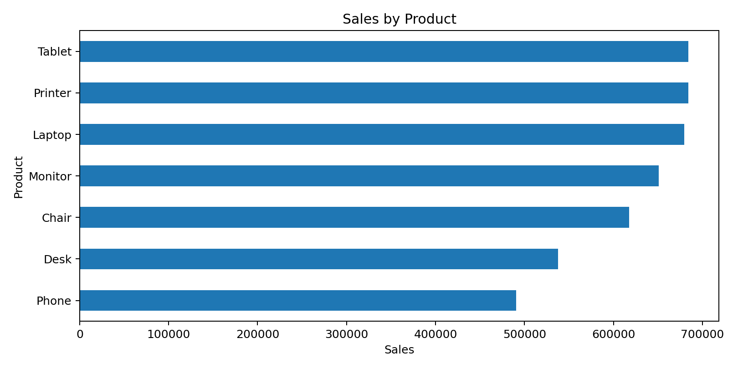
Tablet generated the highest product sales at ₹684,407.23, closely followed by Printer at ₹684,389.42.
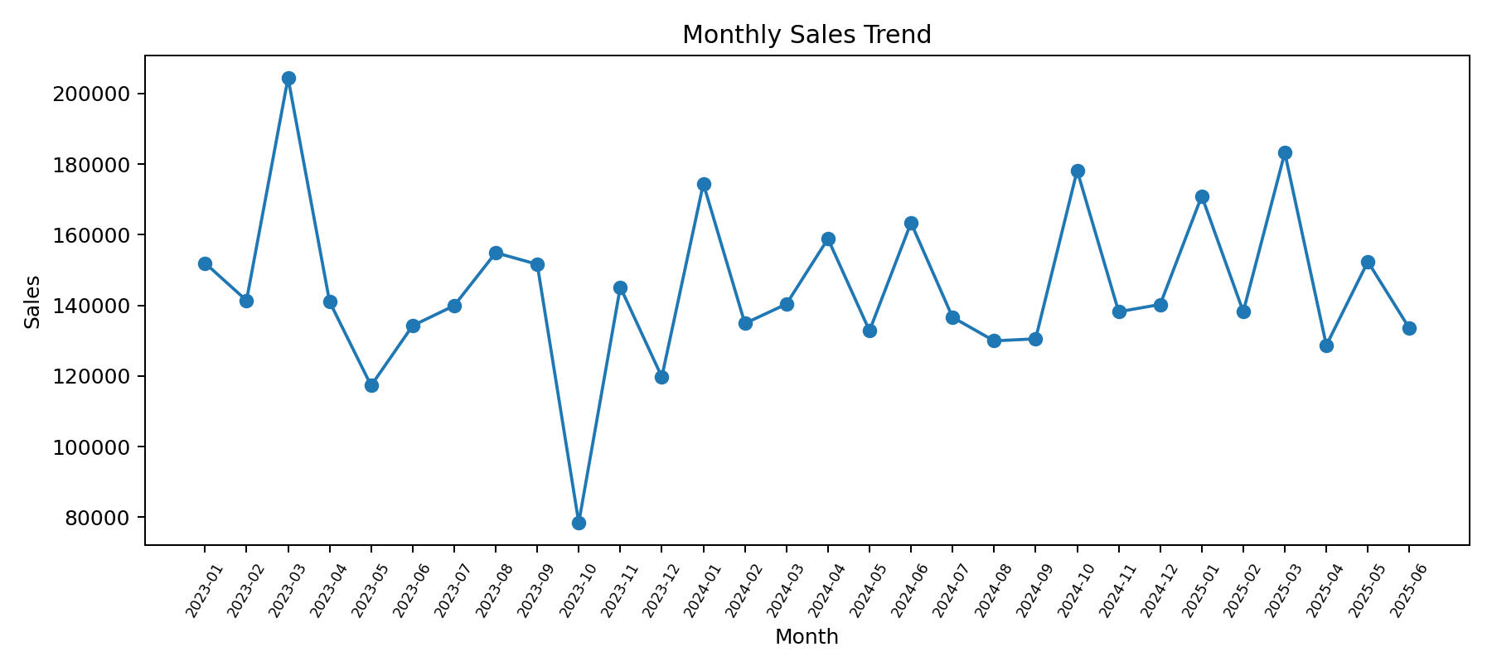
The monthly trend chart is intended to be reproduced interactively in Power BI so that users can slice the period by region, product, store and customer type.

5. Dashboard Design
- Executive Sales Overview: KPI cards for Total Sales, Transactions, Units, Average Transaction Value and Return Rate, plus monthly trend and sales breakdowns.
- Product & Regional Analysis: Region × Product matrix, product sales, regional sales, return rate by product and delivery performance.
- Operations & Customer Analysis: store, salesperson, payment method, promotion, customer type, returns and delivery KPIs.

6. Key Business Insights
- North generated the highest regional sales (₹958,480.21) in the analyzed period.
- Tablet and Printer were the two highest-sales products, each contributing about ₹684,407–₹684,389.
- Store D recorded the highest store sales at ₹1,185,216.96.
- Wholesale and Retail sales were almost evenly split (₹2,172,976.52 vs ₹2,172,097.90), indicating a balanced customer mix.
- Online was the highest-sales payment method at ₹949,548.79.
- The overall return rate was 24.83%; management should drill down by product, region and customer type to identify where returns are concentrated.
- Average delivery time was 6.04 days, with observed delivery durations from 2 to 10 days.

7. Recommendations for Dashboard Monitoring
- Monitor regional and product sales trends monthly rather than relying only on cumulative totals.
- Track return rate alongside sales because high sales volume can hide operational or product-quality issues.
- Use delivery-day analysis to identify regions/products with slower fulfillment.
- Compare promotion performance using sales, transaction count and return rate together.
- Use slicers for Year, Region, Product, Customer Type, Store Location and Promotion to support management drill-down.

8. Conclusion
The cleaned dataset is ready for Power BI ingestion and the project structure covers the required problem statement, dataset information, cleaning process, analysis, dashboard design and business insights. The included DAX and dashboard build guide provide the measures and layout needed to reproduce the interactive Power BI report.

9. Submission Checklist
- Import Product_Sales_Region1_Cleaned.xlsx into Power BI Desktop.
- Create the Date table and DAX measures from PowerBI_DAX_Measures.txt.
- Build the three dashboard pages according to PowerBI_Dashboard_Build_Guide.md.
- Validate the KPI totals against the figures in this report.
- Save the final Power BI file as Product_Sales_Region1_Dashboard.pbix.
- Upload the project folder/repository to GitHub or another accessible platform.
- Submit the public repository/project URL.

