**Queries Used In Carrying Out the Week2 Advanced SQL HandsOn:-**

*1. Use ROW_NUMBER() to assign a unique rank within each category.*

*Query:-*

INSERT INTO Products (ProductID, ProductName, Category, Price) VALUES

(5, 'Smartwatch', 'Electronics', 800.00),

(6, 'Charger', 'Accessories', 50.00),

(7, 'Mouse', 'Accessories', 150.00),

(8, 'Backpack', 'Accessories', 80.00),

(9, 'Notebook', 'Stationery', 10.00),

(10, 'Pen', 'Stationery', 2.00),

(11, 'Marker', 'Stationery', 5.00),

(12, 'Printer', 'Electronics', 1000.00),

(13, 'Desk Lamp', 'Home Decor', 300.00),

(14, 'Cushion', 'Home Decor', 200.00),

(15, 'Rug', 'Home Decor', 500.00);

SELECT

Category,

ProductName,

Price,

RANK() OVER (PARTITION BY Category ORDER BY Price DESC) AS PriceRank

FROM Products;

*Output:-*

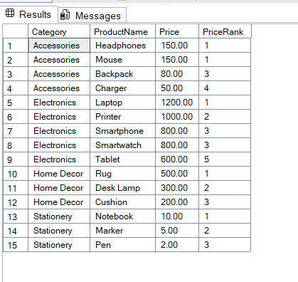

*2. Use RANK() and DENSE_RANK() to compare how ties are handled.*

*Query:-*

SELECT

Category,

ProductName,

Price,

RANK() OVER (PARTITION BY Category ORDER BY Price DESC) AS PriceRank

FROM Products;

***Output:-***

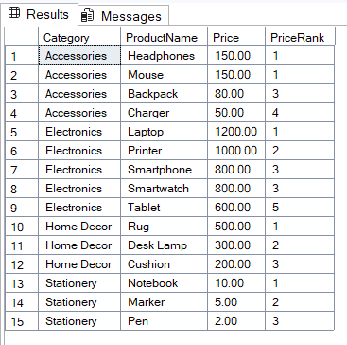

***Query:-***

SELECT

Category,

ProductName,

Price,

DENSE_RANK() OVER (PARTITION BY Category ORDER BY Price DESC) AS DensePriceRank

FROM Products;

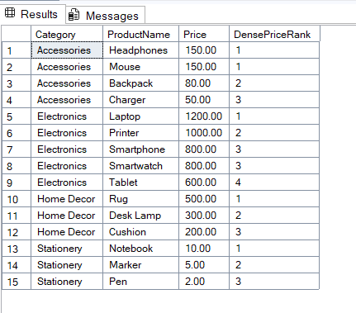

*3. Use PARTITION BY Category and ORDER BY Price DESC.*

*Query:-*

SELECT * FROM (

SELECT

Category,

ProductName,

Price,

DENSE_RANK() OVER (PARTITION BY Category ORDER BY Price DESC) AS DensePriceRank

FROM Products

) AS Ranked

WHERE DensePriceRank <= 3;

