**CIS551- Modern Programming in Java**

**Final Project**

**Web Based Job Notification System**

**By,**

**Shreyas Ramesh (950536229)**

**Prateek Shivalingayya Hiremath (907558538)**

**Web Based Job Notification System**

Note: The functionalities that we had mentioned in the project proposal have all been completed. In addition to this we have also added a filter in which the emails are only sent to job seekers with skills relevant to the job posting. We feel the more apt name for the project would be “Web Based Job Notification System” rather than “Web based recruitment process system” and hence decided to change the name.

Required:

* MySQL (Download and install the MySQL installer)
* Apache Tomcat Server

Project Setup:

1. Import the Schema for the database.
   1. Open MySQL Workbench and open your connection or create a new one if you don’t have one already.
   2. Once created, go to Server menu -> Data Import.
   3. Select ‘Import from Self-contained file’ and browse to the location containing the dump file. (Location: MySQL Dump file folder )
   4. Next select the Default Target Schema from the dropdown menu or create a new one named “RecruitmentDb”.
   5. By default ‘Dump Structure and Data’ will be selected. Leave it as it is.
   6. Then select ‘Start Import’.
   7. Once this is successful, you will see a message telling the same.
   8. Now the tables and data of our schema have been successfully imported.
2. Import the Project to Eclipse
   1. File->Import.
   2. Possible Build errors-
      1. Target runtime Apache Tomcat v*.0 is not defined.

Solution:

1. Install Apache Tomcat Server (If you don’t have it in the system or the workspace by downloading it and then following the next steps.)
   1. File->New->Other->Server->Select Apache->”Version of your choice”->Next
   2. Browse to the installation directory->Next
   3. Add the project to configure them on the server and finish
2. (If installed already) Right click on the project->Build Path-> Configure Build path and select Targeted Runtime and select your installed version of Tomcat on your system and unselect any other version. Apply and OK.

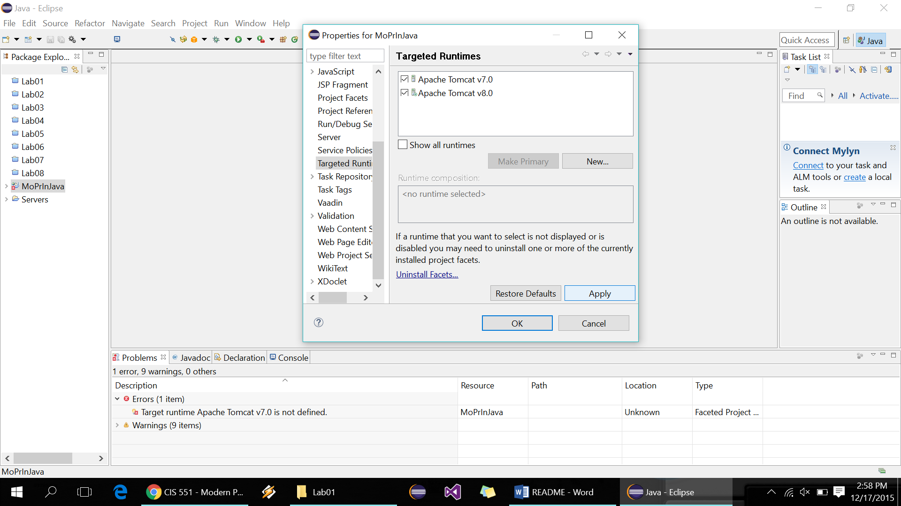

* + 1. Unbound class path container: 'JRE System Library [jre1.8.0_60]' in project.

Solution: Right click on the project and select Build Path -> Configure Build path.

Go to Libraries. Select JRE System Library -> Edit -> Workspace default JRE -> Finish, Apply and OK.

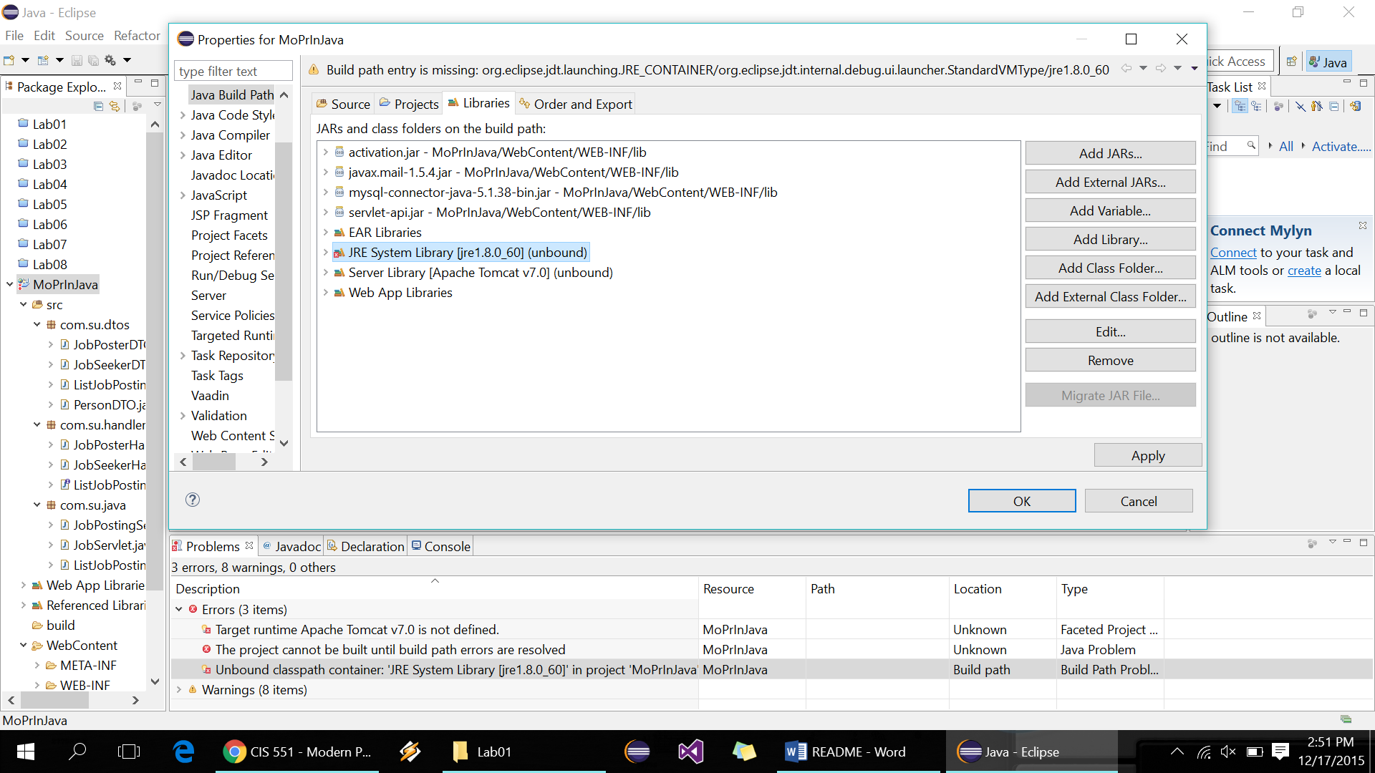

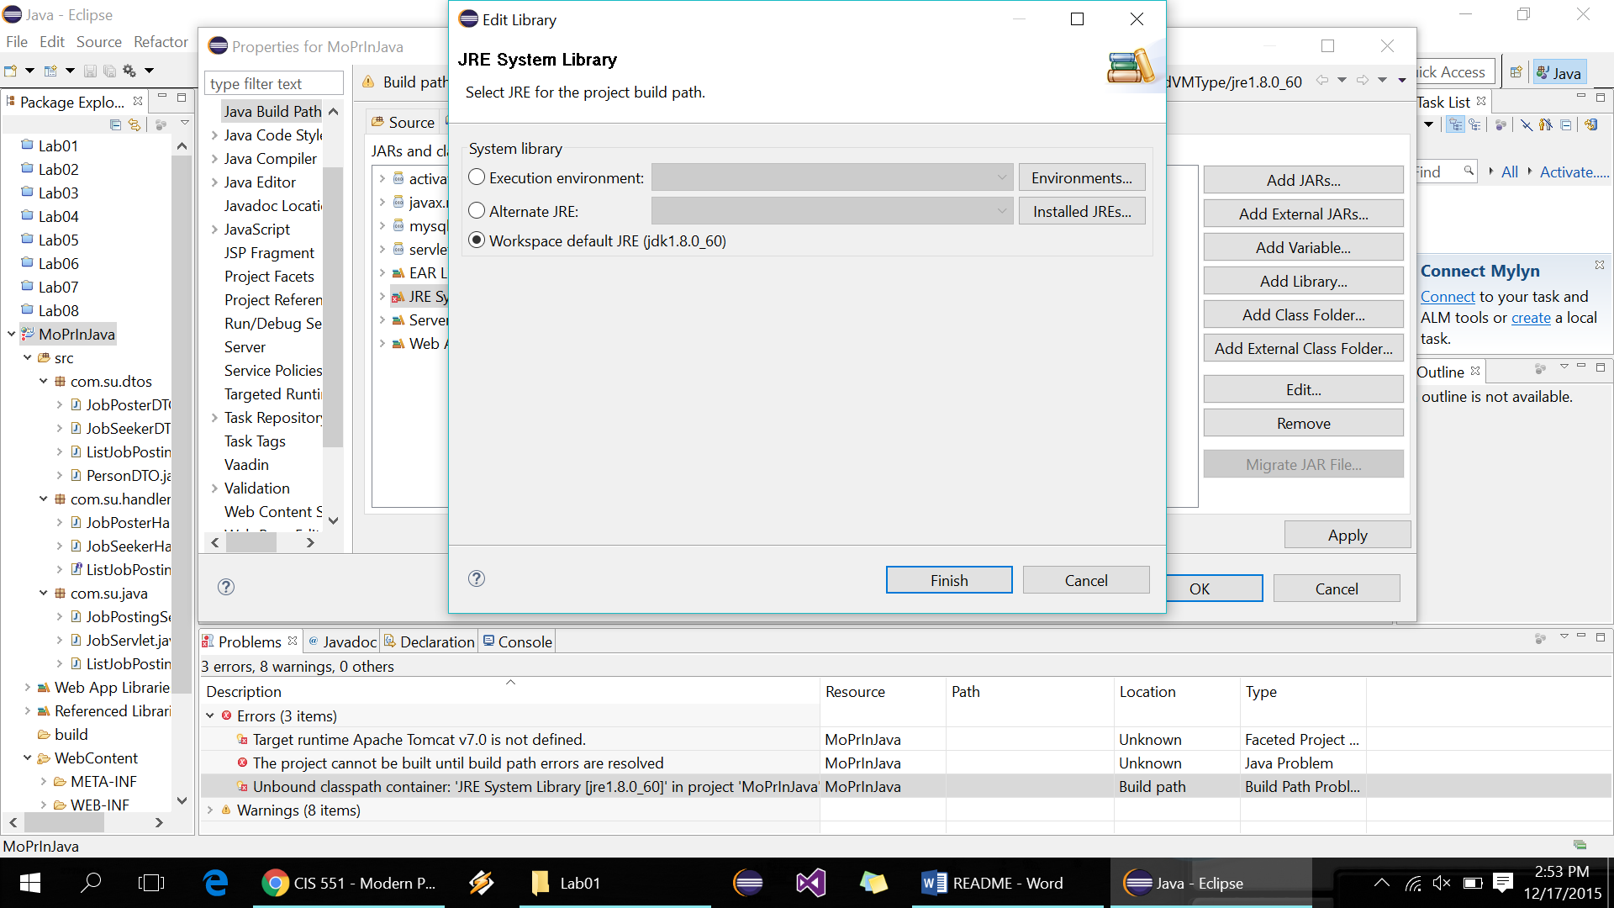

1. The *config.properties* file (in the location: \MoPrInJava\WebContent\WEB-INF\classes) has the properties required to connect with the database. The user and password is set to “root” and “root123” for our system. You will need to change it to your login name and password set for your MySQL to establish the connection with the database.
2. Now your project is ready to run.
   1. Right click on the project and select Run as -> Run on server.
   2. Select the server->Next
   3. Make sure the project is configured on the server-> Finish.
   4. Based on your settings, the web application might open on the browsers i.e., Eclipse default, Internet Explorer, Mozilla or the Chrome.
   5. You can copy-paste the below address into the browser of your choice once you run the project and the default browser opens.

<http://localhost:8080/MoPrInJava/>

Using the application:

1. In the browser, the home page shown below opens. Job seeker page opens by default.

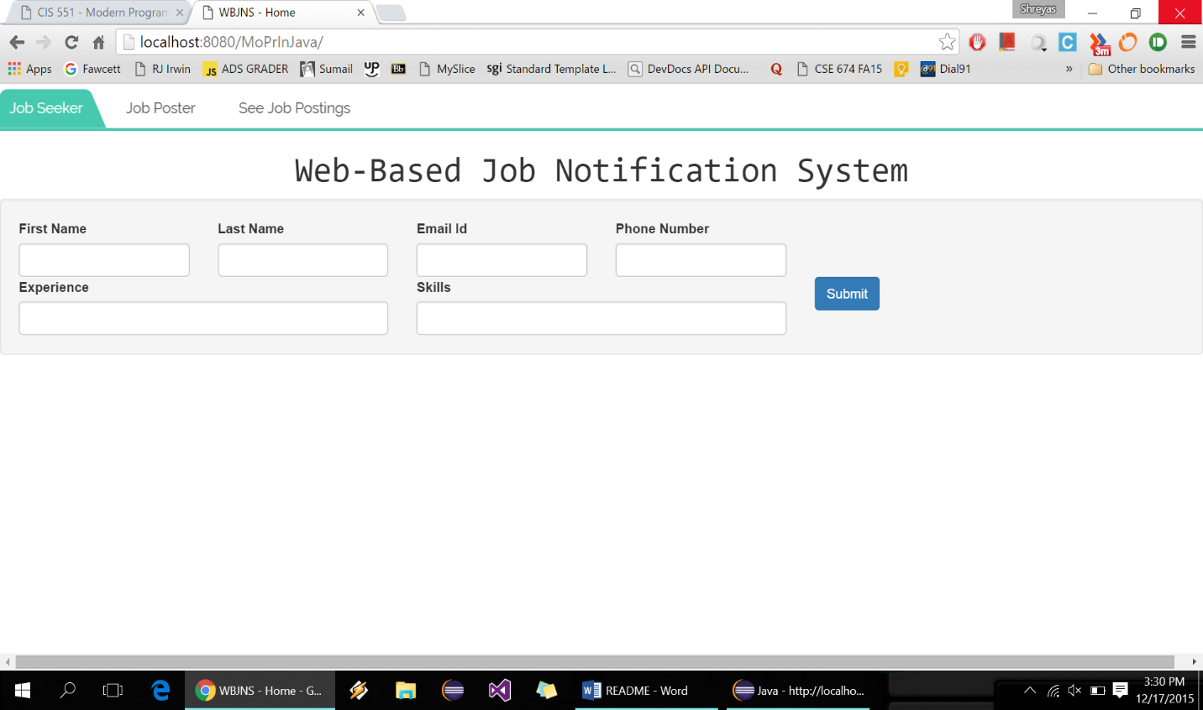

This is the Job Seeker page which allows a user to subscribe to the system to allow him to receive job notifications whenever his skillsets matches with the job requirements.

Input fields:

First Name and Last Name: First and last name respectively of the job seeker.

Email Id: This should be a valid existing email Id for the job seeker to receive emails from the system whenever his skillsets matches with the job requirements skillsets.

Phone Number: Phone number of the job seeker.

Experience: Experience of the jobseeker.

Skills: This represents the skills of the user. More than one skills should be comma separated.

After hitting submit, a new page opens with a successful message if the submission was a success else an unsuccessful message is displayed.

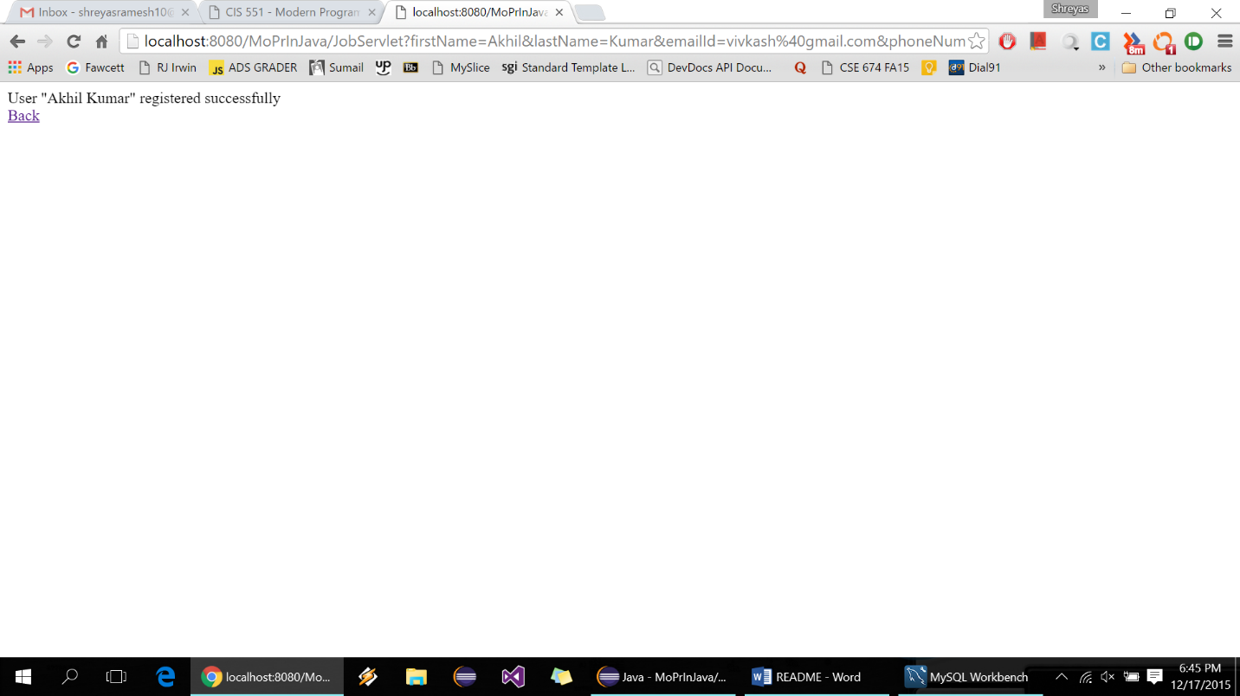

1. Job Posting page is opened by selecting the Job poster tab at the top.

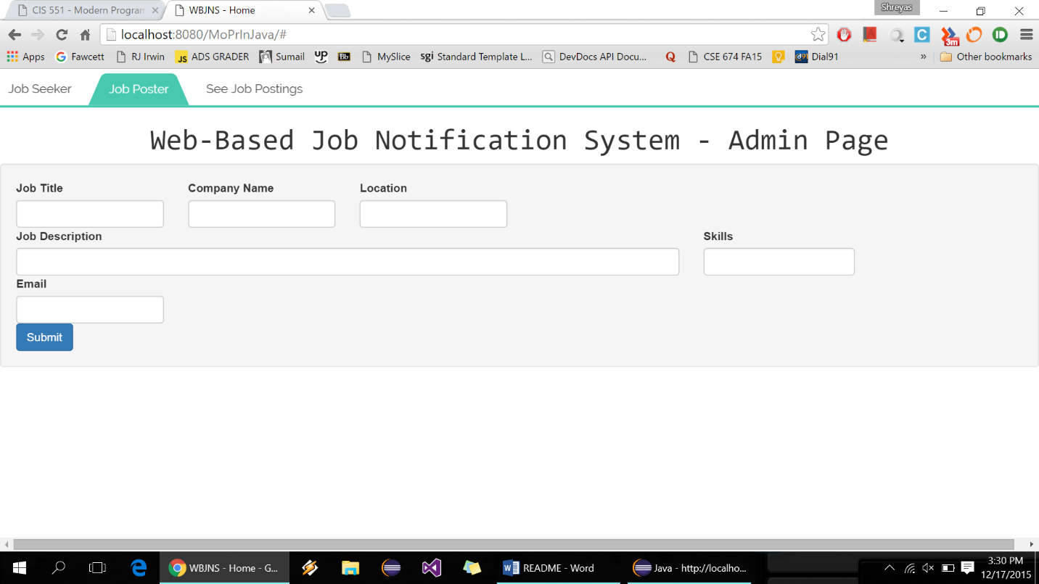

Input fields:

Job title: Job title of the job being posted

Company Name: Name of the company

Location: Location of the job posted

Job Description: Roles and duties of the job (<150 characters)

Skills: Skills required for the job posted. More than one skills requirement is entered as comma separated.

Email: Email Id in case the job seeker wants to contact the job poster directly.

After hitting submit, a new window displaying the success or not success message opens.

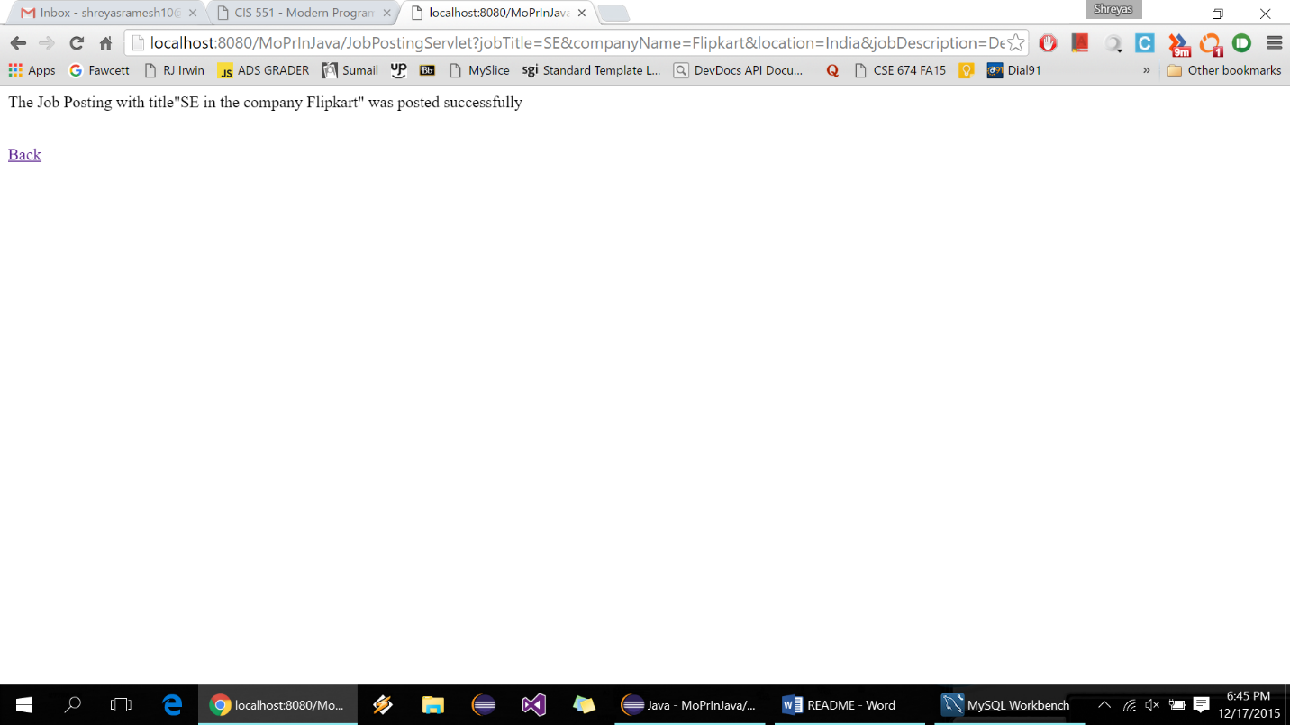

If success, then an email is sent out on a separate thread to all the job seekers whose skills match with the skills required for the current posted job.

1. All the jobs posted can be seen by selecting the third tab, ‘See Job Postings’. Here click on the List Button to see the list of all the jobs posted.

