Pet Adoption Trend Analysis

Project Plan

Version 1.0

Revision History

*NA*

Table of Contents

1. Introduction 4

1.1 Purpose of this document 4

1.2 Intended Audience 4

1.3 Scope 4

1.4 Definitions and acronyms 4

1.4.1 Definitions 4

1.4.2 Acronyms and abbreviations 5

1.5 References 5

2. Background and Objectives

3. Architecture and High level Design 5

4. Organization 6

*4.1* Project group 6

4.2 Customer 6

5. Development process 6

*6.* Deliverables 6

7. Project risks 7

8. Communication 7

8.1 Collaboration 7

8.2 Git 7

9. Project plan 7

9.1 Time schedule 7

9.1.1 Remarks 8

9.2 Test plan 8

9.2.1 Testing Remarks 8

10. References 8

# Introduction

## Purpose of this document

The purpose of this document is to provide a detailed project description of the project, how analyzing the intakes and outcomes of pet adoption can help animal care centers to increase the numbers of pets being adopted. This document includes details about organization, roles, deliverables, project risks, time plans and financial plans.

## Intended Audience

This document shall be used in all phases of the project as a guideline. Intended audiences of this project are all project stakeholders:

* project supervisor
* project leader
* team members
* animal care centers

## Scope

This document defines the project plan of the Pet adoption analysis. The overview includes objectives of the project, organization of the project team, development process that is going to be used during the project, assessment of possible risks, communication used between project stakeholders and project plan that includes time schedule and activity plan.

## Definitions and acronyms

### Definitions

| **Keyword** | **Definitions** |
| --- | --- |
| Project Name | Pet Adoption Analysis |
| Project Supervisor | Andrew Bond |
| Project Leader | Richa Sharma |
| Team Member | Bhakti Raichura  Khushee Thakker  Shreya Srirama  Richa Sharma |
| Milestone | A time in a project that marks the end of a project phase or the completion of an important deliverable. |
| Git | <https://github.com/Dataanalystwhotellsstories/Data-228-Project> |
| Scrum | An iterative and incremental agile software development method for managing software projects and product or application development |
| Scrum sprint | The basic unit of development in Scrum |
| Scrum master | Ensures the smooth working of the Scrum team and enforces Scrum practices |
| Product owner | Responsible for product management and its quality |

### Acronyms and abbreviations

*NA*

## References

1. <https://data.austintexas.gov/Health-and-Community-Services/Austin-Animal-Center-Intakes/wter-evkm>
2. <https://data.austintexas.gov/Health-and-Community-Services/Austin-Animal-Center-Outcomes/9t4d-g238>
3. <https://www.aspca.org/helping-people-pets/shelter-intake-and-surrender/pet-statistics>

# Background and Objectives

There are currently over 5k independently run animal shelters across the world providing love and care to millions of abandoned animals. While many of these animals are adopted into loving homes, the adoption rates are still worse than we expect As per research paper [Pet Statistics | Shelter Intake and Surrender | ASPCA](https://www.aspca.org/helping-people-pets/shelter-intake-and-surrender/pet-statistics) 6.5 million animals enter animal shelters each year. Furthermore, each year 1.5 million shelter animals are euthanized.

# Architecture & High Level Design

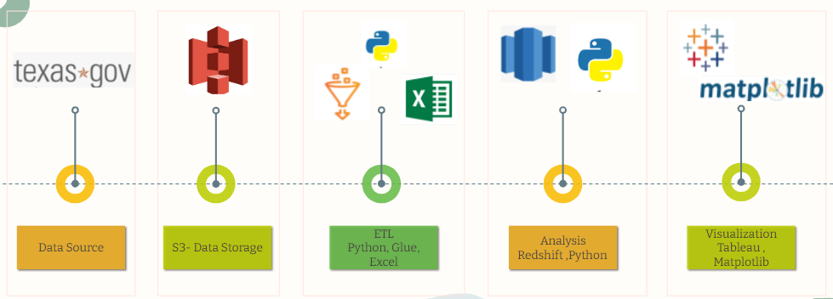

# Organization

MSDA DATA -228- Big Data Technology and Applications

## Project group

| **Name** | **Initials** | **Responsibility (roles)** |
| --- | --- | --- |
| Richa Sharma [014638494] | RS | Python- Analysis and ML |
| Bhakti Raichura [016020628] | BR | Tableau Website |
| Khushee Thakker [015271529] | KT | AWS S3, Glue |
| Shreya Srirama [016029845] | SS | AWS Glue, Redshift |

## Customer

The target customers are listed below:

* Supervisor
* Student’s Reference
* Animal Shelter’s

# Development process

**Tools we used throughout the project development process and project flow.**

| **Name** | **Usage** |
| --- | --- |
| Python | Data cleaning, Analysis and Predictive analysis |
| Tableau | Data Visualization |
| AWS S3 | Data lake and hosting website |
| AWS Glue | ETL Tool |
| AWS Redshift | Analytical Queries |

# Deliverables

| Phase | Detail | Tentative week |
| --- | --- | --- |
| Abstract | Abstract definition and data selection | Feb last week |
| Design | Data cleaning and pipeline designing | March 2nd week |
| Coding | AWS pipeline creation | April 1nd week |
| Testing | User acceptance testing | April 2nd week |
| Documentation | Data documentation and visualization | April 4th week |

# Project risks

*NA*

# Communication

* Zoom
* Scrum meetings

## Collaboration

* Pair Programming on GitHub
* Collab

## Git

All source code and finished documentation will be uploaded to Github repository.

Repository URL: <https://github.com/Dataanalystwhotellsstories/Data-228-Project>

# Project plan

## Time schedule

| **Id** | **Milestone**  **Description** | **Responsible Dept./Initials** | **Finished week** |
| --- | --- | --- | --- |
|  |  |  | **Plan** |
|  |  |  |  |
| P_1 | Abstract | Team | Feb 3rd week |
| P_2 | Design | Team | March 2nd week |
| P_3 | Code | KT | April 1st week |
| P_4 | ETL- AWS Glue | SS | April 1st week |
| P_5 | Analysis- Python | RS | April 1st week |
| P_6 | Analysis- Redshift | SS | April 1st week |
| P_7 | Code Testing | KT | April 2nd week |
| P_8 | Prediction Model | RS | April 3rd week |
| P_9 | Visualization | BR | April 3rd week |
| P_10 | Website | BR | April 4th week |
| P_11 | Documentation | Team | May 1st week |

### Remarks

*NA*

## Test plan

*NA*

### Testing Remarks

*NA*

# References

* <https://bhaktiraichura1995.wixsite.com/pet-adoption-analysi>
* <https://github.com/Dataanalystwhotellsstories/Data-228-Project>
* <https://data.austintexas.gov/Health-and-Community-Services/Austin-Animal-Center-Outcomes/9t4d-g238>
* <https://data.austintexas.gov/Health-and-Community-Services/Austin-Animal-Center-Intakes/wter-evkm>
* <https://public.tableau.com/app/profile/bhakti.r5707/viz/Pet_Adoption_New/Dashboard1#1>
* <https://www.aspca.org/helping-people-pets/shelter-intake-and-surrender/pet-statistics>