**Microwave Engineering Expt no- 8**

**Aim:**

To study the behavior of impedance matching for passive networks using a smith chart. **Software:**

Virtual Labs – IIT Kanpur

**Theory:**

Transmission line impedance matching:

Transmission lines are used for the transmission of power and information. For radio frequency power transmission, it is highly desirable that as much power as possible is transmitted from the generator to the load and as little power as possible is lost on the line itself. This will require that the load be matched to the characteristic impedance of the line so that the standing-wave ratio on the line is as close to unity as possible. For information transmission it is essential that the lines be matched because reflections from mismatched loads and junctions will result in echoes and will distort the information-carrying signal. In this section we discuss several methods for impedance-matching on lossless transmission lines. We note parenthetically that the methods we develop will be of little consequence to power transmission by 60(Hz) lines in as much as these lines are generally very short in comparison to the 5(mm) wavelength and the line losses are appreciable. Sixty-hertz power-line circuits are usually analyzed.

Impedance matching by single-stub:

We will now look into the problem of matching a load impedance ZL to a lossless line that has a characteristic impedance R0 by placing a single short-circuited stub in parallel with the line, as shown in fig.

This is the single-stub method for impedance matching. We need to determine the length of the stub, *l*, and the distance from the load, *d*, such that the impedance of the parallel combination to the right of points *B-B'* equals R0.

Short-circuited stubs are usually used in preference to open-circuited stubs because an infinite terminating impedance is more difficult to realize than a zero- terminating impedance for reasons of radiation from an open end and coupling effects with neighboring objects.

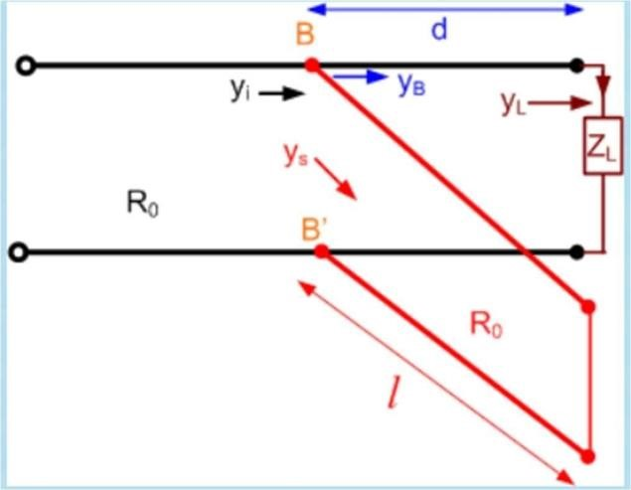

Moreover, a short-circuited stub of an adjustable length and a constant characteristic resistance is much easier to construct than an open-circuited one. Of course, the difference in the required length for an open-circuited stub and that for a short-circuited stub is an odd multiple of a quarter-wavelength.

The parallel combination of a line terminated in ZL and a stub at points *B-B'* in the above figure suggest that it is advantageous to analyze the matching requirements in terms of admittances. The basic requirement is Yi = YB + Y S = Y0 = 1/R0.

In terms of normalized admittances, the above equation becomes,

1 = yB + yS, where yB = R0 YB is for the load section and ys = R0 YS is for the short- circuited stub.

However, since the input admittance of a short-circuited stub is purely susceptive, ys is purely imaginary.

**Procedure:**

1. Enter the values of the Resistive and Reactive part of load impedance.
2. Enter the value of characteristic impedance.
3. Length of stub (in terms of wavelength) and location of stub from the load end (in terms of wavelength) can be varied from the vertical bars provided. 4) Run the VI to see the desired plot in the Smith chart. The output can also be seen to the right of the smith chart from numeric indicators.

**Output:**



1.



ZL



=



(60



–



j80)



Ω;



Z0



=



50Ω



d1



=



0.1104



λ;



l1



=



0.949



λ

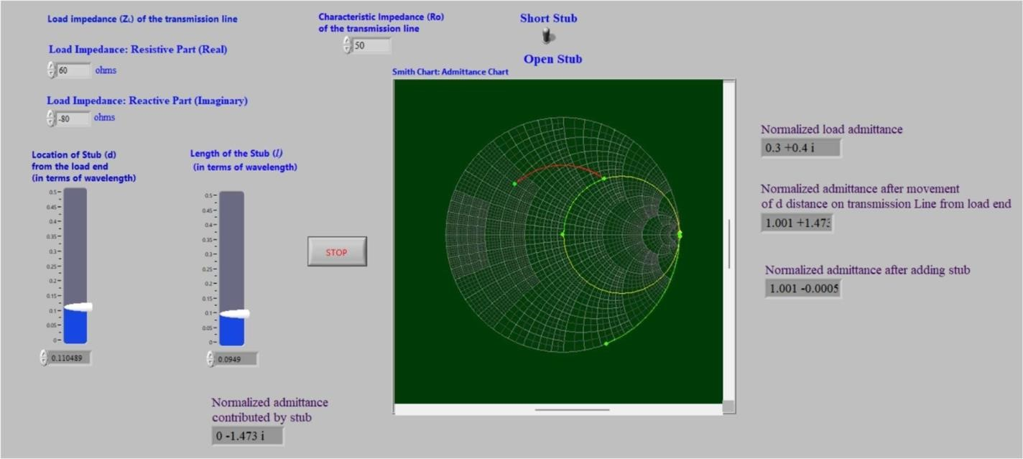

# Conclusion :-

In this experiment, impedance matching in passive networks using a Smith chart was studied. Transmission line impedance matching is essential to minimize power loss and signal distortion in RF applications. The experiment focuses on impedance matching through a single short-circuited stub placed in parallel with a transmission line, aiming to determine the stub's length and distance from the load for effective matching. This method is preferred due to practical considerations and is analyzed in terms of admittances, with the goal of achieving unity normalized admittance for efficient matching.