ORBIT
Mobile Application
UI Wireframe & Interaction Report
Week 2 Deliverable | Screen specifications, navigation, usability, privacy, and scope

Project information | Details
Application | Orbit — Personal Life Operations Hub
Platform | Android mobile application (proposed)
Deliverable | Low-/mid-fidelity wireframe specification with supplied screen images
Design status | Conceptual design; implementation and usability validation are pending
Data note | All names, dates, totals, and records shown in the wireframes are illustrative sample data

Prepared for: Yuva Intern — Junior Mobile App Developer Internship
Week 2: Designing User Interface

Executive summary
Orbit is proposed as an offline-first personal organization app that brings everyday records and time-sensitive obligations—such as bills, subscriptions, purchase receipts, warranty dates, documents, reminders, and shopping-list items—into a single mobile experience. This report converts the supplied wireframes into a structured UI specification: it describes each screen’s user goal, visible controls, expected interactions, example data, usability rationale, and initial acceptance checks.
The design uses five persistent primary destinations (Home, Timeline, Library, Bills, and Insights), with secondary screens opened contextually. The screen set is intended to make capture, retrieval, and follow-through easy without implying that every proposed feature is already implemented. In particular, backup/restore and app-lock controls are shown as planned or placeholder concepts and require later technical and security decisions.

1. Product context and design problem
People often keep purchase receipts, warranty dates, recurring payment details, reminders, and shopping tasks in separate apps or paper records. That fragmentation can make it difficult to answer practical questions such as “What is due this week?”, “Where did I save the receipt?”, or “When does this product’s warranty end?”. Orbit’s UI concept groups these information types and connects records to dates and actions.

1.1 Target users and user needs
User group (design assumption) | Need / scenario | UI response
Students and early-career adults | Track subscriptions, bills, purchases, and reminders while managing a busy schedule. | Dashboard summary, due-date Timeline, quick capture, shopping checklist.
Households / shared expense organizers | Keep recurring obligations and household purchase records accessible. | Bills list, saved record details, category-based Library.
People who retain product/document records | Find receipts, expiry dates, or warranty information when needed. | Search, attachments, record detail, reminder association.

These are provisional personas derived from the product concept, not findings from formal user interviews. A later usability study should confirm which groups and workflows are most important.

1.2 Design objectives
- Expose time-sensitive obligations promptly without requiring users to open every category.
- Make adding a record predictable by separating required fields from optional metadata.
- Support both date-driven browsing (Timeline) and category/content-driven browsing (Library/Search).
- Use consistent labels, status vocabulary, navigation, and interaction patterns.
- Minimize unnecessary collection and exposure of personal data; communicate feature limitations clearly.

2. Design method and evidence conventions
The screen analysis is based on the supplied wireframe images. The figures are direct visual evidence of the proposed layout, labels, and sample content; they are not evidence of working functionality, user acceptance, accessibility compliance, or measured task efficiency. No usability sessions, analytics, or competitor product tests have yet been conducted.

2.1 Illustrative sample data and worked example
Mockup element | Shown sample | Interpretation / design check
Home summary cards | Upcoming 04; Due soon 02; Open tasks 03 | Counts are examples. Define counting rules and ensure they reconcile with underlying items.
Electricity bill | ₹1,240; due today | Timeline screenshot labels a similar item “Overdue”; status/date logic must be standardized.
Cloud storage subscription | ₹199/month; renewal 26 Oct | A recurring obligation should appear consistently in Home, Timeline, Bills, and Insights.
Insights monthly recurring total | ₹2,439 | Illustrative total, not calculated from a verified dataset. For a live app, define whether totals include bills, subscriptions, and paid/unpaid items.
Headphones purchase | ₹8,499; purchase date 18 Oct; warranty ends 14 Dec | Example relationship: purchase record → receipt attachment → warranty date → reminder.

Worked scenario: a user saves a headphones purchase for ₹8,499 and attaches its receipt. They enter a warranty-end date of 14 December and set a reminder for 7 December at 9:00 AM. The purchase appears in the Library and Record Details; the warranty date is surfaced in the Timeline; the reminder should be scheduled locally only after notification permission and reminder settings are respected. The wireframe dates are demonstration values, not real user records.

2.2 Prototype data-quality issues to resolve
- Status consistency: the electricity bill is shown as “Due today” on Home and “Overdue” on Timeline. Decide whether the status is due today, overdue after a defined cutoff, or completed, and apply the same rule across screens.
- Date consistency: the example bill appears with different date contexts across screens. Use a single source-of-truth due date.
- Totals: ₹2,439 is marked illustrative. In implementation, derive totals from saved items and document the calculation (e.g., monthly equivalents for annual subscriptions).
- Feature-state clarity: “Backup data,” “Restore data,” and “App lock” are shown as placeholders/proposed features. Keep them visually labelled as not yet implemented until delivered.

3. Navigation model and task flows
The bottom navigation bar is the persistent global navigation for the five primary sections. It should remain stable across top-level screens; secondary pages should provide a clear back action and preserve the user’s context where feasible.
User task | Proposed route | Completion / feedback
Capture a purchase | Home → Add Record → Save → Record Details | Saved confirmation; record becomes searchable and appears in Library.
Check what is due | Home → View timeline → select item → Record Details | Item shows consistent date/status and related actions.
Record a bill payment | Bills → bill item → Mark as Paid | Status updates; payment state is reflected in relevant summaries.
Find a receipt | Library or Search → category/filter → result → Record Details | Search result identifies record and relevant metadata.
Add shopping item | Home → Shopping List → enter item → Add → check off | Item moves from To buy to Completed; clear-completed is explicit.
Review recurring costs | Insights → upcoming renewals → Bills & Subscriptions | User can inspect source items and understand how totals were calculated.
Change preferences | Settings → notification, data, privacy, or appearance control | Setting change is visibly reflected and can be reversed where appropriate.

3.1 Simplified screen map
Primary tabs: Home | Timeline | Library | Bills | Insights
Contextual destinations: Add Record; Record Details; Search; Shopping List; Settings.
The wireframes show Settings without an explicit bottom-tab destination. Decide whether Settings is opened from a profile/menu control on Home or through a consistent app-bar action, and document that entry point in the final UI.

4. Screen-by-screen specification

1. Home Dashboard
Purpose. Give the user an at-a-glance overview of upcoming responsibilities and fast access to frequent actions.
Key UI elements and features: Brand/header and date; greeting; summary cards (Upcoming, Due soon, Open tasks); Next up list; quick actions (Add Record, Add Bill, Shopping List); Recent records; bottom navigation.
Primary interaction: Tap a summary card or View timeline to inspect relevant obligations; quick actions open the corresponding capture/workflow; selecting a recent item opens its details.
Worked example from the mockup: Sample: Electricity bill ₹1,240 due today; cloud storage renewal ₹199/month on 26 Oct; summary counters 04/02/03. All are mock values.
Usability rationale: Prioritize urgent information near the top. Keep action labels explicit. Avoid making summary cards decorative: each should lead to a filtered view or clearly explain its meaning.
Proposed acceptance checks: Every summary has a defined counting rule; urgent item is reachable in one tap; scroll does not obscure bottom navigation or quick actions.
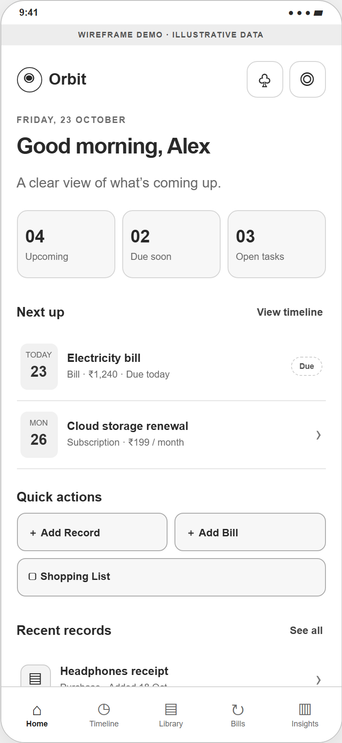
Figure 1. Home Dashboard — supplied Orbit wireframe (illustrative data).

2. Timeline
Purpose. Present date-based bills, renewals, reminders, document expiries, and warranties in chronological order.
Key UI elements and features: Category filters (All, Bills, Subscriptions, Documents, Warranties); search; date-group headings; item title/type/date; status chip or completion control.
Primary interaction: Select a filter to narrow the list; tap an item to open details; mark completion only for items where completion is meaningful.
Worked example from the mockup: Sample groups: Today—electricity bill; Tomorrow—return library book; This week—cloud storage; Later—headphones warranty.
Usability rationale: Chronological grouping supports scanning. Status must use consistent, unambiguous language; distinguish Due today, Overdue, Upcoming, and Completed.
Proposed acceptance checks: Items sort by date; filters behave predictably; status/date are consistent with Home and Bills; empty and past-date states are designed.
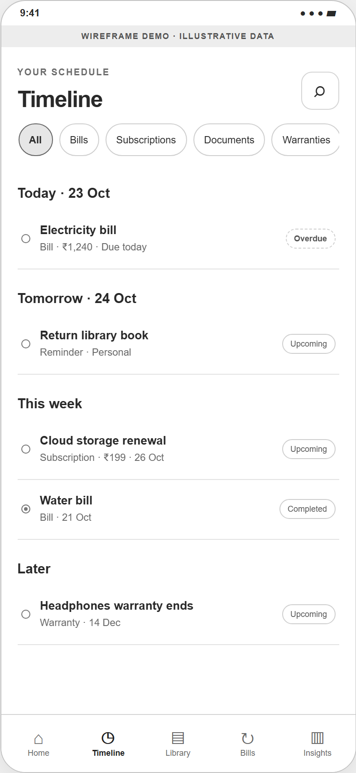
Figure 2. Timeline — supplied Orbit wireframe (illustrative data).

3. Add Record
Purpose. Capture a new personal record with the minimum required information and optional useful context.
Key UI elements and features: Category selector; required record name; optional notes, purchase date, warranty/due date, amount, attachment; reminder toggle and date/time; back/save actions.
Primary interaction: Choose category, complete required fields, optionally add metadata or file, set reminder if wanted, then save. Validate required fields and date logic.
Worked example from the mockup: Sample purchase: wireless headphones; ₹8,499; purchase 18 Oct 2026; warranty 14 Dec 2026; reminder 7 Dec 2026 at 09:00.
Usability rationale: Required/optional labels reduce uncertainty. Group related dates and explain reminder timing. Provide validation and preserve entered data if the user navigates back.
Proposed acceptance checks: Cannot save without category/name; invalid amount/date is rejected with a useful message; attachment selection uses Android picker; reminder setting has a clear permission path.
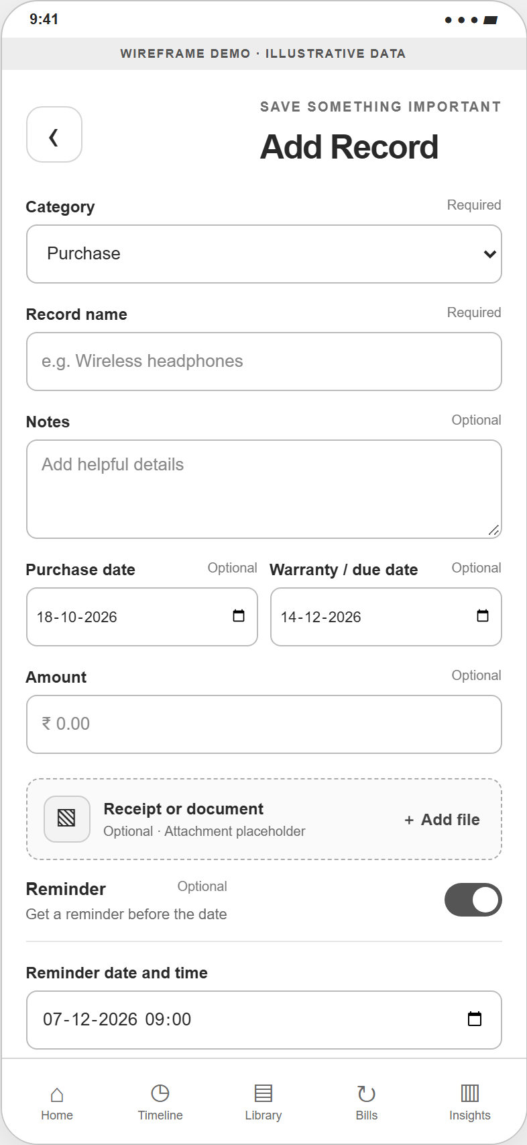
Figure 3. Add Record — supplied Orbit wireframe (illustrative data).

4. Library
Purpose. Provide a browsable archive of saved records organized by category.
Key UI elements and features: Category tiles (Documents, Purchases, Warranties, Notes, Subscriptions); record counts; All records; sort; search; add button; record rows.
Primary interaction: Tap category or All records; sort or search; open a row for Record Details; use add button to create a record.
Worked example from the mockup: Sample: Headphones receipt, headphones warranty, apartment agreement; category counts are mock data.
Usability rationale: Category cards support recognition while a compact list supports rapid browsing. Counts should update after create/delete and not mislead when filtered.
Proposed acceptance checks: Category count equals matching stored records; sort choices are explained; list rows expose title and key metadata; empty category has helpful next action.
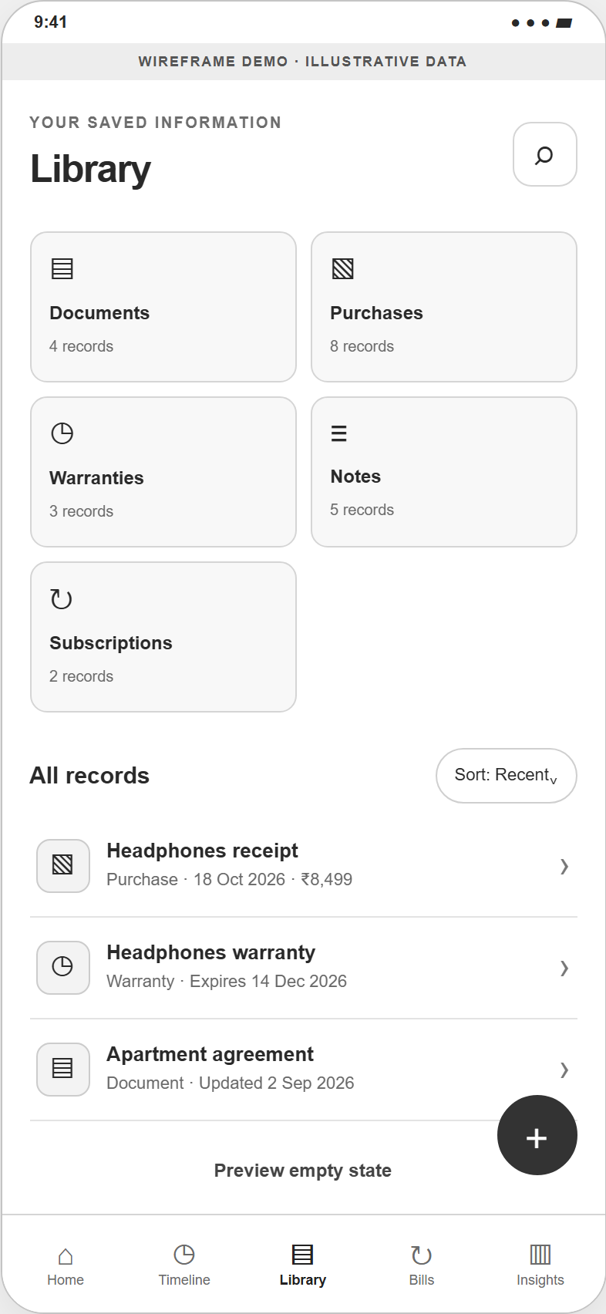
Figure 4. Library — supplied Orbit wireframe (illustrative data).

5. Bills & Subscriptions
Purpose. Manage recurring obligations, payment status, and upcoming renewal dates without processing payments.
Key UI elements and features: Monthly total, next payment, active-item count; All/Bills/Subscriptions filters; list entries with cadence, due/renewal date, amount, status; Mark as Paid; Add action.
Primary interaction: Open an item to inspect/edit; mark bill paid; add a new bill or subscription; filter by type.
Worked example from the mockup: Sample electricity ₹1,240; cloud storage ₹199/month renewing 26 Oct; internet ₹1,000. Total ₹2,439 is illustrative and needs a defined calculation.
Usability rationale: State clearly that the app tracks status and does not initiate bank/card payments. Make payment-state changes reversible or confirm them when necessary.
Proposed acceptance checks: Recurring totals are derived and explainable; paid state updates related views; bill and subscription recurrence fields are distinct; no payment processing is implied.
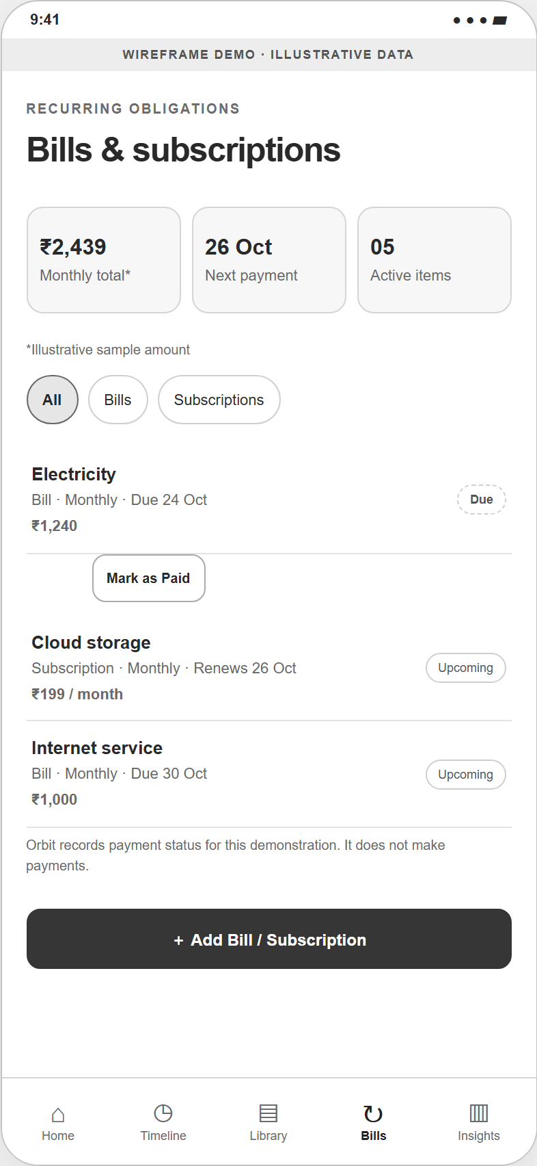
Figure 5. Bills & Subscriptions — supplied Orbit wireframe (illustrative data).

6. Shopping List
Purpose. Offer a lightweight checklist for planned purchases.
Key UI elements and features: Add-item input and Add button; To buy list with checkboxes; Completed group; Clear completed action.
Primary interaction: Enter item and tap Add; check item to complete; clear completed only after confirmation or with undo.
Worked example from the mockup: Sample unchecked items: dish soap, notebook, light bulbs; oat milk is completed.
Usability rationale: Keep this workflow intentionally simple and fast. Completed items should remain visually distinguishable and accessible until removed.
Proposed acceptance checks: Empty list shows a useful prompt; adding prevents blank items; check/uncheck works; clear-completed does not accidentally delete active items.
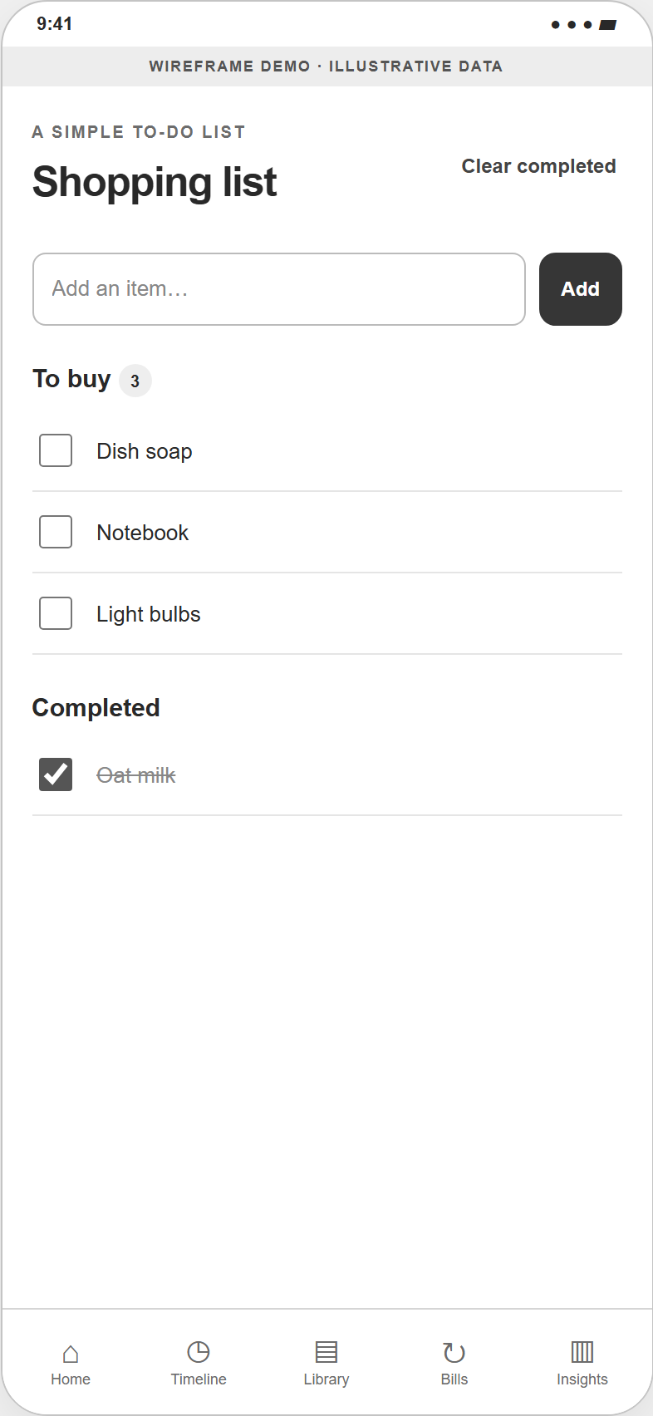
Figure 6. Shopping List — supplied Orbit wireframe (illustrative data).

7. Record Details
Purpose. Show a single record’s stored fields, attachment, reminder, and relationships in one inspectable page.
Key UI elements and features: Title/category/status; record-information panel; attachment card; reminder panel with edit; related-record section; overflow actions.
Primary interaction: Open from Library, Timeline, or Search; edit record/reminder; open attachment using supported viewer; access related warranty/purchase.
Worked example from the mockup: Worked example: headphones purchase ₹8,499, receipt PDF, warranty expiry 14 Dec, reminder scheduled 7 Dec 09:00.
Usability rationale: Grouping details into labelled panels improves scanning. Sensitive attachment handling and deletion confirmation are important; show whether a reminder is scheduled or merely configured.
Proposed acceptance checks: Details match saved record; file can be opened or missing-file state shown; reminder state is accurate; destructive action requires confirmation.
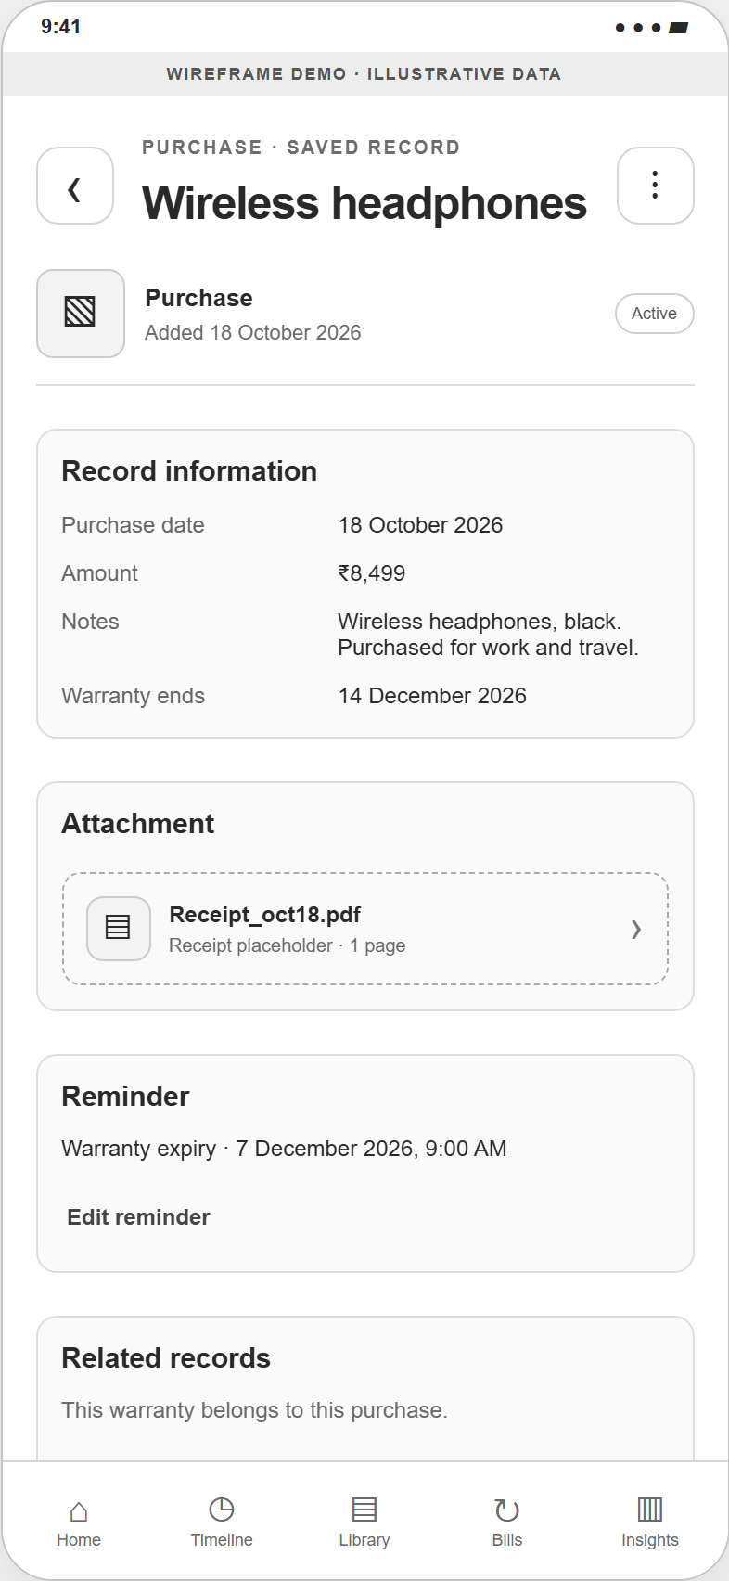
Figure 7. Record Details — supplied Orbit wireframe (illustrative data).

8. Search
Purpose. Find a saved record by name or note, with category filters to narrow results.
Key UI elements and features: Search field; All/Purchases/Bills/Warranties/Documents filters; recent searches; browse-category shortcuts; results state (not visible in this empty-query mockup).
Primary interaction: Type a query; optionally apply category filter; tap result to open Record Details; clear query to return to recent/browse state.
Worked example from the mockup: Example queries shown: “warranty” and “electricity”.
Usability rationale: Search should tolerate partial terms and provide a clear no-results state. Recent searches may reveal personal data, so provide a clear/delete option and avoid syncing them by default.
Proposed acceptance checks: Search covers agreed fields (title/notes/category); filter and query combine correctly; no-result state offers recovery; recent query history can be cleared.
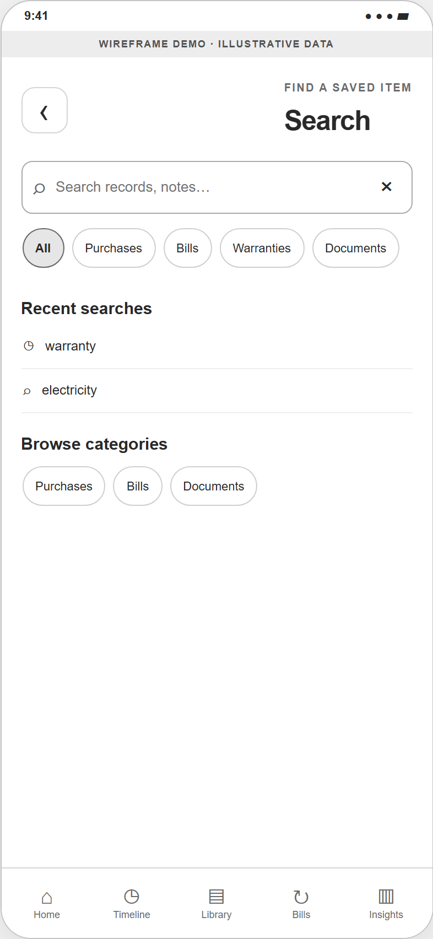
Figure 8. Search — supplied Orbit wireframe (illustrative data).

9. Insights
Purpose. Summarize recurring costs and upcoming obligations so users can plan ahead.
Key UI elements and features: Month/Next month selector; recurring total, upcoming payment and overdue metrics; recurring-cost chart; upcoming renewals; link to Bills.
Primary interaction: Switch period; tap renewal to open item; use Bills link to inspect or manage underlying records.
Worked example from the mockup: Sample monthly recurring amount ₹2,439, 3 upcoming payments, 1 overdue item; chart months Aug–Nov is illustrative only.
Usability rationale: Charts need labels and accessible textual summaries. Explain period, currency, inclusion rules, and data source; do not present mock values as computed personal analytics.
Proposed acceptance checks: Chart values are computed from records; month selector updates all metrics; totals reconcile with Bills; text alternative conveys chart trend.
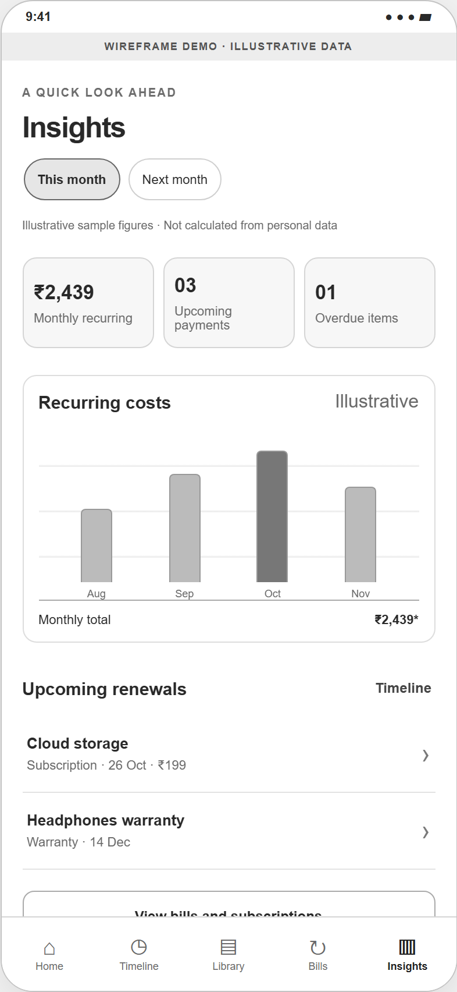
Figure 9. Insights — supplied Orbit wireframe (illustrative data).

10. Settings
Purpose. Let users configure notification behavior, appearance, and data/privacy actions.
Key UI elements and features: Reminder toggle/timing; quiet hours; backup/restore entries; app-lock/privacy information; theme selector.
Primary interaction: Change preference and confirm visible state. Backup/restore and app lock remain nonfunctional placeholders until designed, implemented, and security-reviewed.
Worked example from the mockup: Wireframe labels backup/restore as “Design placeholder—not connected” and app lock as “Proposed feature—not implemented.”
Usability rationale: Separate available controls from future features. Explain notification permissions and provide privacy information before users store sensitive documents.
Proposed acceptance checks: Each active setting persists and can be changed; disabled/planned controls are clearly marked; data export/import has documented format and failure recovery before release.
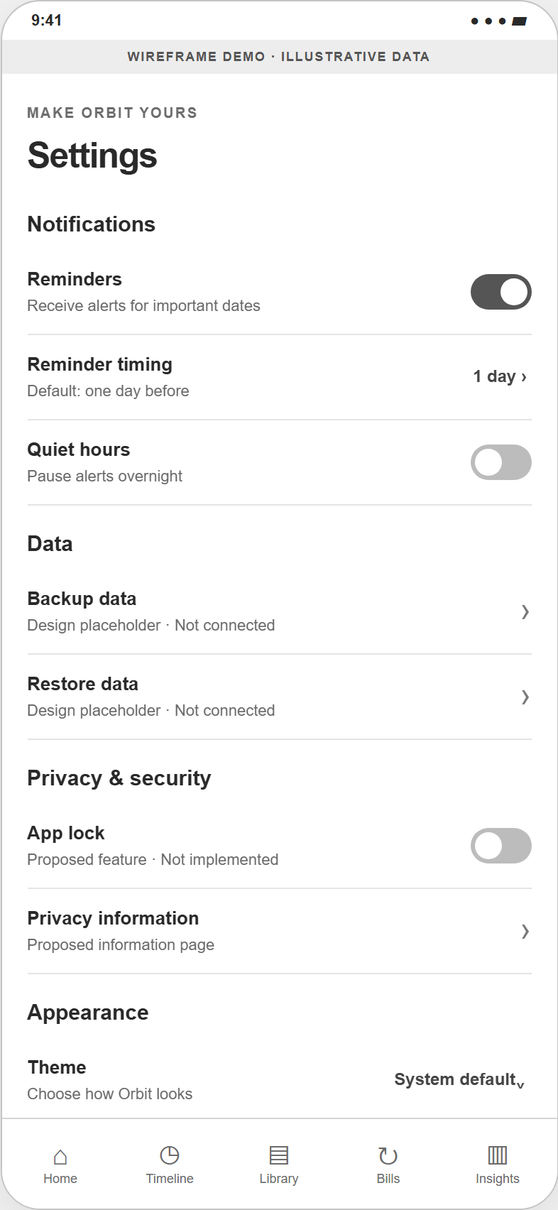
Figure 10. Settings — supplied Orbit wireframe (illustrative data).

5. Cross-screen usability and accessibility review
Design principle | Application to Orbit | Validation method (planned)
Navigation consistency | Persistent five-item bottom navigation; secondary pages have back/context actions. | Task-based usability walkthrough; check tab labels and selected state.
Information hierarchy | Urgent dates and next actions appear before long record lists. | Ask participants to identify next due item and add a record.
Input clarity | Required fields are marked; optional metadata is separated. | Test incomplete, malformed, and realistic entries.
Status semantics | Use consistent status terms and date rules across Home/Timeline/Bills. | Cross-screen test with same bill/renewal record.
Touch/readability | Adequate touch targets, contrast, text scaling, scroll behavior. | Review on different Android screen sizes and font scales; accessibility checks.
Feedback and recovery | Save confirmation, validation errors, undo/confirmation for destructive actions. | Observe whether users understand save, complete, delete, and reminder state.

Accessibility is a design target, not a verified result. The current screenshots should be checked against Android accessibility guidance during implementation, including touch-target sizing, content descriptions for icons, contrast, font scaling, TalkBack focus order, and keyboard/assistive navigation where applicable.

6. Privacy and data protection considerations
Orbit may store purchase history, financial amounts, document metadata, receipt files, and reminder dates. Even if the first release is offline-first, these records can be sensitive. The UI and implementation should follow data-minimization and user-control principles.
- Data minimization: collect only fields needed for the user’s chosen record; make notes, amounts, and attachments optional where possible.
- Local-first storage: keep core records on-device for the MVP; do not add cloud synchronization or analytics by default without a clear purpose and consent.
- Attachment safety: use Android’s system photo/document picker and persist only the access needed; avoid broad storage permissions when not necessary.
- Transparency: explain what reminders do, whether they require notification permission, and what backup/export includes.
- User control: provide a deliberate delete/export path and confirmation for destructive operations; document how local data is removed.
- Protection at rest: assess Android platform protections and whether app-level encryption or device authentication is appropriate for sensitive files; do not claim encryption unless implemented and tested.
- Privacy by design: recent searches and notification previews may expose sensitive names; allow clearing search history and consider privacy-conscious notification text.
- Backup security: if backup/restore is implemented, specify file format, storage destination, encryption approach, and recovery behavior before release.
This section is a design checklist, not a legal compliance claim or completed security assessment.

7. Project scope and limitations

7.1 Proposed MVP scope
- Create, view, edit, and delete local records with category, title, notes, dates, amount, and optional attachment metadata.
- Track bills/subscriptions and let the user record payment status; do not execute payments.
- Show a chronological timeline and local reminders for dates the user configures.
- Browse/search saved records and use a basic shopping checklist.
- Provide simple, derived summaries only when their calculation rules are defined.

7.2 Explicitly out of scope for the initial version
- Automatic bank-account/card integration, payment initiation, or financial advice.
- Cloud account, multi-device sync, shared household collaboration, or server-based data storage.
- Automatic receipt OCR, AI extraction, document classification, or generative recommendations.
- Guaranteed notification delivery across all device conditions; Android battery/permission settings may affect reminders.
- Fully implemented backup/restore, app lock, or encryption until requirements and security design are completed.
- Claims of accessibility compliance, production readiness, or user-validated usability before testing.

7.3 Risks and mitigations
Risk / limitation | Potential impact | Mitigation / follow-up
Feature breadth exceeds internship time | Incomplete or inconsistent modules. | Prioritize a narrow MVP; mark later features as future scope.
Conflicting date/status representations | User may miss or misinterpret a due item. | Define status rules and test same record across all screens.
Incorrect financial aggregates | Insights may mislead users. | Document recurrence normalization and include/exclude rules; test with hand-calculated cases.
Sensitive records exposed in UI/notifications | Privacy loss on shared/visible device. | Minimize notification text; provide clear privacy controls; evaluate local protection.
Wireframe layout does not fit all devices | Clipped controls or excessive scrolling. | Adapt Compose layouts, test multiple screen sizes and font scales.
Reminder permission denied or scheduling affected | Reminder may not appear. | Explain permission state and show in-app reminder status/fallback.

8. Prototype acceptance checklist and next steps
- Resolve the mockup inconsistency for the electricity bill’s due/overdue label and align the due date across screens.
- Specify data model fields and relationships for a purchase, attached receipt, warranty date, and reminder.
- Implement the primary navigation and core record flows before adding advanced settings.
- Test a complete worked scenario end-to-end: add purchase → attach receipt → set warranty reminder → find record → see timeline entry.
- Conduct a small usability review with representative users; record tasks, observed errors, and resulting design changes.
- Replace illustrative figures with calculated values once data logic is implemented; label all demo/sample content.

Conclusion
The supplied Orbit wireframes establish a coherent initial navigation and screen set for a personal records-and-obligations app. This expanded specification makes the design more reviewable by tying each screen to user tasks, concrete sample scenarios, usability checks, privacy considerations, and explicit implementation boundaries. The next iteration should resolve data/status inconsistencies and validate the key workflows before visual styling and feature implementation are treated as final.

Appendix A — Wireframe inventory
Figure | Screen | Primary entry point
1 | Home Dashboard | App launch / Home tab
2 | Timeline | Timeline tab / View timeline
3 | Add Record | Home quick action / Library add
4 | Library | Library tab
5 | Bills & Subscriptions | Bills tab
6 | Shopping List | Home quick action
7 | Record Details | Select a record from any list
8 | Search | Search control from Timeline/Library
9 | Insights | Insights tab
10 | Settings | App-level settings entry point (to be defined)

Appendix B — Competitive and category-level UI benchmark
This is a preliminary design benchmark based on common product categories, not a verified, version-by-version audit of current competitor features. It is included to make Orbit’s intended positioning explicit and to identify patterns worth validating through hands-on research.
Product/category | Typical user job (benchmark lens) | UI pattern worth learning from | Orbit’s intended distinction / trade-off
Google Keep / note-and-checklist apps | Capture short notes, lists, and quick reminders. | Fast entry, lightweight lists, simple retrieval. | Orbit adds structured records, dates, attachments, and links between purchase/warranty/reminder. Trade-off: more fields and complexity than a pure notes app.
Todoist / task-management apps | Plan and complete tasks with due dates and priorities. | Clear task states, due-date visibility, focused completion flows. | Orbit’s Timeline includes obligations tied to stored records, not only user-created tasks. Trade-off: should not attempt to replicate full project/task management.
Subscription/bill tracking apps | Monitor recurring charges, renewal dates, and spending. | Recurring-item summaries, renewal reminders, payment status. | Orbit combines recurring expenses with receipts, warranties, documents, and general reminders. Trade-off: avoid advanced financial integrations in MVP.
Cloud drive / document-library apps | Store, organize, and retrieve files. | Folder/category browsing, search, file previews, metadata. | Orbit stores record context around a file (e.g., purchase amount, warranty date, reminder). Trade-off: not intended as a full document editor or cloud-storage replacement.
Calendar/reminder apps | Show events and notify users at scheduled times. | Chronological views, notification controls, repeat schedules. | Orbit surfaces domain-specific records in a unified schedule. Trade-off: keep reminder scheduling simple and clearly explain Android permission/device limits.

Benchmark conclusions
- Orbit’s core value proposition is not that it replaces every specialist app. It is that it links a record to the dates and actions that matter for that record.
- The strongest design test is a connected workflow: save a purchase and receipt, associate a warranty date, schedule a reminder, then find the item and see it on the Timeline.
- The main product risk is feature overload. The MVP should prioritize record capture, browsing/search, timeline visibility, and local reminders; sophisticated budgeting, cloud sync, OCR, and payment integrations should remain outside initial scope.
- Before making stronger competitor claims, record the exact competitor version, date reviewed, tested tasks, and observed outcomes. A feature matrix should distinguish verified observations from assumptions.

