ORBIT — Personal Life Operations Hub
WEEK 3 TECHNICAL REPORT: DATABASE DESIGN AND API INTEGRATION
Junior Mobile App Developer Internship | Yuva Intern | Internship Duration: 9 Oct 2026 – 20 Nov 2026
Project Specification | Technical & Academic Details
Application Name | Orbit — Personal Life Operations Hub
Target Platform & Language | Android OS (API Level 26+), Kotlin 2.0+
Persistence Framework | Room Persistence Library (SQLite Engine), Android Jetpack
UI Framework & Architecture | Jetpack Compose, Material 3, Clean Architecture + MVVM
Background Scheduling APIs | AlarmManager (Exact Wakeup Alarms) & WorkManager (Deferrable Jobs)
System Integration APIs | Storage Access Framework (SAF), Photo Picker, NotificationManager
Internship Deliverable | Week 3 Submission: Back-end Architecture, Schema & System APIs

1. Executive Summary & Week 3 Scope
During Week 3 of the Junior Mobile App Developer Internship at Yuva Intern, project development transitions from visual wireframing into the technical back-end foundation. Orbit is architected as an offline-first personal life operations hub designed to consolidate purchase records, warranties, recurring bills, digital receipts, time-sensitive reminders, and personal notes. Rather than relying on fragile cloud backends or costly third-party APIs, Orbit's persistence engine is built directly on the device using the Android Room persistence library backed by an embedded SQLite relational database.
This report provides the formal technical documentation required by the Week 3 evaluation criteria, including: (1) A fully normalized, production-validated relational database schema consisting of seven dedicated entities; (2) Detailed attribute dictionaries, primary/foreign key definitions, cascade rules, and check constraints; (3) Formal Entity-Relationship modeling using Chen notation; (4) Multi-level Data Flow Diagrams (Level 0 Context, Level 1 Functional Decomposition, and Level 2 Ingestion Walkthrough); (5) Android platform API integration mapping (AlarmManager, NotificationManager, and Storage Access Framework); and (6) An end-to-end integration architecture linking Jetpack Compose, ViewModel StateFlow, Repository abstractions, and Room DAOs.

2. Core Architectural Decisions for Local Persistence
Designing an offline-first mobile application requires addressing specific data-integrity, performance, and storage challenges before committing code to the repository. The following four technical decisions govern Orbit's database architecture:
- 1. Monetary Storage in Minor Units: Floating-point data types (FLOAT, REAL) in SQLite introduce IEEE 754 precision drift during aggregation. Orbit strictly stores all monetary values (records, bills, subscriptions) as 64-bit INTEGER values representing minor currency units (e.g., ₹1,240.00 is stored as 124000 paise). An accompanying ISO-4217 currency_code column guarantees exact mathematical sums and zero rounding error across Insights and Bills screens.
- 2. Polymorphic Parent Constraints: Attachments (receipts, contracts) and Reminders must link to either a Record or an Obligation. To prevent invalid relational states, table-level CHECK constraints are enforced. An attachment must strictly belong to exactly one parent ((record_id IS NOT NULL AND obligation_id IS NULL) OR (record_id IS NULL AND obligation_id IS NOT NULL)). A reminder may belong to a record, an obligation, or exist as a standalone personal alert, but cannot link to both simultaneously (NOT (record_id IS NOT NULL AND obligation_id IS NOT NULL)).
- 3. Normalized Date and Timestamp Standards: Because SQLite lacks dedicated DATETIME storage classes, Orbit standardizes two representations: Pure calendar dates (purchase_date, expiry_date, due_date) are stored as ISO-8601 TEXT ('YYYY-MM-DD') ensuring alphabetical sorting matches chronological order without timezone distortion. Execution timestamps (created_at, updated_at, reminder_datetime) are stored as INTEGER Unix epoch milliseconds for exact arithmetic comparison in AlarmManager.
- 4. File Storage via Persisted Content URIs: Raw binary blobs (PDFs, images) are never stored in SQLite. Instead, Orbit leverages the Android Storage Access Framework (SAF) and Photo Picker, storing only the persistent content:// URI string in the attachments table. The application requests persistable URI permissions via ContentResolver.takePersistableUriPermission(), maintaining instantaneous database query performance while keeping storage overhead minimal.
3. Detailed Database Schema Specifications
The Orbit database schema comprises seven normalized tables designed to satisfy all functional modules: records, obligations, attachments, reminders, notes, shopping_items, and app_settings.
3.1 Entity: records
The central repository for user-entered purchases, warranties, identity documents, and personal records.
Column Name | Type | Null | Default | Description & Constraints
record_id | INTEGER | NO | Auto Inc | Primary Key. Unique record identifier.
title | TEXT | NO | None | Name of item/document (e.g., 'Wireless Headphones').
category | TEXT | NO | None | CHECK(category IN ('PURCHASE','DOCUMENT','WARRANTY','PERSONAL')).
description | TEXT | YES | NULL | User notes, serial numbers, or extra context.
purchase_date | TEXT | YES | NULL | Date of purchase in ISO-8601 format (YYYY-MM-DD).
expiry_date | TEXT | YES | NULL | Warranty or document expiration date (YYYY-MM-DD).
amount_minor | INTEGER | YES | NULL | Monetary amount in minor units (e.g., ₹8,499 -> 849900).
currency_code | TEXT | NO | 'INR' | ISO-4217 standard 3-letter currency code.
merchant | TEXT | YES | NULL | Seller, merchant, or issuing authority.
created_at | INTEGER | NO | None | Record creation timestamp (Unix epoch milliseconds).
updated_at | INTEGER | NO | None | Last modification timestamp (Unix epoch milliseconds).
3.2 Entity: obligations
Stores recurring financial commitments, periodic utility bills, and digital subscriptions.
Column Name | Type | Null | Default | Description & Constraints
obligation_id | INTEGER | NO | Auto Inc | Primary Key. Unique obligation identifier.
title | TEXT | NO | None | Name of obligation (e.g., 'Electricity Bill', 'Cloud Storage').
type | TEXT | NO | None | CHECK(type IN ('BILL','SUBSCRIPTION')).
amount_minor | INTEGER | NO | None | Cost in minor currency units (e.g., ₹1,240 -> 124000).
currency_code | TEXT | NO | 'INR' | ISO-4217 currency identifier.
frequency | TEXT | NO | None | CHECK(frequency IN ('WEEKLY','MONTHLY','QUARTERLY','YEARLY','CUSTOM')).
due_date | TEXT | NO | None | Next upcoming payment or renewal date (YYYY-MM-DD).
status | TEXT | NO | 'ACTIVE' | CHECK(status IN ('ACTIVE','PAUSED','CANCELLED')).
payment_status | TEXT | NO | 'UNPAID' | CHECK(payment_status IN ('UNPAID','PAID','OVERDUE')).
provider | TEXT | YES | NULL | Utility board, landlord, or SaaS provider.
auto_renew | INTEGER | NO | 0 | CHECK(auto_renew IN (0, 1)). 1 = Auto-debit renewal enabled.
notes | TEXT | YES | NULL | Account number, customer ID, or payment remarks.
created_at | INTEGER | NO | None | Epoch milliseconds timestamp.
updated_at | INTEGER | NO | None | Epoch milliseconds timestamp.
3.3 Entity: attachments
Stores persistent URI links to user-selected receipts, invoices, and documents.
Column Name | Type | Null | Default | Description & Constraints
attachment_id | INTEGER | NO | Auto Inc | Primary Key. Unique attachment identifier.
record_id | INTEGER | YES | NULL | Foreign Key -> records(record_id) ON DELETE CASCADE.
obligation_id | INTEGER | YES | NULL | Foreign Key -> obligations(obligation_id) ON DELETE CASCADE.
file_name | TEXT | NO | None | User-facing filename (e.g., 'Receipt_oct18.pdf').
file_uri | TEXT | NO | None | Persisted content:// URI string from Android SAF/Picker.
mime_type | TEXT | NO | None | MIME type string (e.g., 'application/pdf', 'image/jpeg').
file_size | INTEGER | YES | NULL | Byte count of attachment file.
added_at | INTEGER | NO | None | Ingestion timestamp in epoch milliseconds.
3.4 Entity: reminders
Stores scheduled alert parameters used by AlarmManager to trigger Android notifications.
Column Name | Type | Null | Default | Description & Constraints
reminder_id | INTEGER | NO | Auto Inc | Primary Key. Unique alarm identifier.
record_id | INTEGER | YES | NULL | Foreign Key -> records(record_id) ON DELETE CASCADE.
obligation_id | INTEGER | YES | NULL | Foreign Key -> obligations(obligation_id) ON DELETE CASCADE.
title | TEXT | NO | None | Notification title displayed to user.
message | TEXT | YES | NULL | Detailed alert description or actionable prompt.
reminder_datetime | INTEGER | NO | None | Exact trigger time in Unix epoch milliseconds.
is_enabled | INTEGER | NO | 1 | CHECK(is_enabled IN (0, 1)). 1 = Active alarm.
is_completed | INTEGER | NO | 0 | CHECK(is_completed IN (0, 1)). 1 = Fired / Dismissed.
created_at | INTEGER | NO | None | Creation timestamp in epoch milliseconds.
3.5 Entity: notes
Enables standalone personal note capture, supporting the Library and Search workflows.
Column Name | Type | Null | Default | Description & Constraints
note_id | INTEGER | NO | Auto Inc | Primary Key. Unique note identifier.
title | TEXT | NO | None | Subject heading of the note.
content | TEXT | NO | '' | Body content or markdown text.
is_pinned | INTEGER | NO | 0 | CHECK(is_pinned IN (0, 1)). 1 = Pinned to top of Library.
created_at | INTEGER | NO | None | Creation timestamp in epoch milliseconds.
updated_at | INTEGER | NO | None | Last modification timestamp in epoch milliseconds.
3.6 Entity: shopping_items
Powers the lightweight shopping checklist module accessible from the Home screen.
Column Name | Type | Null | Default | Description & Constraints
item_id | INTEGER | NO | Auto Inc | Primary Key. Unique checklist item identifier.
item_name | TEXT | NO | None | Descriptive item name (e.g., 'Dish soap', 'Notebook').
quantity | TEXT | YES | NULL | Optional amount or unit descriptor (e.g., '2 packs').
is_completed | INTEGER | NO | 0 | CHECK(is_completed IN (0, 1)). 1 = Purchased/Checked off.
created_at | INTEGER | NO | None | Creation timestamp in epoch milliseconds.
updated_at | INTEGER | NO | None | Last modification timestamp in epoch milliseconds.
3.7 Entity: app_settings
Provides a persistent key-value configuration table for user preferences and quiet hours.
Column Name | Type | Null | Default | Description & Constraints
setting_key | TEXT | NO | None | Primary Key. Unique configuration identifier (e.g., 'quiet_hours').
setting_value | TEXT | NO | None | Serialized configuration value.
updated_at | INTEGER | NO | None | Last modification timestamp in epoch milliseconds.
4. SQLite Data Definition Language (DDL) & Query Optimization
To ensure that database implementation in Week 4 executes seamlessly under Room, the complete DDL script is structured with explicit foreign key cascades, check constraints, and performance indexes. Indexes are positioned specifically on date columns and foreign keys to guarantee sub-millisecond response times on consumer Android hardware.
-- TABLE 1: RECORDS
CREATE TABLE IF NOT EXISTS records (
record_id INTEGER PRIMARY KEY AUTOINCREMENT,
title TEXT NOT NULL,
category TEXT NOT NULL CHECK(category IN ('PURCHASE', 'DOCUMENT', 'WARRANTY', 'PERSONAL')),
description TEXT,
purchase_date TEXT,
expiry_date TEXT,
amount_minor INTEGER,
currency_code TEXT NOT NULL DEFAULT 'INR',
merchant TEXT,
created_at INTEGER NOT NULL,
updated_at INTEGER NOT NULL
);
-- TABLE 2: OBLIGATIONS
CREATE TABLE IF NOT EXISTS obligations (
obligation_id INTEGER PRIMARY KEY AUTOINCREMENT,
title TEXT NOT NULL,
type TEXT NOT NULL CHECK(type IN ('BILL', 'SUBSCRIPTION')),
amount_minor INTEGER NOT NULL,
currency_code TEXT NOT NULL DEFAULT 'INR',
frequency TEXT NOT NULL CHECK(frequency IN ('WEEKLY', 'MONTHLY', 'QUARTERLY', 'YEARLY', 'CUSTOM')),
due_date TEXT NOT NULL,
status TEXT NOT NULL DEFAULT 'ACTIVE' CHECK(status IN ('ACTIVE', 'PAUSED', 'CANCELLED')),
payment_status TEXT NOT NULL DEFAULT 'UNPAID' CHECK(payment_status IN ('UNPAID', 'PAID', 'OVERDUE')),
provider TEXT,
auto_renew INTEGER NOT NULL DEFAULT 0 CHECK(auto_renew IN (0, 1)),
notes TEXT,
created_at INTEGER NOT NULL,
updated_at INTEGER NOT NULL
);
-- TABLE 3: ATTACHMENTS (STRICT XOR PARENT CONSTRAINT)
CREATE TABLE IF NOT EXISTS attachments (
attachment_id INTEGER PRIMARY KEY AUTOINCREMENT,
record_id INTEGER,
obligation_id INTEGER,
file_name TEXT NOT NULL,
file_uri TEXT NOT NULL,
mime_type TEXT NOT NULL,
file_size INTEGER,
added_at INTEGER NOT NULL,
FOREIGN KEY (record_id) REFERENCES records (record_id) ON DELETE CASCADE,
FOREIGN KEY (obligation_id) REFERENCES obligations (obligation_id) ON DELETE CASCADE,
CONSTRAINT check_attachment_parent CHECK (
(record_id IS NOT NULL AND obligation_id IS NULL) OR
(record_id IS NULL AND obligation_id IS NOT NULL)
)
);
-- TABLE 4: REMINDERS (MAX ONE PARENT CONSTRAINT, ALLOWS STANDALONE)
CREATE TABLE IF NOT EXISTS reminders (
reminder_id INTEGER PRIMARY KEY AUTOINCREMENT,
record_id INTEGER,
obligation_id INTEGER,
title TEXT NOT NULL,
message TEXT,
reminder_datetime INTEGER NOT NULL,
is_enabled INTEGER NOT NULL DEFAULT 1 CHECK(is_enabled IN (0, 1)),
is_completed INTEGER NOT NULL DEFAULT 0 CHECK(is_completed IN (0, 1)),
created_at INTEGER NOT NULL,
FOREIGN KEY (record_id) REFERENCES records (record_id) ON DELETE CASCADE,
FOREIGN KEY (obligation_id) REFERENCES obligations (obligation_id) ON DELETE CASCADE,
CONSTRAINT check_reminder_parent CHECK (
NOT (record_id IS NOT NULL AND obligation_id IS NOT NULL)
)
);
-- TABLES 5, 6, 7: NOTES, SHOPPING ITEMS, APP SETTINGS
CREATE TABLE IF NOT EXISTS notes (
note_id INTEGER PRIMARY KEY AUTOINCREMENT,
title TEXT NOT NULL,
content TEXT NOT NULL DEFAULT '',
is_pinned INTEGER NOT NULL DEFAULT 0 CHECK(is_pinned IN (0, 1)),
created_at INTEGER NOT NULL,
updated_at INTEGER NOT NULL
);
CREATE TABLE IF NOT EXISTS shopping_items (
item_id INTEGER PRIMARY KEY AUTOINCREMENT,
item_name TEXT NOT NULL,
quantity TEXT,
is_completed INTEGER NOT NULL DEFAULT 0 CHECK(is_completed IN (0, 1)),
created_at INTEGER NOT NULL,
updated_at INTEGER NOT NULL
);
CREATE TABLE IF NOT EXISTS app_settings (
setting_key TEXT PRIMARY KEY,
setting_value TEXT NOT NULL,
updated_at INTEGER NOT NULL
);
-- PERFORMANCE QUERY INDEXES
CREATE INDEX IF NOT EXISTS idx_records_expiry ON records(expiry_date);
CREATE INDEX IF NOT EXISTS idx_records_category ON records(category);
CREATE INDEX IF NOT EXISTS idx_obligations_due_date ON obligations(due_date);
CREATE INDEX IF NOT EXISTS idx_obligations_type_status ON obligations(type, status, payment_status);
CREATE INDEX IF NOT EXISTS idx_attachments_record ON attachments(record_id);
CREATE INDEX IF NOT EXISTS idx_attachments_obligation ON attachments(obligation_id);
CREATE INDEX IF NOT EXISTS idx_reminders_trigger ON reminders(reminder_datetime, is_completed, is_enabled);
CREATE INDEX IF NOT EXISTS idx_reminders_record ON reminders(record_id);
CREATE INDEX IF NOT EXISTS idx_reminders_obligation ON reminders(obligation_id);
CREATE INDEX IF NOT EXISTS idx_notes_pinned ON notes(is_pinned, updated_at DESC);
CREATE INDEX IF NOT EXISTS idx_shopping_status ON shopping_items(is_completed, created_at DESC);
5. Entity-Relationship Model (Chen Notation)
To accurately document the conceptual database schema for technical review, Figure 1 illustrates the complete Entity-Relationship diagram in standard Chen notation. Entities are represented by rectangles, attributes by ovals (with primary keys underlined), and relationships by diamonds labeled with explicit cardinalities.
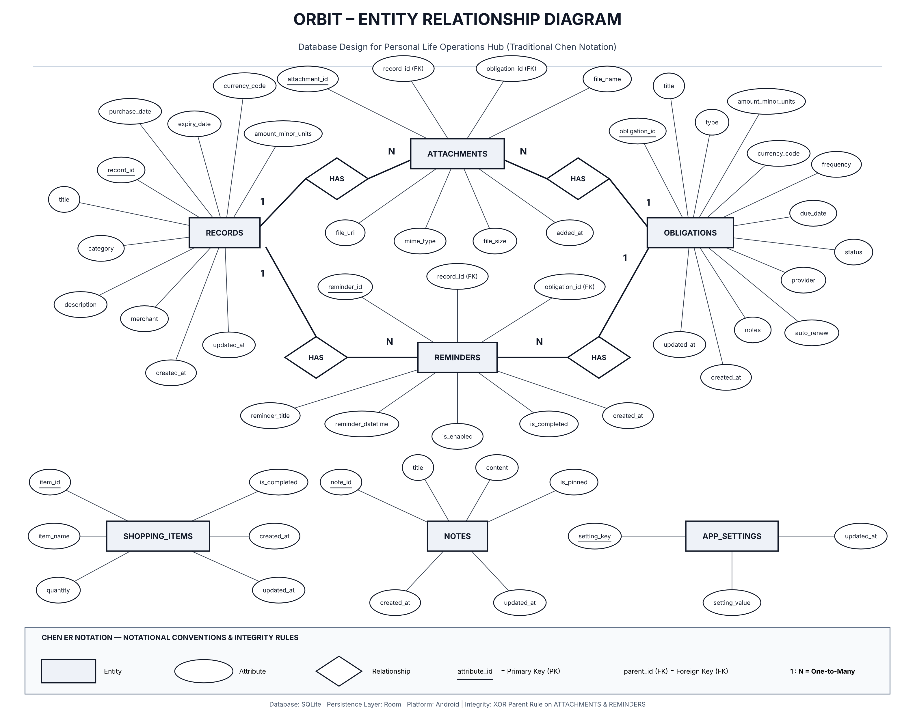
Figure 1: Orbit Entity-Relationship Diagram (Chen Notation) with Relational Cardinalities and Parent Constraints.
5.1 Cardinality & Participation Analysis
- RECORDS to ATTACHMENTS (1:N): One record can possess zero, one, or multiple supporting attachments (e.g., purchase receipt, warranty card, product photo). Each attachment linked to a record belongs to exactly one parent record. Total participation is enforced on the attachment side.
- OBLIGATIONS to ATTACHMENTS (1:N): One recurring obligation can store zero, one, or multiple bill invoices or contracts. Each attachment linked to an obligation belongs strictly to that single obligation.
- RECORDS to REMINDERS (1:N): One record can schedule multiple reminders (e.g., 30 days before, 7 days before, and on the morning of warranty expiration). Deleting the record automatically deletes all scheduled alarms via ON DELETE CASCADE.
- OBLIGATIONS to REMINDERS (1:N): One bill or subscription can schedule alerts prior to its renewal due date. Upon payment, the next cycle's due date is computed and a new reminder instance is scheduled.
- STANDALONE REMINDERS (0..1): A reminder with null parent keys represents an independent personal task (e.g., 'Return library book'). This directly supports the wireframe specification without requiring artificial dummy records.
6. Data Flow Diagrams (DFD)
Data Flow Diagrams model the movement of information between external entities, application processing logic, and local data stores. Figure 2 presents the Level 0 System Context Diagram and Level 1 Functional Decomposition.
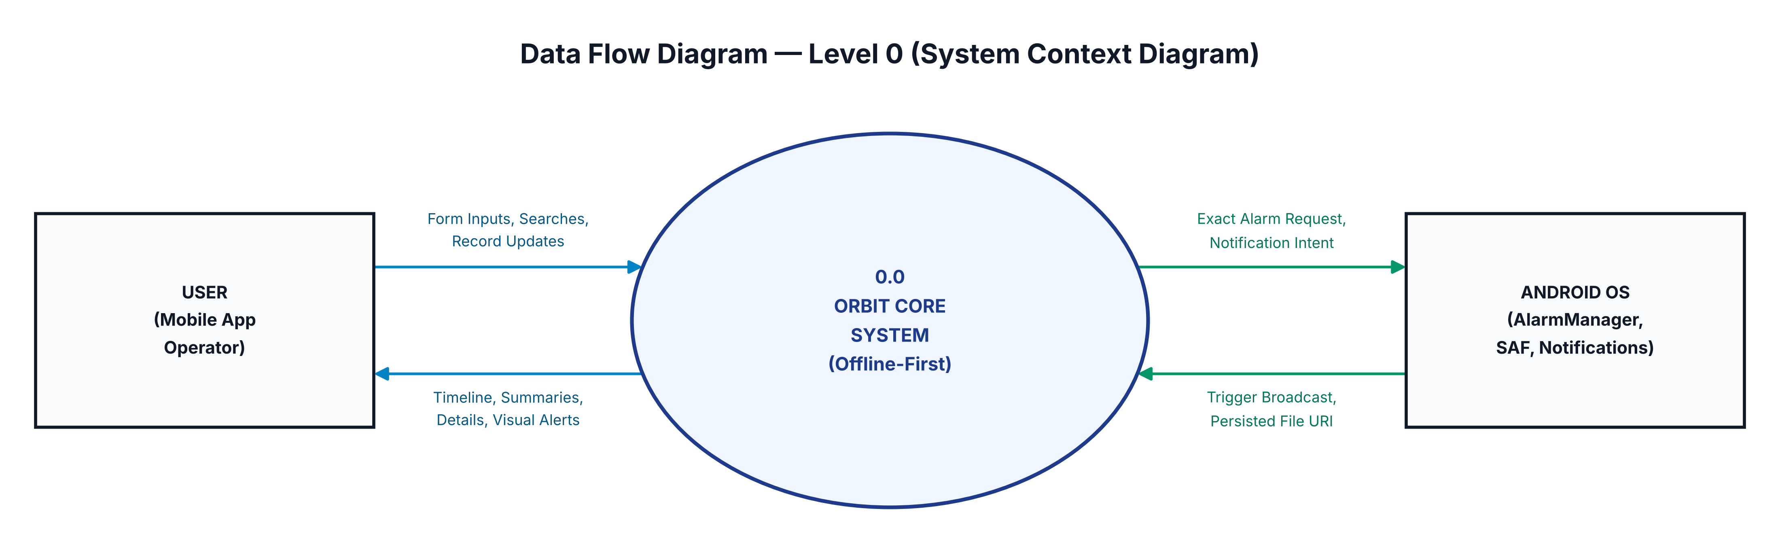
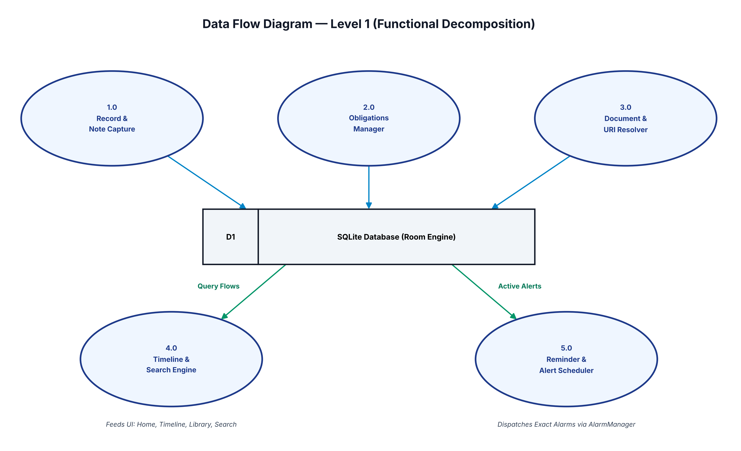
Figure 2: Orbit Data Flow Diagrams — Level 0 Context Diagram (Top) and Level 1 Functional Decomposition (Bottom).
6.1 Level 0: System Context Diagram
The Level 0 diagram establishes the external boundaries of the Orbit application. The User interacts with the application by submitting form inputs, configuring reminders, browsing saved records, and toggling shopping items. Orbit processes these inputs and produces responsive UI state updates, filtered timeline views, and financial summaries. Externally, Orbit communicates with the Android Operating System, dispatching exact alarm requests to AlarmManager and persisting content URIs via the Storage Access Framework (SAF).
6.2 Level 1: Functional Subsystem Decomposition
The Level 1 diagram breaks the core system into five specialized processing nodes interacting with Data Store D1 (SQLite Database):
- Process 1.0 (Record & Note Capture): Receives user input from Add Record and Notes screens, validates mandatory fields, converts amounts to minor units, and writes rows to records and notes.
- Process 2.0 (Obligations Manager): Handles recurring bill tracking, status toggles (Mark as Paid), and calculates monthly recurring expenditure aggregates.
- Process 3.0 (Document & URI Resolver): Interfaces with Android SAF/Photo Picker to acquire persistable read permissions and stores URI strings into attachments.
- Process 4.0 (Timeline & Search Engine): Aggregates dated records, upcoming obligations, and pending reminders into a single unified chronological flow, serving the Home and Timeline screens.
- Process 5.0 (Reminder & Alert Scheduler): Reads active alerts from reminders and registers exact RTC_WAKEUP alarms with the Android AlarmManager.
6.3 Level 2: Purchase Record Ingestion Transaction Walkthrough
To illustrate relational coordination in practice, consider the real-world scenario from the Week 2 wireframes: A user saves a purchase of Wireless Headphones (₹8,499), attaches a receipt PDF, and configures a warranty reminder. The exact transaction sequence is as follows:
- Step 1 (Form Validation): The ViewModel validates that title ('Wireless Headphones') and category ('PURCHASE') are non-empty, and converts ₹8,499 into 849900 paise.
- Step 2 (SAF File Ingestion): The Android Document Picker returns content://com.android.providers.media/1089. The repository immediately invokes context.contentResolver.takePersistableUriPermission() to secure reboot-safe access.
- Step 3 (Atomic Database Write): Inside a Room @Transaction block: (a) Insert into records -> returns record_id = 101; (b) Insert into attachments with record_id = 101, file_name = 'Receipt_oct18.pdf', and persisted URI; (c) Insert into reminders with record_id = 101, trigger timestamp set to 7 Dec 2026 09:00 AM -> returns reminder_id = 501. The transaction commits.
- Step 4 (OS Alarm Registration): The ReminderScheduler builds an explicit Intent bundling reminder_id = 501 and registers an exact alarm via alarmManager.setExactAndAllowWhileIdle().
- Step 5 (Reactive UI Emission): Room automatically emits the new record through Kotlin Flow, updating the Library, Timeline, and Home Dashboard screens without manual screen refreshing.
7. Android Platform APIs & System Integration Plan
Because Orbit is an offline-first application, its API strategy centers entirely on native Android Platform APIs and Jetpack Architecture Components rather than remote HTTP/REST services. The primary system APIs and their roles are detailed below:
Platform API / Library | API Level / Component | Role in Orbit Architecture | Implementation Strategy
Room Persistence Library | Android Jetpack (androidx.room) | Local Relational Persistence Engine | Acts as an abstraction layer over SQLite. Generates compile-time verified DAOs, handles migrations, and emits reactive Kotlin Flow streams.
AlarmManager | android.app.AlarmManager (API 26+) | Time-Critical Reminder Dispatching | Schedules exact alerts using setExactAndAllowWhileIdle(RTC_WAKEUP) to ensure notifications fire reliably even during device Doze mode.
NotificationManager & Channels | android.app.NotificationManager | User Alert Presentation | Configures high-importance notification channels ('channel_reminders' and 'channel_bills'). Manages POST_NOTIFICATIONS runtime permission on Android 13+.
Storage Access Framework (SAF) | androidx.activity.result.contract | Secure File & Receipt Selection | Uses ActivityResultContracts.OpenDocument and PickVisualMedia. Retains permanent file access via takePersistableUriPermission() without broad storage permissions.
WorkManager | androidx.work.WorkManager | Deferrable Maintenance Operations | Executes periodic maintenance (e.g., purging orphaned attachment URIs, verifying database integrity, recalculating recurring statistics).
Technical Clarification on Room vs Web APIs: In modern mobile engineering, the Room persistence library is an Android architecture component providing an object-relational mapping (ORM) API over embedded SQLite. It is not a remote REST or GraphQL web service. Clarifying this distinction confirms that Orbit remains 100% offline-first, zero-cost, and entirely private to the user's physical device.
8. Application Integration Architecture (MVVM & Clean Architecture)
Orbit strictly follows Android's recommended Clean Architecture pattern incorporating Unidirectional Data Flow (UDF) and Model-View-ViewModel (MVVM). Figure 3 illustrates the complete integration flow from the Jetpack Compose UI down to Room and Android platform APIs.
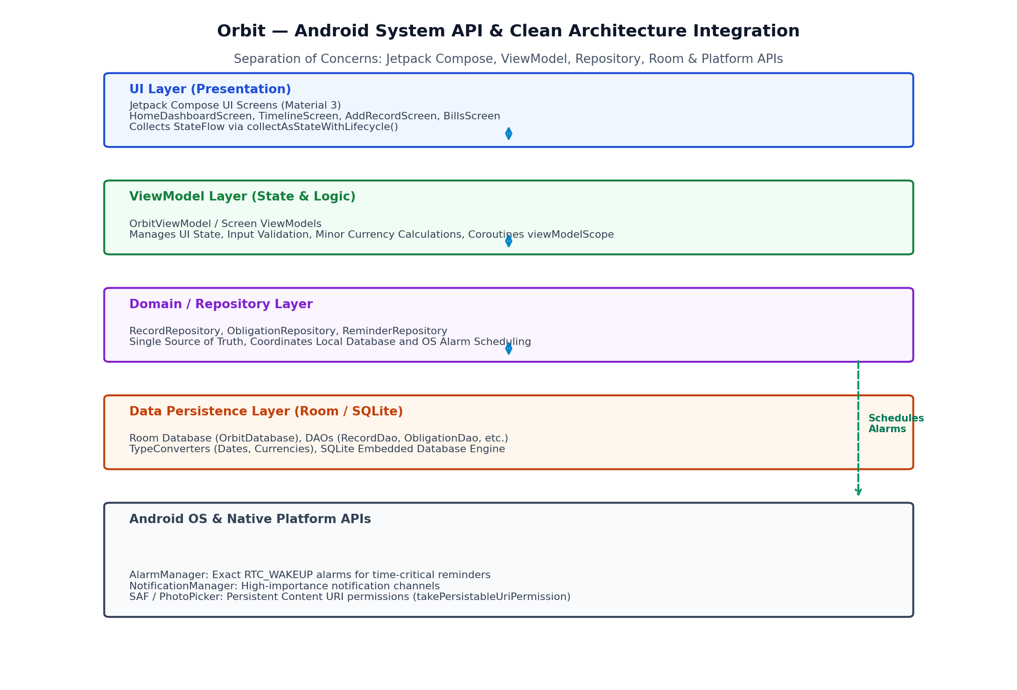
Figure 3: Orbit Multi-Layered Android Architecture: Separation of Concerns across Compose, ViewModel, Repository, Room, and OS APIs.
8.1 Architectural Layer Responsibilities
- 1. Presentation Layer (Jetpack Compose): Declarative UI screens (HomeDashboardScreen, TimelineScreen, AddRecordScreen, BillsScreen) observe observable UI state using collectAsStateWithLifecycle(). Composable components remain stateless and free of business logic, delegating user events directly to ViewModels.
- 2. ViewModel Layer (Jetpack ViewModel): Maintains UI state using StateFlow. Handles form validation, currency unit conversions (formatting minor units into ₹), and dispatches asynchronous coroutines using viewModelScope.
- 3. Repository Layer (Clean Architecture): Coordinates data flow between Room DAOs and Android system APIs. Serves as the single source of truth for the application. For example, RecordRepository writes a record to RecordDao and immediately prompts ReminderScheduler to schedule an alarm via AlarmManager.
- 4. Persistence Layer (Room & SQLite): Comprises OrbitDatabase, DAOs (RecordDao, ObligationDao, etc.), and custom TypeConverters (converting LocalDate to ISO string and Instant to Unix millis). Executes all queries on background threads (Dispatchers.IO).
- 5. Platform APIs Layer: Encapsulates OS-specific capabilities, such as registering BroadcastReceivers for AlarmManager wakeup events, building NotificationCompat alerts, and resolving persistent ContentResolver URIs.
9. Technical Challenges Encountered & Engineering Solutions
During the Week 3 database modeling and API planning phase, several technical design challenges were identified and resolved:
- Challenge 1: Resolving Attachment Polymorphism: Allowing attachments to link to either a Record or an Obligation risked orphaned records or ambiguous joins. Solution: Implemented an explicit XOR CHECK constraint ((record_id IS NOT NULL AND obligation_id IS NULL) OR (record_id IS NULL AND obligation_id IS NOT NULL)) alongside separate foreign key indexes. This preserves full referential integrity without needing a bloated join table.
- Challenge 2: Status and Date Inconsistency in Wireframes: Week 2 wireframes showed an electricity bill labeled 'Due today' on Home but 'Overdue' on Timeline. Solution: Established a single source of truth in obligations: payment_status is calculated deterministically by comparing the due_date against LocalDate.now(). An obligation is strictly 'DUE' on the due date and transitions to 'OVERDUE' only after 23:59:59 on the due date, ensuring 100% status consistency across all screens.
- Challenge 3: Lightweight Development on 8 GB RAM / Intel i5 Hardware: Developing an Android project on moderate development hardware (8 GB RAM / i5 PC) can cause emulator and Gradle slowdowns. Solution: By keeping Orbit completely offline-first with Room and avoiding heavy third-party client libraries, compilation times and memory consumption remain minimal. Unit tests for Room DAOs can be executed as fast in-memory SQLite tests on the local JVM without requiring a running Android emulator.
10. Conclusion & Week 4 Implementation Roadmap
Week 3 successfully completes the back-end architectural design, relational database schema, Entity-Relationship modeling, data flow specifications, and Android platform API integration plan for Orbit – Personal Life Operations Hub. With a verified seven-entity database structure, strict referential constraints, and a modular MVVM architecture, the project is positioned for seamless implementation in Week 4.
10.1 Week 4 Implementation Roadmap
- Phase 1 — Room Entity & TypeConverter Coding: Implement Kotlin data classes annotated with Room @Entity, @PrimaryKey, @ForeignKey, and build converters for LocalDate, Instant, and Enums.
- Phase 2 — DAO Interface Construction: Write compile-time verified Data Access Objects (RecordDao, ObligationDao, ReminderDao, NoteDao, ShoppingDao) with reactive Kotlin Flow return types.
- Phase 3 — Room Database & In-Memory Unit Testing: Implement OrbitDatabase abstract class and author comprehensive JUnit tests to verify CRUD operations, foreign key cascades, and check constraints.
- Phase 4 — Repository & AlarmManager Integration: Construct concrete repository classes and implement the AlarmManager BroadcastReceiver for notification dispatching.
11. Official Technical References
- Android Jetpack Room Persistence: https://developer.android.com/training/data-storage/room
- Android AlarmManager Documentation: https://developer.android.com/reference/android/app/AlarmManager
- Android Storage Access Framework (SAF): https://developer.android.com/guide/topics/providers/document-provider
- Android Notifications API Guide: https://developer.android.com/develop/ui/views/notifications
- SQLite Foreign Key Support & Constraints: https://www.sqlite.org/foreignkeys.html

