ORBIT

Android Prototype
Week 4 Development Deliverable
Junior Mobile App Developer Internship
Prototype report and screen captures

Prototype at a glance
Orbit is an offline-first Android personal life-management app. This Week 4 prototype carries the earlier dashboard, timeline, record library, bills, reminders, notes, and shopping-list concept into a native Android interface. Record creation, search, deletion, and shopping-list updates use on-device SQLite storage.

Prepared from the Week 1 app concept, Week 2 UI wireframe report, and Week 3 database design report.
November 2026 | Prototype version 0.2

1. Executive Summary
Orbit brings everyday personal responsibilities—such as purchase records, bills, renewals, documents, reminders, notes, and shopping items—into one Android app. The prototype preserves the information architecture developed in the first three weeks and makes the central record and shopping-list flows interactive.
The app provides ten connected screens: Home, Timeline, Add Record, Library, Bills and Subscriptions, Shopping List, Record Details, Search, Insights, and Settings. Users can save a categorized record with a title, notes, and amount; browse and search saved records; view a record and delete it; and add, complete, restore, or clear shopping items. These records and list changes are stored in a local SQLite database.
The prototype demonstrates the main workflow rather than the full planned production architecture. The existing Android project is written in Java with Android Views and uses SQLiteOpenHelper. Week 3 proposed Kotlin, Jetpack Compose, and Room. Calendar fields, reminder scheduling, attachment selection, payment state, computed insights, backup, and cloud sync remain visual or future-work items.

2. Design Basis and Week 1–3 Continuity
Earlier work | Design decision carried forward | Week 4 prototype implementation
Week 1 · App concept | Offline-first personal life hub; connect records, dates, and actions; include quick capture, records, bills, shopping, and search. | Native Android app with Home, Timeline, Library, Bills, Shopping, Search, and Settings routes. Core record and shopping data stays on the device.
Week 2 · UI wireframes | Ten-screen navigation model, required record title, optional notes/amount, category browse, record detail, reminder/attachment affordances, and shopping checklist. | The ten screens and primary navigation are implemented. The record title is validated; saved records and shopping interactions work locally. Date, reminder, and attachment controls remain placeholders.
Week 3 · Database/API design | Seven-entity relational model, integer minor currency units, Room/SQLite persistence, local notifications, and Android document selection. | A small SQLite prototype stores records and shopping items. Amounts are converted from rupees to integer paise. Room entities, the other five entities, notification scheduling, and file URI persistence are not yet implemented.

3. Functionality Demonstrated
Screen / flow | What the user can do | Implementation status
Home | See the daily overview and open primary sections or quick actions. | Navigation works. Summary values and upcoming events are illustrative sample content.
Timeline | Review date-grouped events and use category chips. | Screen and navigation are present; event dates and status groups are sample content, not computed from stored dates.
Add Record | Choose a category; enter a required name, optional notes, and amount; save. | Saves to SQLite. Empty names show inline validation. Amounts are stored in integer paise.
Library | Browse category counts and open saved records. | Record list and category counts query SQLite. Selecting a record opens its details.
Bills and Subscriptions | Review example recurring items and open the record flow. | Overview uses illustrative values. It does not calculate totals or record payment state.
Shopping List | Add items, mark them complete, restore them, and clear completed items. | All four actions update SQLite and remain available after app restart.
Record Details | View a saved record and delete it after confirmation. | Displays stored title, category, and notes; confirmed delete removes the SQLite row. Edit currently opens the add form.
Search | Search record titles or notes and filter by category. | Text and category filtering use SQLite queries.
Insights | View the recurring-cost illustration and sample renewal list. | Illustrative chart and metrics are not calculated from user data.
Settings | Explore notification, data, privacy, and appearance controls. | Controls are visual demonstrations; notification scheduling, backup, app lock, and saved preferences are not connected.

4. Prototype Implementation

4.1 Android application structure
The launcher opens MainActivity, which builds the ten screen layouts and manages navigation between them. OrbitStore extends Android SQLiteOpenHelper and owns the local database. The UI calls the store to insert, query, update, and delete record or shopping-item rows. Sample records and list items are inserted on first database creation so the screens have content for a demonstration.
Local data flow
MainActivity (Android Views) → OrbitStore (SQLiteOpenHelper) → orbit-prototype.db (records and shopping_items) → refreshed Library, Search, Details, and Shopping List screens.

4.2 Stored prototype data
Table | Stored fields | Prototype use
records | record_id (INTEGER primary key), title, category, description, amount_minor_units, created_at | Add, list, filter, search, detail, and delete record flows.
shopping_items | item_id (INTEGER primary key), item_name, is_completed, created_at | Add items, move between open and completed lists, and clear completed items.

The record amount is converted from rupees to paise before insertion, avoiding floating-point storage for money. The current prototype schema is intentionally smaller than the seven-entity Week 3 ER model. Record dates, obligations, attachments, reminders, notes, and settings are not yet persisted as separate entities.

4.3 Design-to-code mapping
- The Week 2 screen map is implemented with a bottom navigation bar for Home, Timeline, Library, Bills, and Insights; secondary screens open from quick actions and record rows.
- The Add Record form uses a required title and category selector. Validation prevents an empty title from being saved. Optional description and amount are persisted with the record.
- Library and Search read saved records from SQLite. Search matches title or description and can restrict results by category.
- The shopping checklist stores completion state in SQLite so list changes survive a process restart.
- Week 3’s planned architecture called for Kotlin, Compose, ViewModel/Repository layers, and Room. The prototype uses Java Views and a direct SQLite helper from the existing project, so it is a functional stepping stone rather than a complete implementation of that architecture.

5. Prototype Scope and Next Steps
The prototype is suitable for demonstrating navigation, capture, local retrieval, and checklist management. It does not make payments, require an account, or connect to a remote service. Sample dates and financial summaries should be treated as display examples; they do not represent live schedules or calculated totals.

Current limitations
- Due-date fields, reminder switches, attachment controls, and several settings are interface placeholders; no AlarmManager notification or Storage Access Framework file picker is wired up.
- Timeline groups, Bills summaries, Insights charts, and some Home metrics use static sample content rather than the database.
- Editing an existing record, recurring bill state, note management, export/restore, and preference persistence are not included.
- The current Java/SQLiteOpenHelper implementation has not yet been migrated to the Kotlin/Compose/Room architecture described in the design reports.

Recommended next implementation steps
- Add Room entities and DAOs for the seven designed entities, including foreign-key rules and the mutually exclusive parent constraints for attachments and reminders.
- Persist ISO calendar dates and Unix-millisecond timestamps; drive the Timeline, Bills, and Insights screens from database queries.
- Connect date pickers and local reminder scheduling, then request Android notification permission where required.
- Add a system document picker and persist user-approved attachment URIs instead of storing file bytes in the database.
- Implement editing, payment-status updates, settings persistence, and database/UI checks for the main flows.

Project files
Android project: week2-wireframes. MainActivity.java contains screen layouts and navigation. OrbitStore.java defines the prototype SQLite schema and local data operations. The Android manifest labels the launcher app Orbit; the project README describes the current prototype and its limits.

Appendix A · Prototype Screens
Home and Timeline
Android screen captures from the Orbit project. Sample values illustrate the interface; only the record and shopping-list flows described above are connected to local SQLite storage.
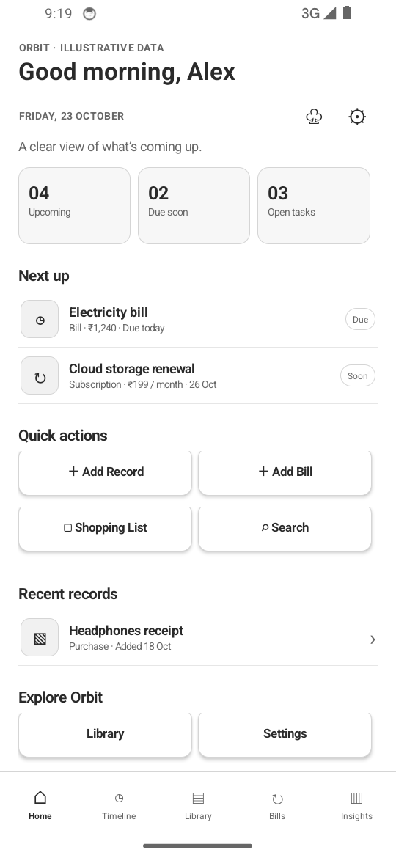  Figure 1. Home dashboard with daily summary cards, upcoming items, quick actions, and primary navigation. | 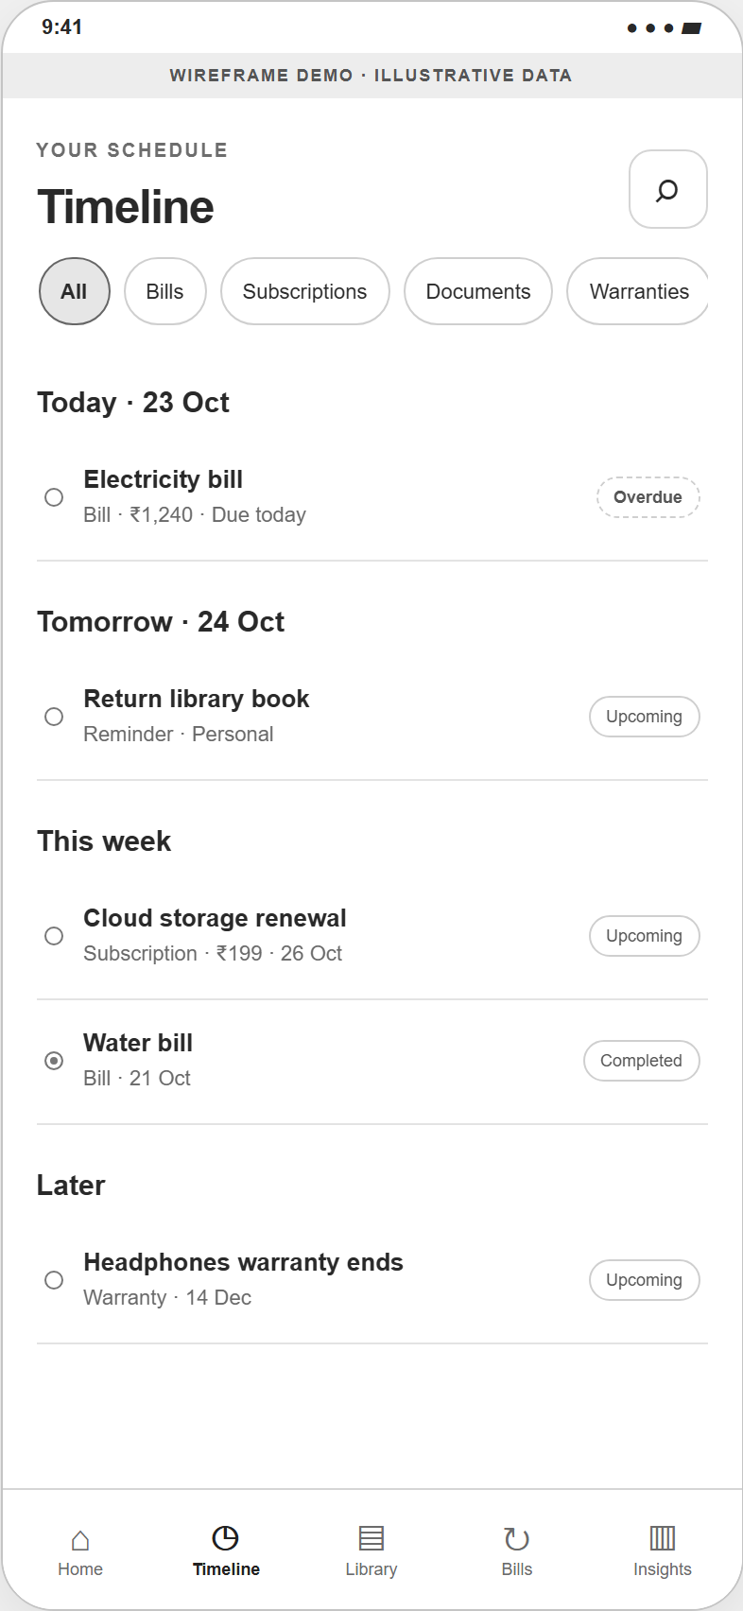  Figure 2. Timeline with date groups, category filters, and status labels.

Appendix A · Prototype Screens (continued)
Capture and Library
Android screen captures from the Orbit project. Sample values illustrate the interface; only the record and shopping-list flows described above are connected to local SQLite storage.
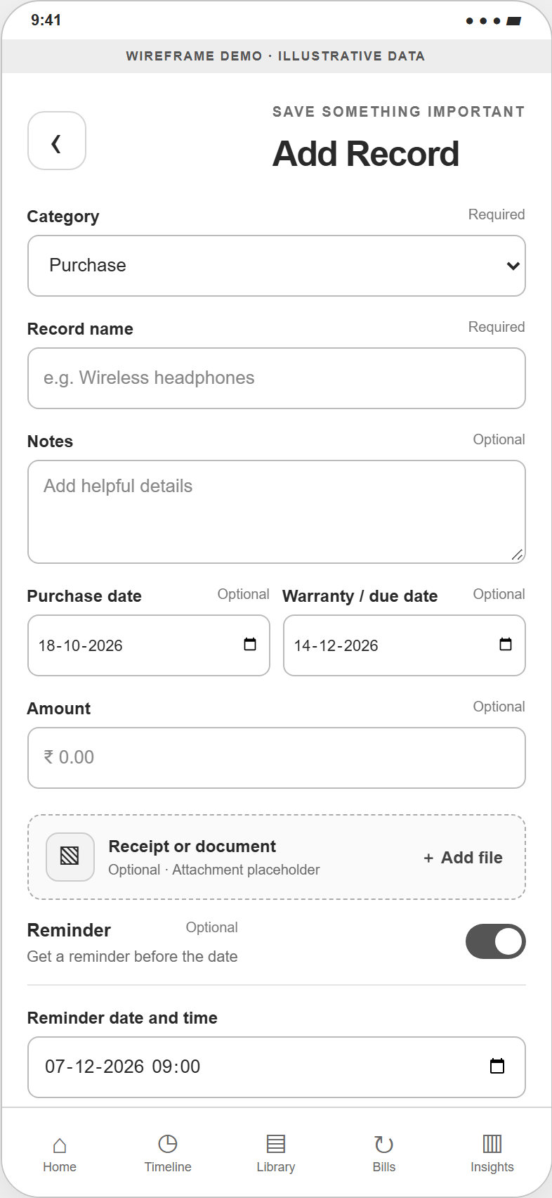  Figure 3. Add Record form with category, required title, optional detail fields, and reminder affordance. | 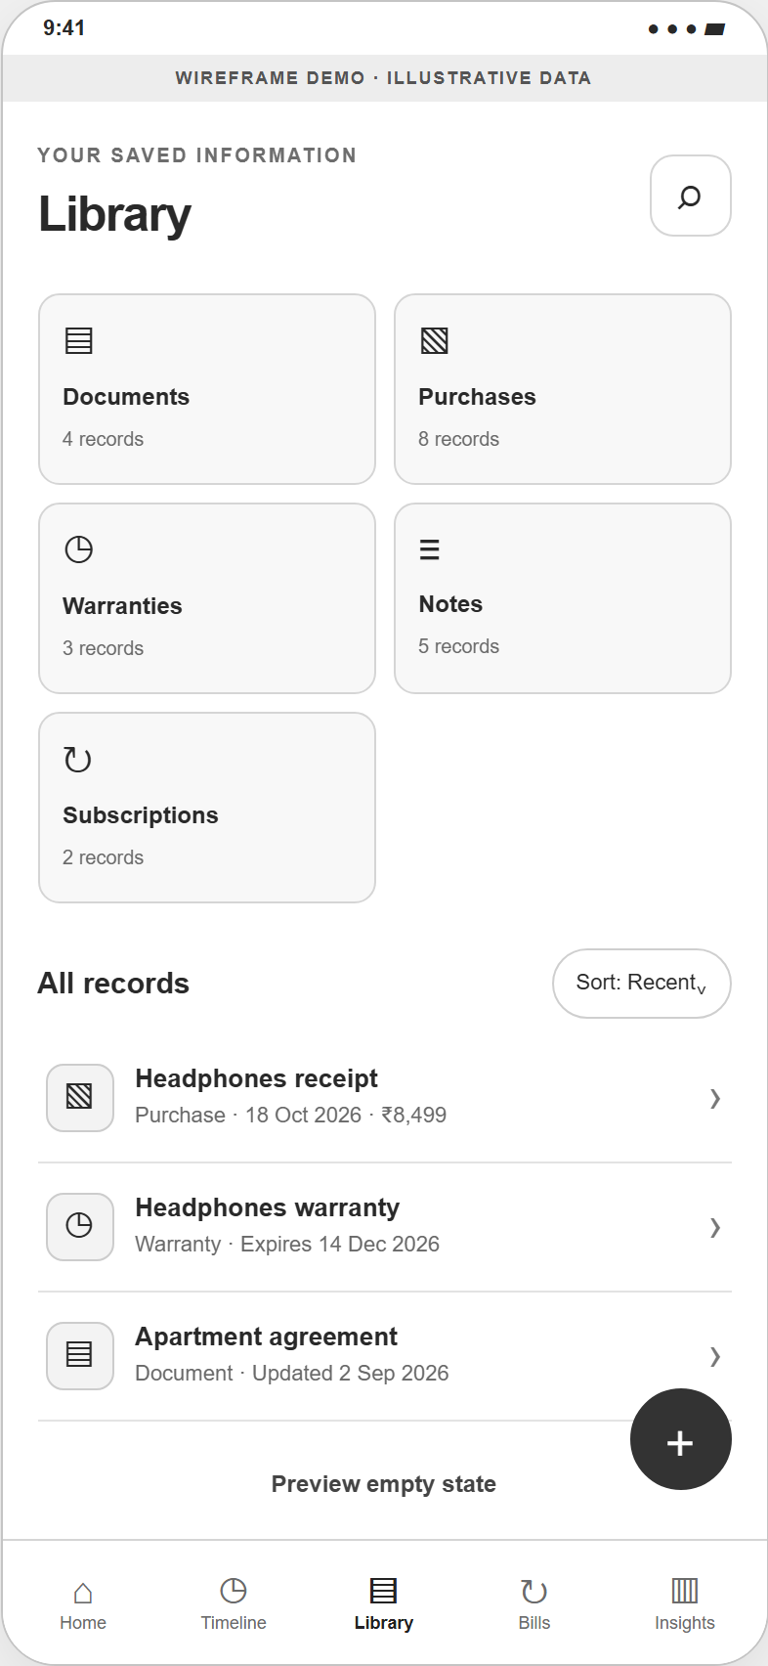  Figure 4. Library for browsing saved information by category and opening a record.

Appendix A · Prototype Screens (continued)
Bills and Shopping
Android screen captures from the Orbit project. Sample values illustrate the interface; only the record and shopping-list flows described above are connected to local SQLite storage.
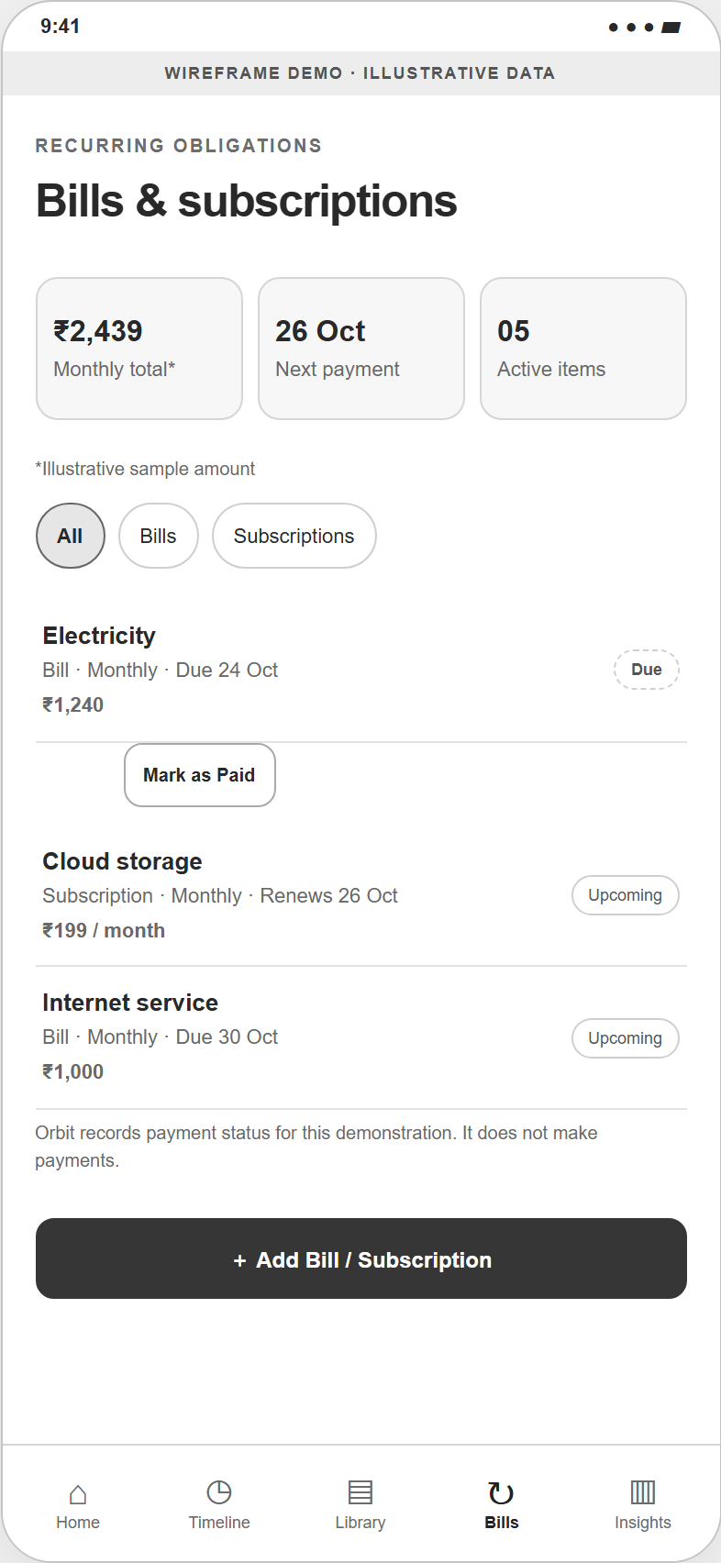  Figure 5. Bills and Subscriptions overview with recurring-cost examples. | 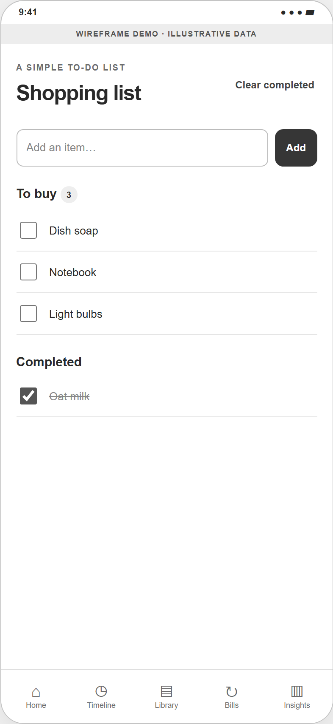  Figure 6. Shopping list with open and completed items.

Appendix A · Prototype Screens (continued)
Record Details and Search
Android screen captures from the Orbit project. Sample values illustrate the interface; only the record and shopping-list flows described above are connected to local SQLite storage.
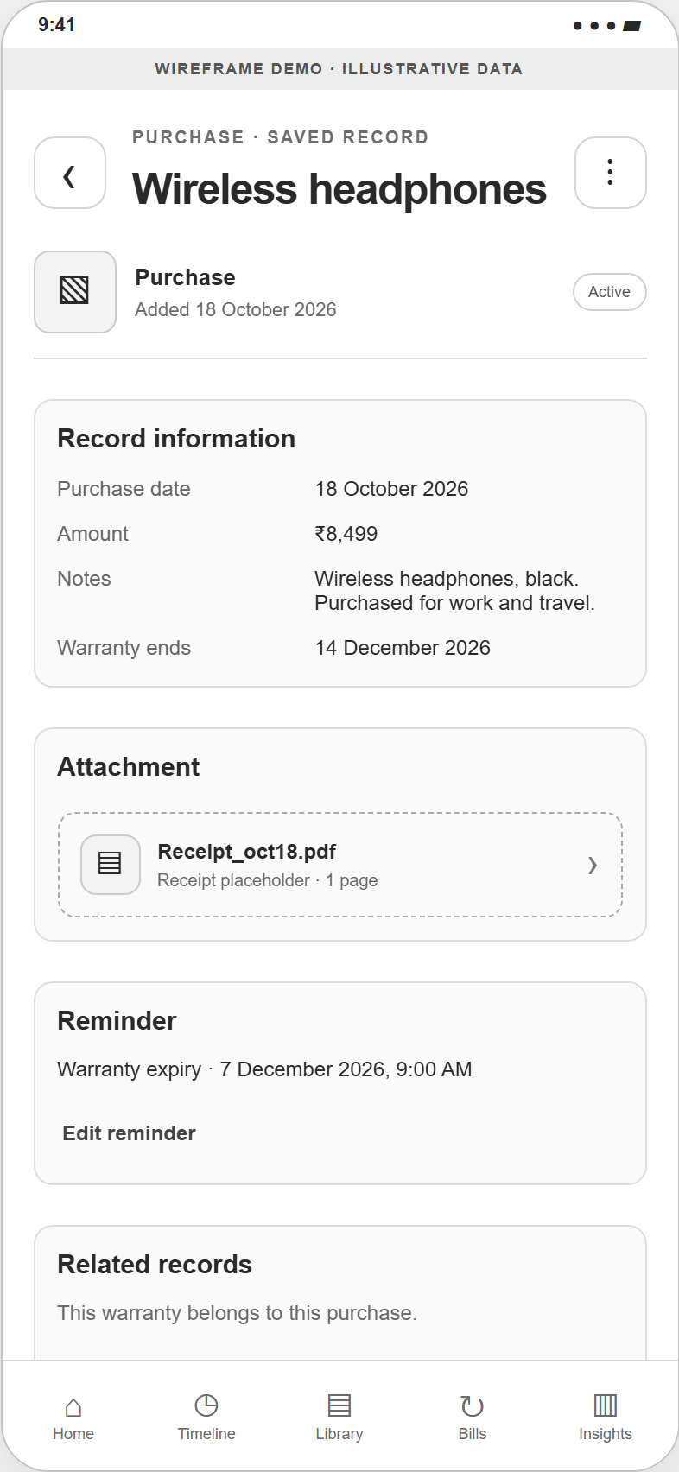  Figure 7. Record Details view with related information and available actions. | 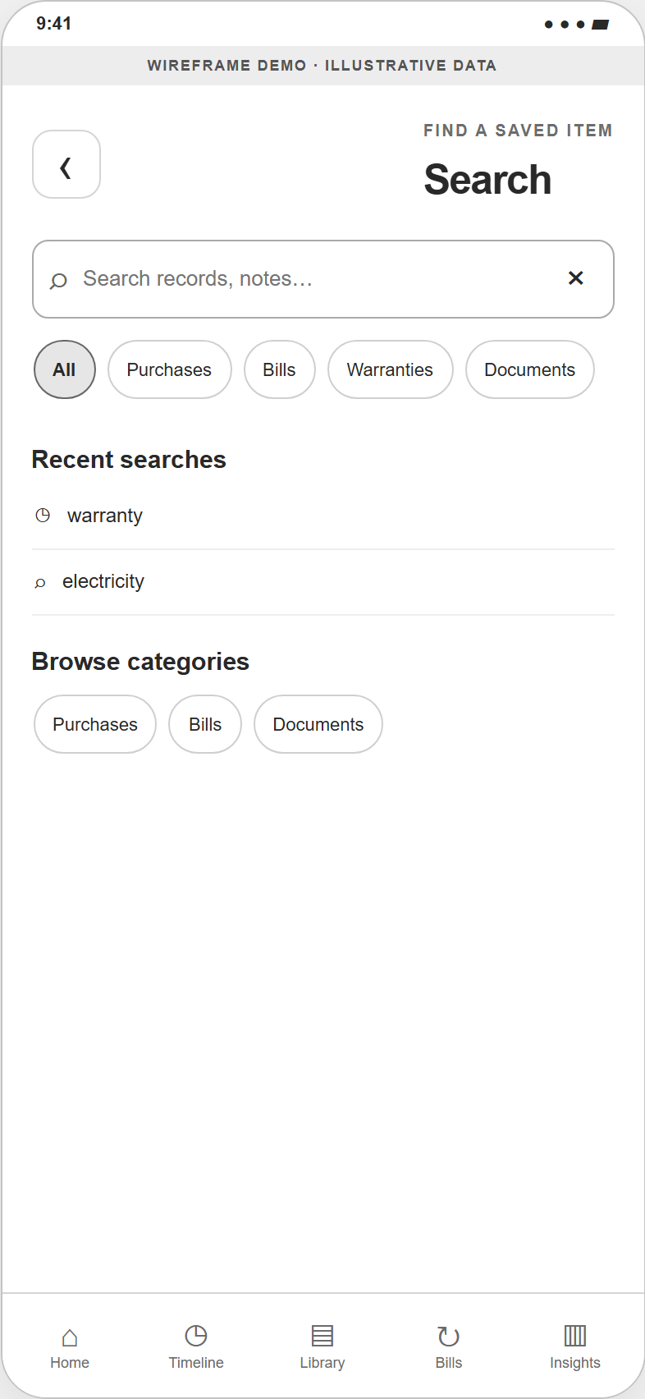  Figure 8. Search screen with query input, category filters, and matching results.

Appendix A · Prototype Screens (continued)
Insights and Settings
Android screen captures from the Orbit project. Sample values illustrate the interface; only the record and shopping-list flows described above are connected to local SQLite storage.
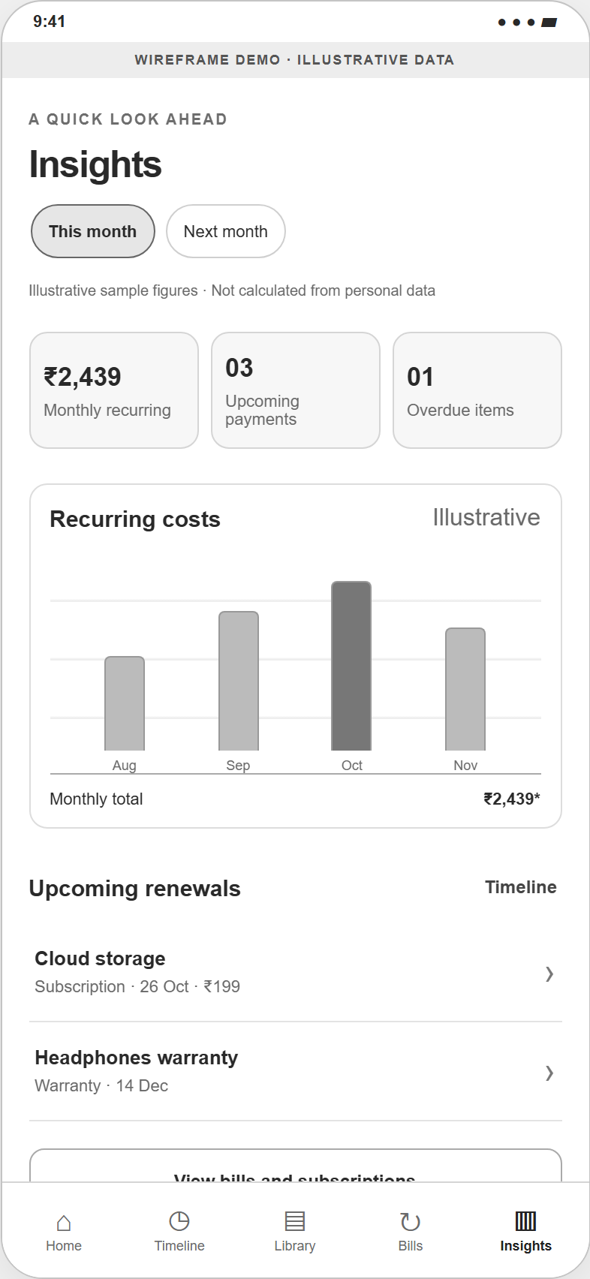  Figure 9. Insights screen showing illustrative recurring-cost summaries. | 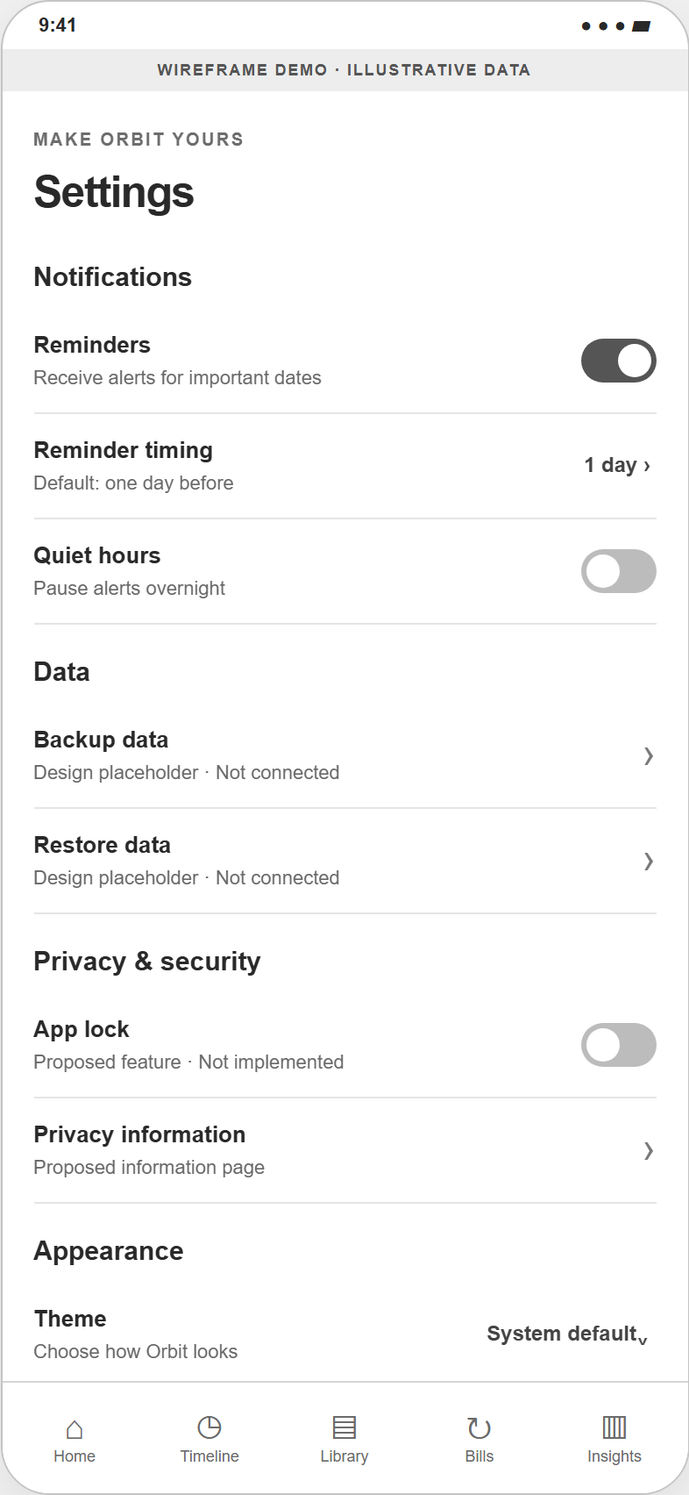  Figure 10. Settings screen for reminder, data, privacy, and appearance preferences.

