Retry Mechanism for Events in Data Fabric

## Prerequisites

Here user must be able to retry an event from the event page if the event has failed to successfully process the event. It includes Failure message with an error retries of more than 1. Initially we had a mechanism for retrying the event for 3 times (default value but can increase in connections) after that it would display an event as failed. There was no process of retrying failed event. So, this requirement solves this problem by providing a button for the user to retry. To avoid accidental click of the button after clicking the retry button we are disabling the functionality to some minutes. This time is also configurable in the Tenant page. This works only for **Outbox and Inbox** agents. Also, this works for only **Mongo** and **SQL** connection type where data is stored in the database to retry a specific event.

Another important thing to keep in mind is that we can retry only latest failed events. We find the latest message by Key column. For the same record that is updated the events will have same key. A screenshot of a computer

Figure 1: Select query latest record is descending order of Created Date

In the above example we have numerous records for the same EventType but was created on different dates and the latest once is the record with latest created date. We can see they have same EventType, Key and Scope. So record with Id 100 should only be retried. If we click of the record 99 then we get a message to the user that only latest message can be retried.

## Test Setup

1. Run a source Agent by downloading the latest build.
2. Open the database, here we are using insert a record into the Oubox table with a record retries as 3, Status as 3 (Error) and ProcessedDate as nullA screenshot of a computer program

   Description automatically generated
3. Next go to events page and refresh the page with source connection, then we will see the newly added record with error status.
4. Click the expand button, we will see a retry button as seen below. A screenshot of a computer

   Description automatically generated

Figure 2: Event page retry for sql based connections

1. Once clicking on the button we call a validation to check the threshold time (first time the status will pass), and it will send a command to the running agent which will reset the status from Error to Unprocessed but retry count remains. For Outbox -> when this happens the Agent will see the status (Unprocessed) and processes this particular event as regular event processing. For inbox the event NextRunDate column is set to current date time utc so that external system can pick this during their next run.
2. Retry button operation will be disabled as long as the time limit we have set in the tenant page. In order to set the value, Go to Tenant page **>** enable edit **>** ignore limit check, then the value in number text box will be enabled. Based on this value added in minutes it will be enabled after the time limit. If nothing is provided, then it will take a default minutes which is set in the key vault under the name “**EventRetryDisableButtonThresholdInMinitues”**

Figure 3: Tenant Config page

1. If the event has again failed event this scenario is covered by this requirement. The button operation will be disabled if the time limit has not exceeded from tenant page. 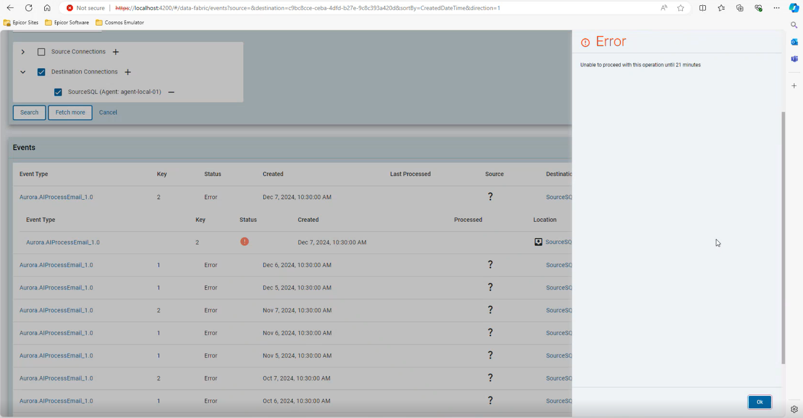

Figure 4: Threshold message for retry event

1. When we try retry a non-latest events then we will get a error message like below to the user

Figure 5: Retry for latest message error

1. Once the limit has exceeded refresh the page and click on the button same process continues. (This is valid if the retried event had failed even during the first click of retry event)
2. Button for Retry Failed events will be visible for other records but will not be able to retry since they are not latest messages.

## Code Changes

1. AgentRetryOutboxCommand Function app– Function app under CommandFunction class which is used to send a retry command to the agent. And also update in the agent telemetry latest repository with last clicked date, user email, event type name.
2. RetryOutboxEventCommand- Under Agent project called from CommandProcessor class. (newly added)
3. EventTypeRetryValidation Function app – Function app under Event functions which is used to validate if the button must be disabled and visible. Called when the user clicked on expand button. (newly added)
4. event-group-detail.component.ts – front end code where these changes are made including the retry button.
5. **EventRetryDisableButtonThresholdInMinitues** – key vault name with a default value of 30 mins. (newly added)

New Changes for Inbox and latest event

Integration Portal

<https://dev.azure.com/epicor-corp/LABS/_git/EpicorIntegrationPortal/pullrequest/119145>

DataFabric Backend and FrontEnd

<https://dev.azure.com/epicor-corp/LABS/_git/EpicorDataFabric/pullrequest/119800>

https://dev.azure.com/epicor-corp/LABS/_git/Epicor.DataFabric.App/pullrequest/117442