TASK-1:SQL BASED DESCRIPTIVE ANALYTICS AND REPORTING USING NORTHWIND DATABASE

1. Introduction

Objective
The objective of this project is to perform descriptive analytics on the Northwind database using PostgreSQL. The project focuses on data inspection, data cleaning, SQL joins, aggregation, window functions, KPI analysis, cohort analysis, and reporting to derive meaningful business insights from the data.

2. Dataset Description
Dataset: Northwind Database
Database Management System: PostgreSQL
The Northwind database is a sample business database that represents the operations of a retail trading company. It contains information about customers, products, suppliers, employees, shippers, orders, and order details. The dataset consists of multiple related tables that allow relational analysis using SQL.

Tables Used
- Customers
- Orders
- Order Details
- Products
- Categories
- Suppliers
- Employees
- Shippers

3. Database Setup and Familiarization
The Northwind database was successfully imported into PostgreSQL using pgAdmin. The dataset was inspected to understand its structure, primary keys, foreign keys, and relationships between tables.

Major Relationships
- Customers → Orders
- Orders → Order Details
- Products → Order Details
- Categories → Products
- Suppliers → Products
- Employees → Orders
- Shippers → Orders
The database contains 14 relational tables.

4. Data Inspection
The dataset was examined using SQL queries to understand the available records.
The following activities were performed:
- Displayed the first five records of Customers, Orders, and Products tables.
- Counted the number of records in major tables.
- Verified the table structure.
- Examined important attributes for analysis.

5. Data Cleaning
Data quality checks were performed before analysis.
The following checks were carried out:
- Missing values
- Duplicate records
- Text standardization using TRIM()
- Country name formatting using UPPER()
- Product status categorization using CASE statements
No major missing values or duplicate records were identified in the Northwind dataset.

6. Business Questions and Analysis

Business Question 1

How many customers are available?
SELECT COUNT(*) AS total_customers
FROM customers;

Output
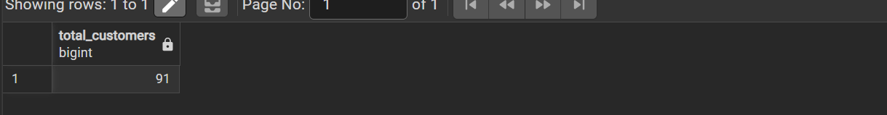

Insight
The query determines the total number of customers available in the database.

Business Question 2

How many orders have been placed?
SQL Query
SELECT COUNT(*) AS total_orders
FROM orders;
Output
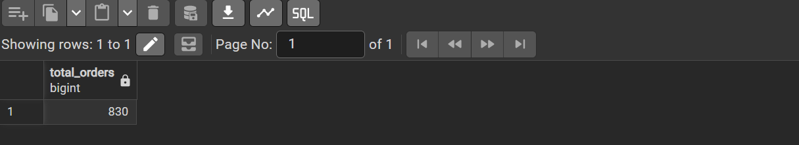
Insight
The query provides the total number of customer orders.

Business Question 3

What is the average price?
SQL Query
SELECT ROUND(AVG(unit_price)::numeric,2) AS average_price
FROM products;

Output
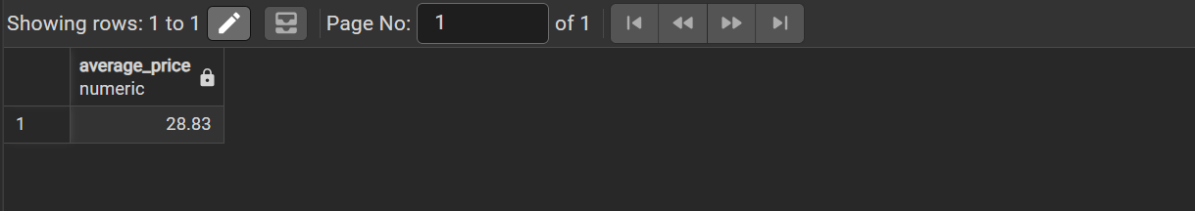
Insight
The average product price helps understand the overall pricing strategy.

Business Question 4

Which are the most expensive products?
SQL Query
SELECT product_name, unit_price
FROM products
ORDER BY unit_price DESC
Output
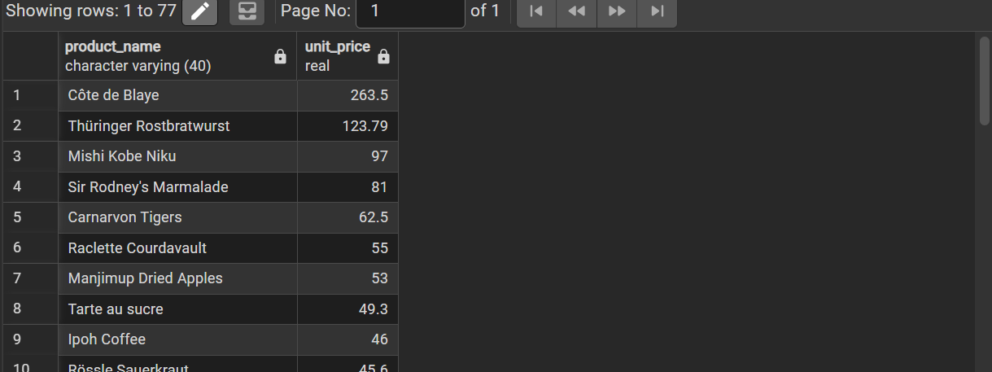
Insight
The highest-priced products represent premium items sold by the company.

Business Question 5

Which customer placed which order?
SQL Query
SELECT
c.customer_id,
c.company_name,
o.order_id,
o.order_date
FROM customers c
INNER JOIN orders o
ON c.customer_id = o.customer_id
ORDER BY o.order_date;
Output
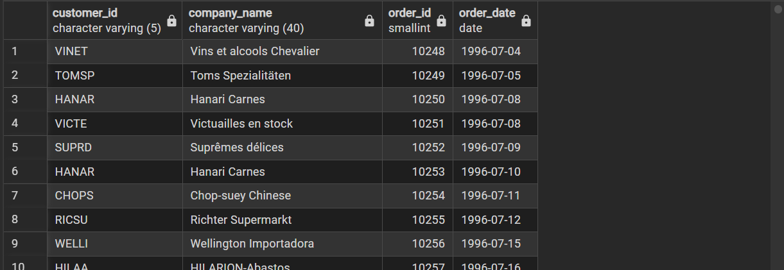
Insight
INNER JOIN combines customer and order information to analyze customer purchasing behavior.

Business Question 6

Which products were ordered?
SQL Query
SELECT
o.order_id,
p.product_name,
od.quantity
FROM orders o
JOIN order_details od
ON o.order_id = od.order_id
JOIN products p
ON od.product_id = p.product_id
LIMIT 20;
Output
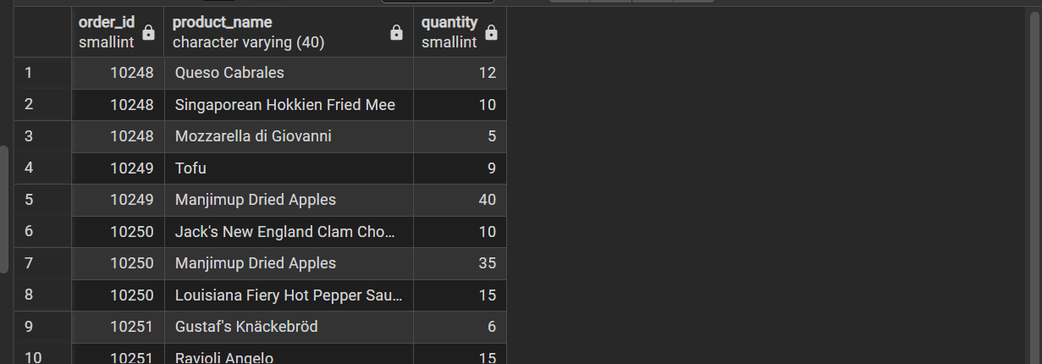
Insight
Joining Orders, Order Details, and Products provides product-level sales information.

Business Question 7

Which customers never placed an order?
SQL Query
SELECT
c.customer_id,
c.company_name,
c.contact_name
FROM customers c
LEFT JOIN orders o
ON c.customer_id = o.customer_id
WHERE o.order_id IS NULL;
Output
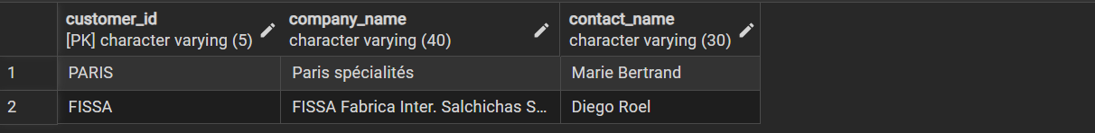
Insight
The LEFT JOIN identifies inactive customers.

Business Question 8

Which customers placed the highest number of orders?
SQL Query
SELECT
c.company_name,
COUNT(o.order_id) AS total_orders
FROM customers c
JOIN orders o
ON c.customer_id = o.customer_id
GROUP BY c.company_name
ORDER BY total_orders DESC;

Output
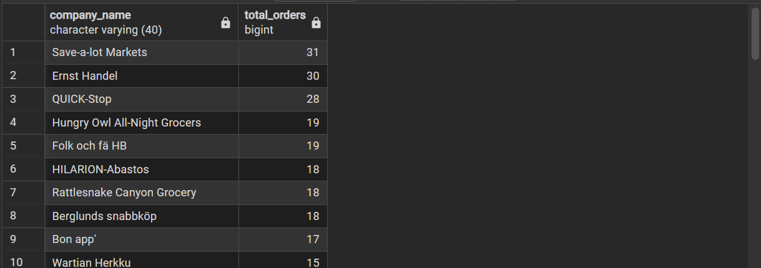
Insight
This identifies the most active customers.

Business Question 9

Which customers placed more than 10 orders?
SQL Query
SELECT
c.company_name,
COUNT(o.order_id) AS total_orders
FROM customers c
JOIN orders o
ON c.customer_id = o.customer_id
GROUP BY c.company_name
HAVING COUNT(o.order_id) > 10
ORDER BY total_orders DESC;
Output
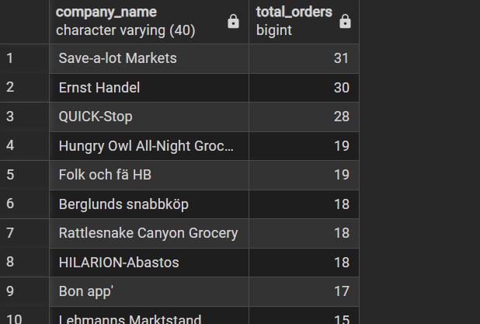
Insight
The HAVING clause filters customers with significant purchasing activity.

Business Question 10

Which product category generated the highest sales?
SQL Query
SELECT
c.category_name,
SUM(od.quantity * od.unit_price) AS total_sales
FROM categories c
JOIN products p
ON c.category_id = p.category_id
JOIN order_details od
ON p.product_id = od.product_id
GROUP BY c.category_name
ORDER BY total_sales DESC;

Output
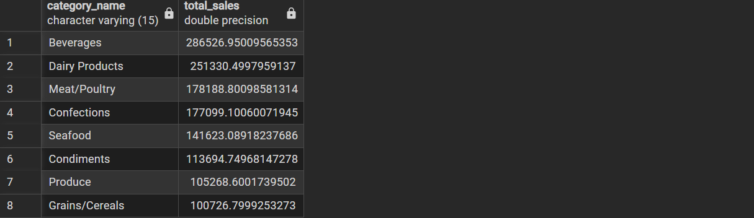
Insight
The category-wise sales analysis identifies the best-performing product category.

Business Question 11

How do orders vary over time?
SQL Query
SELECT
DATE_TRUNC('month', order_date) AS month,
COUNT(*) AS total_orders
FROM orders
GROUP BY month
ORDER BY month;

Output
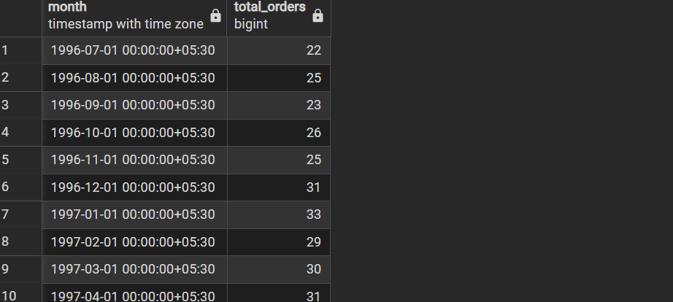
Insight
Monthly order trends help identify seasonal demand patterns.

Business Question 12

Who are the top revenue-generating customers?
SQL Query
SELECT
c.company_name,
ROUND(SUM(od.quantity * od.unit_price)::numeric,2) AS revenue
FROM customers c
JOIN orders o
ON c.customer_id = o.customer_id
JOIN order_details od
ON o.order_id = od.order_id
GROUP BY c.company_name
ORDER BY revenue DESC
LIMIT 10;

Output
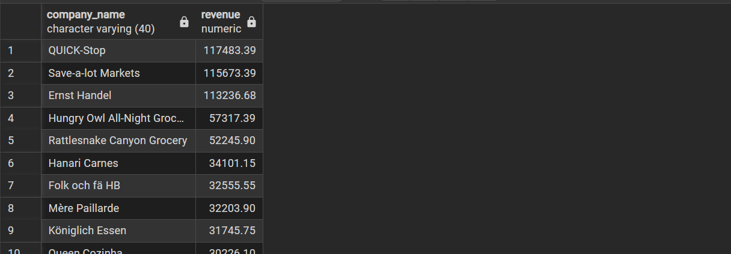
Insight
These customers contribute significantly to total sales and are valuable for customer retention.

Business Question 13

Which products are sold the most?
SQL Query
SELECT
p.product_name,
SUM(od.quantity) AS quantity_sold
FROM products p
JOIN order_details od
ON p.product_id = od.product_id
GROUP BY p.product_name
ORDER BY quantity_sold DESC
LIMIT 10;
Output
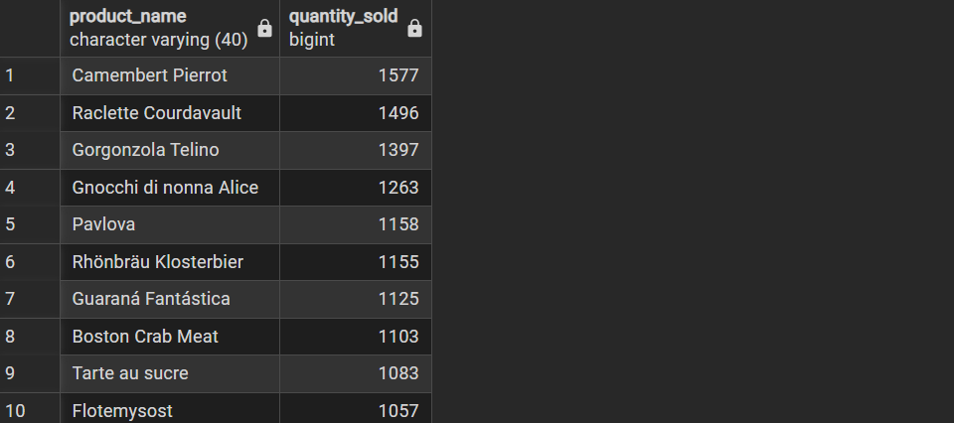
Insight
The analysis identifies products with the highest sales volume.

Window Function Analysis

Window Function 1:ROW_NUMBER()

Business Question 1
How can each product be assigned a unique sequential number based on its price?
SELECT
product_name,
unit_price,
ROW_NUMBER() OVER (ORDER BY unit_price DESC) AS row_number
FROM products;
Output
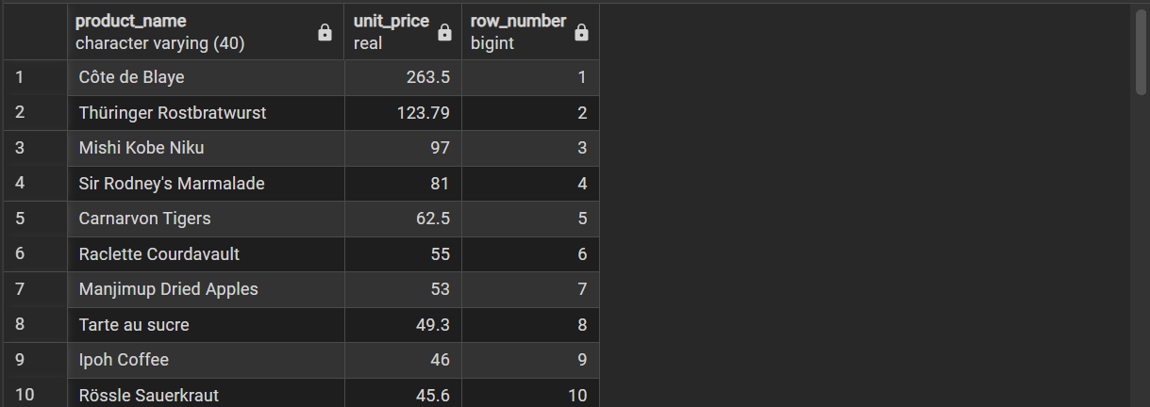

Insight
This function is useful for creating ordered lists and uniquely identifying records based on a sorting criterion

Window Function 2: RANK()

Business Question 2
How can products be ranked according to their price?

SQL Query
SELECT
product_name,
unit_price,
RANK() OVER (ORDER BY unit_price DESC) AS price_rank
FROM products;

Explanation
RANK() assigns a rank to each product based on its price. Products with the same price receive the same rank, and the next rank is skipped accordingly.
Output
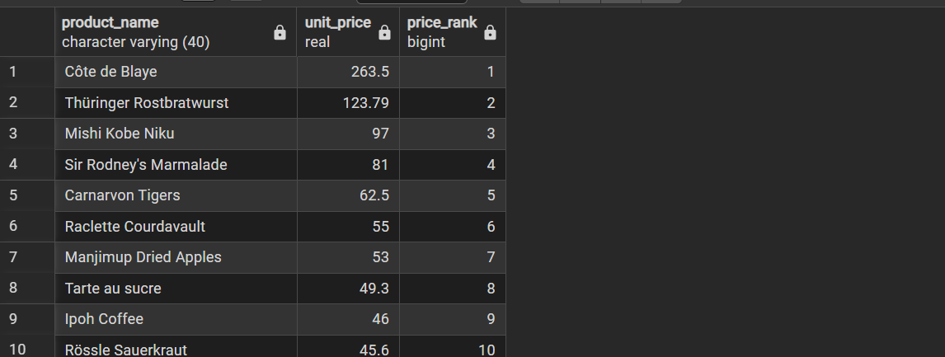

Insight
Ranking helps identify the highest-priced products while correctly handling ties.

Window Function 3: Running Total (SUM OVER)

Business Question 3
How does cumulative freight cost increase over time?

SQL Query
SELECT
order_date,
freight,
SUM(freight) OVER (ORDER BY order_date) AS running_total
FROM orders;

Explanation
SUM() OVER() calculates a running total of freight charges by ordering the records according to the order date.
Output
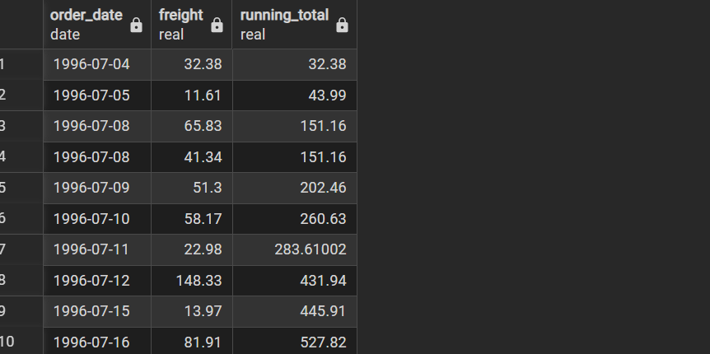

Insight
The running total shows how freight expenses accumulate over time and is useful for tracking cumulative business metrics.

7. KPI Analysis
The following Key Performance Indicators (KPIs) were calculated:
- Total Revenue
- Average Order Value
- Total Customers
- Total Orders
- Monthly Orders
- Top Revenue Customers
These KPIs provide an overview of business performance and customer activity

8. Cohort Analysis
A basic cohort analysis was performed by grouping customers according to the year of their first purchase.
This analysis helps understand customer acquisition trends over time and provides insights into customer growth.

9. Key Findings
- The Northwind database contains multiple related tables suitable for relational analysis.
- SQL joins successfully combined information across customers, products, and orders.
- Aggregate functions summarized customer and sales information effectively.
- Monthly order analysis revealed ordering trends over time.
- Category-wise sales helped identify high-performing product categories.
- Window functions ranked products and generated cumulative metrics.
- KPI analysis provided a comprehensive overview of business performance.
- Cohort analysis grouped customers based on their first purchase period

10. Conclusion
This project successfully demonstrated descriptive analytics using the Northwind database in PostgreSQL. Data inspection, cleaning, joins, aggregation, window functions, KPI analysis, and cohort analysis were performed to generate business insights. The project highlights the practical application of SQL for analyzing relational databases and supporting business decision-making.

TASK 2:Excel / Spreadsheet Analysis & Dashboarding

Dataset: Sample Superstore Dataset

1. Objective
The objective of this task was to perform data preprocessing, analyze the dataset using spreadsheet functions and pivot tables, and develop an interactive dashboard that presents key business insights.

2. Data Pre-processing
The Sample Superstore dataset was imported into Excel and cleaned before analysis.

Data Cleaning Performed
- Checked for missing (blank) values using Go To Special → Blanks.
- No missing values were found.
- Checked for duplicate records.
- Repeated Order IDs were verified as valid because a single order can contain multiple products.
- Applied TRIM() to remove unnecessary spaces.
- Applied CLEAN() to remove hidden/non-printable characters.
- Applied PROPER() to standardize text formatting.
- Verified data types for:
  - Order Date
  - Ship Date
  - Sales
  - Profit
  - Quantity
The dataset was already clean and required minimal preprocessing.

3. Pivot Table Analysis
The following Pivot Tables were created:

Sales by Region
Shows the total sales generated from:
- Central
- East
- South
- West

Sales by Category
Shows sales distribution across:
- Furniture
- Office Supplies
- Technology

Profit by Segment
Shows total profit for:
- Consumer
- Corporate
- Home Office

Sales by State
Displays total sales for each state.

4. Formula & Metric Analysis
The following spreadsheet functions were used:

Basic Functions
- SUM()
- AVERAGE()
- MAX()
- MIN()
- COUNTA()

Conditional Functions
- SUMIFS()
- COUNTIFS()
- AVERAGEIFS()

KPI Metrics Calculated
- Total Sales
- Total Profit
- Total Orders
- Average Sales
- Maximum Sales

5. Dashboard Development
A dashboard was created to visualize important business insights.

Dashboard Components
- KPI Cards
  - Total Sales
  - Total Profit
  - Total Orders
  - Average Sales
- Sales by Region (Column Chart)
- Sales by Category (Pie Chart)
- Profit by Segment (Column Chart)
- Sales by State (Bar Chart)
- Filters/Slicers for:
  - Region
  - Category
  - Segment
  - Ship Mode

6. Key Findings
- The West region generated the highest sales.
- Technology contributed the highest share of sales among product categories.
- The Consumer segment generated the highest profit.
- Sales varied significantly across different states.
- KPI metrics provided a quick overview of business performance.

7. Challenges Faced
- The free version of Microsoft Excel had limited support for Pivot Tables and slicers.
- Google Sheets was used to complete pivot table analysis and dashboard creation.
- Some interactive slicer functionality available in Excel Desktop was not fully supported in Google Sheets.

8. Conclusion
The task successfully demonstrated spreadsheet-based data analysis using Excel and Google Sheets. Data preprocessing, pivot table analysis, spreadsheet formulas, KPI calculations, and dashboard creation were completed successfully. The final dashboard presents business insights in a clear and visually organized manner, enabling easier decision-making.
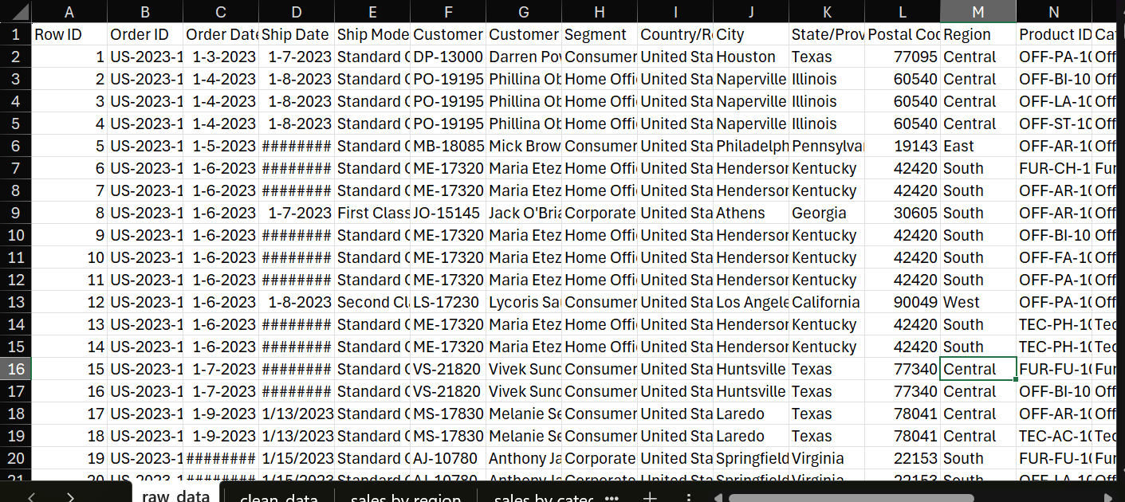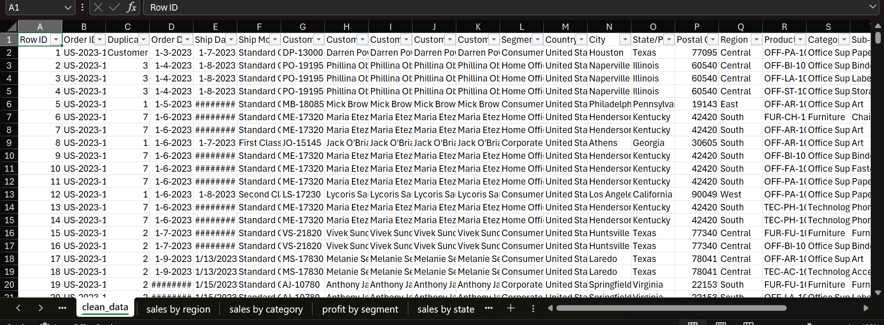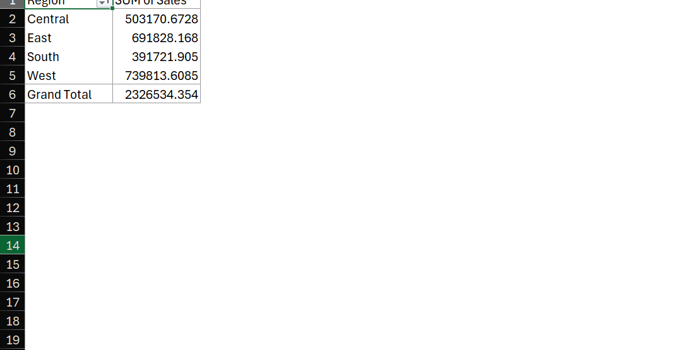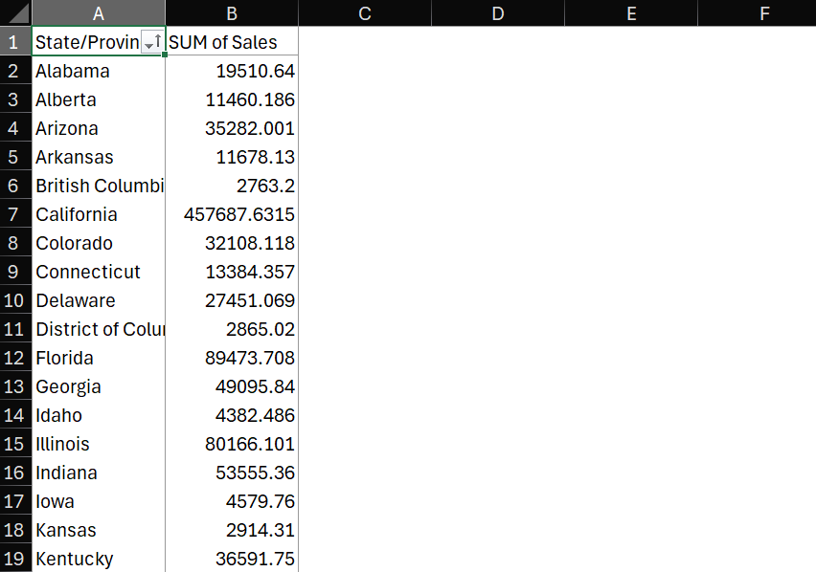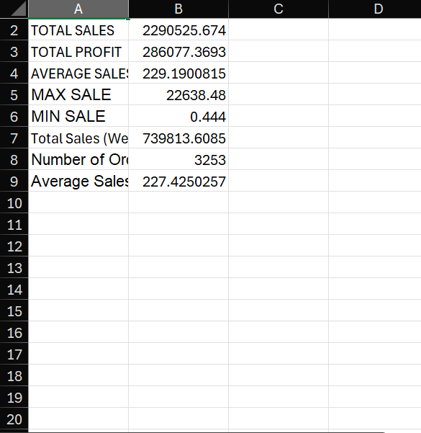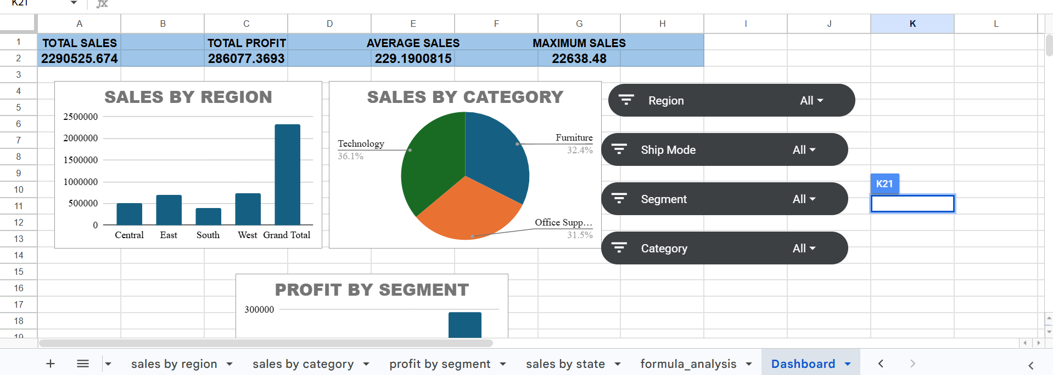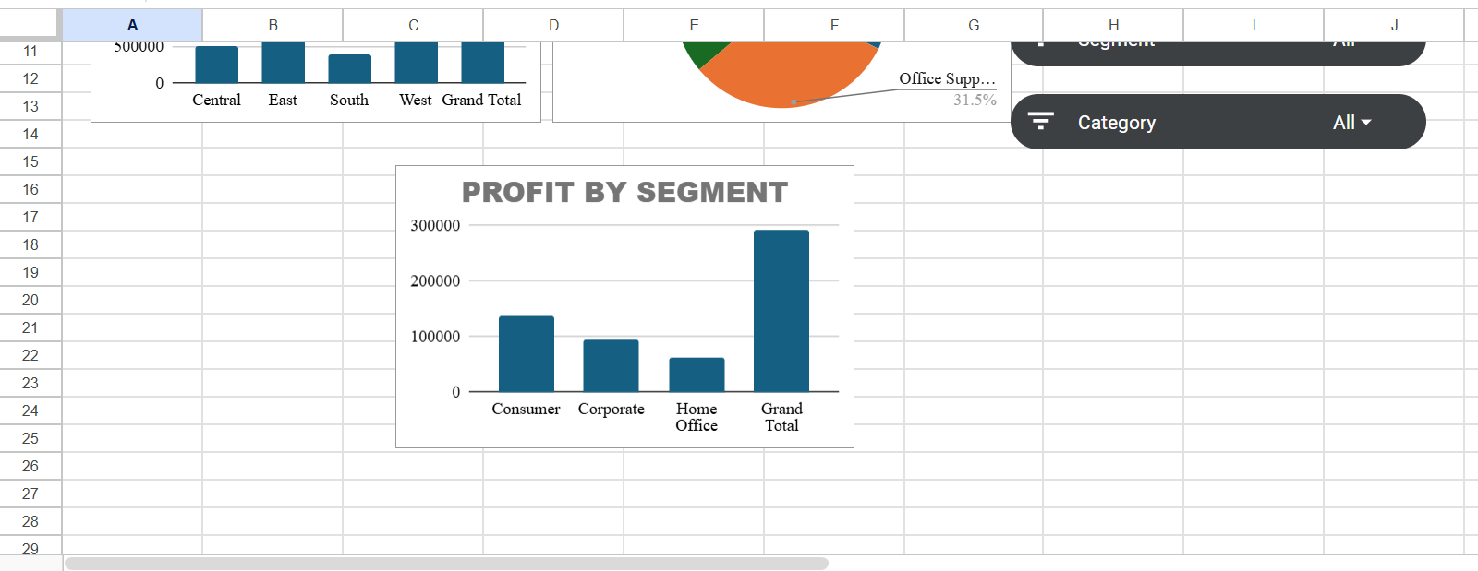

TASK 3:Business Intelligence Dashboards using Power BI and Tableau

1. Project Overview

Objective
The objective of this project is to analyze the Online Retail dataset using Power BI and Tableau by performing data preprocessing, modeling, and visualization. The dashboards provide insights into sales performance, customer behavior, and product performance to support business decision-making.

2. Dataset Information
Dataset: Online Retail
Fields Used
- Invoice No
- Invoice Date
- Customer ID
- Country
- Description
- Quantity
- Unit Price
- Sales

3. Data Pre-processing

Power BI
Performed using Power Query.
Steps:
- Imported Excel dataset
- Checked for missing values
- Renamed columns
- Changed data types
- Removed unnecessary records
- Created Sales column
- Loaded cleaned data into the model

Tableau
Performed using Tableau Data Source.
Steps:
- Connected to Excel dataset
- Verified data types
- Checked missing values
- Renamed fields where required
- Loaded the cleaned dataset

4. Data Modeling

Power BI
- Created a simple star-like model using the imported dataset.
- Created DAX measures for:
  - Total Sales
  - Total Orders
  - Total Customers

Tableau
- Imported the cleaned dataset.
- Created calculated fields for KPIs where required.
- Used Tableau's aggregation functions for visualization.

5. Dashboard Development

Power BI Dashboard
Visuals Included:
- KPI Card – Total Sales
- KPI Card – Total Orders
- KPI Card – Total Customers
- Sales by Month
- Top 10 Countries by Sales
- Top 10 Products by Sales
Features:
- Interactive slicers
- Cross-filtering
- Drill-down capability

Tableau Dashboard
Visuals Included:
- KPI Card – Total Sales
- KPI Card – Total Orders
- KPI Card – Total Customers
- Sales by Month (Line Chart)
- Top 10 Countries by Sales
- Top 10 Products by Sales

6. Business Questions Answered
- What is the total sales value?
- How many orders were placed?
- How many unique customers made purchases?
- How do monthly sales change over time?
- Which countries generate the highest sales?
- Which products contribute the highest revenue?

7. Key Insights
- Total Sales: 9.75 Million
- Total Orders: 22,061
- Total Customers: 4,372
- Sales increased toward the end of the year.
- The United Kingdom generated the highest sales.
- A few products accounted for a large share of total sales.

8. Dashboard Screenshots

Power BI Dashboard
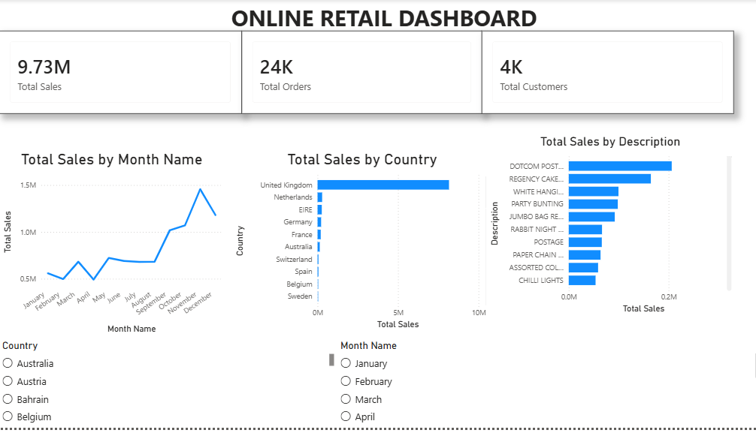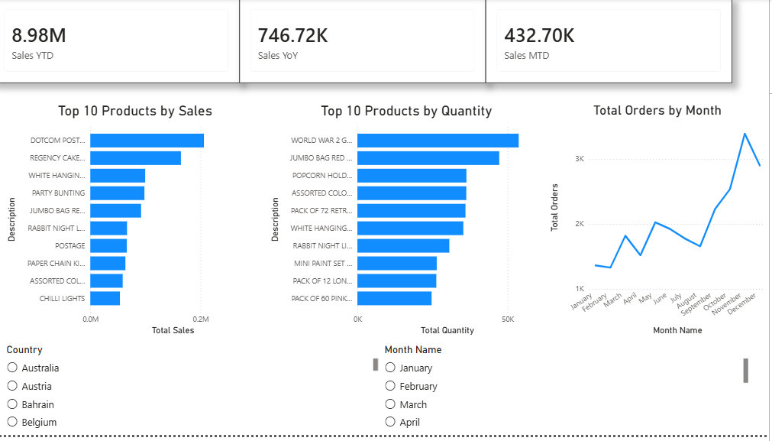

Tableau Dashboard
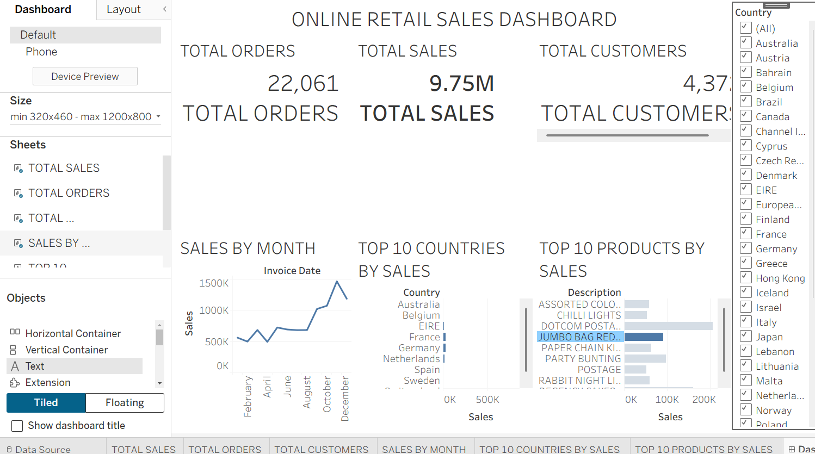

9. Tools Used
- Microsoft Power BI
- Tableau Public
- Microsoft Excel

10. Conclusion
This project demonstrates how the same business dataset can be analyzed using both Power BI and Tableau. Both dashboards effectively visualize key business metrics and trends, enabling users to monitor sales performance, identify top-performing countries and products, and support data-driven decision-making. While Power BI offers powerful data modeling and DAX capabilities, Tableau provides intuitive and flexible visualization features.

MAIN PROJECT:Superstore Sales & Profit Analysis Report

Business Problem
The management of the Superstore wants to improve profitability but lacks clear visibility into sales performance, product profitability, customer behavior, and regional performance. While the company generates high sales, some products and regions may be contributing little profit or even losses. The business needs data-driven insights to identify improvement opportunities and make better strategic decisions

Project Overview
This project analyzes the Superstore retail dataset to evaluate sales performance, profitability, customer segments, regional trends, and product performance. The objective is to identify key business insights that can help management improve profitability and make data-driven decisions.

Objective
The main objectives of this analysis are to:
- Analyze overall sales and profit performance.
- Identify the most profitable and least profitable product categories.
- Understand customer purchasing behavior across different segments.
- Compare regional sales performance.
- Study the impact of discounts on profitability.
- Identify high-performing and loss-making products.
- Build an interactive Power BI dashboard for decision-making.

Tools Used
- Python (Pandas)
  - Data cleaning
  - Missing value analysis
  - Column name standardization
- PostgreSQL
  - Data storage
  - SQL queries
  - Business analysis
- Power BI
  - Dashboard development
  - KPI visualization
  - Interactive filtering

Data Preparation
The dataset was cleaned before analysis.
The following preprocessing steps were performed:
- Imported the CSV dataset into Python.
- Checked for missing values.
- Verified duplicate records.
- Converted column names to lowercase.
- Standardized column naming conventions.
- Imported the cleaned dataset into PostgreSQL for SQL analysis.

Key Performance Indicators (KPIs)
The dashboard includes the following KPIs:
- Total Customers: ~10K
- Total Sales: $2.33 Million
- Total Profit: $292.30 Thousand
- Profit Margin: 12.56%
These KPIs provide an overall summary of the company's business performance.

Sales Analysis
Sales were analyzed across different product categories.
The analysis indicates that:
- Technology contributes the highest sales.
- Furniture and Office Supplies also contribute significantly to total revenue.
- Sales distribution helps identify which product categories are driving business growth.

Profit Analysis
Profit was analyzed independently from sales.
Key observations include:
- Technology generates the highest profit.
- Some categories with high sales produce comparatively lower profit.
- This suggests that higher sales do not always translate into higher profitability.

Customer Segment Analysis
Customers are grouped into three segments:
- Consumer
- Corporate
- Home Office
The dashboard compares the contribution of each segment toward overall sales/profit, helping identify the most valuable customer group.

Regional Analysis
The dashboard includes region-based filtering and analysis.
This allows management to compare business performance across:
- Central
- East
- South
- West
Users can interactively filter the dashboard to understand regional performance differences.

Product Analysis
SQL analysis was performed to identify:
- Top-selling products
- Most profitable products
- Loss-making products
- Products generating high sales but low profit
These insights help management decide:
- Which products should be promoted
- Which products require pricing or discount strategy changes
- Which products may need to be discontinued

Discount Analysis
Discount analysis was conducted to understand its effect on profitability.
The objective was to determine:
- Whether higher discounts increase sales
- Whether discounts reduce overall profit
- Which discount levels are financially sustainable
This analysis helps improve future pricing strategies.

SQL Analysis Performed
The following business questions were answered using SQL:
- Total Sales
- Total Profit
- Profit Margin
- Sales by Category
- Profit by Category
- Sales by Customer Segment
- Top Products by Sales
- Top Products by Profit
- Loss-Making Products
- Sales by Region
- Sales by State
- Impact of Discounts on Profit
- Shipping Mode Performance

Dashboard Features
The Power BI dashboard contains:
- KPI Cards
- Interactive slicers
- Sales by Category
- Profit by Category
- Sales by Customer Segment
- Region filter
- State filter
- Dynamic cross-filtering between visuals
The dashboard allows users to interactively explore business performance.

Business Insights
Based on the analysis, the following insights can be drawn:
- Technology is the strongest-performing product category in terms of revenue and profit.
- Customer segments contribute differently to sales and profitability.
- Certain products generate sales but produce little or negative profit.
- Profitability varies across regions, indicating opportunities for regional strategy improvements.
- Discount policies should be reviewed to ensure they do not negatively impact profits.

Recommendations
- Focus marketing efforts on high-profit categories and products.
- Review pricing strategies for products with consistently low or negative profit.
- Optimize discount policies to balance customer acquisition and profitability.
- Expand business in high-performing regions while investigating the causes of lower profitability in underperforming areas.
- Monitor customer segment performance and tailor promotional strategies accordingly.

Conclusion
This project demonstrates a complete end-to-end data analytics workflow, starting from data cleaning in Python, moving to business analysis in PostgreSQL using SQL, and ending with an interactive Power BI dashboard. The analysis provides actionable insights into sales, profitability, customer segments, product performance, and regional trends, enabling better business decision-making.
This project showcases practical skills in Python, SQL, PostgreSQL, and Power BI, making it a strong portfolio project for entry-level Data Analyst roles.
