Practical no. 06
IP Security (IPsec) Configuration: Configure IPsec on network devices to provide secure communication and protect against unauthorized access and attacks.

#take 6 PC – pc0, pc1, pc2, pc3, pc4, pc5
#take 2 switches – 2960-24TT switch0 , 2960-24TT switch1
#take 3 routers – 1941 router0 , 1941 router1 , 1941 router2
#connect PCs to switches and switches to router using Copper Straight –Through wire
#connect Router to router with Copper Cross-over

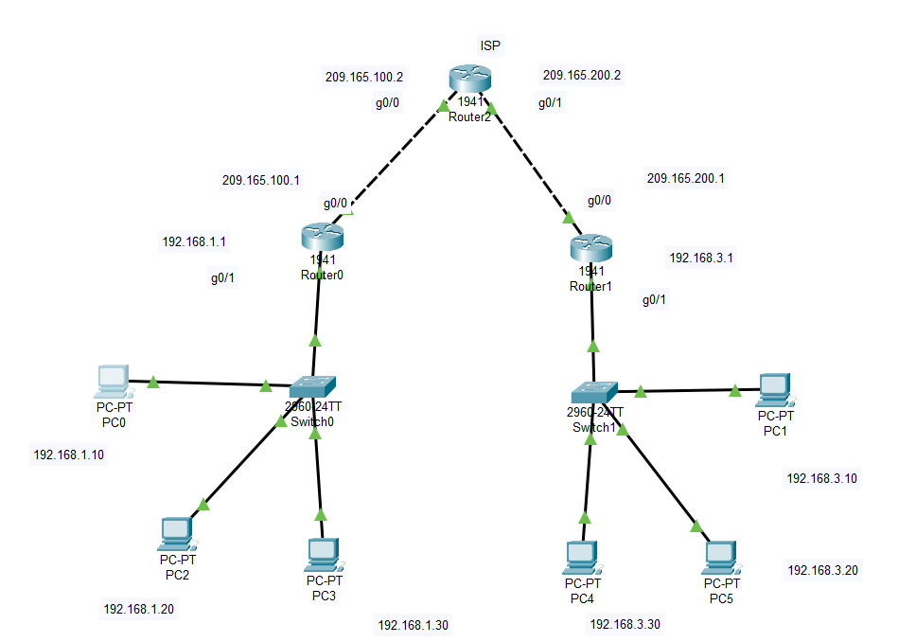
# IP assigning
- Network 1
- Pc0 – 192.168.1.10 default gateway 192.168.1.1
- Pc2 – 192.168.1.20 default gateway 192.168.1.1
- Pc3 – 192.168.1.30 default gateway 192.168.1.1
- Router0 – g0/1 – 192.168.1.1
- Network 2
- Pc1 – 192.168.3.10 default gateway 192.168.3.1
- Pc5 – 192.168.3.20 default gateway 192.168.3.1
- Pc4 – 192.168.3.30 default gateway 192.168.3.1
- Router1 – g0/1 – 192.168.3.1
- Network 3
- Router0 – g0/0 – 209.165.100.1
- Router2 – g0/0 – 209.165.100.2
- Network 4
- Router2 – g0/1 – 209.165.200.2
- Router1 – g0/0 – 209.165.200.1

# click on router0 and then go to the CLI
#Give name to the router
en
conf t
hostname R1

#same for router1
en
conf t
hostname R2

#for router2
en
conf t
hostname ISP

#for R1
R1(config-if)#exit
R1(config)#exit
R1#show version
You can see the security is none
R1#conf t
R1(config)#ip route 0.0.0.0 0.0.0.0 209.165.100.2

#for R2
R2(config-if)#exit
R2(config)#exit
R2#show version
You can see the security is none
R2#conf t
R2(config)#ip route 0.0.0.0 0.0.0.0 209.165.200.2
#now we have to add security to both routers
For R2
R2#conf t
R2(config)#license boot module c1900 technology-package securityk9 > accept yes
R2(config)#exit
R2#copy run startup-config
R2#reload

For R1
R1#conf t
R1(config)#license boot module c1900 technology-package securityk9 > accept yes
R1(config)#exit
R1#copy run startup-config
R1#reload

Now go to R1
R1>en
R1#conf t
R1(config)# access-list 100 permit ip 192.168.1.0 0.0.0.255 192.168.3.0 0.0.0.255

Now go to R2
R2>en
R2#conf t
R2(config)# access-list 100 permit ip 192.168.3.0 0.0.0.255 192.168.1.0 0.0.0.255

Now go to R1
R1>en
R1#conf t
R1(config)# crypto isakmp policy 10
R1(config-isakmp)# encryption aes 256
R1(config-isakmp)# authentication pre-share
R1(config-isakmp)# group 5

Now go to R2
R2>en
R2#conf t
R2(config)# crypto isakmp policy 10
R2(config-isakmp)# encryption aes 256
R2(config-isakmp)# authentication pre-share
R2(config-isakmp)# group 5

Now again go to R1
R1(config)# crypto isakmp key secretkey address 209.165.200.1

Now again go to R2
R2(config)# crypto isakmp key secretkey address 209.165.100.1

#IPsec transform-set
Go to R1
R1(config)# crypto ipsec transform-set R1->R2 esp-aes 256 esp-sha-hmac

Go to R2
R2(config)# crypto ipsec transform-set R2->R1 esp-aes 256 esp-sha-hmac

#Crypto mapping
Router R1
Run following command all at once :

crypto map IPSEC-MAP 10 ipsec-isakmp
set peer 209.165.200.1
set pfs group5
set security-association lifetime seconds 86400
set transform-set R1->R2
match address 100

Router R2
Run following command all at once :

crypto map IPSEC-MAP 10 ipsec-isakmp
set peer 209.165.100.1
set pfs group5
set security-association lifetime seconds 86400
set transform-set R2->R1
match address 100

in R2
R2(config)#int g0/0
R2(config-if)#crypto map IPSEC-MAP

in R1
R1(config)#int g0/0
R1(config-if)#crypto map IPSEC-MAP

#check ISP router
show ip route
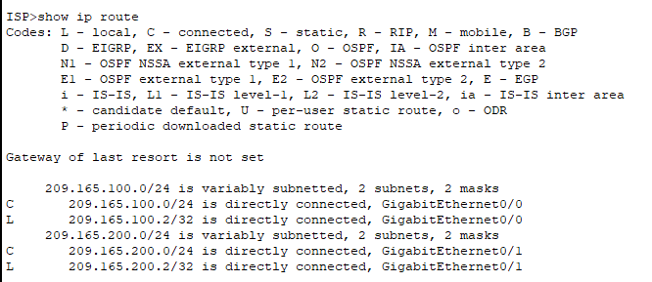

Check whether it is working or not
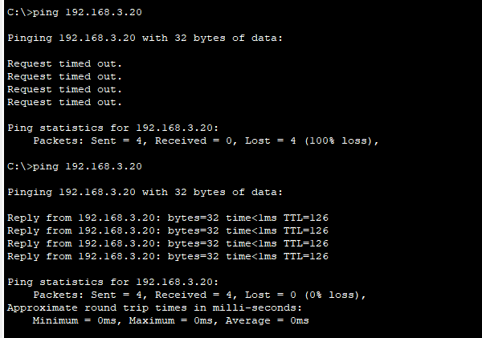

Check with simulation by sending packet from one PC to another
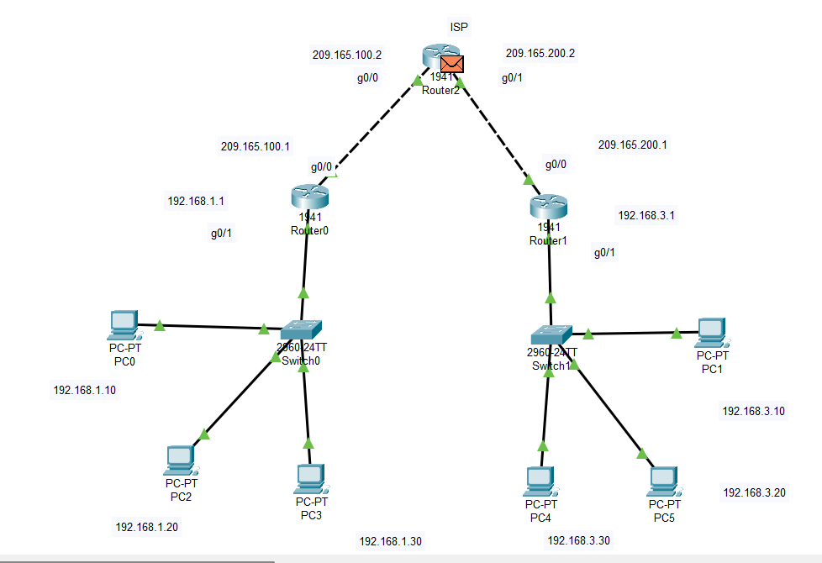
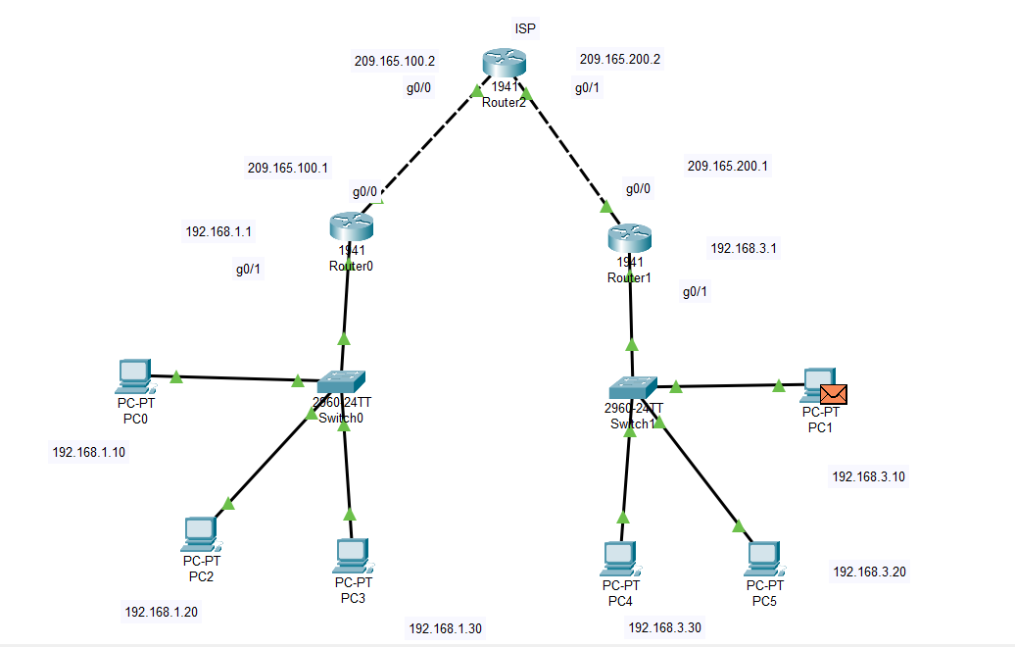

#packet successfully transfer from one PC to another
