PRACTICAL NO.08
Intrusion Detection System: Set up and configure an intrusion detection system (IDS) to monitor network traffic and detect potential security breaches or malicious activities.

#take two PCs , three routers , two switches and one server
Connect router to each other using serial DTE cable ,and another connection using automatic cable
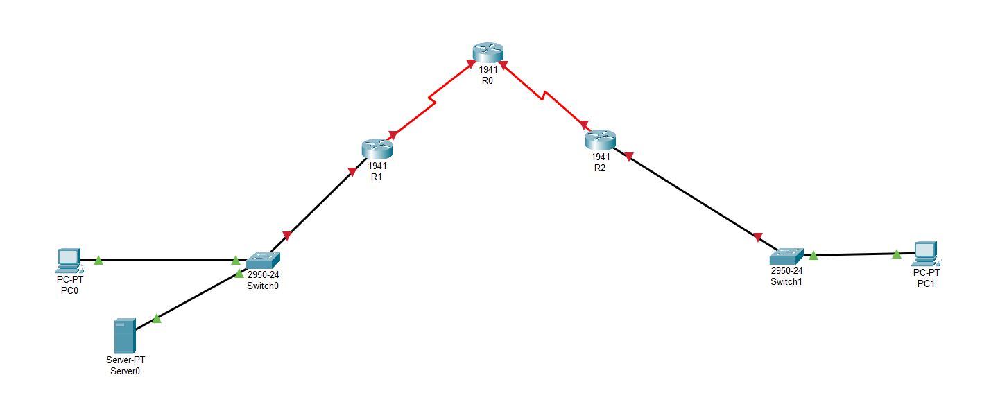
#Assign IP to PC 1
IP : 192.168.1.4
Default Gateway : 192.168.1.1
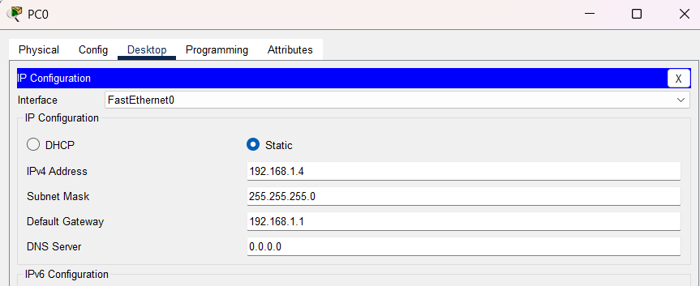
#Assign IP to PC 2
IP : 192.168.4.4
Default Gateway : 192.168.4.1
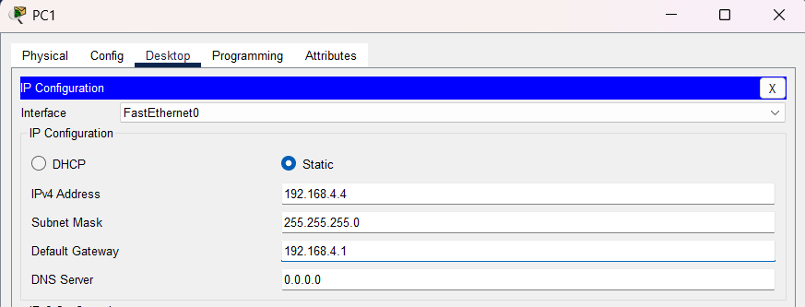
#Click on router 1 (left) > Open CLI
Int gigabitEthernet 0/0
Ip address 192.168.1.1 255.255.255.0
No shut
Int sesrial0/1/0
Ip address 192.168.2.1 255.255.255.0
No shut
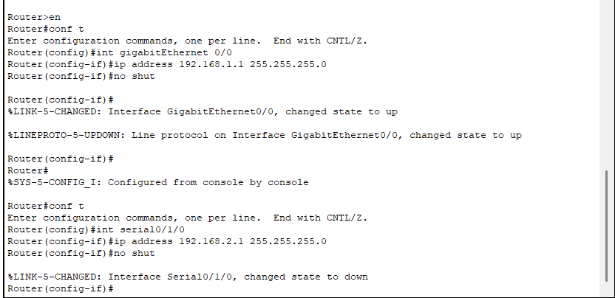
#Click on router 0 (top) > Open CLI
Int serial0/1/0
Ip address 192.168.2.2 255.255.255.0
No shut
Exit
Int serial0/1/1
Ip address 192.168.3.1 255.255.255.0
No shut
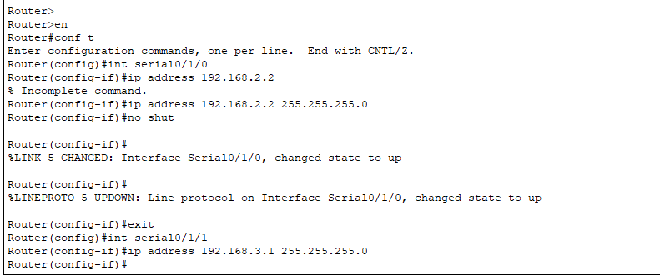
#Click on router 2 (right) > Open CLI
Int serial0/1/0
Ip address 192.168.3.2 255.255.255.0
No shut
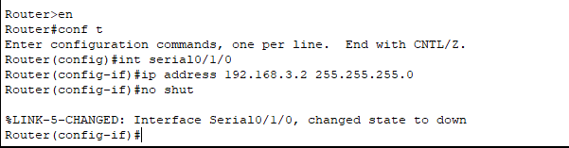
Exit
Int gigabitEthernet 0/0
Ip address 192.168.4.1 255.255.255.0
No shut
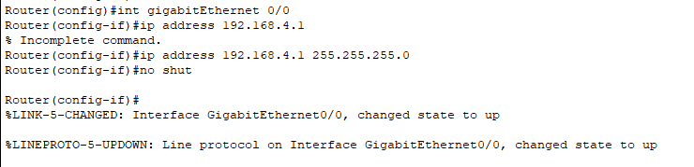
#Click on Router 1 (Left)
Router rip
Netw 192.168.1.0
Netw 192.168.2.0
Exit (2 times))
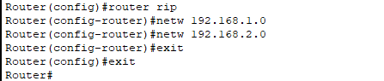
Show Ip route
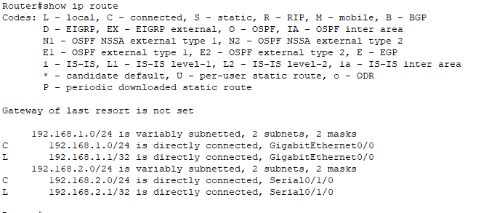
#Click on router 0 (top)
Router rip
Netw 192.168.2.0
Netw 192.168.3.0
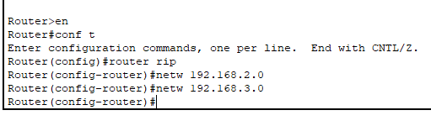
Show ip route
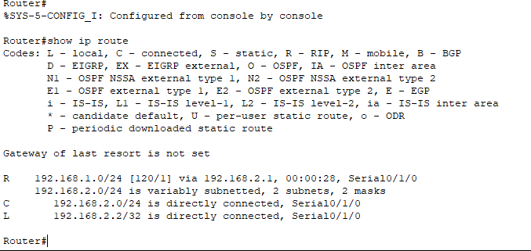
#Click on Router R2 (right)
Router rip
Netw 192.168.3.0
Netw 192.168.4.0
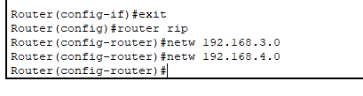
Show ip route
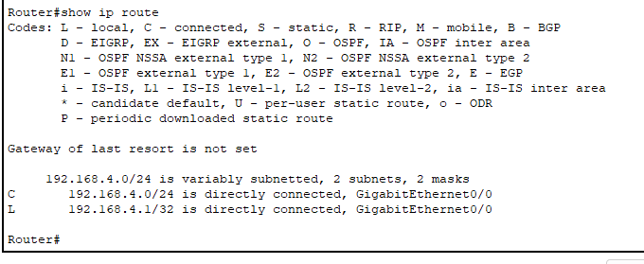
#Open server
Ip config > assign IP to it
IP : 192.168.1.50
Default gateway : 192.168.1.1
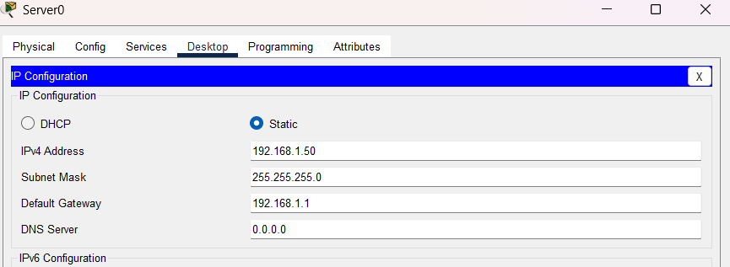
#Make sure HTTP and HTTPs service on of server
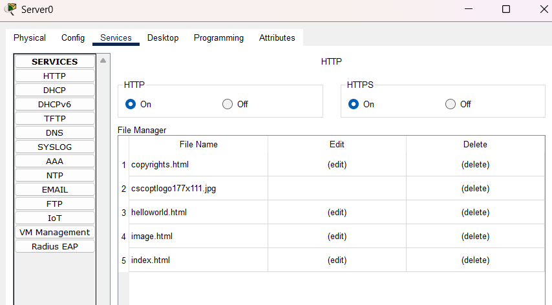
#Ping pc 1 to pc 2 (pc 1 can communicate with pc 2)
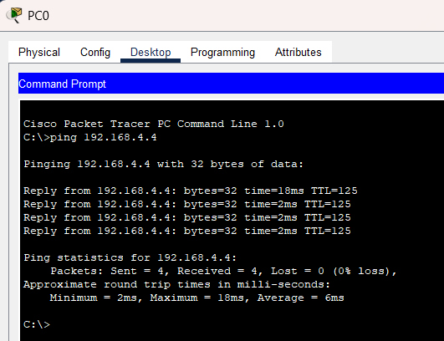
#Ping from pc 2 to pc 1(pc 2 can communicate with pc 1)
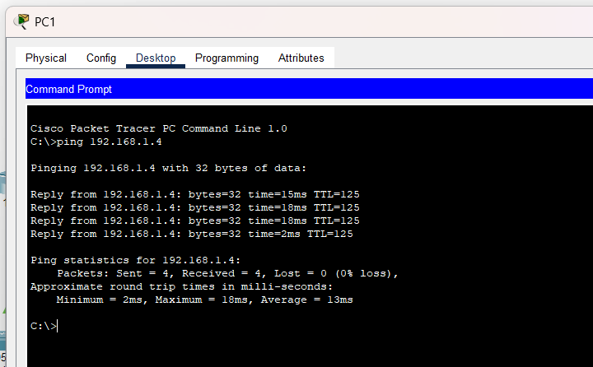
#Apply security
#Open router 1 (left)
Show version
On config mode
License boot module c1900 technology-package securityk9
Exit
Copy run startup-config
Reload
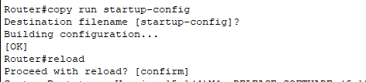
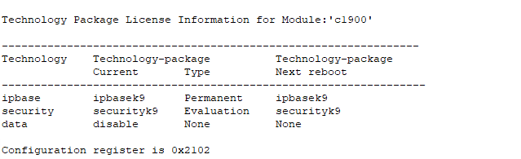
#Open Router R1 (left)
Mkdir ipdir
Conf t
Ip ips config location ipdir
Ip ips name iosips
Ip ips signauture-category
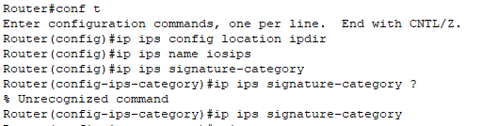
Just write “ ? “ (if not understand anything )
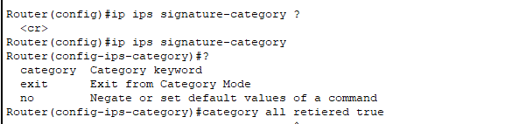
Category all
Retired true
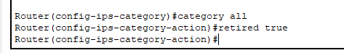
Exit
Category ?
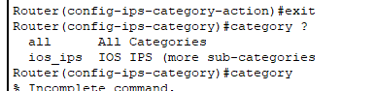
Category ios_ips
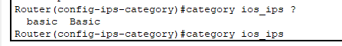
Retired false
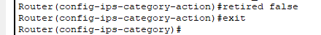
Category ios_ips basic
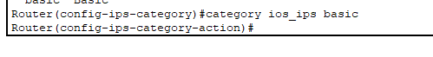
exit
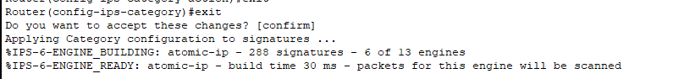
Interface gigabitEthernet 0/0
Ip ips iosips out
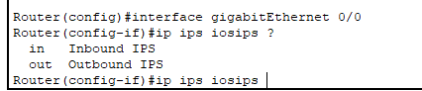
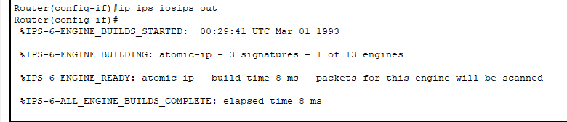
Exit
Logging host 192.168.1.50
Service timestamps log datetime msec
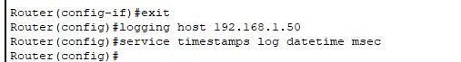
Ip ips signature-definition
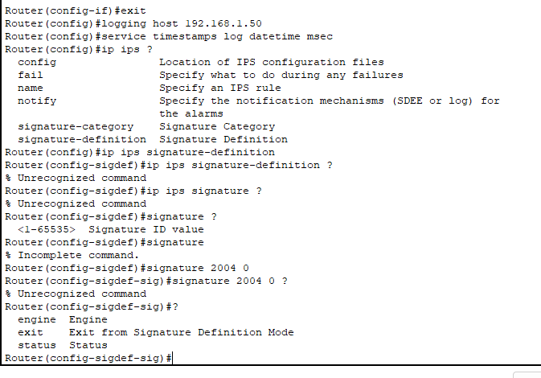
Signature 2004 0
Just write “ ? “
status
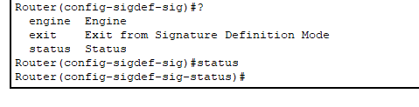
Retired false
Enable true
exit
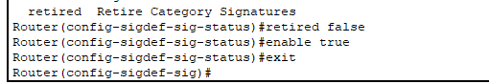
Engine
Event action deny-packet-inline
exit
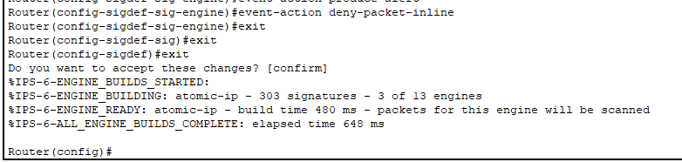
Do show ip ips all
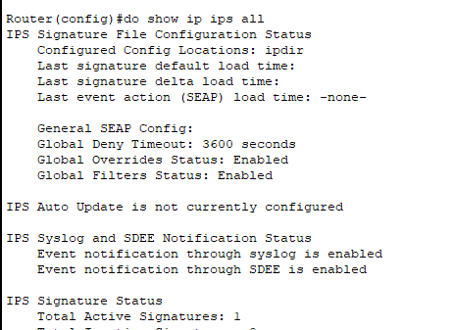
Ping from pc 1 to pc 2 – (pc1 can communicate with pc2)
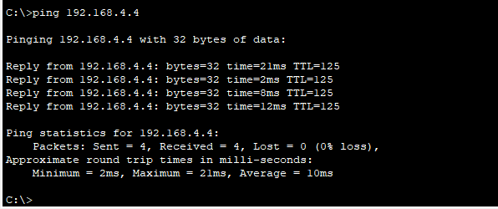

Ping from pc 2 to pc 1 – (pc2 can not communicate with pc1)
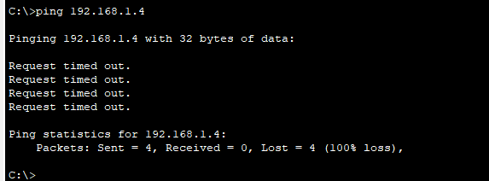
Check server syslog
