

**SYSC 5104 A**

**METHODOLOGIES FOR DISCRETE EVENT MODELING AND SIMULATION**

**Fall 2019**

**Assignment # 2**

**Cauchy-Euler Model, Cellular Automata Simulation of the Rate of Recovery of the Infected Airway form COPD**

**Student: Shreya Taneja**

**Student Number: 101132722**

**Email:** [**shreyataneja@cmail.carleton.ca**](mailto:shreyataneja@cmail.carleton.ca)

**INTRODUCTION**

The aim of the proposed model is to model the deposition of the inhaled drug on the infected airway into Cauchy-Euler differential equation and use Cell DEVS to simulate the evolution of the recovery of the inflamed airway.

Chronic obstructive pulmonary disease (COPD) is associated with the respiratory system. COPD is often treated with inhalers whose two major ingredients are the bronchodilators and the steroids. In this paper we mathematically model the deposition of the inhaled drug on the infected airway into Cauchy-Euler differential equation and use Cell DEVS to simulate the evolution of the recovery of the inflamed airway.

Chronic obstructive pulmonary disease (COPD) is associated with lower respiratory diseases. Other names of COPD are chronic obstructive airway disease (COAD), chronic airflow limitation (CAL) and chronic obstructive respiratory disease (CORD). COPD is caused by noxious particles or gas, smoking, which trigger an abnormal inflammatory response in the lung. COPD is often treated with inhalers whose two major ingredients are the bronchodilators and the steroids. When bronchodilators are inhaled they open the airways quickly and we first model the amount of deposition of the inhaled drug on the inflamed airway into a two dimensional cellular automaton on a square grid using *Cauchy-Euler Equation.*

**Cell DEVS specifications for COPD model**

Now we shall explain in detail the simulation of the rate of recovery of the infected airway using the two-dimensional cellular automaton on a square grid with von Neumann neighbourhood of range 1. The infected airway is divided into 10000 cells with L = W = 100.

Certain assumptions are in order to carry out the desired simulation in a sensible manner.

As per the original model, the following is the model specification:

* A parameter p (0 < p _ 1) is introduced as the rate of infection.
* Each of the 10000 cells in the two-dimensional cellular automaton is in any one of the four states Sn (n = 1, 2, 3,4): 0 <= S1 < 0.25, 0.25 <= S2 < 0.5 , 0.5 <=S3 < 0.75 and 0.75 <= S4 <= 1. The meaning is that the rate of infection of a cell which is in a state S2 is anywhere from 0.25 to 0.5 (the upper boundary value 0.5 is not included). We assign: State 1 – Green; State 2 – Yellow; State 3 – Red; State 4 – Pink.
* A time step, *t*, is inhalation of 60 metered doses. An inhalation of one metered dose contains 256 mcg of the drug.
* In order to specify the current status of the infected airway we proceed as follows. We first assume a value for p: p = 0.7 which translates into the fact that nearly 70% of the airway is infected. Then the program is activated to generate random numbers for each cell starting from (1, 1) to (10000, 10000) in a row wise. The state of each cell undergoes a change according to the p-random numbers, i.e., the random numbers multiplied by p. And this is accepted as the current status of the infected airway.

In the current Cell DEVS model designed, there is a slight variation while defining the input values of the cell (Initial Row Values) and the states of the cell. As per the cell DEVS model, the initial cell values are given in a range [0,10] for example for row 1, we have the initial values as:

Initialrowvalue:0 9879879789795659879565987984465489984979656532214987987656897989797441187989565555978987986597987987

The initial row values are considered the way that our model shows 70% of the COPD Infected area.

The 4 states (State 1, State 2, State 3, State 4) of the cells are taken as 10, 20, 30 and 40 respectively, different from original model where the states were given as 1, 2, 3, 4.

The initial state defining rules and the transition rules are same as the original model, without and variation, giving the same simulation results as expected and are defined below.

The Cell DEVS Specification for the given model is as follows:

* We first assume the fact that nearly 70% of the airway is infected and we provide the model has the initial cell values in range [0 to 10], greater the value of cell the more infected it is.

Example:Initialrowvalue:0 9879879789795659879565987984465489984979656532214987987656897989797441187989565555978987986597987987

* The infected airway is divided into 10000 cells with L = W = 100.
* The defaultDelayTime is defined as: 100 and border is considered to be wrapped
* The neighbourhood is defined as follows:

COPD(0,-1) COPD(0,0) COPD(0,1) COPD(1,0) COPD(-1,0)

Or a visual representation of the neighbourhood is as follows:

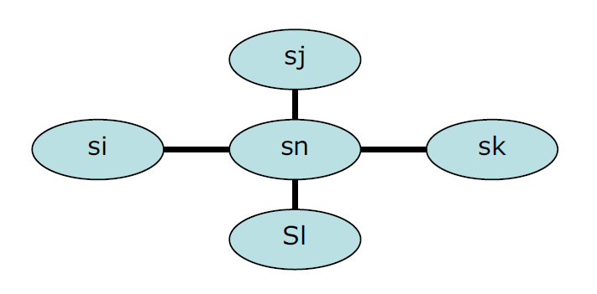

* In order to specify the current status of the infected airway we proceed as follows. The initial values of the cell determine the status of the cell initially. And this is accepted as the current status of the infected airway.
* Each of the 10000 cells in the two-dimensional cellular automaton is in any one of the four states:

State 1 - 10 if { currentcell >= 0 and currentcell < 3 }

State 2 - 20 if { currentcell >= 3 and currentcell < 5 }

State 3 - 30 if { currentcell >= 5 and currentcell < 7 }

State 4 - 40 if { currentcell >= 7 and currentcell < 10 }

The states to cell are given by the following rules:

%defining state for each cell rule

[COPD-rule]

rule : 10 100 { (0,0) >= 0 and (0,0) < 3 }

rule : 20 100 {(0,0) >= 3 and (0,0) < 5 }

rule : 30 100 {(0,0) >= 5 and (0 ,0) < 7 }

rule : 40 100 {(0,0) >= 7 and (0,0) < 10 }

* The meaning is that the rate of infection of a cell which is in for example, a state 2 is anywhere from 3 to 5 (the upper boundary value 5 is not included). We assign: State 1 – Green; State 2 – Yellow; State 3 – Orange; State 4 – Pink.
* A time step, *t*, is inhalation of 60 metered doses. An inhalation of one metered dose contains 256 mcg of the drug.
* The Transition rules for the simulation are defined as below:

|  |  |
| --- | --- |
| Sum of the neighbouring cells | The new state of the cell |
| 160<=Sum<=240 | 40 |
| 120<=Sum<160 | 30 |
| 80<=Sum<120 | 20 |
| 40<=Sum<80 | 10 |

%transition rules

rule : 40 100 { ((0,-1) +(0,1) +(1,0)+(-1,0))>=160 and ((0,-1) +(0,1) +(1,0)+(-1,0))<=240}

rule : 30 100 { ((0,-1) +(0,1) +(1,0)+(-1,0))>=120 and ((0,-1) +(0,1) +(1,0)+(-1,0))<160 }

rule : 20 100 { ((0,-1) +(0,1) +(1,0)+(-1,0))>=80 and ((0,-1) +(0,1) +(1,0)+(-1,0))<120}

rule : 10 100 { ((0,-1) +(0,1) +(1,0)+(-1,0))>=40 and ((0,-1) +(0,1) +(1,0)+(-1,0))<80}

rule : {(0,0)} 0 { t }

* The simulation was made to run for 1:00 minute to generate log file, further generating the visual results for the model.

**Results**

Cauchy-Euler equation modelling the deposition of the inhaled drugs in the form of nanoparticles is derived. Cellular automata with von Neumann neighbourhood is used to simulate the recovery of the airway infected by COPD.

* The initial simulation is displayed as below, which shows the 70% of the COPD infected area. Most of the cells have either pink or orange and it shows that the airway is highly infected.

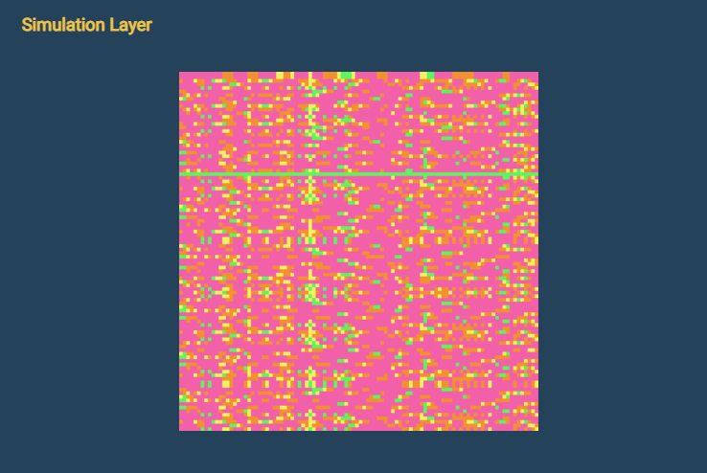

* After some treatment, i.e., after the inhalation of some amount of the drug particles the infection level has been brought down and is evident from the following figure. We may loosely say that the number of cells with pink or orange is very much lower that the number of cells with yellow and green.

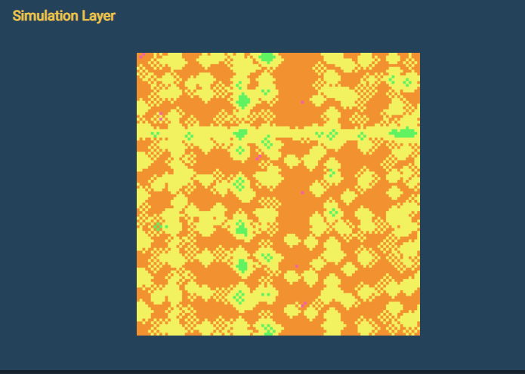

* At this stage, the omnipresence of the state S1 indicates that the recovery is 75%.

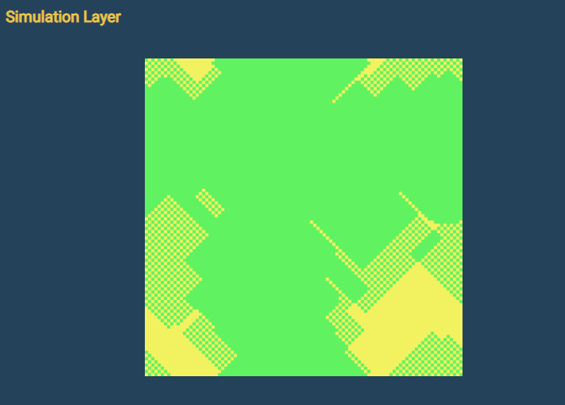

* The final state of the simulation is complete presence of green, i.e. State 1, which indicates the complete recovery of infection.

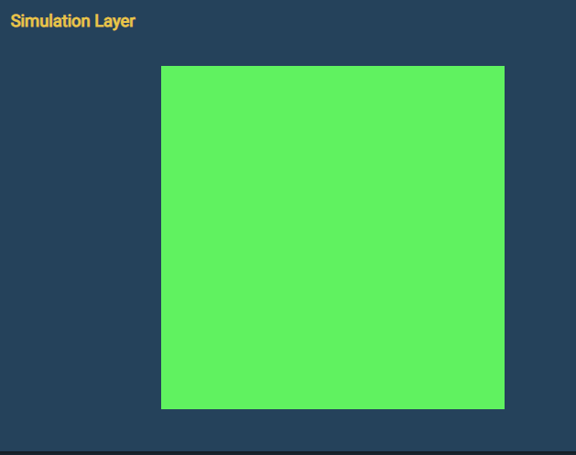

**References**

* **Cauchy-Euler Model, Cellular Automata Simulation of the Rate of Recovery of the Infected Airway from COPD.**

(Proceedings of the International Conference on Pattern Recognition, Informatics and Medical Engineering, March 21-23, 2012)

B. Mayil Vaganan, Department of Applied Mathematics and Statistics, Madurai Kamaraj University, Madurai-625021, India

S. Sundar, Department of Mathematics, Indian Institute of Technology Madras, Chennai-600036, India

D. Pandiaraja, Department of Mathematics, Thiagarajar College, Madurai-625009, India

E. Emily Priya, School of Mathematics, Madurai Kamaraj University, Madurai-625021, India