**Front End Engineering-II**

                                                                  Project Report

Semester-IV (Batch-2022)

Random Quote Generator

**Supervised By:**  **Submitted By:**

MR. RAVEESH SAMKARIA                Shreya Tewari

2210990839

G13A

**Department of Computer Science and Engineering**

**Chitkara University Institute of Engineering & Technology,**

**Chitkara University, Punjab**

**ABSTRACT**

The Random Quote Generator is a web-based application designed to provide users with inspirational quotes tailored to their mood. Leveraging Bootstrap for a responsive and visually appealing interface, the generator offers users an engaging experience in discovering motivational content.

The application features a user-friendly layout, employing Bootstrap's grid system to ensure compatibility across devices. The main functionality revolves around presenting users with a random quote upon accessing the website. Additionally, users can select their mood from predefined categories such as "Inspirational," "Wisdom," and "Motivational" using Bootstrap-styled buttons.

Behind the scenes, the application utilizes JavaScript to handle the logic for generating random quotes based on the selected mood. The quotes are organized into categories, allowing for efficient retrieval and presentation. Upon selecting a mood, the application dynamically updates the displayed quote without requiring a page refresh, providing a seamless user experience.

The Random Quote Generator aims to inspire and uplift users by delivering meaningful quotes that resonate with their current emotional state. By combining Bootstrap's robust styling capabilities with JavaScript's dynamic functionality, the application offers users a simple yet impactful tool for finding motivation and encouragement in their daily lives.

**TABLE OF CONTENT:**

|  |  |  |
| --- | --- | --- |
| Serial No. | Section | Page No. |
| 1 | Introduction | 4 |
| 2 | Problem Definitions and Requirements | 5-6 |
| 3 | Proposed Design and Methodology | 7-8 |
| 4 | File Structure | 9 |
| 5 | Results | 10 |
| 6 | Codes | 11-17 |
| 7 | References | 18 |

**1. INTRODUCTION**

The Random Quote Generator is a web application developed to provide users with a source of inspiration and motivation through randomly generated quotes. Utilizing the Bootstrap framework for front-end design, the generator offers a visually appealing and responsive interface that enhances user experience across various devices.

In today's fast-paced and often stressful world, individuals often seek sources of inspiration and encouragement to help them navigate challenges and maintain a positive outlook. The Random Quote Generator addresses this need by offering a simple yet effective tool for accessing inspirational quotes at the click of a button.

The purpose of this report is to provide an overview of the Random Quote Generator, including its features, design considerations, implementation details, and potential future enhancements. By examining the development process and functionality of the application, this report aims to showcase the value and utility of the Random Quote Generator as a mood-based inspirational tool.

Throughout this report, we will delve into the various aspects of the Random Quote Generator, highlighting its key components and functionalities. From its user-friendly interface to its seamless integration of Bootstrap for styling and JavaScript for dynamic quote generation, the Random Quote Generator exemplifies the intersection of design and functionality in web development.

Overall, the Random Quote Generator offers a valuable resource for fostering positivity and motivation in daily life.

**2. PROBLEM DEFINITION AND REQUIREMENTS**

**Problem Definition:**

The Random Quote Generator aims to address the need for a simple and accessible tool that provides users with inspirational and motivational quotes based on their mood preferences. In today's fast-paced world, individuals often seek sources of encouragement and positivity to help them stay motivated and focused. The problem lies in the lack of easily accessible platforms that cater to this need, especially in a way that allows users to customize their experience based on their current emotional state or mood.

**2.2 Requirements:**

**User Interface:**

* The application should have a visually appealing and user-friendly interface.
* It should be responsive and compatible with various screen sizes and devices.

**Random Quote Generation:**

* The application should be able to generate random quotes from a predefined list.
* Quotes should be categorized based on different moods, such as inspirational, funny, and motivational.

**Mood Selection:**

* Users should be able to select their mood preferences from a list of predefined categories.
* Mood selection should dynamically update the displayed quote based on the chosen mood.

**Accessibility:**

* The application should be accessible to users with disabilities, adhering to web accessibility standards.

**Performance:**

* The application should load quickly and efficiently, providing a seamless user experience.
* Quote generation and mood selection should be fast and responsive.

**Customization:**

* Users should have the option to customize their experience, such as adjusting the font size or background color.

**Integration with Bootstrap:**

* The application should utilize Bootstrap for styling and layout, ensuring a consistent and modern design.
* Bootstrap components and utilities should be leveraged to enhance the user interface and improve usability.

**Scalability:**

* The application should be designed to accommodate future enhancements and scalability, such as adding new quote categories or expanding functionality.

1. **PROPOSED DESIGN AND METHODOLOGY**

**3.1 PROPOSED DESIGN**

**Layout:**

* A single-page application with a clean and modern UI.
* Use Bootstrap’s grid system to create a responsive layout that adapts to different screen sizes.
* Incorporate Bootstrap components like buttons for a cohesive look and feel.

**Color Scheme:**

* Choose a color scheme that is visually appealing and provides good contrast for readability.
* Utilize Bootstrap’s color utility classes to maintain consistency across the application.

**Typography:**

* Use web-safe fonts or integrate Google Fonts for a more customized typography.
* Ensure text is legible and accessible by following best practices for font sizes and line spacing.

**Icons and Graphics:**

* Use Bootstrap icons or Font awesome for graphical elements like copy buttons and sliders.
* Keep graphics minimal to maintain focus on functionality.

**3.2 METHODOLOGY**:

**HTML Structure:**

* Create an HTML document with semantic elements to define the structure of the quote generator.
* Include input fields for quote generating criteria and buttons for moving to the next or previous quote.

**CSS Styling:**

* Write CSS rules to style the HTML elements, adhering to the chosen color scheme and typography.
* Use Bootstrap classes to style components and manage layout responsiveness.

**JavaScript Implementation:**

* Write JavaScript functions to handle the logic of quote generation.
* Implement event listeners for user interactions like clicking the generate button or changing the mood.

**Quote Generation Logic:**

* Develop an algorithm to create random quotes based on user-selected criteria.
* Ensure the algorithm generates quotes.

**User Interaction:**

* The user interface (UI) will be designed using Bootstrap to ensure a responsive, visually appealing, and user-friendly layout.
* The UI will consist of a header displaying the application title, a quote display area, mood selection buttons, and a footer.

**Accessibility Considerations:**

* Accessibility features such as proper semantic HTML markup, ARIA attributes, and focus management will be implemented to ensure the application is accessible to users with disabilities.
* High contrast colors, sufficient color contrast, and keyboard navigation support will be incorporated to improve accessibility.

**Documentation:**

* Comprehensive documentation will be provided, including code comments, usage instructions, and a user manual.
* The design rationale, implementation details, and any dependencies will be documented for future reference and maintenance.

**4**. **FILE STRUCTURE**

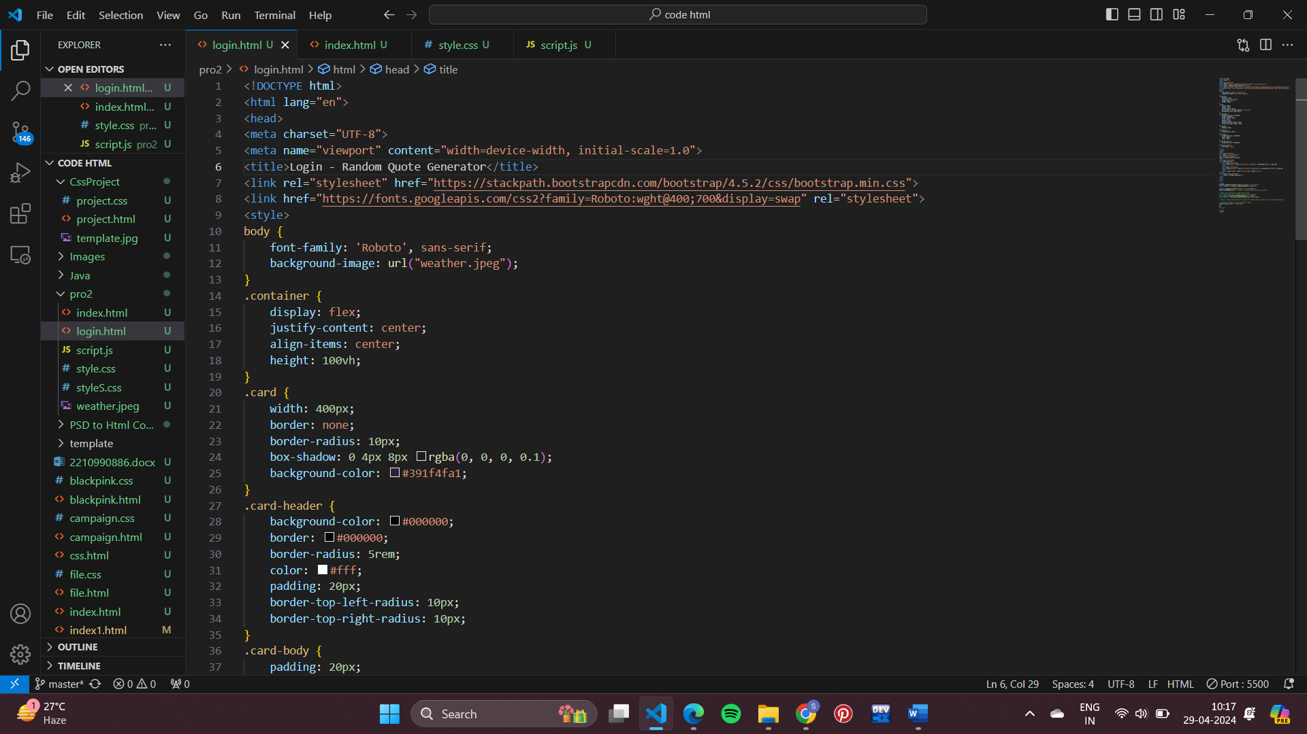

Fig. File Structure

**5. RESULTS**

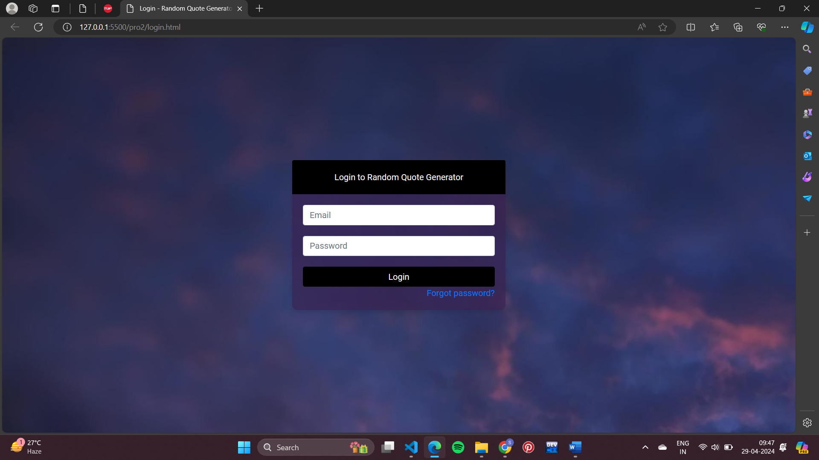

Fig.1.1 Login Page

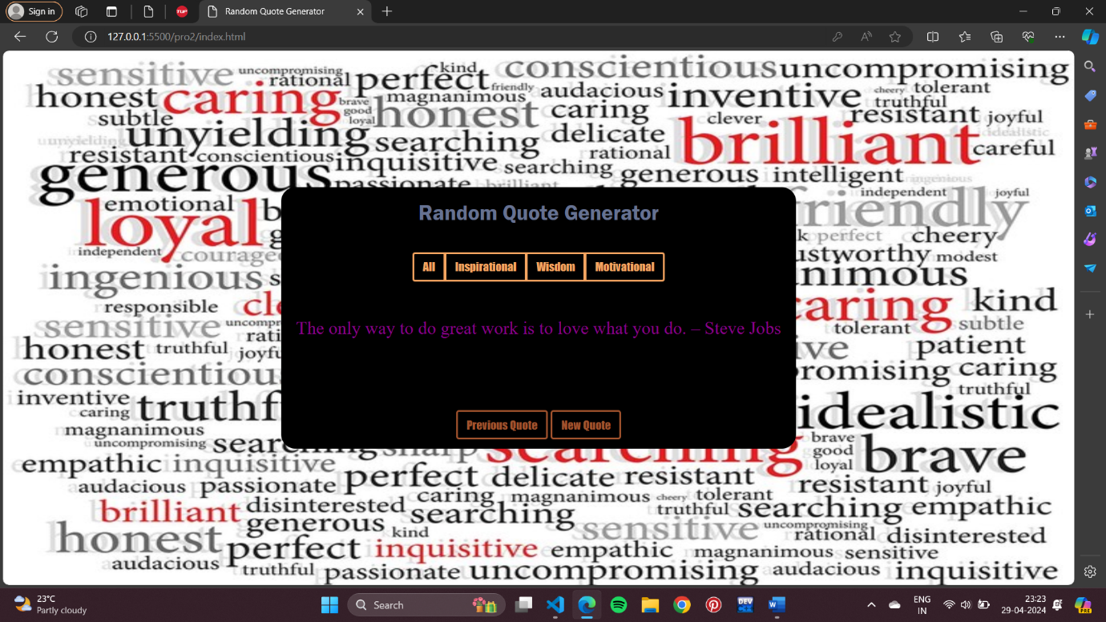

Fig.2.2 Main Page

**6. CODE**

**6.1 HTML CODE**

Login.html:

<!DOCTYPE html>

<html lang="en">

<head>

<meta charset="UTF-8">

<meta name="viewport" content="width=device-width, initial-scale=1.0">

<title>Login - Random Quote Generator</title>

<link rel="stylesheet" href="https://stackpath.bootstrapcdn.com/bootstrap/4.5.2/css/bootstrap.min.css">

<link href="https://fonts.googleapis.com/css2?family=Roboto:wght@400;700&display=swap" rel="stylesheet">

<style>

body {

    font-family: 'Roboto', sans-serif;

    background-image: url("weather.jpeg");

}

.container {

    display: flex;

    justify-content: center;

    align-items: center;

    height: 100vh;

}

.card {

    width: 400px;

    border: none;

    border-radius: 10px;

    box-shadow: 0 4px 8px rgba(0, 0, 0, 0.1);

    background-color: #391f4fa1;

}

.card-header {

    background-color: #000000;

    border: #000000;

    border-radius: 5rem;

    color: #fff;

    padding: 20px;

    border-top-left-radius: 10px;

    border-top-right-radius: 10px;

}

.card-body {

    padding: 20px;

}

.form-group {

    margin-bottom: 20px;

}

.btn-login {

    background-color: #000000;

    color: #fff;

    width: 100%;

}

.btn-login:hover {

    background-color: #000000;

}

.forgot-password {

    text-align: right;

}

</style>

</head>

<body>

<div class="container">

<div class="card text-center">

<div class="card-header">

Login to Random Quote Generator

</div>

<div class="card-body">

<form id="loginForm">

    <div class="form-group">

    <input type="email" class="form-control" id="email" placeholder="Email" required>

    </div>

    <div class="form-group">

    <input type="password" class="form-control" id="password" placeholder="Password" required>

    </div>

    <button type="submit" class="btn btn-login">Login</button>

</form>

<div class="forgot-password">

    <a href="#">Forgot password?</a>

</div>

</div>

</div>

</div>

<script>

document.addEventListener("DOMContentLoaded", function() {

const loginForm = document.getElementById("loginForm");

loginForm.addEventListener("submit", function(event) {

event.preventDefault(); // Prevent the default form submission behavior

// Here you can add your authentication logic

// For simplicity, let's assume the login is successful

const email = document.getElementById("email").value;

const password = document.getElementById("password").value;

// Check if email and password are valid (for demonstration purpose, we're skipping validation)

// Redirect to index.html upon successful login

window.location.href = "index.html";

});

});

</script>

</body>

</html>

Index.html:

<!DOCTYPE html>

<html lang="en">

<head>

  <meta charset="UTF-8">

  <meta name="viewport" content="width=device-width, initial-scale=1.0">

  <title>Random Quote Generator</title>

  <link rel="stylesheet" href="https://stackpath.bootstrapcdn.com/bootstrap/4.5.2/css/bootstrap.min.css">

  <link rel="stylesheet" href="style.css">

</head>

<body>

  <div class="container d-flex justify-content-center align-items-center vh-100">

    <div class="row">

      <div class="col">

        <div class="card text-center">

          <div class="card-header">

            Random Quote Generator

          </div>

          <div class="card-body">

            <div class="btn-group">

                <button type="button" class="btn btn-secondary mood-btn" data-mood="all">All</button>

                <button type="button" class="btn btn-secondary mood-btn" data-mood="inspirational">Inspirational</button>

                <button type="button" class="btn btn-secondary mood-btn" data-mood="wisdom">Wisdom</button>

                <button type="button" class="btn btn-secondary mood-btn" data-mood="motivational">Motivational</button>

                </div>

            <blockquote class="blockquote">

              <p id="quoteDisplay"></p>

            </blockquote>

          </div>

          <div class="card-footer">

            <button id="previousQuoteBtn" class="btn btn-primary">Previous Quote</button>

            <button id="newQuoteBtn" class="btn btn-primary">New Quote</button>

          </div>

        </div>

      </div>

    </div>

  </div>

  <script src="script.js"></script>

</body>

</html>

**6.2 CSS CODE**

body{

    background-image: url("weather.jpeg");

    background-repeat:no-repeat;

    background-size: 1500px 1000px;

    scroll-behavior: none;

}

  .card {

    border-radius: 20px;

    background-color: #000000;

  }

  .card-header {

    border-radius: 20px;

    color: #667292;

    font-family: 'Franklin Gothic Medium';

    font-size: 30px;

  }

  .card-body{

    padding: 50px;

  }

  p{

    color:darkmagenta;

    font-family:serif;

    font-size: 25px;

  }

  .btn-primary {

    background-color: rgb(0, 0, 0);

    color: sienna;

    font-family: fantasy;

    border-color: sienna;

    border-width: 3px;

  }

  .btn-primary:hover {

    background-color: gray;

    color:black;

  }

  .btn-secondary {

    background-color: rgb(0, 0, 0);

    font-family: fantasy;

    color: sandybrown;

    border-color: sandybrown;

    border-width: 3px;

  }

  .btn-secondary:hover{

    color:black;

  }

**6.3 JAVASCRIPT CODE**

// Define an object of quotes categorized by mood

const quotesByMood = {

  all: [

    "The only way to do great work is to love what you do. – Steve Jobs",

    "Innovation distinguishes between a leader and a follower. – Steve Jobs",

    "Your time is limited, don’t waste it living someone else’s life. – Steve Jobs",

    "Strive not to be a success, but rather to be of value. – Albert Einstein",

    "Two things are infinite: the universe and human stupidity; and I'm not sure about the universe. – Albert Einstein",

    "You miss 100% of the shots you don’t take. – Wayne Gretzky",

    "The best time to plant a tree was 20 years ago. The second best time is now. – Chinese Proverb",

    "You have to believe in yourself when no one else does. —Serena Williams",

    "When you have a dream, you’ve got to grab it and never let go. —Carol Burnett",

    "The most important thing is to enjoy your life—to be happy—it’s all that matters. —Steve Jobs",

    "Spread love everywhere you go. Let no one ever come without leaving happier. —Mother Teresa",

    "Be yourself; everyone else is already taken. —Oscar Wilde",

    "The biggest adventure you can take is to live the life of your dreams. —Oprah Winfrey",

    "The only thing we have to fear is fear itself. —Franklin D. Roosevelt",

    "I can accept failure, everyone fails at something. But I can’t accept not trying. —Michael Jordan",

    "You’ve got to be in it to win it. —Tony Robbins",

  ],

  inspirational: [

    "Believe you can and you're halfway there. – Theodore Roosevelt",

    "The future belongs to those who believe in the beauty of their dreams. – Eleanor Roosevelt",

    "The only way to achieve the impossible is to believe it is possible. – Charles Kingsleigh",

    "Success is not final, failure is not fatal: It is the courage to continue that counts. – Winston Churchill",

    "Do one thing every day that scares you. -Eleanor Roosevelt",

    "Well done is better than well said. -Benjamin Franklin",

    "Life is really simple, but we insist on making it complicated.– Confucius",

    "May you live all the days of your life. – Jonathan Swift",

    "Life itself is the most wonderful fairy tale. – Hans Christian Andersen",

    "Do not let making a living prevent you from making a life. – John Wooden",

  ],

  wisdom: [

    "The only mystery in life is why the kamikaze pilots wore helmets. – Al McGuire",

    "I asked God for a bike, but I know God doesn’t work that way. So I stole a bike and asked for forgiveness. – Emo Philips",

    "Behind every great man is a woman rolling her eyes. – Jim Carrey",

    "Poor eyes limit your sight; poor vision limits your deeds.- Franklin Field",

    "I do not pray for success. I ask for faithfulness.- Mother Teresa",

    "I used to ask God to help me. Then I asked if I might help him- Hudson Taylor",

    "The wise person doesn't give the right answers, but poses the right questions.- Claude Levi-Strauss",

    "What happens is not as important as how you react to what happens.- Ellen Glasgow",

    "The journey of a thousand miles begins with one step.- Lao Tzu",

  ],

  motivational: [

    "The only limit to our realization of tomorrow will be our doubts of today. – Franklin D. Roosevelt",

    "You are never too old to set another goal or to dream a new dream. – C.S. Lewis",

    "Success is not the key to happiness. Happiness is the key to success. If you love what you are doing, you will be successful. – Albert Schweitzer"

  ]

};

// Function to generate a random quote based on mood

function generateQuote(mood) {

  const moodQuotes = quotesByMood[mood] || quotesByMood.all;

  const randomNumber = Math.floor(Math.random() * moodQuotes.length);

  const quoteDisplay = document.getElementById("quoteDisplay");

  quoteDisplay.innerText = moodQuotes[randomNumber];

}

// Initial quote generation

generateQuote("all");

// Event listener for the mood buttons

const moodButtons = document.querySelectorAll(".mood-btn");

moodButtons.forEach(button => {

  button.addEventListener("click", function() {

    const selectedMood = this.getAttribute("data-mood");

    generateQuote(selectedMood);

  });

});

document.getElementById("newQuoteBtn").addEventListener("click", generateQuote);

document.getElementById("previousQuoteBtn").addEventListener("click", generateQuote);

**7.REFERENCES**

* <https://getbootstrap.com/>
* <https://www.w3schools.com/css/>