LAB-10

Step-I] Downloading GDC-Manifest File

A screenshot of a social media post with text and people in background

Description generated with high confidence

Step-II] Download Expression Quantification Data using gdc-client

Total Downloaded Files: 11487

A close up of a building

Description generated with high confidence

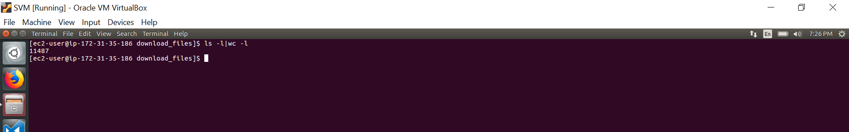

Step-III] Check the integrity of downloaded files

A close up of a screen

Description generated with high confidence

Step-IV] Get Case_ID related to the file

A screenshot of a computer

Description generated with very high confidence

Step V] Getting the meta_data of files and corresponding cases:

A screenshot of a map

Description generated with very high confidence

A close up of a piece of paper

Description generated with high confidence

Step-VI] Generating mi_RNA matrix

A close up of a device

Description generated with high confidence

A screenshot of a cell phone

Description generated with high confidence

A screenshot of a cell phone

Description generated with very high confidence

Step-VII] Performing predict.py

A screenshot of a cell phone

Description generated with very high confidence