Terraform.tf

Main.tf
Setup access key, secret access key and default region
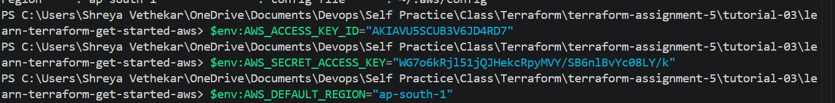

Verify the credentials
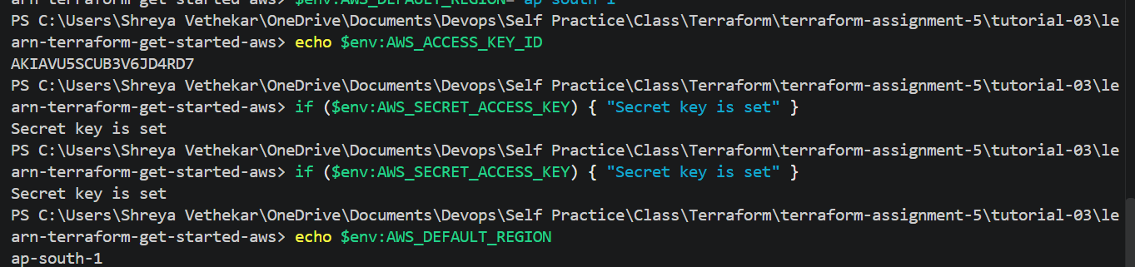

Check in AWS
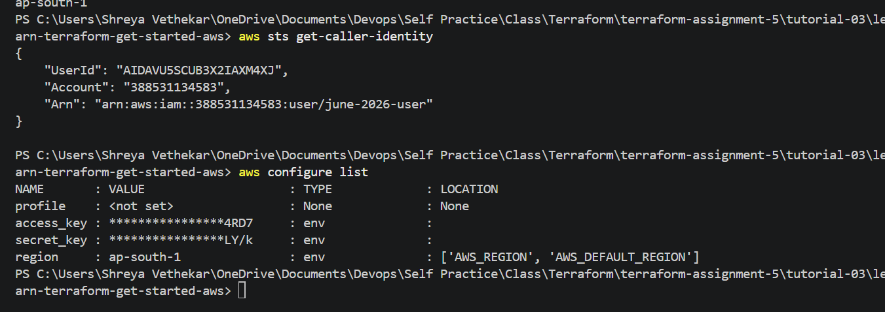

Terraform init
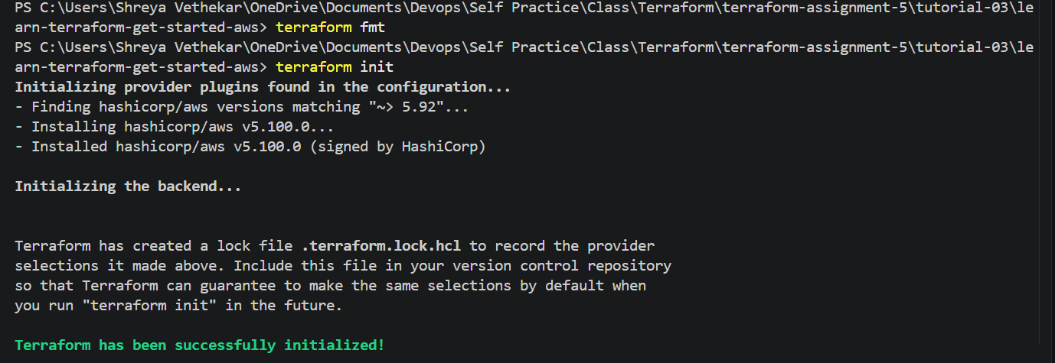

Terraform plan

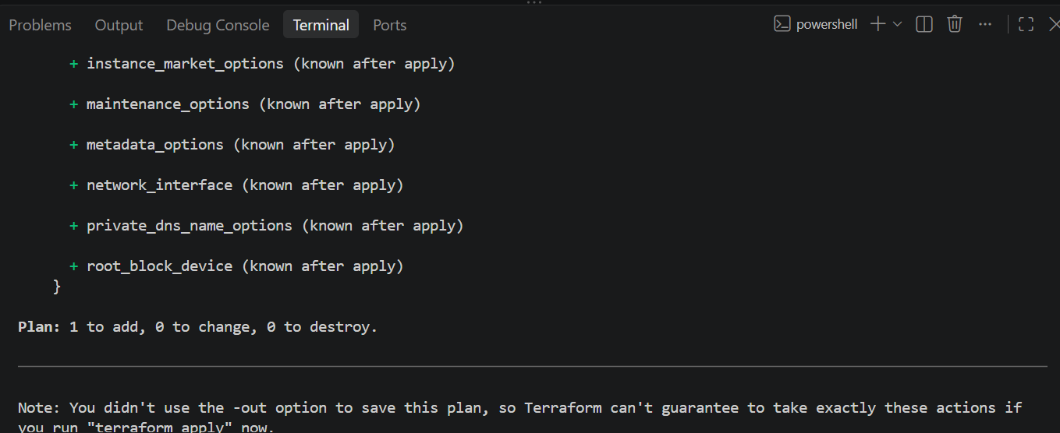

Terraform apply
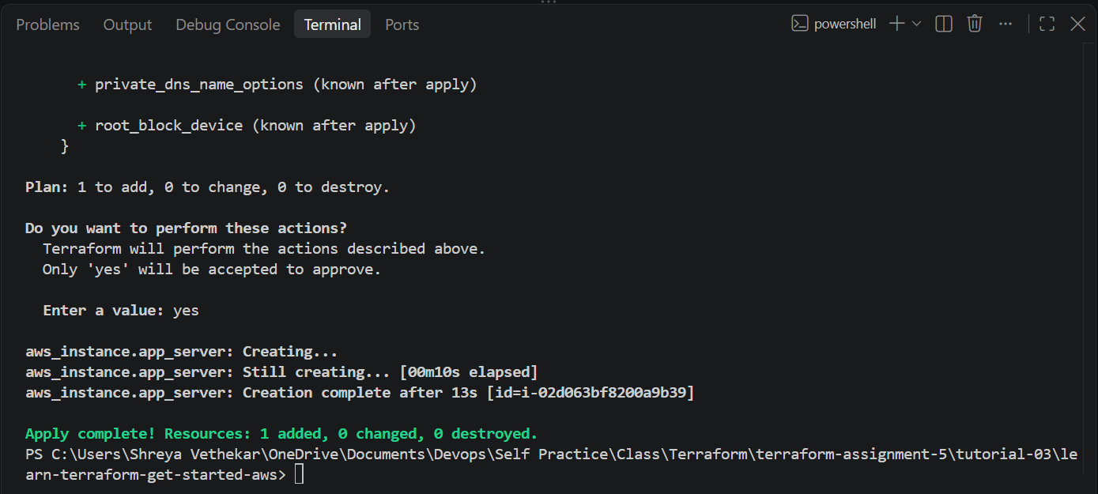

AWS console
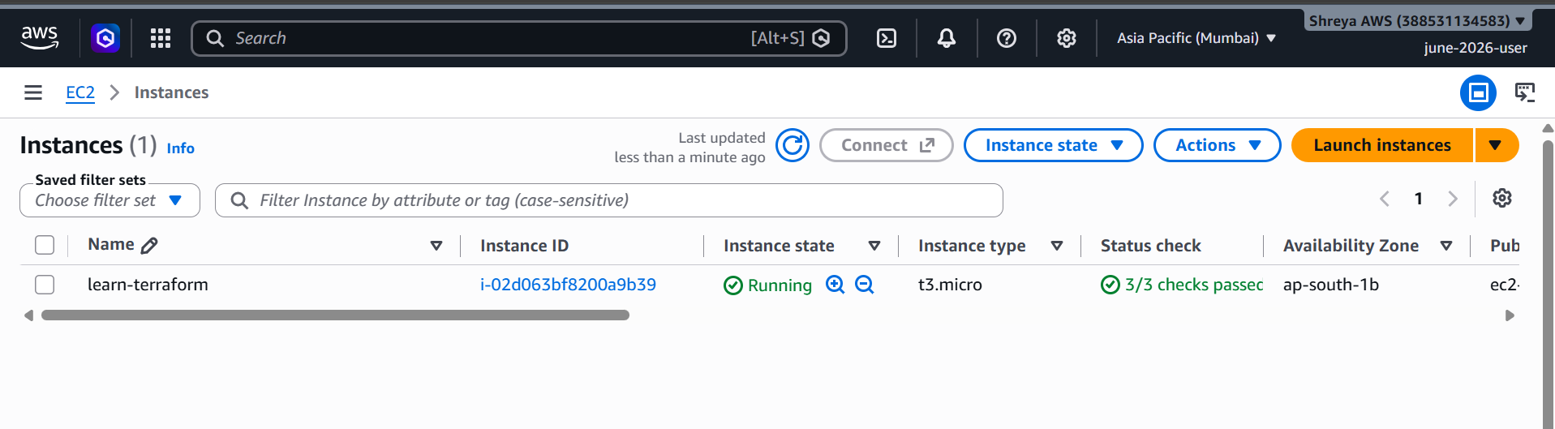

Terraform destroy

