Analysis of YOLO Dataset Configuration Files and Metadata
YOLO (You Only Look Once) is a popular computer vision framework used for object detection and image segmentation. To train and validate YOLO models, datasets must be organized in a specific format and accompanied by metadata files. These metadata files provide information about dataset locations, training and validation directories, and object classes. In this report, the COCO8-SEG dataset configuration used by Ultralytics YOLO is analyzed to understand the structure and purpose of these files.
Figure 1: YOLO Dataset YAML Configuration File
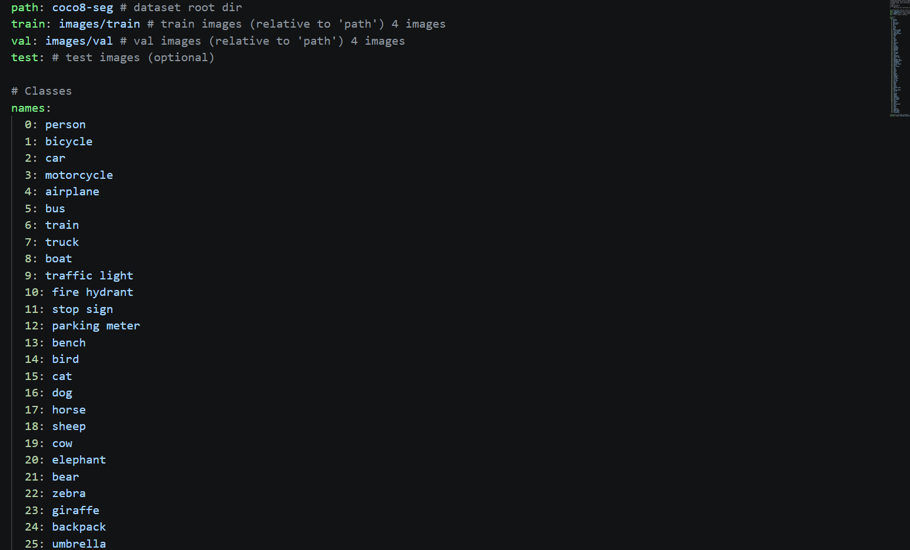

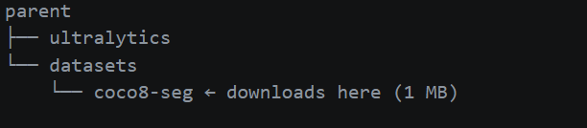

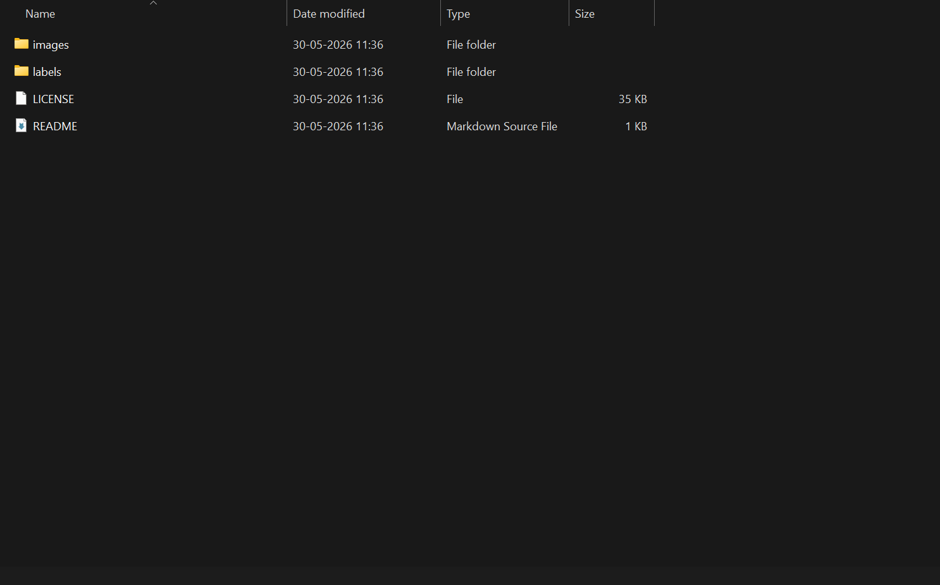
Figure 2: COCO8-SEG Dataset Directory Structure

Figure 3: Sample YOLO Label File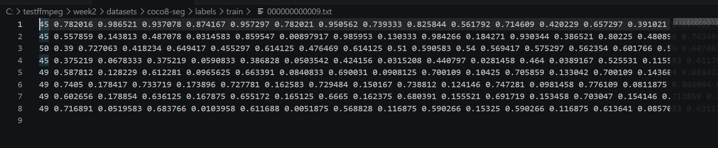

The COCO8-SEG dataset contains an images directory storing the dataset images and a labels directory containing annotation files. Additional files such as README.md and LICENSE provide dataset documentation and usage information.

References
- Ultralytics YOLO Datasets Documentation – https://docs.ultralytics.com/datasets/
- Ultralytics Object Detection Dataset Format – https://docs.ultralytics.com/datasets/detect/
- Ultralytics Segmentation Dataset Format – https://docs.ultralytics.com/datasets/segment/
- Ultralytics GitHub Repository – https://github.com/ultralytics/ultralytics

