CAPSTONE PROJECT REPORT
Forex Risk and Portfolio Analysis
How risky are the dollar, euro, pound and yen for someone who holds rupees?
Student: [Name] | Reg. No.: [Number] | Course: [Course name] | Submission: 10 October 2026

1. Introduction and proposal
The Indian rupee has been losing value against most big currencies for decades. If you import goods, pay fees abroad, or hold foreign currency as an investment, that matters. A rupee that drops 1% overnight can wipe out the profit on a small trade. This project looks at four exchange rates, USDINR, EURINR, GBPINR and JPYINR, and tries to answer three simple questions.
- Which of the four currencies has been the most risky in the last five years, and by how much?
- Is there a clear trend in each rate right now?
- If an investor split money across the four currencies, which mix would have given the lowest risk?
Everything is done in Python with pandas, NumPy, SciPy and Matplotlib. The work is split into data cleaning, time-series analysis, moving averages, risk metrics, a Markowitz portfolio and a small text-sentiment test. A simple web dashboard shows live rates for the same four pairs.

Scope and data sources
Source | What it contains | Used for
RBI reference rates (CSV) | Daily INR price of USD, EUR, GBP and JPY from 25 Aug 1998 to 1 Sep 2026 | All the statistical work
Frankfurter API (ECB rates) | Latest daily rates for the same pairs | Live dashboard only
sample_headlines.csv | 16 short headlines written for this exercise | Text sentiment demo

Role allocation
Team member | Role | Main deliverables
[Member 1] | Data collection and cleaning | Section 2, data folder, README
[Member 2] | Time series, moving averages, risk | Sections 3 to 5, notebook
[Member 3] | Markowitz, text analytics, dashboard | Sections 6 to 8, final editing
(Replace the bracketed names with the real group members, or delete rows for an individual project.)

2. Data pipeline and description
The RBI file has 6,656 rows, one per working day, with columns for AED, EUR, GBP, IDR, JPY and USD. AED and IDR are almost empty, so they were dropped. The euro column has 81 gaps because the euro only started in January 1999. GBP and JPY have one gap each. After checking for duplicate dates (there were none), the four currencies were kept, renamed to the usual market style (USDINR and so on), and any row with a missing value was removed. That left 6,575 clean days, from 4 January 1999 to 1 September 2026.
For the risk work only the last five years are used, which is 1,181 trading days from 1 September 2021. Older data is still useful for seeing the long trend, but recent behaviour says more about today's risk. One detail to remember: RBI quotes the yen per 100 yen, so JPYINR in this report is about 59 rupees for 100 yen.
Pair | Mean | Std. dev. | Min | Max | Latest (1 Sep 2026)
USDINR | 59.23 | 15.38 | 39.27 | 96.84 | 94.87
EURINR | 69.33 | 16.95 | 38.79 | 112.37 | 110.07
GBPINR | 87.39 | 14.14 | 63.96 | 130.66 | 128.43
JPYINR (per 100) | 52.39 | 10.85 | 32.69 | 72.12 | 59.31
Table 1. Summary of INR per unit of foreign currency, full history
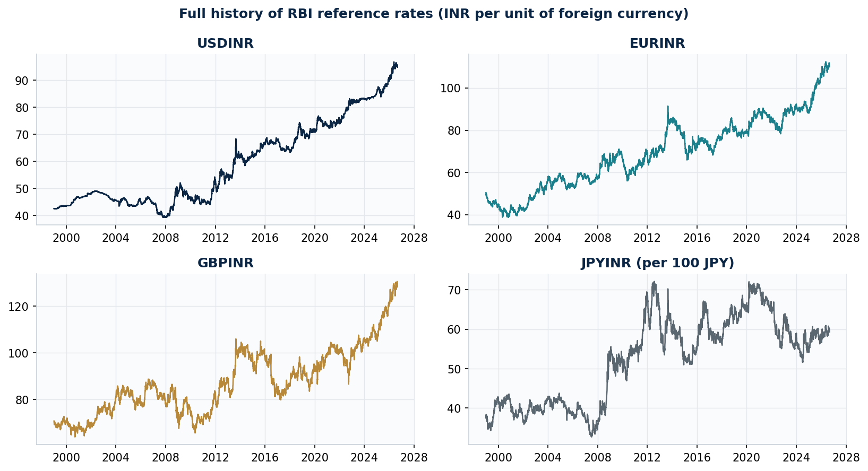
Figure 1. The four rates since 1999
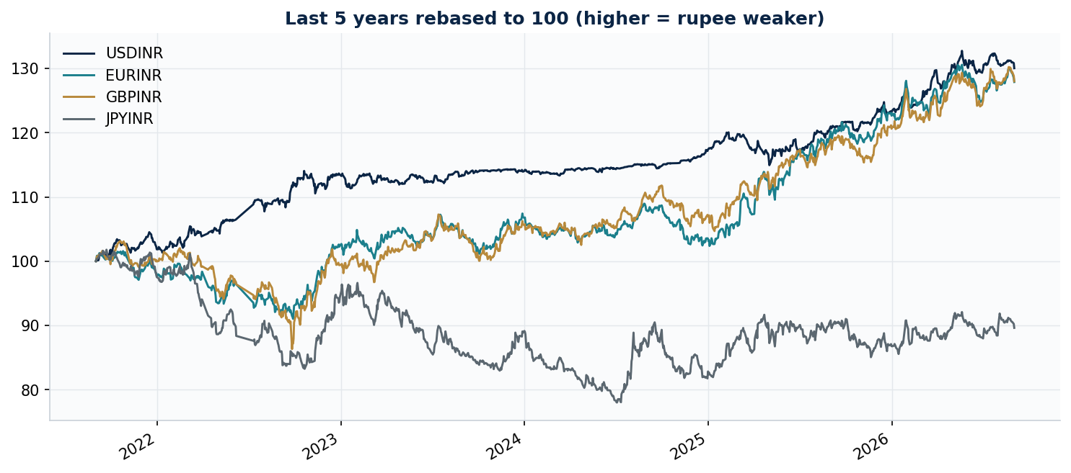
Figure 2. Last five years, all rates set to 100 at the start
What this means: Figure 2 puts the rates on the same scale. The dollar, euro and pound each cost roughly 28 to 30% more rupees than five years ago (USD +30.0%, EUR +27.9%, GBP +28.0%). The yen went the other way and lost 10.4%. Because these prices climb steadily, the raw price is a poor thing to analyse directly, so the next sections use daily returns instead.

3. Time-series analysis
A return is just the percentage change from one day to the next. We use log returns, ln(today / yesterday), because they add up neatly over time and make different currencies easy to compare. Table 2 describes how these returns behave, and Table 3 checks whether today's move depends on yesterday's (autocorrelation).
Pair | Mean daily % | Std. daily % | Skewness | Excess kurtosis | Jarque-Bera p
USDINR | 0.0223 | 0.2729 | 0.075 | 6.83 | 0.000
EURINR | 0.0208 | 0.4577 | -0.278 | 3.23 | 0.000
GBPINR | 0.0209 | 0.5130 | -0.543 | 8.69 | 0.000
JPYINR | -0.0093 | 0.6566 | 0.588 | 4.35 | 0.000
Table 2. Daily log return statistics, last 5 years
Pair | Lag-1 price | Lag-1 return | Lag-1 squared return | Trend (% per year)
USDINR | 0.999 | -0.012 | 0.087 | 2.97
EURINR | 0.999 | 0.049 | 0.095 | 3.07
GBPINR | 0.998 | 0.029 | 0.086 | 1.72
JPYINR | 0.993 | 0.021 | 0.141 | 2.20
Table 3. Autocorrelation, and long-run trend over 1999 to 2026
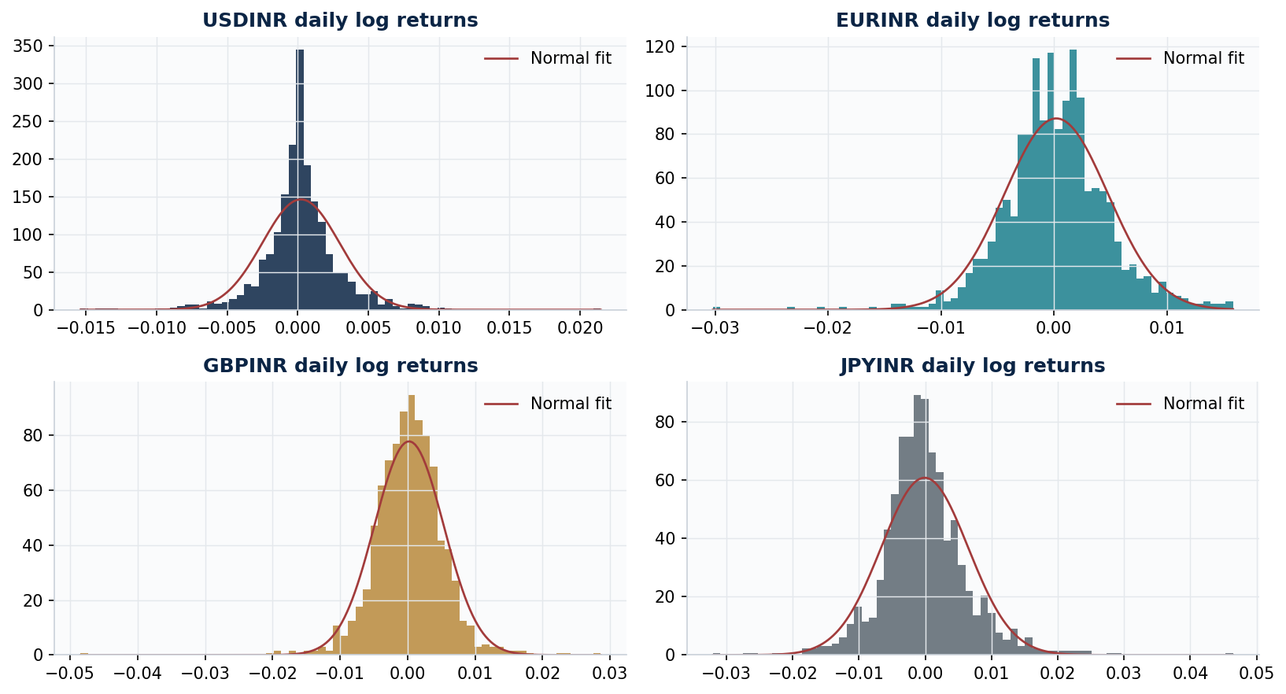
Figure 3. Histograms of daily returns, with a normal curve for comparison
What this means: Prices have an autocorrelation of almost 1, which just says that today's price is very close to yesterday's. Returns sit close to 0, so yesterday's return tells us almost nothing about tomorrow's. The histograms have taller peaks and fatter tails than the red normal curve. This is what the kurtosis values (3.2 to 8.7) and the Jarque-Bera test say as well: very big days happen more often than a normal distribution would predict. The squared returns are positively correlated (0.09 to 0.14), meaning calm and wild periods tend to come in clumps. Over the full 27 years the rupee has slipped by roughly 2 to 3% a year against the dollar and the euro.

4. Moving averages
A moving average is the average price over the last N days. It smooths out the daily noise so the direction is easier to see. Here we use a 50-day and a 200-day simple moving average (SMA). When the 50-day line is above the 200-day line, the recent price is higher than the longer-term price, so the trend is up. For these pairs, an uptrend means the foreign currency is getting more expensive in rupees.
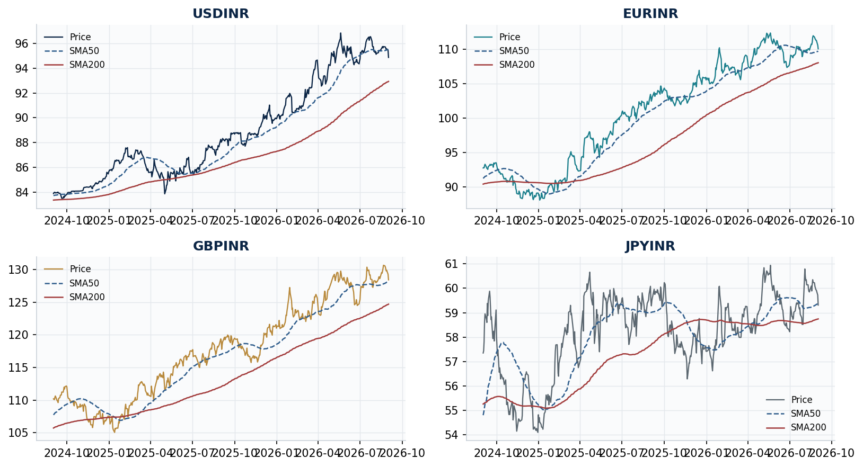
Figure 4. Price with the 50-day and 200-day averages, last two years
Pair | Price | SMA50 | SMA200 | Price vs SMA50 | Trend | Last crossover
USDINR | 94.87 | 95.51 | 92.93 | Below | Up | None in window
EURINR | 110.07 | 109.73 | 108.05 | Above | Up | 19 Mar 2025
GBPINR | 128.43 | 128.22 | 124.71 | Above | Up | 10 Mar 2025
JPYINR | 59.31 | 59.38 | 58.75 | Below | Up | 8 Apr 2026
Table 4. Moving-average position on 1 September 2026
What this means: All four pairs have the 50-day line above the 200-day line, so the medium-term story is still a weaker rupee. In the short term, USDINR and JPYINR have dipped under their 50-day lines, which looks like a pause or small pullback. The dollar has stayed in an uptrend for the whole window, with no crossover since the 200-day average became available in August 2022. The yen only turned up in April 2026, so its signal is the newest and the least proven. One thing to keep in mind: moving averages react after the price has already moved, so they confirm a trend rather than forecast one.

5. Risk metrics
Several measures are used, each answering a slightly different question. Volatility is how much the rate bounces around in a year. Value at Risk (VaR) at 95% is the one-day loss that should only be beaten on 5 days out of 100. CVaR is the average loss on those worst days. Maximum drawdown is the biggest fall from a peak, measured here as a rise in the rupee's value against the currency. The Sharpe ratio compares return to risk after subtracting a 6% risk-free rate, which is an assumption we made. All annual figures use 252 trading days.
Metric | USDINR | EURINR | GBPINR | JPYINR
Annual return % | 5.61 | 5.25 | 5.27 | -2.34
Annual volatility % | 4.33 | 7.27 | 8.14 | 10.42
Sharpe ratio | -0.09 | -0.10 | -0.09 | -0.80
VaR 95% (1 day) % | 0.38 | 0.68 | 0.74 | 0.99
VaR 99% (1 day) % | 0.78 | 1.08 | 1.27 | 1.62
CVaR 95% % | 0.64 | 0.99 | 1.13 | 1.40
Max drawdown % | -4.26 | -10.38 | -16.28 | -23.37
VaR 95% on Rs 10 lakh | Rs 3,809 | Rs 6,779 | Rs 7,389 | Rs 9,926
Table 5. Risk metrics, last 5 years
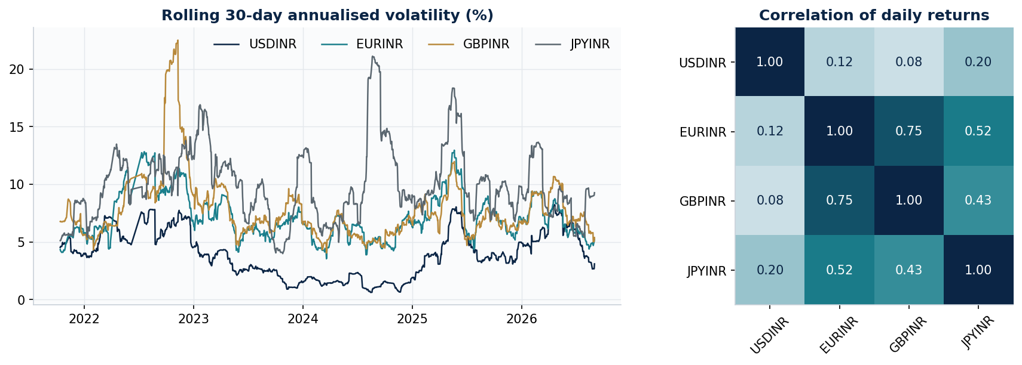
Figure 5. Rolling 30-day volatility (left) and correlation between currencies (right)
What this means: Risk goes up as you move from the dollar to the yen. USDINR has 4.3% volatility and a one-day VaR of 0.38%. JPYINR has 10.4% and 0.99%, so a Rs 10 lakh yen position could lose more than about Rs 9,900 in a single day roughly once every twenty days. CVaR is bigger than VaR in every case, which shows how much worse the really bad days are. The Sharpe ratios are all negative simply because the 6% hurdle was higher than what the currencies earned. The euro and pound move together (correlation 0.75), so holding both adds little protection. The dollar is almost unrelated to the others (0.08 to 0.20), which makes it the best diversifier. The left chart shows risk is not constant, for example GBPINR volatility jumped above 20% in late 2022.

6. Markowitz mean-variance portfolio
Harry Markowitz showed that the risk of a portfolio depends not only on each asset's risk but on how the assets move together. Mixing assets that do not move together lowers risk without necessarily lowering return. To test this, we take the yearly average return of each pair and the covariance matrix, then look for the best long-only mix (no short selling, weights between 0 and 100% adding to 100%). First, 5,000 random mixes are plotted to see the range of possible outcomes. Then SciPy's SLSQP optimiser finds two special portfolios: the minimum-variance one, and the one with the highest Sharpe ratio. A fixed random seed (42) keeps the result repeatable.
Portfolio | USD % | EUR % | GBP % | JPY % | Return % | Vol. % | Sharpe | VaR95 1d %
Equal weight | 25.0 | 25.0 | 25.0 | 25.0 | 3.45 | 5.69 | -0.45 | 0.51
Minimum variance | 75.5 | 15.3 | 9.2 | 0.0 | 5.52 | 3.87 | -0.12 | 0.35
Maximum Sharpe | 0.0 | 0.0 | 100.0 | 0.0 | 5.27 | 8.14 | -0.09 | 0.74
Table 6. Weights and performance of the three portfolios
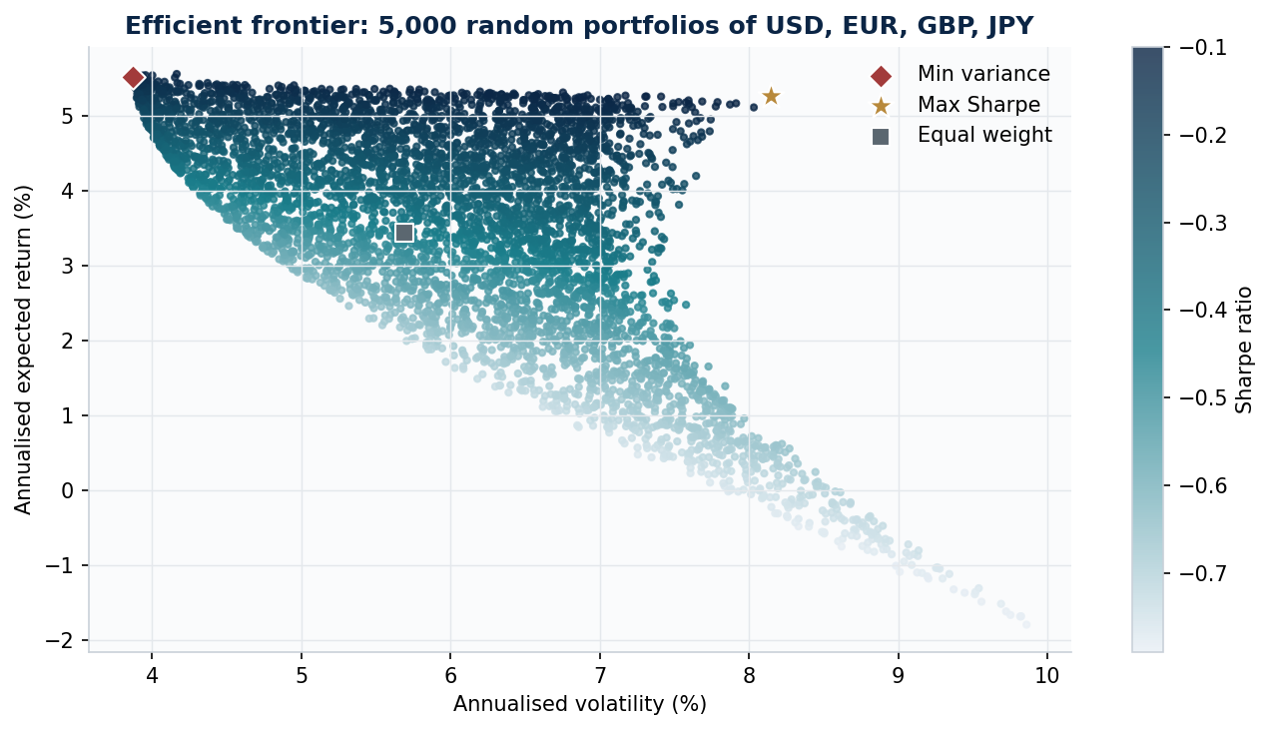
Figure 6. Random portfolios and the efficient frontier
What this means: The minimum-variance mix is mostly dollars (75.5%) with some euro and pound and no yen. Its volatility is 3.87%, which is lower than holding only dollars (4.33%), and its one-day VaR drops from 0.51% for equal weights to 0.35%. So diversification really does help here. The maximum-Sharpe result puts everything in the pound. That looks odd, and it is a known weakness: the optimiser leans hard on past average returns, and those are noisy. Since every Sharpe ratio is negative against the 6% benchmark, the so-called best portfolio is only the least bad. The minimum-variance answer is more trustworthy because it depends on the covariance matrix and not on guessed returns.

7. Financial text analytics
Prices are not the only information in markets, so a small text test was added. Sixteen rupee headlines, four for each pair, were scored with a short word list. A word like gains, strengthens or inflows adds one point, and a word like weakens, falls, slides or deficit takes one away. A positive score means the wording is good news for the rupee. These headlines were written for this exercise and are not real news, so the results only show that the method works.
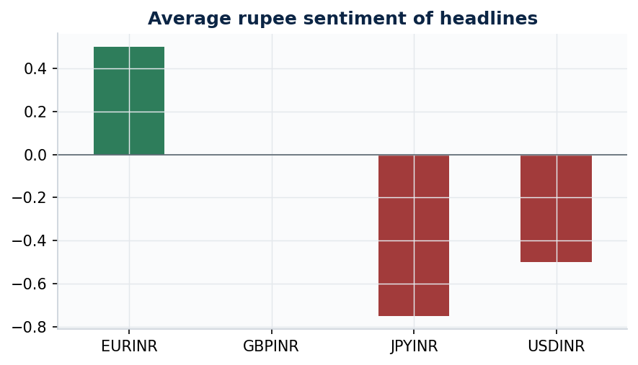
Figure 7. Average rupee sentiment of the sample headlines
What this means: The averages are +0.50 for EURINR, 0.00 for GBPINR, -0.50 for USDINR and -0.75 for JPYINR. With only four headlines per pair, nobody should read a market view into this. The word-list method also has an obvious flaw: it ignores context. The headline 'Yen slides and rupee rallies' scores zero because one bad word cancels one good word, although it is clearly good news for the rupee. Better tools would be the Loughran-McDonald finance dictionary or a trained model such as FinBERT, applied to real news from a proper source.

8. Live dashboard
To go with the analysis, a small website was built (website/index.html). It pulls the latest USD, EUR, GBP and JPY rates against the rupee from the free Frankfurter API and shows them as cards with a mini trend line. It also has tabs for the overview chart, moving averages, risk metrics, Markowitz portfolios and text sentiment, and a page that lists the report sections and the code. If the live feed cannot be reached, the page falls back to a saved copy of the RBI data so it still works. The dashboard uses about a year of data, so its numbers will differ a little from the five-year figures in this report.

9. Conclusions and limitations
- The rupee lost about 28 to 30% against the dollar, euro and pound in five years, while the yen lost 10.4% against the rupee.
- The dollar is the steadiest pair (4.3% volatility) and the yen the riskiest (10.4% volatility and a 23.4% maximum drawdown).
- Returns have fat tails and volatility comes in clusters, so a plain normal-distribution VaR would understate real tail risk.
- A mix that is mostly dollars gave the lowest risk (3.87% volatility). The euro and the pound are too similar to protect each other.
- Limits of the study: it uses past data only, one five-year window, a daily reference rate, an assumed 6% risk-free rate, and sample headlines instead of real news.

10. Responsible-AI and reproducibility declaration
Use of AI: An AI assistant (Claude, by Anthropic) was used to help set up the project structure, draft the Python code, build the dashboard and write a first draft of this report. [Edit this paragraph so it describes exactly what you did yourself and what you changed or checked.] The code was run, the outputs were compared with the data, and the results in this report come from that run.
Data: RBI reference rates supplied with the assignment, and live rates from the Frankfurter API (ECB reference rates). The headlines in data/sample_headlines.csv are illustrative only.
Reproducibility: the work uses Python 3 with pandas, NumPy, SciPy and Matplotlib (see requirements.txt). Running python src/forex_analysis.py from the project folder, or running every cell of the notebook, recreates all tables and figures. A short version of the code is in src/forex_analysis_simple.py. The random seed is fixed at 42. The printed results are also stored in outputs/Code_Output_Sheet.xlsx.
Academic integrity: I confirm that I understand the method and results in this report and that all sources and AI assistance are acknowledged here. Signature: __________ Date: __________

References
- Markowitz, H. (1952). Portfolio Selection. The Journal of Finance, 7(1), 77-91.
- Jorion, P. (2007). Value at Risk: The New Benchmark for Managing Financial Risk (3rd ed.). McGraw-Hill.
- Loughran, T. and McDonald, B. (2011). When is a liability not a liability? Textual analysis, dictionaries, and 10-Ks. The Journal of Finance, 66(1), 35-65.
- Reserve Bank of India. Reference rates (data file supplied with the assignment).
- Frankfurter API. Exchange rates based on European Central Bank reference rates. frankfurter.dev
- pandas, NumPy, SciPy and Matplotlib documentation.

