WEEK 3 TASK REPORT
Advanced Data Analysis and Visualization in Logistics
Hypothetical Logistics Dataset | Python-Based Exploratory Data Analysis

1. Introduction
This report presents an exploratory analysis of a hypothetical logistics dataset using Python. The objective is to examine shipment volumes, transportation distances, delivery times, transportation costs, delays, and customer ratings. The analysis demonstrates how descriptive statistics and visualizations can support data-driven decisions in logistics operations.

2. Objectives
- Define and simulate a realistic logistics dataset.
- Perform exploratory data analysis using central tendency, dispersion, distributions, and correlations.
- Create visualizations showing operational trends, cost patterns, and potential bottlenecks.
- Interpret the visualizations from an operational logistics perspective.
- Provide actionable recommendations for improving delivery efficiency and controlling transportation costs.

3. Dataset Description
The simulated dataset contains 120 shipment records. Each record represents one shipment and includes the shipment region, transportation mode, shipment volume, distance, delivery time, transportation cost, delay status, delay duration, and customer rating.
Variable | Type | Description
Shipment_ID | Categorical | Unique shipment identifier
Region | Categorical | North, South, East, or West
Transport_Mode | Categorical | Road, Rail, or Air
Shipment_Volume_kg | Numeric | Shipment weight in kilograms
Distance_km | Numeric | Transportation distance
Delivery_Time_days | Numeric | Delivery duration in days
Transport_Cost_INR | Numeric | Estimated transportation cost
Delayed | Categorical | Whether shipment was delayed
Delay_Days | Numeric | Number of delay days
Customer_Rating | Numeric | Customer rating from 1 to 5

4. Methodology
The workflow consisted of five stages: data simulation, data inspection, descriptive analysis, visualization, and interpretation. Pandas was used for data manipulation and aggregation, NumPy for numerical simulation, and Matplotlib for visualization. The generated data was checked for missing values and summarized using mean, median, standard deviation, minimum, and maximum values. Correlation analysis was then applied to the numerical variables to identify relationships that may be relevant to logistics performance.

5. Exploratory Data Analysis
The dataset contains 120 rows and 10 columns. No missing values were intentionally introduced in the simulated dataset. The numerical variables show substantial variation because shipment distance, volume, transportation mode, and delivery conditions differ between records.

5.1 Descriptive Statistics
Metric | Mean | Median | Std. Dev. | Minimum | Maximum | Unit
Shipment_Volume_kg | 267.28 | 264.0 | 144.67 | 21.0 | 500.0 | kg
Distance_km | 1005.74 | 981.0 | 540.94 | 54.0 | 1956.0 | km
Delivery_Time_days | 4.8 | 4.75 | 1.57 | 1.1 | 8.3 | days
Transport_Cost_INR | 60518.82 | 39704.5 | 67268.27 | 2500.0 | 383943.0 | INR
Delay_Days | 0.25 | 0.0 | 0.82 | 0.0 | 4.0 | days
Customer_Rating | 3.57 | 3.64 | 0.7 | 2.07 | 5.0 | 1–5
The average shipment volume is 267.3 kg and the average delivery time is 4.80 days. The mean transportation cost is approximately INR 60,519. The overall delay rate is 10.8%.

5.2 Transport Mode Analysis
Mode | Shipments | Avg Delivery (days) | Avg Cost (INR) | Avg Distance (km) | Delay Rate (%)
Air | 15.0 | 3.26 | 188629.0 | 1135.87 | 6.67
Rail | 31.0 | 6.44 | 40942.74 | 1181.77 | 9.68
Road | 74.0 | 4.42 | 42751.34 | 905.62 | 12.16
The mode-level summary allows the organization to compare speed, cost, distance, and delay exposure. Air shipments are expected to have shorter delivery times but higher unit costs, while road and rail can support larger or longer-distance movements at different cost and service levels.

6. Visualizations and Interpretation

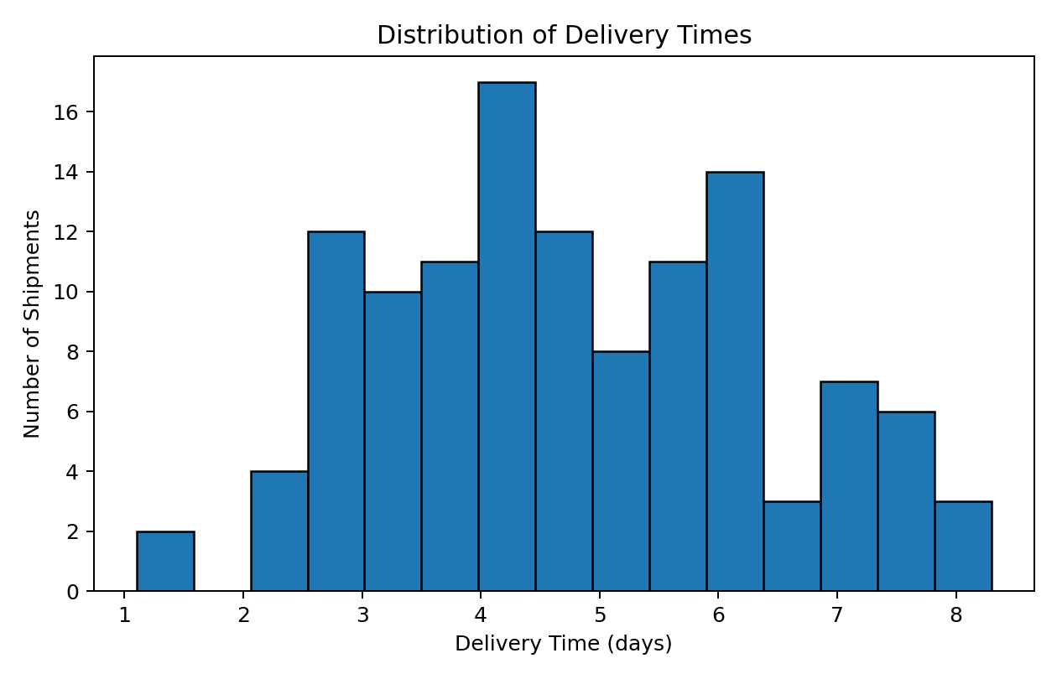
Figure 1. Distribution of Delivery Times
Interpretation: The histogram shows the distribution of delivery times. It helps identify the typical delivery range and whether a small number of unusually long deliveries may be contributing to service variability.
Why this visualization: A histogram is appropriate because delivery time is continuous and the objective is to examine frequency and spread.

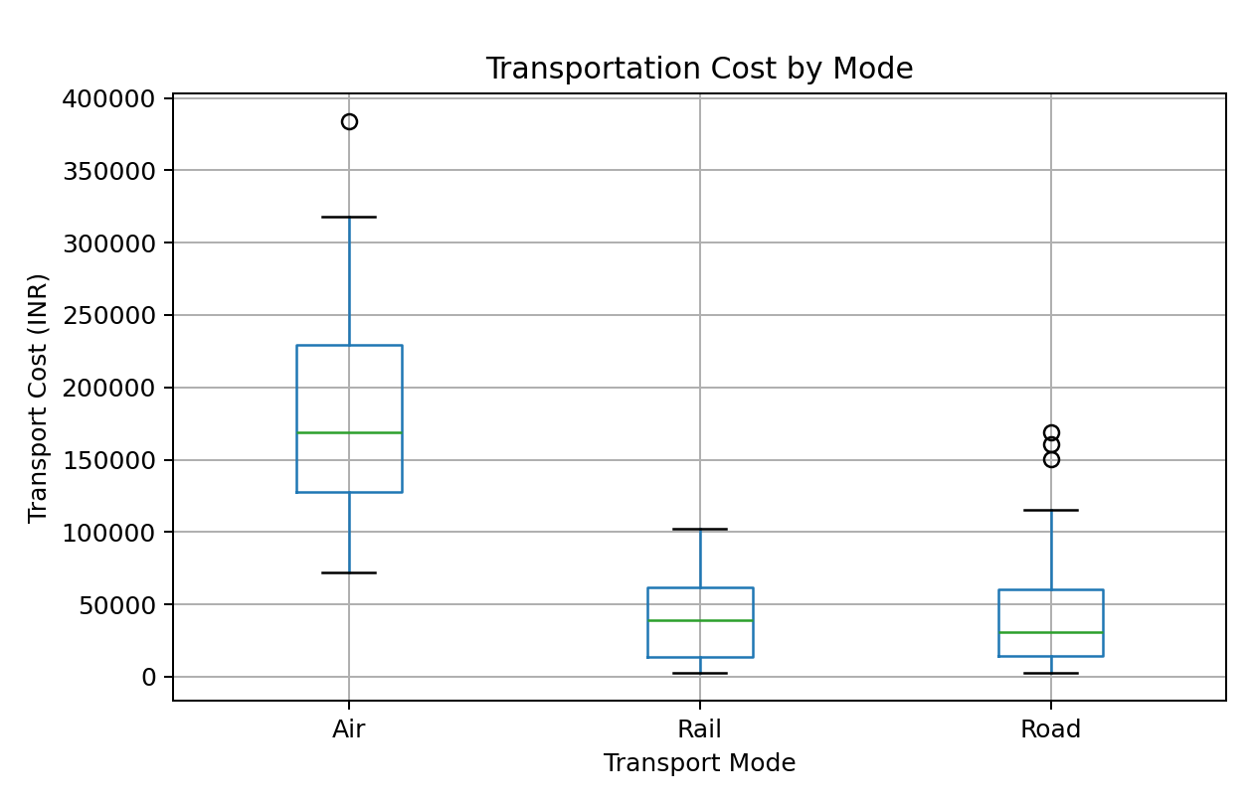
Figure 2. Transportation Cost by Transport Mode
Interpretation: The box plot compares transportation-cost distributions across modes. Differences in median cost and spread reveal whether a mode has consistently higher costs or more variable expenses.
Why this visualization: A box plot is useful for comparing distributions and identifying potential outliers.

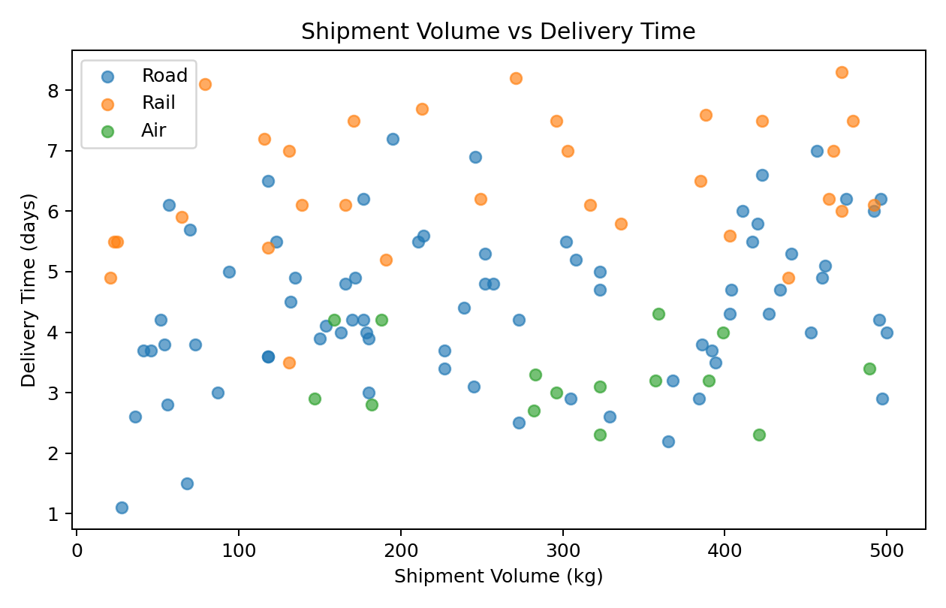
Figure 3. Shipment Volume vs Delivery Time
Interpretation: The scatter plot examines whether larger shipments are associated with longer delivery times. The separate mode markers make it easier to identify whether the relationship changes across transportation methods.
Why this visualization: A scatter plot is appropriate for examining relationships between two numerical variables.

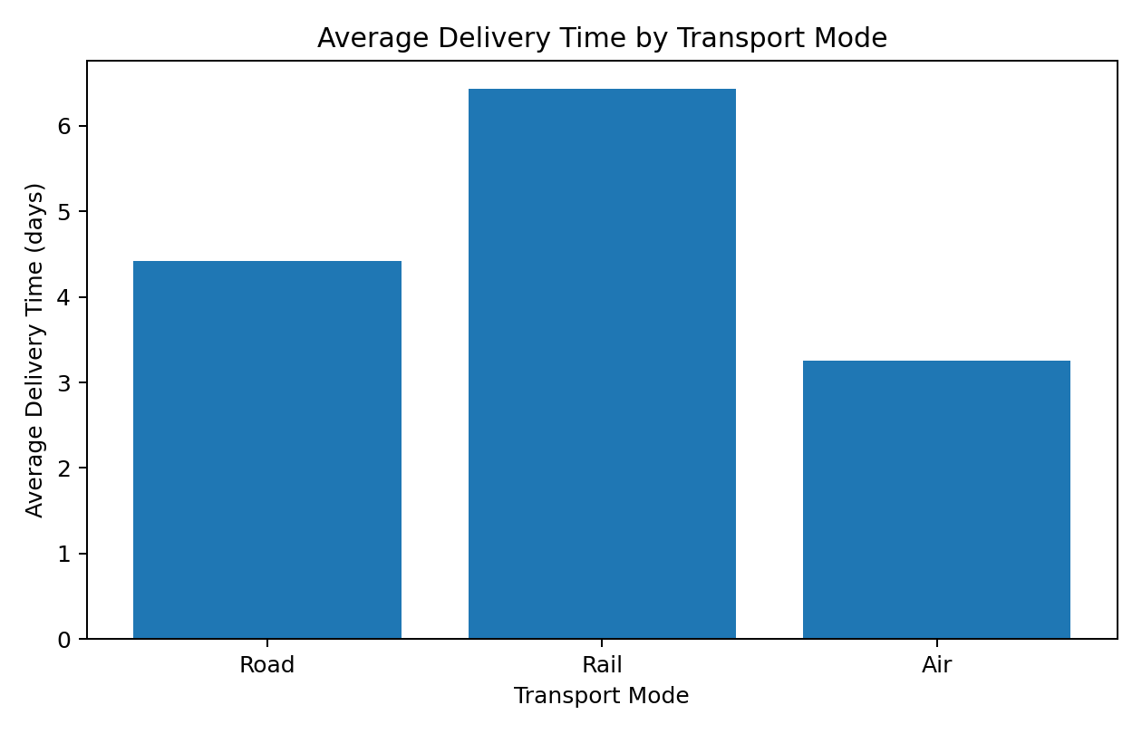
Figure 4. Average Delivery Time by Transport Mode
Interpretation: The bar chart compares average delivery time by transportation mode. It provides a direct operational comparison of service duration.
Why this visualization: A bar chart is suitable for comparing averages across discrete categories.

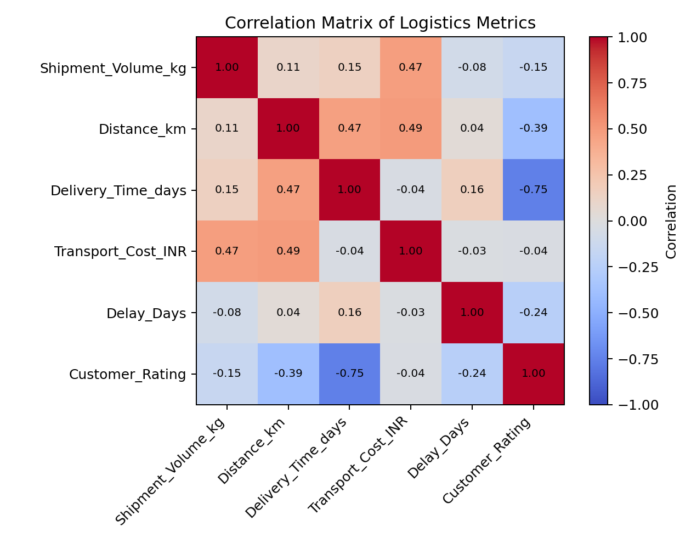
Figure 5. Correlation Matrix
Interpretation: The correlation matrix summarizes linear relationships among the main numerical metrics. Strong positive or negative values can highlight variables that deserve further operational investigation.
Why this visualization: A correlation matrix provides a compact overview of relationships across several numerical variables.

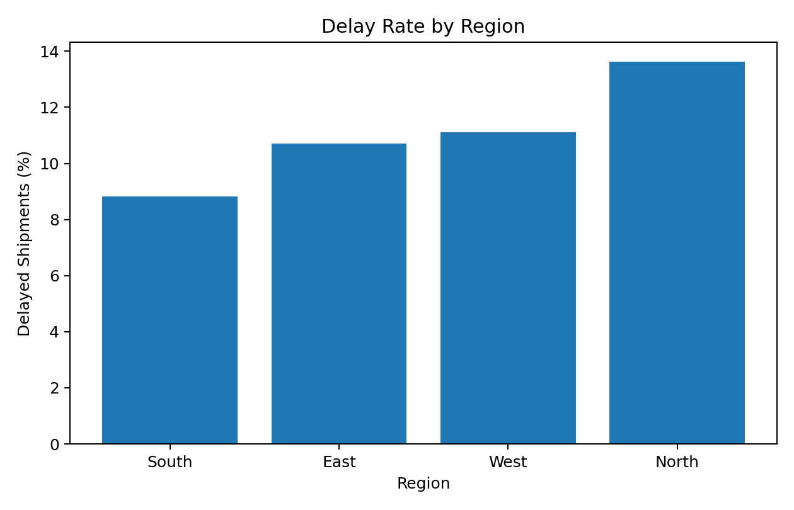
Figure 6. Regional Delay Rate
Interpretation: The regional delay chart highlights geographic variation in service reliability. Regions with higher delay rates can be investigated for route congestion, handoff problems, capacity constraints, or scheduling issues.
Why this visualization: A bar chart is appropriate because regions are categorical and the metric being compared is a percentage.

7. Key Analytical Insights
- Delivery performance varies across shipments, with an average delivery time of 4.80 days.
- The overall simulated delay rate is 10.8%, indicating that delay management is an important operational metric.
- Air has the lowest average delivery time in this simulation, while Air has the highest average transportation cost.
- North records the highest regional delay rate in the simulated dataset at approximately 13.6%, making it a candidate for route-level investigation.
- Shipment volume and distance should be considered together with transportation mode when planning capacity and delivery schedules.
- Cost analysis should distinguish between total shipment cost and service performance because a lower-cost option may have different delivery-time characteristics.

8. Potential Bottlenecks
- Long-distance shipments may require additional transit time and coordination between logistics nodes.
- High shipment volumes can create capacity pressure during sorting, loading, and transportation stages.
- Regional differences in delay rates may indicate route-specific or facility-specific operational constraints.
- Transportation-mode selection can create a trade-off between delivery speed and transportation cost.

9. Recommendations
- Monitor delivery-time distributions weekly and investigate shipments in the upper tail of the distribution.
- Use transportation-mode comparisons when selecting routes, balancing cost requirements with required service levels.
- Create regional delay dashboards so operations teams can identify recurring bottlenecks.
- Use shipment-volume information for capacity planning and peak-period resource allocation.
- Track transportation cost together with delivery time and delay rate rather than using cost alone as the optimization metric.
- Extend the analysis with real historical data, seasonal variables, fuel prices, warehouse processing time, and route-level information before making operational decisions.

10. Python Code Used
import pandas as pd
import numpy as np
import matplotlib.pyplot as plt
# Load the logistics dataset
df = pd.read_csv("hypothetical_logistics_dataset.csv")
# Basic EDA
print(df.shape)
print(df.head())
print(df.isnull().sum())
# Descriptive statistics
print(df.describe())
# Group analysis
print(df.groupby("Transport_Mode")[
["Delivery_Time_days", "Transport_Cost_INR"]
].mean())
# Distribution
plt.hist(df["Delivery_Time_days"], bins=15, edgecolor="black")
plt.xlabel("Delivery Time (days)")
plt.ylabel("Number of Shipments")
plt.title("Distribution of Delivery Times")
plt.show()
# Relationship analysis
plt.scatter(df["Shipment_Volume_kg"], df["Delivery_Time_days"])
plt.xlabel("Shipment Volume (kg)")
plt.ylabel("Delivery Time (days)")
plt.title("Shipment Volume vs Delivery Time")
plt.show()
# Correlation analysis
print(df[["Shipment_Volume_kg", "Distance_km",
"Delivery_Time_days", "Transport_Cost_INR",
"Delay_Days", "Customer_Rating"]].corr())

11. Conclusion
This Week 3 analysis demonstrates how Python-based exploratory data analysis can convert logistics records into operational insights. Descriptive statistics summarize the central tendency and variability of shipments, while the visualizations reveal delivery-time patterns, cost differences, relationships between shipment characteristics, and regional delay variation. The analysis also shows why logistics decisions should consider multiple performance indicators simultaneously. For a production environment, the same workflow can be extended with real shipment history, route information, warehouse processing times, fuel costs, seasonal demand, and service-level targets.

12. Deliverables Included
- Detailed written analysis and methodology.
- Six embedded logistics visualizations.
- Descriptive-statistics and transport-mode tables.
- Python code excerpts used for analysis and visualization.
- Analytical insights, bottlenecks, and recommendations.
- Generated hypothetical CSV dataset for reproducibility.

End of Report

