CONSULTADD

LINUX ASSIGNMENT

110 Wall Street,

New York, NY 10005

United States

QUESTIONS

- If we are in the directory X and we are running rmdir X being in that directory X. Will this command successfully removes the directory or not.
Answer 1:
No, the command will not run. It will give the following error:

- What are daemons?
A daemon is also known as a background process. It is a LINUX or UNIX program that runs in background. Almost all daemons have names that end with the letter "d". For example, httpd the daemon that handles the Apache server, or, sshd which handles SSH remote access connections. Linux often start daemons at boot time.

- What are the different modes when using VI editor?

1)Command mode:
-This is the default mode where you can pass the commands to act on the text, using most of the keys of the keyboard
-You can switch to this mode using “Esc” key

2)Insert (Input) mode:
- To enter the text, you have to enter into input mode
-Press the key “i” to enter into insert mode from command mode
-You can switch to command mode by pressing “Esc” key

3)ex mode or line mode:
-You have to save your file or switch to another file or make a global substitution in the file
-You then have to use ex mode, where you can enter the instruction in the last line of the screen
-To enter into this mode, press “Esc” key followed by “:”

- What is a grep command?

The grep filter searches a file for a particular pattern of characters, and displays all lines that contain that pattern. The pattern that is searched in the file is referred to as the regular expression (grep stands for globally search for regular expression and print out).

- What are the contents of /usr/local?

The /usr/local hierarchy is for use by the system administrator when installing software locally.
- How cd ~, cd / and cd - are different from each other?
cd ~ : Bring you to your home directory
cd / : Takes you to the entire system’s root directory
cd - : Brings you to your previous directory of the current directory.

- Which command is used to display the path of the current working directory?
PWD

- What is the command to run a program with elevated permissions?
Answer:
Sudo, the one command to rule them all. stands for “super user do” .

- How to switch to superuser (root) with elevated permissions?

sudo su – will make you the root user and load your custom user environment variables.

- Which command to switch to the root user?

sudo

- Which command is used to switch from superuser to normal user?

Sudo su

- Which command is used to clear the terminal?
Ctrl + L

- Which command is used to create multiple directories simultaneously?
mkdir dir1 dir2 dir3

- Which command is used to move to parent directory?

cd . .

- Which command is used to clear the terminal?

Ctrl + L

- Which command is used to create multiple directories simultaneously?
mkdir dir1 dir2 dir3

- Which command is used to move to parent directory?
cd . .

- Which command is used to display the contents of subdirectories?
ls

- Which command is used to display the list of content in reverse order?
ls -r

  - Which command is used to display the contents of the parent directory?
ls . .

- How to remove directory along with subdirectories?

rm –r directoryname
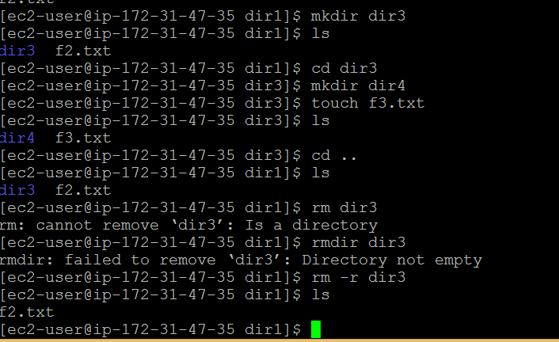
QUESTIONS

- How to move multiple files of the same extension to a different directory?
we use mv command to move files.
Regular expression used here is *.yourextension
Provide the path where you want to move it.

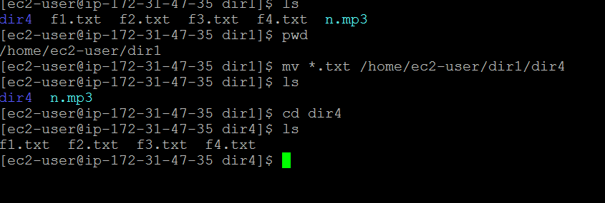

- Which command is used to list the name of files starting from any particular alphabet or string?
ls followed by regular expression.
ls abc*

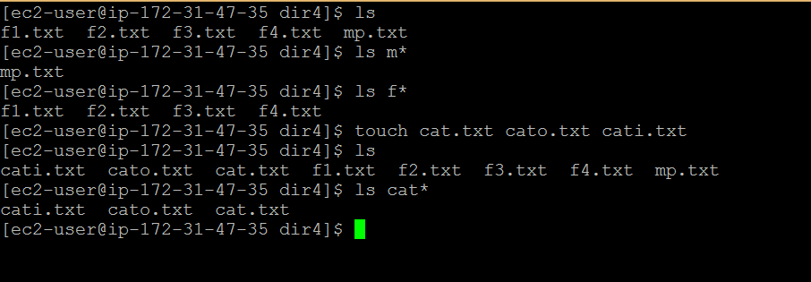

- How to move multiple files of the same extension to a different directory?
We use mv command to move files.
Regular expression used here is *.yourextension
Provide the path where you want to move it.

- What command is used to change the ownership of a file?

The chown command is used to change the owner and group of files, directories and links.

- How to delete a directory forcefully?
rm –rf
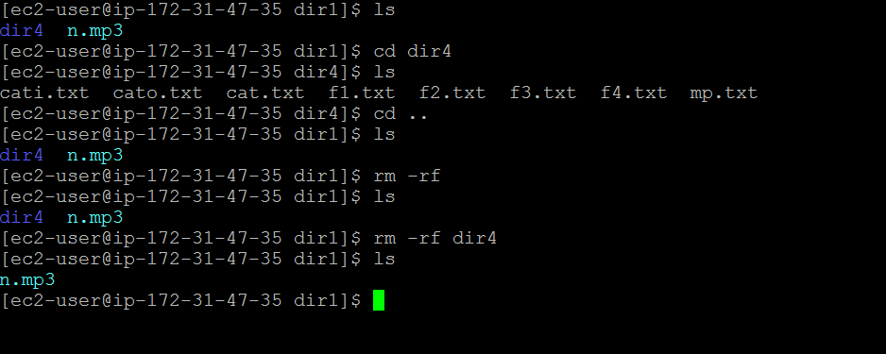

- How to forcefully stop a process which is running in the background?
SIGKILL stands for Kill signal. This signal causes the immediate termination of the process by the Linux kernel. Programs cannot listen for this signal.

- Which command is used to display the current username?
echo $USER

- How to determine the type of a file?
file filename.extension
press enter
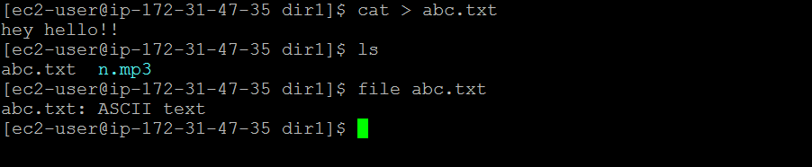

- Which command is used to create a new empty file?
touch filename

- Which command is used to display all the file names along with their types of the current directory?

Ls –l
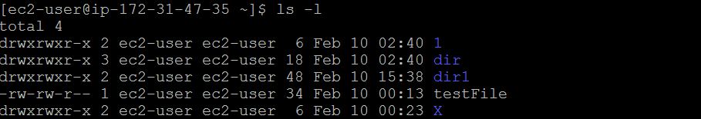

  - Which command is used to display all the file names along with their types of different directory?
Ls –R
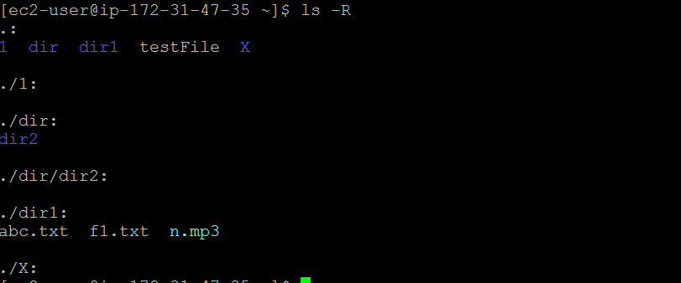

- How to delete a directory recursively i.e. it asks before the deletion on subdirectories?
rm –ri directoryname
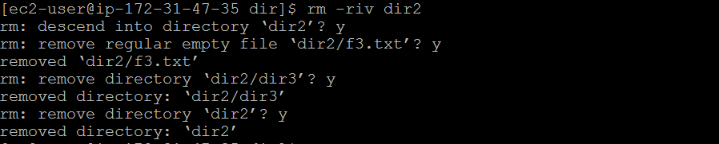

- Which command shows the users that are logged in?
who

Which command is used to rename the file?
To rename a file or directory, use the mv command.
To rename a file with mv, the third word on the command line must end in the new filename.
mv original_name new_name
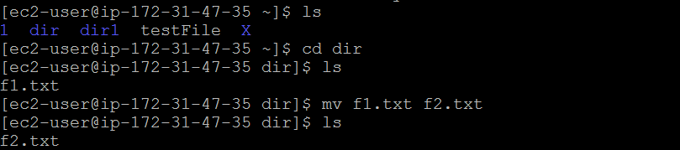

- What is the difference between mv and rename?
- rename cannot move files to another directory or drive, move can.
- rename cannot overwrite existing files, move can (using the /y parameter).
- Rename can rename multiple files at once
rename very-long-name.c *.cpp

- If you want to move a file and you use rename, you'll have to put the same name in twice.
move MyFile.txt MyFolder
rename MyFile.txt MyFolder\MyFile.txt

- Use the mv command to move files and directories from one directory to another or to rename a file or directory. If you move a file or directory to a new directory without specifying a new name, it retains its original name.

- Which command is used to change the permissions of a file?
The chmod command is used to change the permissions of a file or directory.
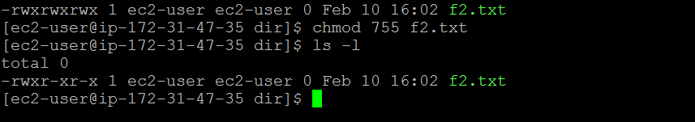

- What command is used to show how long it's been since the server was rebooted?
Last reboot or
Who -b

- What command is used to get the IP addresses of all interfaces on a server?
QUESTIONS

- What command is used to change your password?

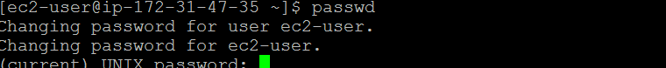

$passwsd

- What command is used to check whether manual page exists or not ? Also where it exists?
Man – to check manual page
Man –w path where it exists.

- How these commands would be working try and explain (files contain “hello” word) :

grep -v -i hello file1.txt

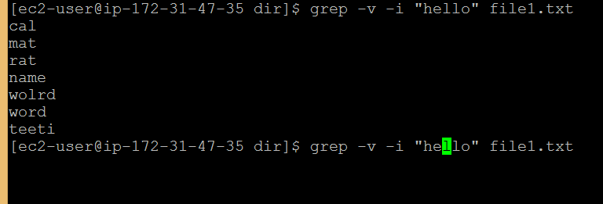

grep -i hello file2.txt :
Case insensitive search
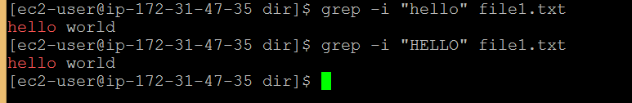

grep -A 2 hello file2.txt : prints the specified N lines after the match as shown below 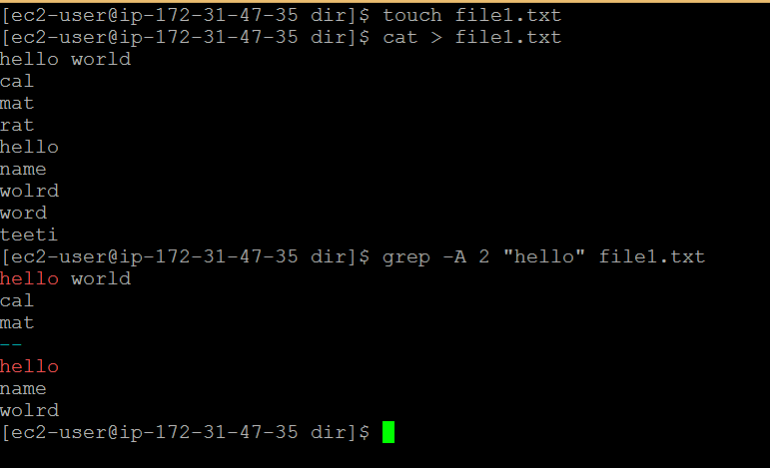

grep -C 4 hello file1.txt : shows N lines in both the side(before & after) of match 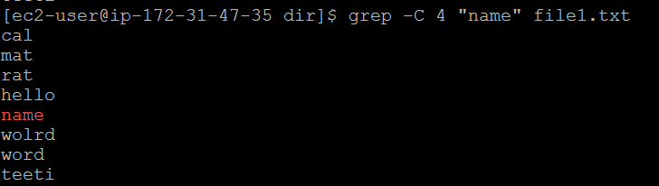

grep -B 3 hello file1.txt : prints the specified N lines before the match 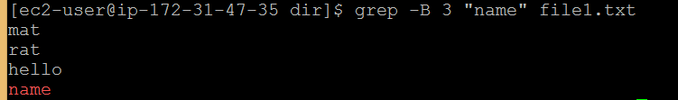

ps -ef | more 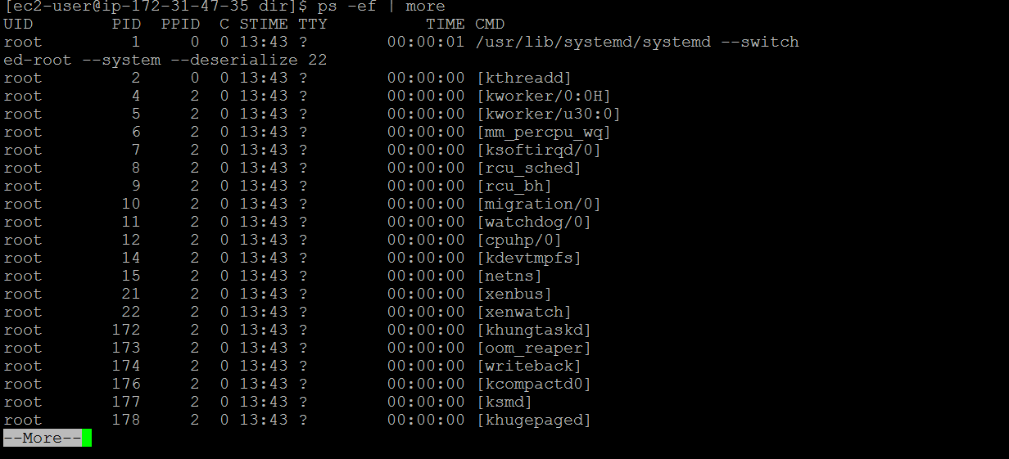

awk '{print $2,$5;}' employee.txt
Awk command programming language requires no compiling, and allows the user to use variables, numeric functions, string functions, and logical operators.
these are statements that define text patterns that are to be searched for in each line of a document and the action that is to be taken when a match is found within a line. Awk is mostly used for pattern scanning and processing.
It searches one or more files to see if they contain lines that matches with the specified patterns and then performs the associated actions
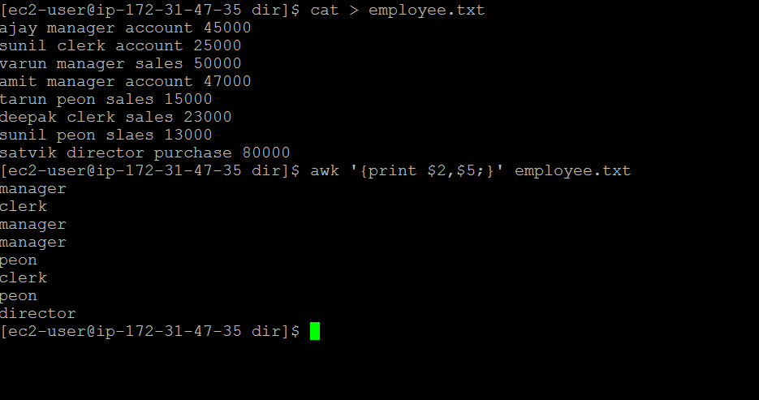

- Practice the following commands:

Shutdown :shutdown command shuts down or reboots the system.

Diff : This command is used to display the differences in the files by comparing the files line by line.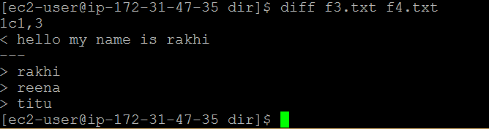

Sort
SORT command is used to sort a file, arranging the records in a particular order. By default, the sort command sorts file assuming the contents are ASCII. Using options in sort command, it can also be used to sort numerically.
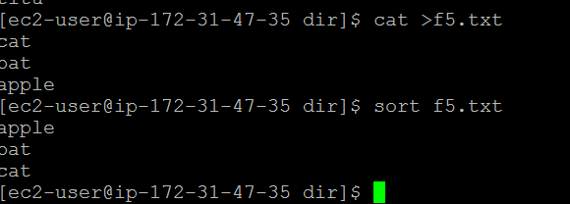

ps 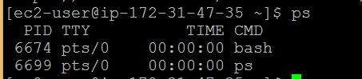

kill
kill command in Linux (located in /bin/kill), is a built-in command which is used to terminate processes manually. kill command sends a signal to a process which terminates the process.
mount 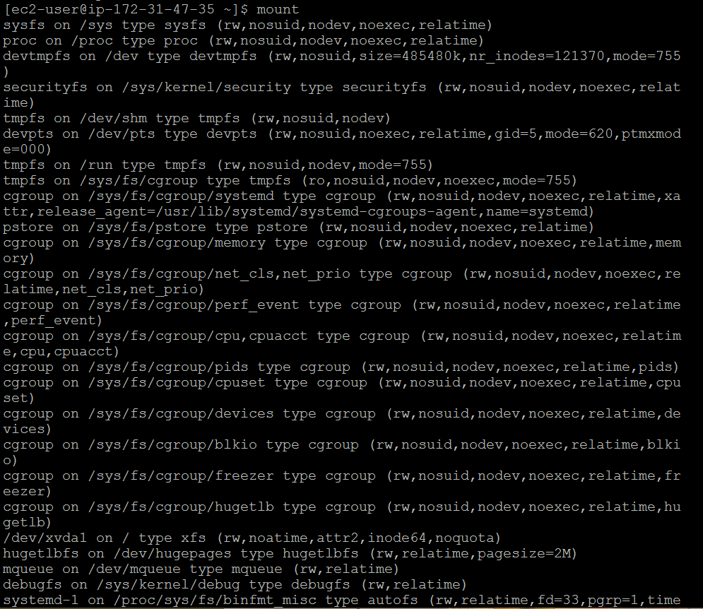

nano 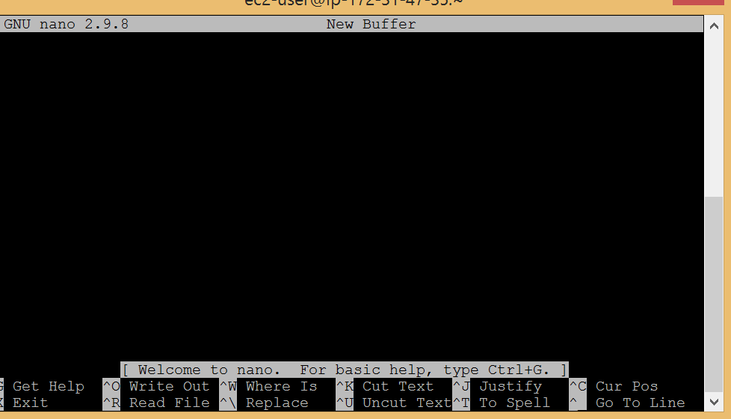

- How to find where a file is located in Linux?
find –iname “ name of the file”

- What does echo command do?
Echo is a Unix/Linux command tool used for displaying lines of text or string which are passed as arguments on the command line.
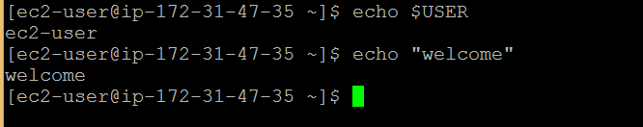

Declare a variable and substitute its value
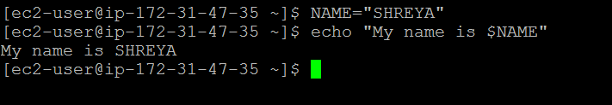

06

NOTE


The last date for submission of assignments is TOMORROW.

APPRECIATED

