VIRTUAL INTERNSHIP
WEEK 4 FINAL REPORT
COMPREHENSIVE DATA ANALYSIS,
REPORTING AND PRESENTATION
Adult Census Income Dataset
Integrated Review of Data Cleaning, Visualization & Predictive Modeling

Submitted by | Shreya Verma
Program | B.Tech – Electronics & Communication Engineering (ECE)
Institute | Institute of Technical Education and Research
University | Siksha 'O' Anusandhan
Internship / Training Program | YUVA Internship
Week | Week 4 – Final Integration
Software / Dataset | R / RStudio | Adult Census Income Dataset

Academic Year: 2026

Table of Contents
Section | Page
1. Introduction | 3
2. Project Objective and Scope | 3
3. Dataset Overview | 4
4. Integrated Analytical Workflow | 4
5. Data Preparation and Cleaning – Week 1 | 5
6. Exploratory Analysis – Week 1 | 6
7. Data Visualization and Insight Communication – Week 2 | 7
8. Statistical Analysis – Week 3 | 10
9. Predictive Modeling – Week 3 | 11
10. Model Evaluation | 12
11. Model Diagnostics | 13
12. Integrated Findings and Impacts | 14
13. Challenges and Solutions | 15
14. Lessons Learned | 16
15. Recommendations and Future Directions | 16
16. Overall Conclusion | 17
17. Appendix – Selected R Code | 18

1. Introduction
This Week 4 report consolidates the complete four-week analytical journey performed on the Adult Census Income dataset using R and RStudio. The work began with data cleaning and preprocessing, progressed through exploratory visualization and insight communication, and then advanced to statistical testing and binary logistic regression. The final stage brings these outputs together into one coherent data-driven narrative for both technical and non-technical readers.
The same dataset was deliberately retained across the internship so that each week could build on the previous stage rather than producing disconnected analyses. Week 1 established a usable analytical dataset, Week 2 translated patterns into visual evidence, and Week 3 tested relationships statistically and developed a predictive baseline. Week 4 therefore focuses on integration, interpretation, practical implications, challenges, lessons learned and future directions.

2. Project Objective and Scope
The overall objective was to examine demographic, educational, occupational, family and work-related characteristics associated with the income class of individuals and to demonstrate a complete R-based analytical workflow. The final report does not treat the model as proof of causation. Instead, it combines descriptive evidence, statistical evidence and predictive evidence to identify patterns and assess how well a baseline logistic regression can distinguish the two income classes.
- Prepare and clean the Adult Census Income dataset.
- Explore income patterns through descriptive analysis and visualization.
- Test selected relationships using statistical methods.
- Build and evaluate a binary logistic regression model.
- Translate technical findings into practical, clearly communicated insights.

3. Dataset Overview
The Adult Census Income dataset contains 32,561 observations and 15 variables. The target variable, income, has two classes: <=50K and >50K. The dataset combines numerical attributes such as age, education.num, capital.gain, capital.loss and hours.per.week with categorical attributes such as workclass, education, marital.status, occupation, relationship, race, sex and native.country.
Attribute | Description
Observations | 32,561
Variables | 15
Target | income: <=50K / >50K
Numerical | 6 variables
Categorical | 9 variables
Missing-value marker | '?' converted to NA during loading
The dataset was selected because it contains mixed data types, missing categorical values and a binary target, allowing the internship tasks to demonstrate cleaning, visualization, statistical analysis and predictive modeling in one consistent project.

4. Integrated Analytical Workflow
Stage | Main Work | Output
Week 1 | Cleaning & preprocessing | Cleaned, encoded and normalized datasets
Week 2 | Visualization & insight communication | 10 question-driven visualizations
Week 3 | Statistical analysis & modeling | Tests, logistic regression and diagnostics
Week 4 | Integration & reporting | Cohesive findings, impacts and recommendations
This staged workflow reduced the risk of interpreting raw data without preparation and made it possible to connect descriptive patterns with statistical and predictive results.

5. Data Preparation and Cleaning – Week 1
Week 1 established the foundation for the later analysis. The raw dataset was loaded in R with the '?' marker treated as missing. Structure, dimensions and sample records were inspected, and the original 15 columns were assigned descriptive names. Missing values were examined by variable and percentage.
Missing values were concentrated in categorical fields including workclass, occupation and native.country. The workflow preserved observations rather than simply deleting incomplete rows. Missing categorical values were represented through an explicit Unknown category in the cleaned modeling workflow. Exact duplicate rows were also checked, and numerical variables were screened for potential outliers using the 1.5×IQR rule.
Categorical variables were converted to factors for modeling, while numerical variables were normalized in the preprocessing stage. These steps produced cleaned, encoded and normalized versions of the dataset and created a reproducible foundation for later visualization and modeling. The Week 1 report specifically notes that the preprocessing stage was intended to prepare the data for later predictive work rather than establish causal conclusions. fileciteturn29file5L474-L480

Key Week 1 outputs
- 32,561 records and 15 original variables were confirmed.
- Missing categorical values were identified and handled.
- Potential numerical outliers were screened using the IQR method.
- Categorical encoding and Min-Max normalization were completed.
- Initial descriptive summaries and correlations were produced.

6. Exploratory Analysis – Week 1
The preliminary analysis showed clear descriptive differences between the income groups. The <=50K class represented 24,720 observations, while >50K represented 7,841 observations. Mean age, education level and working hours differed across the two groups, providing early evidence that these variables could be useful for later analysis.
The correlation analysis across selected numerical variables was generally weak, suggesting that the predictors did not simply duplicate one another through strong pairwise linear relationships. This was useful for moving from descriptive analysis to a more structured predictive model.

Interpretation
At this stage, the findings should be understood as associations rather than causal effects. The Week 1 report explicitly identifies the historical nature of the dataset and the binary income threshold as limitations, and notes that the fnlwgt field is a sampling weight rather than automatically an individual-level socioeconomic measure. fileciteturn29file13L1105-L1114

7. Data Visualization and Insight Communication – Week 2
Week 2 transformed the cleaned dataset into a set of question-driven visualizations. The visualization stage used RStudio with ggplot2 for the main charts and Base R for supporting calculations. The report included bar charts, histograms, boxplots, scatter plots, 100% stacked bar charts and a correlation heatmap. fileciteturn29file6L570-L580
The visual analysis examined income distribution, age distribution, age by income group, education level by income group, age versus working hours, occupation, working hours, marital status, sex and the correlation structure among numerical variables. The purpose was not simply to create charts, but to communicate patterns in a form that could be understood by both technical and non-technical audiences. fileciteturn29file6L606-L610
Figure 1. Selected visualization from Week 2
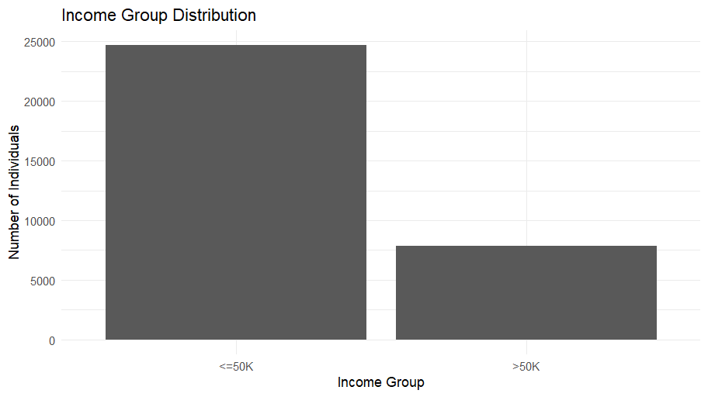
Figure 2. Selected visualization from Week 2
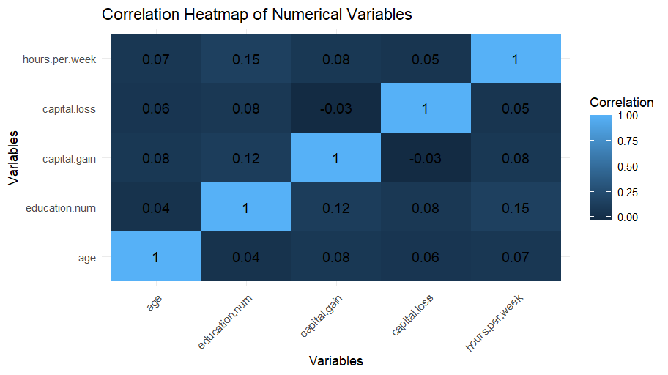
Figure 3. Selected visualization from Week 2
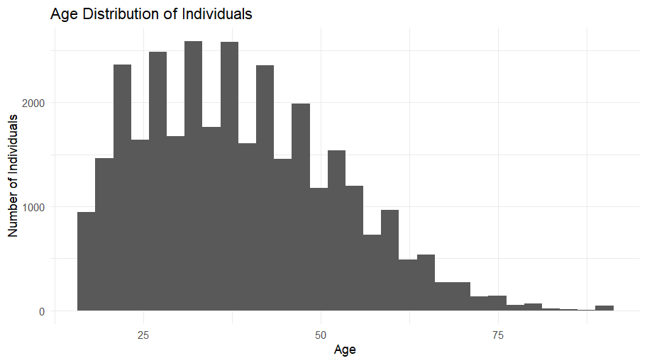
Figure 4. Selected visualization from Week 2
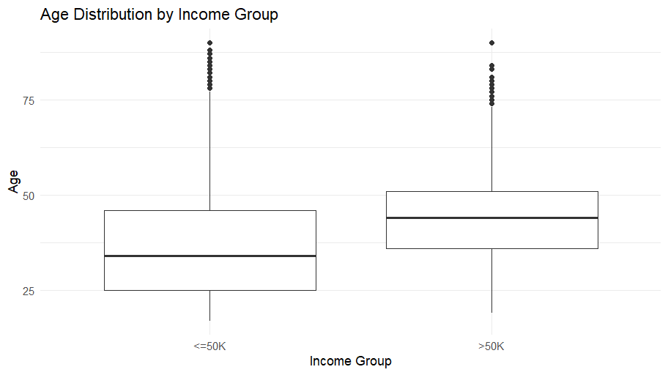
Across the visualizations, higher-income observations were generally associated with older ages, higher education levels and different distributions of working hours. Occupational and marital-status charts also showed that income composition varied substantially between categories. These visual patterns motivated the statistical tests and logistic regression model developed in Week 3.

8. Statistical Analysis – Week 3
Week 3 moved beyond visual patterns to formal statistical testing. A Welch two-sample t-test compared age between the two income groups. Mean age was approximately 36.78 years for <=50K and 44.25 years for >50K, with a very small p-value, supporting a statistically significant difference in mean age.
Pearson correlation between education.num and age was approximately 0.0365 with p-value 4.306e-11. Although statistically significant, the correlation was very weak, showing that statistical significance does not necessarily imply a strong practical relationship. A Shapiro-Wilk test on a sample of age observations rejected normality, which was considered alongside the robustness of the Welch test.

Why this matters
These tests strengthened the analysis by separating visual impressions from formal evidence. They also demonstrated an important analytical lesson: large datasets can produce statistically significant results for relationships that are still weak in practical magnitude. The Week 3 report records the Welch test, Pearson correlation and Shapiro-Wilk results as part of this progression. fileciteturn29file7L661-L674

9. Predictive Modeling – Week 3
A binary logistic regression model was developed to classify income as <=50K or >50K. Predictors included age, education.num, hours.per.week, capital.gain, capital.loss, workclass, marital.status, relationship, race and sex. Logistic regression was appropriate because the target was binary and the model provided interpretable coefficients and odds ratios.
The model indicated that age, education level, working hours and financial variables contributed to the predicted probability of belonging to the >50K class. Several categorical predictors also showed meaningful differences relative to their reference categories. Odds ratios were used to communicate these effects in an interpretable scale: values above 1 indicate higher odds relative to the reference, while values below 1 indicate lower odds, holding other predictors constant.
The model should be interpreted as a predictive baseline rather than a causal model. Relationships in census data can reflect many correlated social and economic factors, and the model does not establish that changing one predictor would directly cause income to change.

10. Model Evaluation
The final model was evaluated using a confusion matrix, accuracy, precision, recall, F1-score and ROC-AUC. Using the latest model state used for the Week 3 report, accuracy was approximately 84.03%, while the F1-score was approximately 64.16%. ROC-AUC was approximately 0.8924, indicating good separation between the two income classes.
Metric | Result | Meaning
Accuracy | 84.03% | Overall proportion classified correctly
Precision | 72.23% | Reliability of positive (>50K) predictions
Recall | 57.36% | Proportion of >50K cases detected
F1-score | 64.16% | Balance of precision and recall
ROC-AUC | 0.8924 | Overall ranking/discrimination ability
The main weakness is recall: the model misses a noticeable share of actual >50K observations. This matters if the practical objective prioritizes identifying higher-income cases rather than simply maximizing overall accuracy. The class imbalance observed in Week 1 provides an important context for interpreting this result.

11. Model Diagnostics
Cook's Distance was used to identify potentially influential observations. The common 4/n cutoff was applied as a screening rule. Although many observations exceeded the very small numerical cutoff, the largest Cook's Distance was still relatively small, so no single observation was treated as overwhelmingly influential.
Manual VIF analysis identified high values for several related categorical dummy variables, particularly marital.status and relationship. This reflects overlap among family and marital-status information and indicates that coefficient interpretation should be made cautiously. The model was retained as a useful baseline because these predictors carry meaningful information, but alternative modeling approaches could address multicollinearity more explicitly.

12. Integrated Findings and Impacts
- Income is substantially imbalanced toward the <=50K class, so accuracy alone is not sufficient for evaluating a classifier.
- Age and education show clear differences across income groups, with higher-income observations tending to be older and more educated in the descriptive analysis.
- Working hours and financial variables such as capital gain provide additional predictive information.
- Visualization made category-level differences visible, while statistical testing quantified selected relationships.
- Logistic regression provides an interpretable baseline with good overall discrimination (AUC ≈ 0.8924).
- Lower recall for >50K shows that the model's practical performance depends on the chosen classification threshold and business objective.
- High VIF values among related categorical variables suggest that coefficient-level interpretation should be treated cautiously.
- Cook's Distance did not identify one extremely dominant observation that would invalidate the model.

Practical / Business Implications
A data-driven income classification workflow can help analysts identify which attributes are most strongly associated with an income category and prioritize further investigation. In a real decision-support setting, the model could support segmentation, targeting or exploratory workforce analysis, but it should not be used as an automatic decision-maker without fairness, validation, current-data checks and domain-specific safeguards.

13. Challenges and Solutions
Challenge | What happened | Resolution
Missing categorical values | Missing-value markers had to be identified and converted to a usable representation rather than silently dropping records. | Missing categorical values were handled explicitly, including an Unknown category in the modeling workflow.
R session/object errors | Objects such as adult, train_data and logistic_model_final were not always available after session resets or script changes. | The workflow was rebuilt by running the required data-loading, preprocessing and model-building steps in sequence.
Package installation/network timeout | The pROC package could not be downloaded because CRAN downloads timed out. | ROC and AUC were calculated manually using probability thresholds and the trapezoidal rule.
Binary target modeling error | Logistic regression produced an error when the target was not coded as 0/1. | A binary income_binary variable was created with <=50K = 0 and >50K = 1 before fitting the model.
Multicollinearity | Several dummy variables had high VIF values. | VIF was explicitly checked and the limitation was documented rather than ignored.
Model interpretation | Accuracy alone did not fully describe performance because the target classes were imbalanced. | Precision, recall, F1-score and ROC-AUC were included alongside the confusion matrix.

14. Lessons Learned
- Data cleaning is not a separate preliminary chore; it directly affects every later result.
- Visualization is most useful when each chart answers a clear analytical question.
- Statistical significance and practical significance are different concepts.
- Model evaluation should include multiple metrics, especially when classes are imbalanced.
- R session state matters: reproducible scripts should be run in a controlled order so required objects exist.
- Interpretable models are valuable because coefficients and odds ratios can be communicated to non-technical audiences.
- Diagnostics such as VIF and Cook's Distance help identify limitations that performance metrics alone cannot show.
- Clear documentation and visual presentation are part of the analytical process, not an afterthought.

15. Recommendations and Future Directions
- Compare logistic regression with decision trees, random forests and gradient-boosting models.
- Use cross-validation for more robust model comparison.
- Investigate class weighting, resampling or threshold optimization to improve >50K recall.
- Consider regularized logistic regression to reduce instability from correlated predictors.
- Reassess categorical groupings and rare categories with domain justification.
- Evaluate fairness and subgroup performance before using any income-related classifier in a real decision setting.
- Use more recent and context-specific data if the goal is current population inference.
- Develop a concise dashboard or presentation layer for non-technical stakeholders.

16. Overall Conclusion
The four-week internship produced a complete R-based data-analysis workflow using the Adult Census Income dataset. Week 1 established the foundation through data inspection, missing-value handling, outlier screening, categorical encoding, normalization and preliminary analysis. Week 2 transformed the cleaned data into visual evidence and demonstrated how chart selection and annotation can improve insight communication. Week 3 extended the work through statistical testing, logistic regression, model evaluation and diagnostics.
The integrated results show consistent evidence that income class is associated with demographic, educational, occupational and working characteristics. The logistic regression model provided a strong baseline with approximately 84.03% accuracy and ROC-AUC of 0.8924, while recall highlighted the limitations created by class imbalance and the chosen classification threshold. VIF analysis also showed that related categorical predictors require cautious interpretation.
The main lesson from the complete project is that effective data analysis is a connected process: reliable cleaning supports meaningful visualization, visualization motivates statistical questions, statistical evidence informs modeling, and diagnostics determine how confidently model results should be interpreted. The final report therefore presents the project not as a collection of weekly tasks, but as one continuous analytical workflow from raw data to actionable insight.

17. Appendix – Selected R Code
The appendix contains representative code from the four-week workflow. The original weekly reports contain the complete scripts. The extracts below focus on the core operations used to reproduce the integrated analysis.

Dataset loading and naming
adult <- read.csv("adult.data.txt", header = FALSE,
na.strings = "?", strip.white = TRUE)

names(adult) <- c(
"age","workclass","fnlwgt","education","education.num",
"marital.status","occupation","relationship","race","sex",
"capital.gain","capital.loss","hours.per.week",
"native.country","income"
)

Missing-value handling
missing_values <- colSums(is.na(adult))
missing_percent <- round(
colSums(is.na(adult)) / nrow(adult) * 100, 2
)

Income distribution
income_counts <- table(adult$income)
income_percent <- round(prop.table(income_counts) * 100, 2)

Binary target creation
train_data$income_binary <- ifelse(
trimws(train_data$income) == ">50K", 1, 0
)

table(train_data$income_binary)

Logistic regression
logistic_model_final <- glm(
income_binary ~ age + education.num + hours.per.week +
capital.gain + capital.loss + workclass +
marital.status + relationship + race + sex,
data = train_data,
family = binomial
)

Confusion matrix and metrics
confusion_matrix <- table(
Actual = test_data$income,
Predicted = test_pred
)

accuracy <- (TP + TN) / (TP + TN + FP + FN)
precision <- TP / (TP + FP)
recall <- TP / (TP + FN)
f1_score <- 2 * (precision * recall) / (precision + recall)

Manual ROC and AUC
thresholds <- sort(unique(test_prob), decreasing = TRUE)

# Calculate TPR and FPR for each threshold,
# then apply the trapezoidal rule to obtain AUC.

Manual VIF
x <- model.matrix(
~ age + education.num + hours.per.week +
capital.gain + capital.loss + workclass +
marital.status + relationship + race + sex,
data = train_data
)[, -1]

# Regress each predictor on all remaining predictors
# and calculate VIF = 1 / (1 - R-squared).

17.1 Reproducibility Checklist
- Load the Adult Census Income dataset and assign the 15 descriptive column names.
- Convert '?' entries to NA and inspect missing values before modeling.
- Create cleaned, encoded and normalized datasets as required by the earlier weekly workflow.
- Create the binary target income_binary with <=50K = 0 and >50K = 1 before logistic regression.
- Run the Week 2 visualization code after loading the cleaned dataset.
- Run the Week 3 statistical tests, logistic regression, evaluation metrics and diagnostics in sequence.
- Save figures and outputs with descriptive names before inserting them into the final report.

17.2 Source-Code Organization
The complete working scripts are retained in the corresponding Week 1, Week 2 and Week 3 reports/files. This final Week 4 appendix presents the core reproducible code blocks used for the integrated workflow, while the weekly source files provide the full scripts and detailed intermediate commands.

