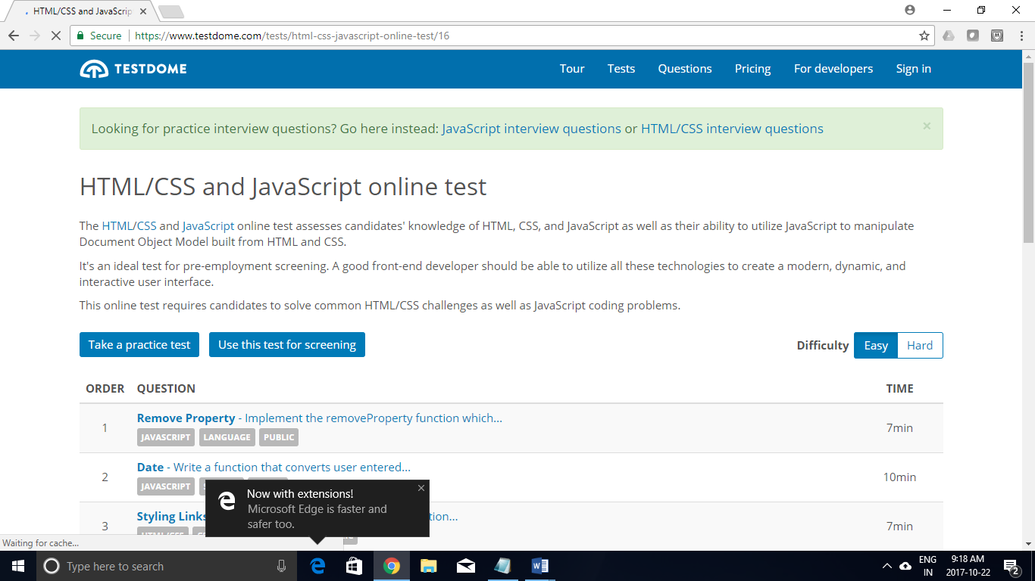

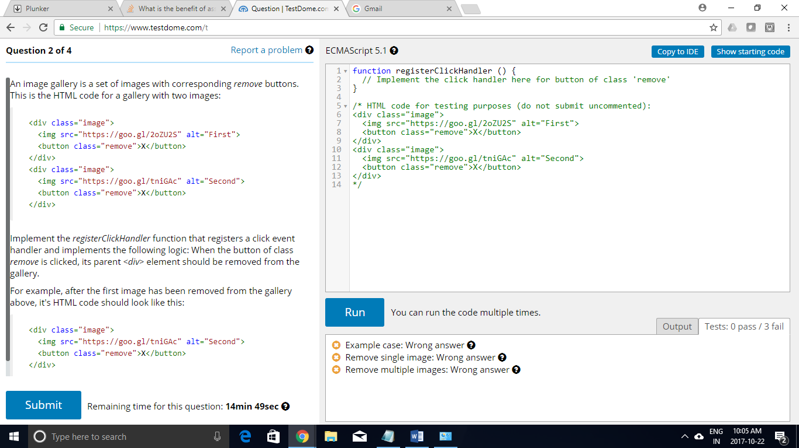

var registerClickHandler=function(){

var elements = document.querySelectorAll("div > button");

elements.forEach(function(e){

e.addEventListener("click",function(event){

event.srcElement.parentElement.remove();

});

});

};

JQUERY

var registerClickHandler=function(){

$(document).ready(function(){

$("div > button").click(function(){

$(this).parent().remove();

});

});

// var elements = document.querySelectorAll("div > button");

// elements.forEach(function(e){

// e.addEventListener("click",function(event){

// event.srcElement.parentElement.remove();

// });

// });

};

--------------------------------------------------------------------------------------------------------

<!DOCTYPE html>

<html>

<head>

<meta charset="utf-8">

<title>Company page</title>

<script src="script.js"></script>

</head>

<body>

<div class="image">

<img src="https://goo.gl/2oZU2S" alt="First">

<button class="Remove">X</button>

</div>

<div class="image">

<img src="https://goo.gl/tniGAc" alt="Second">

<button class="Remove">X</button>

</div>

<button onclick="registerClickHandler()">RegisterEvent</button>

</body>

</html>

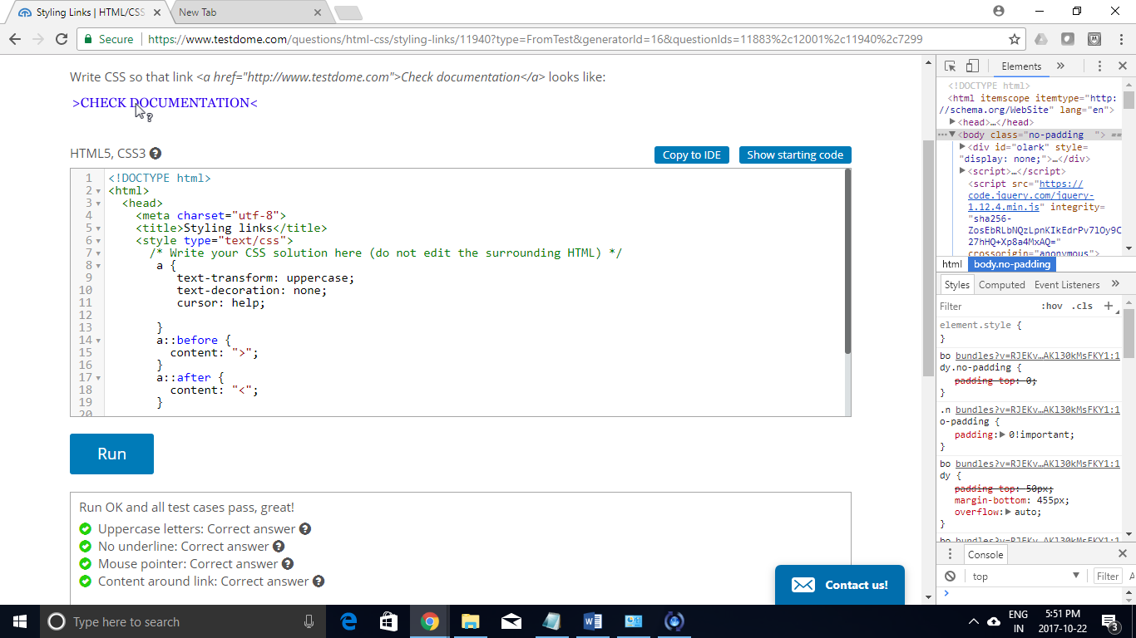

<!DOCTYPE html>

<html>

<head>

<meta charset="utf-8">

<title>Styling links</title>

<style type="text/css">

a {

text-transform: uppercase;

text-decoration: none;

cursor: help;

}

a::before {

content: ">";

}

a::after {

content: "<";

}

/\* Write your CSS solution here (do not edit the surrounding HTML) \*/

</style>

</head>

<body>

<a href="http://www.testdome.com">Check documentation</a>

</body>

</html>