
iNeuBytes Artificial intelligence internship

Consolidated Project Portfolio Report
Task 1 · Task 2 · Major Project
Prepared by: Avni Shukla
Registration No.: INBT021871
Course ID: AIINB10726
Task 1 — CIFAR-10 Image Classification with CNNs
Task 2 — Sentiment/Emotion Analysis: Classical ML vs. LSTM
Major Project — Reel Match: AI Movie Recommendation Web App

Introduction
This report brings together the three deliverables completed as part of the iNeuBytes AI/ML program: two guided tasks (image classification and sentiment analysis) and one independently built major project (a full-stack AI-powered movie recommendation web application). Each section below documents the objective, methodology, results, and key learnings for that project, so that the full body of work can be reviewed as a single, coherent portfolio.
 | Project | Domain | Core Techniques
1 | CIFAR-10 CNN Classification | Computer Vision | CNN, AlexNet-style baseline, BatchNorm, Data Augmentation
2 | Sentiment / Emotion Analysis | Natural Language Processing | TF-IDF, Logistic Regression, SVM, LSTM
3 | Reel Match — Movie Recommender | Full-Stack ML Deployment | TF-IDF + Nearest Neighbors, Flask API, Web Frontend

Task 1 — CIFAR-10 Image Classification with CNNs

1.1 Objective
This task documents the design, implementation, and evaluation of two Convolutional Neural Network (CNN) models trained on the CIFAR-10 dataset:
- Part A: A traditional CNN, adapted from the AlexNet architecture, established as a clean performance baseline.
- Part B: A customized CNN that measurably improves on the Part A baseline through targeted architectural and training changes.
Both models were trained and evaluated under identical conditions (same random seed, same train/validation/test split, same epoch budget) so that the comparison between them isolates the effect of the Part B changes rather than random variation.

1.2 Part A — Traditional CNN

Methodology
- Dataset: CIFAR-10 (60,000 32×32 colour images across 10 classes).
- Split: stratified train/validation/test split with a fixed random seed (SEED = 42), reused unchanged in Part B.
- Preprocessing: pixel values normalized to [0, 1]; labels one-hot encoded; no data augmentation, to keep this a clean baseline.
- Architecture: AlexNet-style CNN adapted for 32×32 inputs — increasing filter counts (64 → 128 → 256), 5×5 kernels in early blocks narrowing to 3×3, stride-1 same-padding convolutions, max-pooling for downsampling (32→16→8→4), and a large fully-connected head (512 → 256 → 10) with 0.5 dropout.
- Training: Adam optimizer (lr = 0.001), categorical cross-entropy loss, batch size 64, fixed epoch budget of 30 epochs.
- Success threshold: ≥ 70% test accuracy.

Results
Metric | Value
Total parameters | 3,326,602
Training time | 4.77 minutes
Epochs trained | 30
Test accuracy | 0.7020
Precision (macro) | 0.7043
Recall (macro) | 0.7020
F1-score (macro) | 0.7004
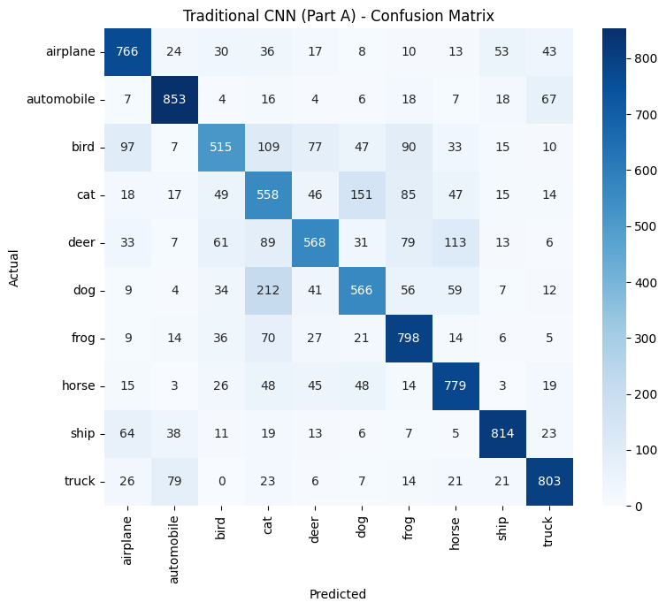
Figure 1.1 — Traditional CNN (Part A): Confusion Matrix
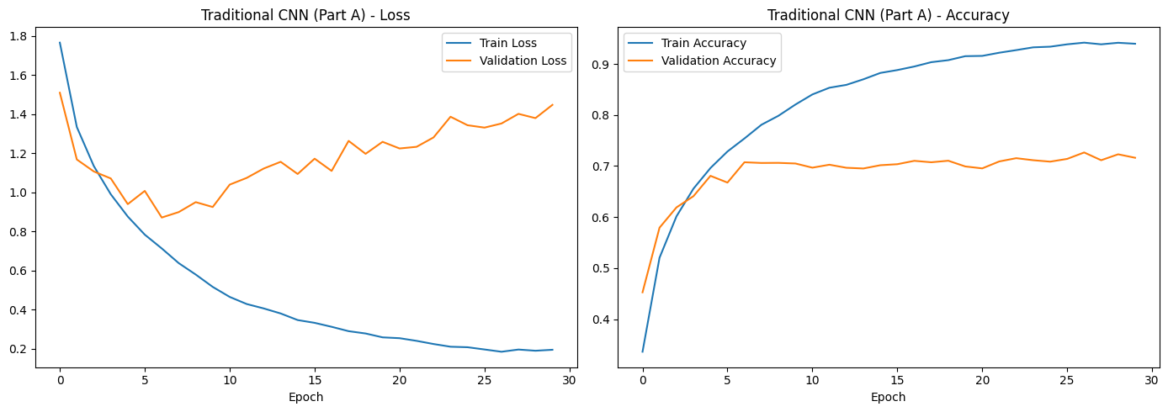
Figure 1.2 — Traditional CNN (Part A): Training/Validation Loss and Accuracy

1.3 Part B — Customized CNN

What Was Changed, and Why
- Extra convolutional block (4th block, 256 filters, no extra pooling): adds representational depth without shrinking the already-small 4×4 feature map further.
- All 3×3 filters instead of 5×5 in early blocks: stacked 3×3 convolutions approximate a larger receptive field with fewer parameters and an extra non-linearity (VGG-style insight).
- Batch Normalization after every convolution: stabilizes and speeds up training, mildly regularizes, and allows a higher effective learning rate.
- Dropout tuned per block (0.2 → 0.3 → 0.4 → 0.5): deeper layers have more parameters and are more prone to overfitting, so regularization is scaled with depth.
- Data augmentation (rotation, shifts, flips, zoom): increases effective training-data diversity, directly addressing overfitting rather than just adding capacity.
- Optimizer tuning (lower learning rate: 0.0005 vs 0.001): a deeper, batch-normalized network trained on augmented data benefits from smaller, more stable update steps.
- ReduceLROnPlateau callback: automatically lowers the learning rate once validation loss plateaus, letting the model fine-tune after coarse learning stalls.

Results
Metric | Value
Total parameters | 3,844,938
Training time | 8.78 minutes
Epochs trained | 30
Test accuracy | 0.8319
Precision (macro) | 0.8472
Recall (macro) | 0.8319
F1-score (macro) | 0.8313
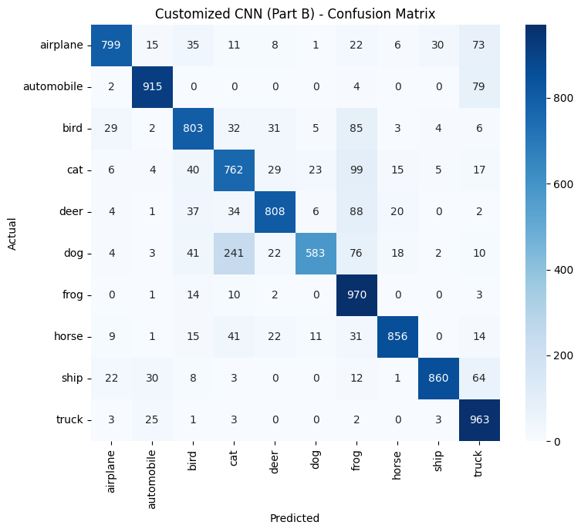
Figure 1.3 — Customized CNN (Part B): Confusion Matrix
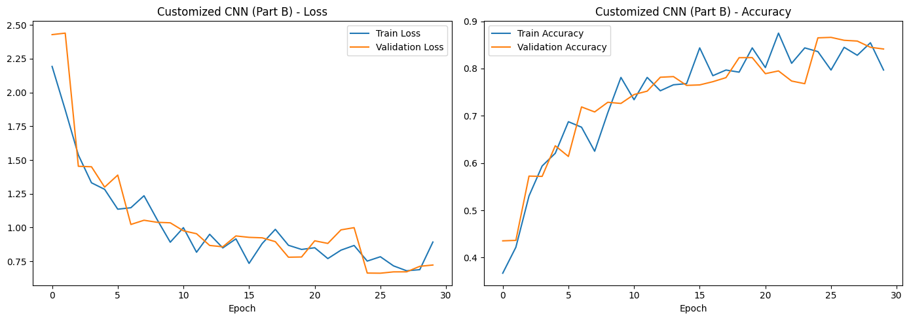
Figure 1.4 — Customized CNN (Part B): Training/Validation Loss and Accuracy

1.4 Comparison and Success-Threshold Check
Metric | Traditional CNN (A) | Customized CNN (B)
Test Accuracy | 0.7020 | 0.8319
Precision (macro) | 0.7043 | 0.8472
Recall (macro) | 0.7020 | 0.8319
F1-score (macro) | 0.7004 | 0.8313
Parameter Count | 3,326,602 | 3,844,938
Training Time (s) | 286.45 | 526.89
Accuracy gain (Part B − Part A): 12.99 percentage points, well above the ≥ 3.0 point target. Parameter count increased by 15.6% and training time increased by 83.9%.
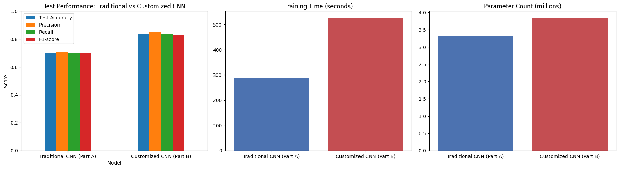
Figure 1.5 — Test Performance, Training Time, and Parameter Count: Traditional vs. Customized CNN

1.5 Why the Customized Model Performed Better
- Greater depth (an extra convolutional block) increases the model's representational capacity to learn more complex, hierarchical features from CIFAR-10 images.
- Batch normalization stabilizes training dynamics, allowing the network to train faster and more reliably, and provides a mild regularization effect on its own.
- Progressive dropout, scaled to each block's depth, more precisely targets overfitting where it is most likely to occur (deeper, higher-capacity layers) rather than only in the fully-connected head.
- Data augmentation exposes the model to a wider variety of transformed images (rotations, shifts, flips, zoom), improving generalization to the unseen test set — something the clean Part A baseline deliberately does not have.
- The lower, adaptively-decayed learning rate (ReduceLROnPlateau) allows finer convergence once the loss plateaus, which a fixed learning rate cannot do.
Because the same seed, data split, and epoch budget are used for both models, the accuracy gain is attributable to these architectural and training changes rather than to extra training time or an easier evaluation set.

1.6 Conclusion
The customized CNN beat the traditional baseline by 12.99 points (≥ 3.0 point target), for a 15.6% increase in parameters and 83.9% more training time. The accuracy gain justifies the added size and time cost.

Task 2 — Sentiment / Emotion Analysis: Classical ML vs. LSTM

2.1 Objective
- Part A: use traditional machine learning (TF-IDF + Logistic Regression + SVM) to perform sentiment/emotion analysis on a text dataset, establishing a classical baseline.
- Part B: implement an LSTM deep learning model and fairly compare it against the classical models from Part A, using the exact same train/test split and evaluation metrics.

2.2 Preprocessing Pipeline

Data Cleaning
- Lowercasing — all text converted to lowercase for consistency.
- Punctuation removal — all punctuation characters stripped using Python's string.punctuation table.
- Number removal — digit characters removed from the text.
- Emoji / non-ASCII removal — characters outside the ASCII range dropped.
- Extra whitespace removal — repeated/leading/trailing spaces collapsed to single spaces.

Tokenization
Cleaned text is split into individual word tokens using NLTK's word_tokenize, which handles punctuation-aware splitting more reliably than a plain .split().

Stopword Removal
Common English stopwords (from NLTK's stopword corpus, e.g. "the", "is", "and") are removed from the token list, since they carry little sentiment-discriminating information. The remaining tokens are re-joined into the final cleaned text used for feature extraction.

Class Distribution
Before modeling, the class distribution of the emotion labels is computed and plotted. Because the dataset is imbalanced across emotion classes, macro-averaged F1-score (rather than raw accuracy) is used as the primary metric throughout Part A and Part B, since it weights all classes equally regardless of size.

Fixed Train/Test Split
A single train_test_split call with test_size=0.20, random_state=42, and stratification by label is used to create the train/test sets. This exact split is reused unchanged for TF-IDF (Logistic Regression, SVM) and for the LSTM, so all three models are evaluated on identical, comparable data.

2.3 Architecture Diagrams
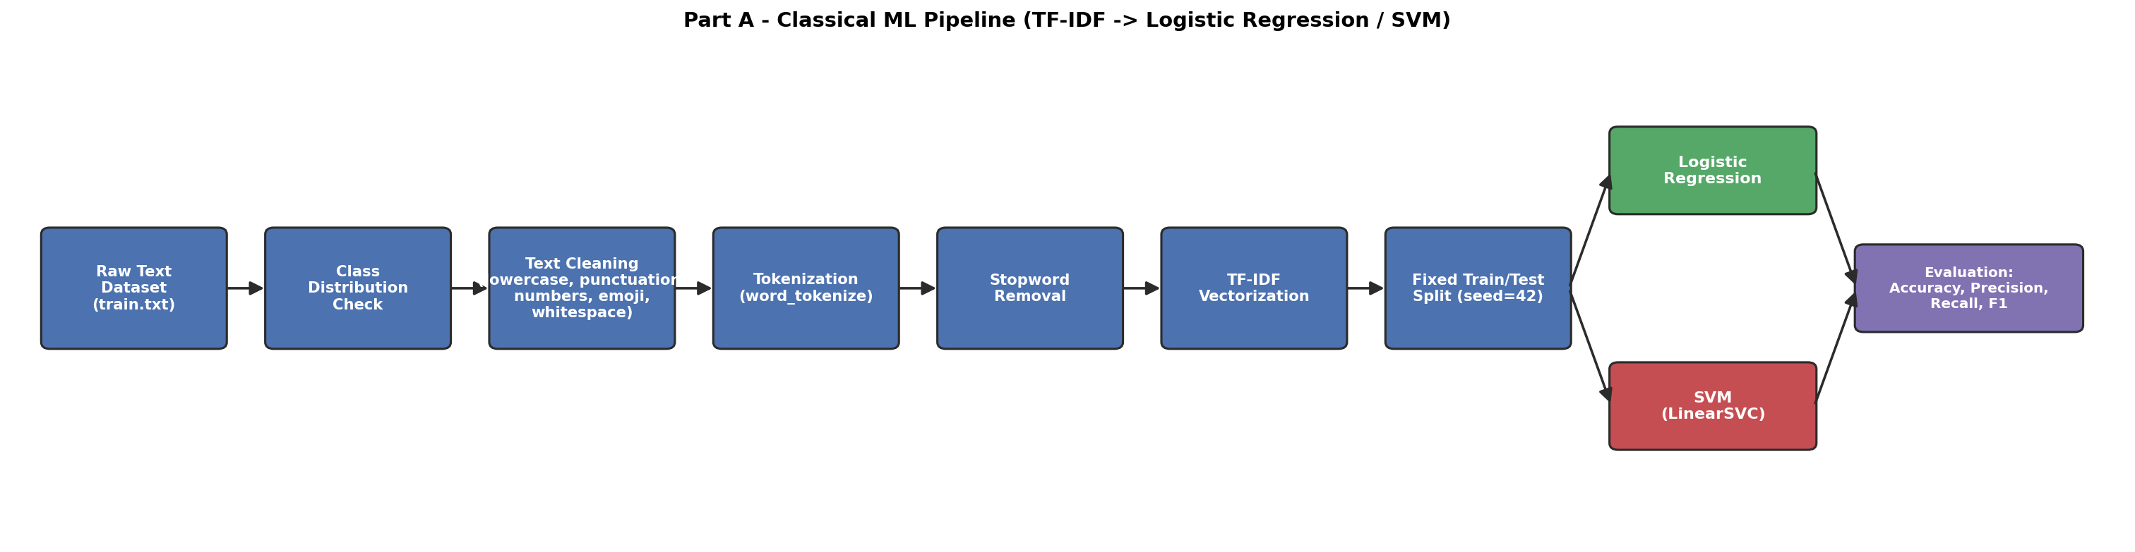
Figure 2.1 — Part A: Classical ML Pipeline (TF-IDF → Logistic Regression / SVM)
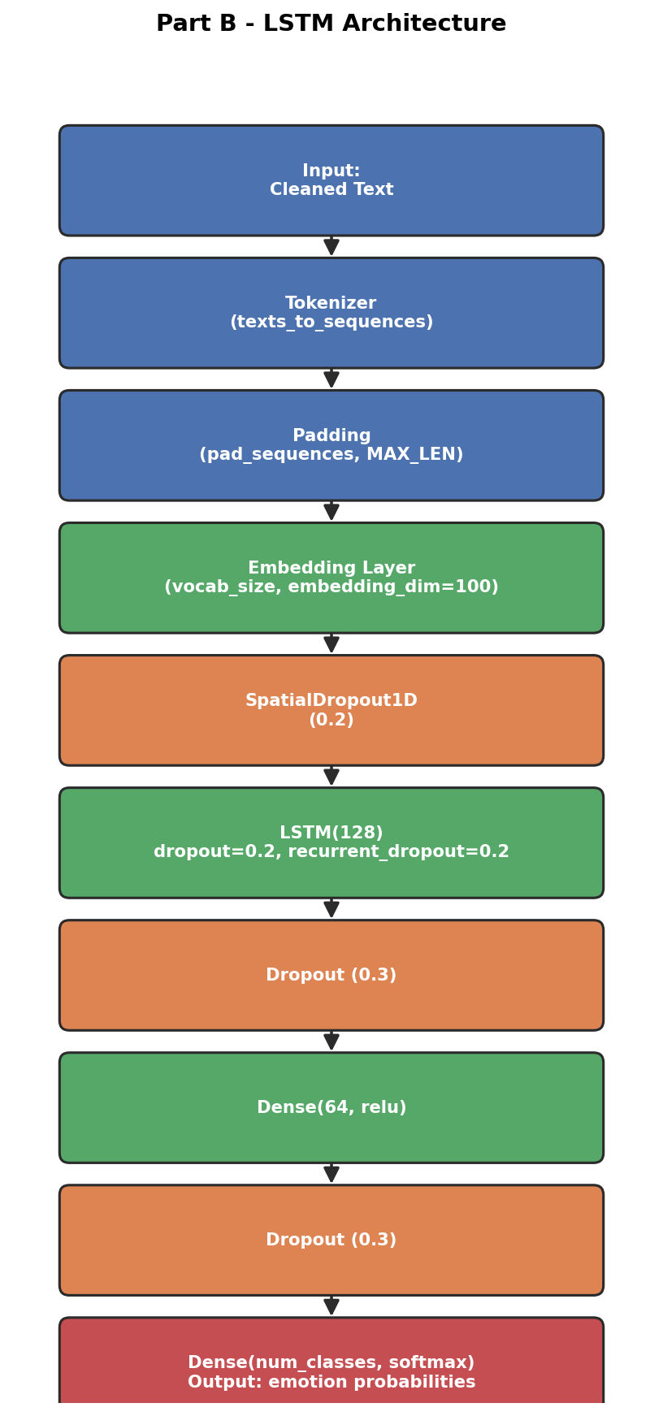
Figure 2.2 — Part B: LSTM Architecture

2.4 Performance Comparison — Logistic Regression vs. SVM vs. LSTM
Model | Accuracy | Precision (macro) | Recall (macro) | F1-score (macro)
Logistic Regression | 0.8509 | 0.8680 | 0.7427 | 0.7872
SVM (LinearSVC) | 0.8869 | 0.8750 | 0.8344 | 0.8527
LSTM | 0.8788 | 0.8251 | 0.8314 | 0.8240
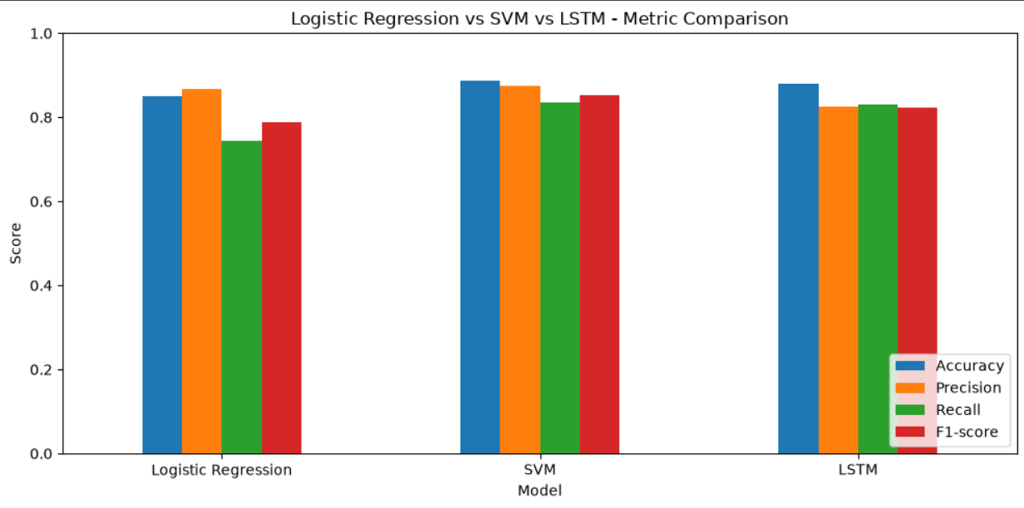
Figure 2.3 — Metric Comparison Across Models
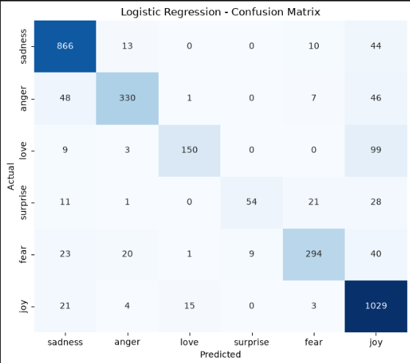
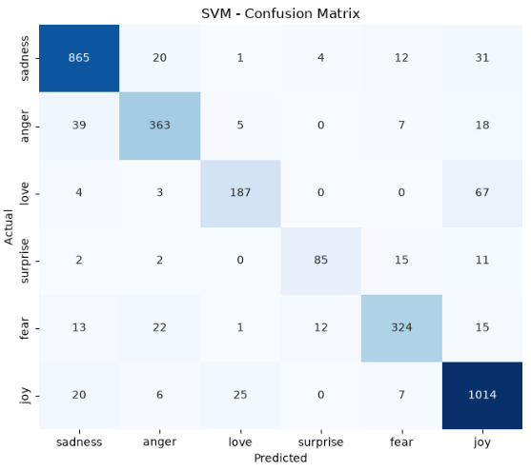
Figure 2.4 & 2.5 — Confusion Matrices (Logistic Regression, SVM)
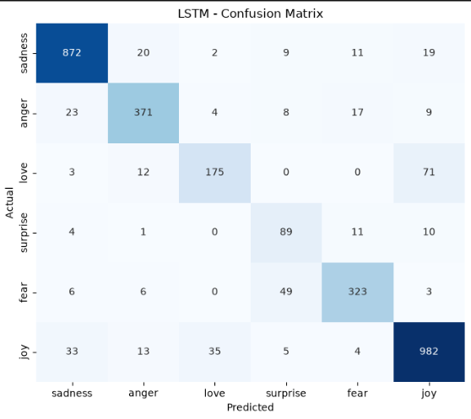
Figure 2.6 — Confusion Matrix (LSTM)

2.5 Discussion

Why LSTM Is Suitable for Text Data
Text is inherently sequential — the meaning of a word depends on the words around and before it (e.g. negation: "not good" vs. "good"). Unlike TF-IDF-based classical models, which treat text as an unordered bag of weighted word frequencies, an LSTM processes tokens in order and maintains a hidden state that carries context forward, so it can in principle capture word order, negation, and longer-range dependencies that TF-IDF discards.

How Sequential Learning Helps Sentiment Analysis
Sentiment is often modified or flipped by context ("not bad at all", "used to love it but…"). A recurrent model like LSTM updates its internal state token by token, so it can pick up on such patterns as they unfold across a sentence, whereas a bag-of-words model sees "not" and "bad" as independent, order-less features.

Did LSTM Improve Performance?
LSTM did not beat the best classical model — it trailed SVM by 0.0287 F1 points.

Why LSTM Did Not Beat the Classical Models
- Dataset size: LSTMs learn word embeddings and sequence patterns from scratch and are data-hungry; with only a few thousand short training examples there may not be enough data to learn a rich embedding space, whereas TF-IDF + Logistic Regression/SVM already gets strong, sample-efficient signal directly from word-presence weighting.
- Short, simple text: emotion-labelled sentences here tend to be short and lexically direct (a few strongly emotion-indicative words are usually enough), so the extra sequence-modeling capacity of an LSTM may not pay off.
- Training time / tuning budget: LSTMs typically need more epochs and careful hyperparameter tuning to reach their full potential; with a modest epoch budget and default hyperparameters, an LSTM often underperforms a well-tuned linear baseline.
- Insufficient data for deep learning to show its advantage: the theoretical strength of LSTMs — modeling long-range dependencies and word order — pays off most on longer, more syntactically complex text; on short, single-sentence inputs that advantage shrinks.
Recognizing when a simpler model wins is a key data-science skill — it is a valid, reportable outcome if the classical models match or beat the LSTM here, and does not indicate a flawed implementation.

Challenges Faced During Training
- Choosing MAX_LEN and vocabulary size (VOCAB_SIZE): too small truncates useful context, too large adds sparse, mostly-padding input.
- Overfitting: LSTMs have many parameters relative to a small dataset, so dropout, recurrent dropout, and early stopping were needed to keep validation loss from diverging from training loss.
- Class imbalance affects the LSTM the same way it affects the classical models; macro F1 is used here too so it is not judged on accuracy alone.
- Longer training time per epoch compared to the classical models, for a comparatively small (or negative) accuracy gain in this case.

2.6 Conclusion
The final recommended model for this task, based on the performance table, is the classical SVM model (F1-score: 0.8527).

Major Project — Reel Match: AI Movie Recommendation Web App

3.1 Overview
Reel Match is a full-stack, content-based movie recommendation system. A user enters a movie they like, and the app returns 10 similar titles — each with poster, rating, genres, and description — pulled directly from a pre-trained dataset. No external API calls are made at request time, which keeps the app fast and free of third-party rate limits.

3.2 How It Works
- Dataset: TMDB + IMDB Movies Dataset.csv (~268 MB, 441k rows).
- Filtering: cleaned to Released, non-adult titles with a poster and a real overview, vote_count ≥ 30, then ranked by a blend of popularity and vote count and cut down to the top 12,000 movies — small and fast to deploy while still covering the titles a user is likely to search for.
- Model: a TF-IDF vectorizer over each movie's overview, tagline, genres, keywords, director, and top-5 cast members, combined with a Nearest Neighbors (cosine similarity) index. This is a classic, lightweight content-based recommender — no heavy deep-learning model, no GPU needed, and it loads in under a second.
- Artifacts: the trained model is saved once as gzip-compressed pickle files (~14 MB total) in backend/model_artifacts/. The Flask server loads these once at startup, not on every request.
- Posters / ratings / descriptions: already present in the source dataset (poster_path, vote_average, overview). Posters are served via TMDB's public image CDN, so no API key or extra network calls are required.

3.3 Project Structure
The project is organized into three top-level folders — backend/, docs/, and train/ — as shown below:
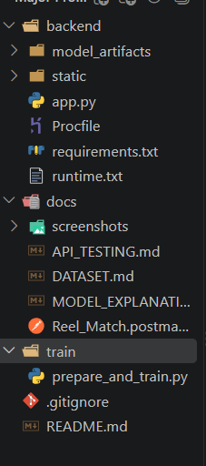
Figure 3.1 — Reel Match project structure
- backend/ — the Flask application (app.py), pinned dependencies (requirements.txt, runtime.txt), a Procfile for Render/Railway, the trained model_artifacts/, and the static/ frontend served directly by Flask.
- train/ — a one-time script (prepare_and_train.py) that turns the raw CSV into the deployed model artifacts.
- docs/ — API_TESTING.md (Postman-style test log), DATASET.md, MODEL_EXPLANATION.md, the importable Postman collection, and a screenshots/ folder documenting the working app.

3.4 Running Locally
From the backend/ directory:
- pip install -r requirements.txt
- python app.py
The app opens at http://127.0.0.1:5000. The frontend and API are served from the same Flask app, so there's nothing else to configure.

3.5 Retraining the Model (Optional)
Trained artifacts already ship in backend/model_artifacts/, so retraining isn't required to deploy. To regenerate them (e.g. with a different dataset revision), run train/prepare_and_train.py, which reads the raw CSV, filters/ranks it down to the top movies, fits the TF-IDF + Nearest Neighbors model, and overwrites the files in backend/model_artifacts/. The raw 268 MB CSV is not committed to GitHub or deployed — only the ~14 MB trained artifacts are.

3.6 API Reference
Endpoint | Method | Purpose
/health | GET | Returns server + model status.
/movies?q=<text> | GET | Lightweight title search for autocomplete.
/recommend | POST | Body {"movie": "<title>"} → returns 10 similar movies as JSON.
All errors (missing field, bad JSON, movie not found, wrong HTTP method, unknown route) return a clean JSON error object with an appropriate status code — the server never crashes or shows a raw 500 page.

3.7 Deployment

Option A — Render (recommended, free tier)
- Push the project to a GitHub repository, excluding the raw dataset CSV (see .gitignore).
- Create a New Web Service on render.com and connect the repo.
- Set root directory to backend, build command to pip install -r requirements.txt, and start command to gunicorn app:app --bind 0.0.0.0:$PORT.
- Deploy. Render provides the PORT environment variable automatically.
- Cold-start note: Render's free tier spins down after inactivity — the first request after idling can take 30–60 seconds to wake, with subsequent requests responding in well under a second (tested locally at ~50 ms for /recommend).

Option B — Railway
- Connect the GitHub repo at railway.app, set the root directory to backend.
- Railway auto-detects the Procfile (gunicorn app:app --bind 0.0.0.0:$PORT) and injects PORT automatically.

Option C — PythonAnywhere
- Upload (or git-clone) the backend/ folder, create a virtualenv, and install requirements.
- In the Web tab, create a new Flask web app (manual configuration), point the WSGI file's app import at backend/app.py's app object, and set the working directory to backend/, then reload.
The project needs no API keys or secrets — posters, ratings, and descriptions all come from the pre-trained dataset rather than a live API.

3.8 Performance Notes
- /recommend responds in ~50 ms once the server is warm — well inside the 3–5 second target.
- Total model footprint is ~14 MB, comfortably inside typical free-tier memory limits (512 MB).
- The model loads once at process startup, not per request.

3.9 Documentation & Testing
Document | Contents
docs/DATASET.md | Dataset source, size, columns used, and cleaning/filtering steps
docs/MODEL_EXPLANATION.md | Plain-language explanation of the TF-IDF + Nearest Neighbors recommender
docs/API_TESTING.md | Postman-style test log for every endpoint, including error cases
docs/Reel_Match.postman_collection.json | Importable Postman collection
docs/screenshots/ | Screenshots of the working app (desktop, mobile, and API test log)
Note on posters in the screenshots: they were captured in a sandboxed build environment that cannot reach image.tmdb.org, so posters show as text-fallback cards there. The poster_url field is present and correct in every API response and renders real poster images once the app is deployed with normal internet access.

3.10 Final Deliverables Checklist
Per the evaluation criteria — a live application link that works from any device, usability without instructions, sensible/relevant model output, clean handling of bad input, a backend that doesn't crash under normal use, a repo that runs from a clean clone, and a README covering setup, usage, testing, and deployment end to end:
Deliverable | Status
Live deployed application link | Pending — deploy per Section 3.7, then add the URL
GitHub repository link | Pending — push the folder, then add the URL
Dataset details and source | Done — docs/DATASET.md
Trained model / loading instructions | Done — backend/model_artifacts/ + Section 3.5
Frontend source code | Done — backend/static/index.html
Flask backend source code | Done — backend/app.py
requirements.txt | Done — backend/requirements.txt
README file | Done
Postman testing screenshots/documentation | Done — docs/API_TESTING.md
Screenshots of the working application | Done — docs/screenshots/
Explanation of the model and how it works | Done — docs/MODEL_EXPLANATION.md
The two pending items require a one-time action: create a GitHub repository named Avni_INBT021871_iNeuBytes and push this code (with Task 1 and Task 2 in their own folders in the same repo, per the submission instructions), deploy it via Render/Railway/PythonAnywhere, and paste both links at the top of the README before final submission.

Summary
Across the three projects, this portfolio demonstrates the full arc of an applied AI/ML workflow: building and improving a computer-vision model from a documented baseline (Task 1), fairly comparing classical and deep-learning approaches on an NLP task and drawing an honest conclusion about which one wins (Task 2), and taking a content-based recommender end-to-end into a deployable, production-shaped web application with a documented API, error handling, and a clear deployment path (Major Project).
Project | Key Result
Task 1 — CIFAR-10 CNN | Customized CNN reached 83.19% test accuracy, a 12.99-point gain over the traditional baseline (70.20%).
Task 2 — Sentiment Analysis | SVM (LinearSVC) was the best model overall with F1 = 0.8527, edging out LSTM (F1 = 0.8240).
Major Project — Reel Match | TF-IDF + Nearest Neighbors recommender over 12,000 curated titles, served via a Flask API responding in ~50 ms once warm.

